Fleet Foxes Debut Sean Pecknold Directed Video For “Featherweight”
and Behind the Scenes Mini-Doc - WATCH HERE

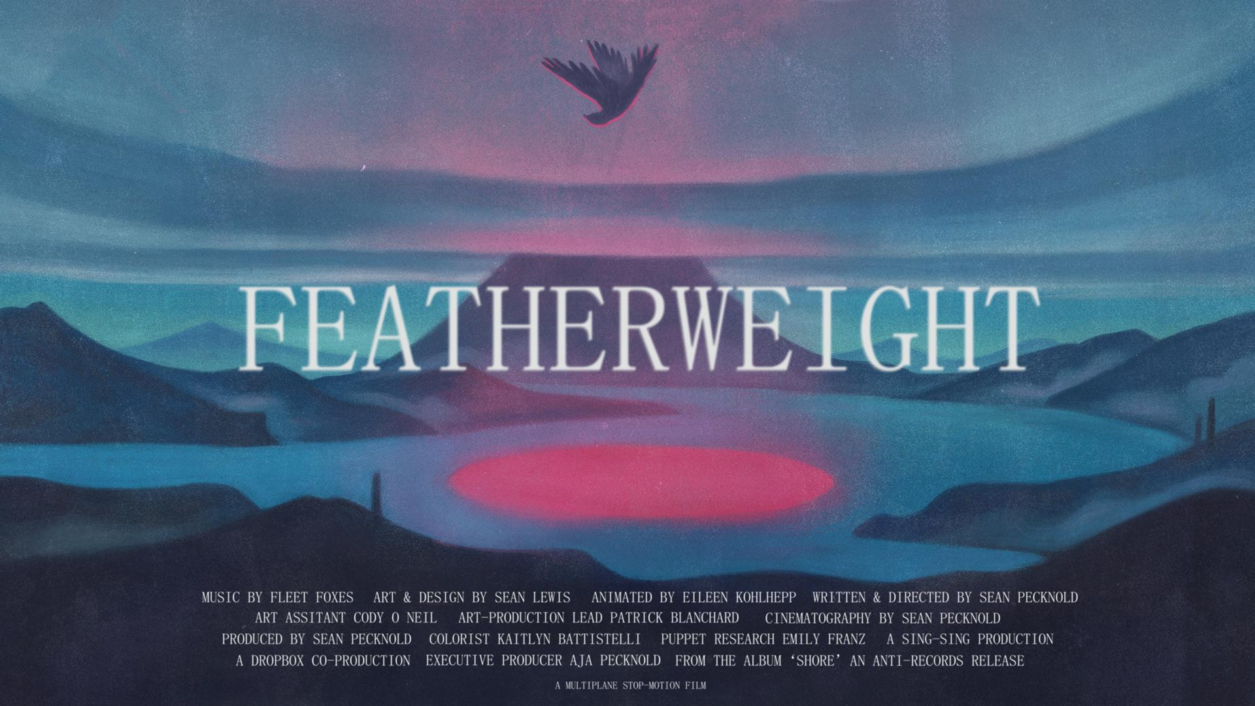

Stop-Motion Film Launches Worldwide Today on the One-Year Autumnal Equinox Anniversary of Fleet Foxes’ Shore

Fleet Foxes have today (Sept. 22) released a stunning new animated video for the song “Featherweight,” the 10th video directed by band frontman Robin Pecknold’s brother and longtime visual collaborator Sean Pecknold. Arriving on the one-year autumnal equinox anniversary of Fleet Foxes’ latest Anti- album, Shore, the video is set amid a world of struggle and hope, brought to life using stop-motion animation and a multiplane camera. The evocative and visually striking film chronicles a young hawk as he struggles to fly with a broken wing, the successes and bitter failures that come from his attempt and the second chances that life will sometimes offer -- even when all seems lost.
Watch “Featherweight” here: https://fleetfoxes.ffm.to/featherweight/youtube
Since 2008, Sean Pecknold has crafted the visual narrative behind Fleet Foxes' songs, interpreting them for the screen in the form of music videos, short films and production design. While his chosen medium shifts dynamically between claymation, stop-frame animation and live action, his point of view remains singularly engaging. Employing analog filmmaking techniques, he creates stories that evoke universal emotions, whether his characters are lonely shapes, people, creatures or objects.
“Robin and I grew up together, watching a lot of the same movies and animations,” explained Sean Pecknold. “So, I think we are able to collaborate in a way that is very trusting and intuitive. We are connected on a similar wavelength."
When concepting each music video, Sean is not only influenced both by the lyrics and the “visual shape” he imagines as he listens to the music. For “Featherweight,” he “was able to see the song in a new way” after listening to the multi-track stems from the original recording session. “Actually hearing the layers that went into the song was a nice exercise for me to think about the layers of the pictures.”
To bring “Featherweight” to life, Sean joined forces with noted animator Eileen Kholheep (Robot Chicken, Anomalisa). “Eileen has an incredible attention to detail and ended up bringing the characters to life in a way I could never have done by myself,” he says. He also worked with Toronto-based artist Sean Lewis, whose character designs and landscapes are fundamental to the world of the short film. “I discovered Sean’s work when he illustrated one of the first Fleet Foxes t-shirts in 2008,” he recalls. “We had a chance to team up in 2020 to create concept art for a feature-length animation I’ve been working on. The experience on that project was so wonderful that I wanted to take the collaboration to the next level with the ‘Featherweight’ animation.”

Watch the behind-the-scenes documentary about the production process behind “Featherweight” HERE.

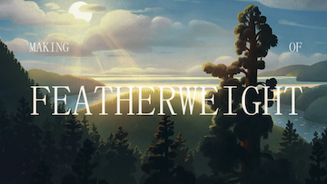

Pecknold previously combined stop-motion animation with multiplane down-shooting on the video for Fleet Foxes’ 2011 epic “The Shrine / An Argument.” “I had seen the multiplane technique in early Disney films like Bambi and Pinocchio, then later when I discovered Lotte Reiniger’s and Yuri Norstein’s films,” he says. “I’m very drawn to the texture, depth-of-field and parallax inherent in the technique.”

Production was facilitated by Dropbox, which enabled the team to easily share files during the five months “Featherweight” was in production. “Dropbox has been a patron of creative short form music videos for the last several years,” says Sean. “They were very supportive of our ideas and the creative direction we chose to bring the song to life.”

Select Sean Pecknold-directed Fleet Foxes videos include:

White Winter Hymnal
Mykonos
The Shrine
Making of Shrine
Fools Errand
Arroyo
Can I Believe You

“Featherweight” is the latest single from Fleet Foxes’ fourth studio album, Shore, which was praised as one of the top albums of 2020 by Rolling Stone, Pitchfork, NPR, The New Yorker, Mojo, Uncut and more. With over 125 million global streams to-date, Shore also found strong support at radio, holding #1 on JBE non-comm chart for 14 weeks in a row and reaching Top 5 BDS Monitored and Top 10 Mediabase at the AAA format with the single “Can I Believe You.”

ACCLAIM FOR SHORE:

“Shore looks to the world and realizes there is already enough, as if staring into a darkness and responding with beauty, acceptance, and light." - PITCHFORK (BEST NEW MUSIC)

"A gorgeous folk-rock song cycle about life, death, and art, full of deep mourning and glimmers of relief on the other side. Track for track, Shore is the most immediately rewarding Fleet Foxes record since their brilliant 2008 debut." - ROLLING STONE (⅘ STARS)

“You soothe our worried minds and fraying souls with some gorgeous-as-fuck artisanal splendor." - ROLLING STONE (⅘ STARS)

"When you’ve got a song on your album called “Quiet Air/Gioia,” and it’s every bit as pretentious as that title suggests and yet in no way sucks, you’ve done your artistic betters proud." - ROLLING STONE (4/5 STARS)

"The gorgeous record found tonal balance amid the chaos of recent months, when the project suddenly seemed inconsequential to its creators and, therefore, more like a refuge. Though still primarily the creation of the band’s front man, Robin Pecknold, “Shore” is a collective effort that includes many contributors, and its glistening arrangements are reflective of the unburdening that collaboration fosters. " THE NEW YORKER

"The album is uniformly gorgeous, sometimes overwhelmingly so when taken in all at once...Every now and then there’s a moment of brightness, an actual good thing, that alleviates the darkness of the wretched year that is 2020. This is one of those good things." - STEREOGUM

"Fleet Foxes made the perfect album for this moment." - VULTURE

"Filled with epic, sweeping songs."- ENTERTAINMENT WEEKLY

"These 15 tracks are the work of an artist taking in everything dark and corrupt about this year, and choosing to craft an artifact of hope." - UPROXX

"There are lush soundscapes, fluttery brass cacophonies and subdividing rhythms...there is an acknowledgment of the past, but in a way that throws into sharp relief the potential that lies ahead and the legacy that is carried into the future" - ASSOCIATED PRESS

"Lucid, warm, and with no shortage of heart, Shore is a wonderful album to lead us into the concluding chapters of what has been a heartbreaker of a year." - CONSEQUENCE OF SOUND

"Shore is their most collaborative, most joyous album, and also one that transcends what Pecknold called the agrarian fantasies of their early days for an earnest plea to hear the call of the wild." THE RINGER

"Robin remains an extremely gifted songwriter, and these songs find him weaving in deceptively simple arrangements and some of the most instantly-satisfying melodies he's written yet." - BROOKLYN VEGAN

"Both vibrant and vital." UNDER THE RADAR

Follow Fleet Foxes:
Website - Instagram - Robin’s Instagram - Facebook

For more information on Fleet Foxes, please contact Grandstand Media:
Kate Jackson - katej@grandstandhq.com
Katie Nelson - katien@grandstandhq.com

