LEYLA MCCALLA SHARES “LOVE WE HAD”
FROM UPCOMING ALBUM
‘SUN WITHOUT THE HEAT’
OUT APRIL 12
LISTEN HERE
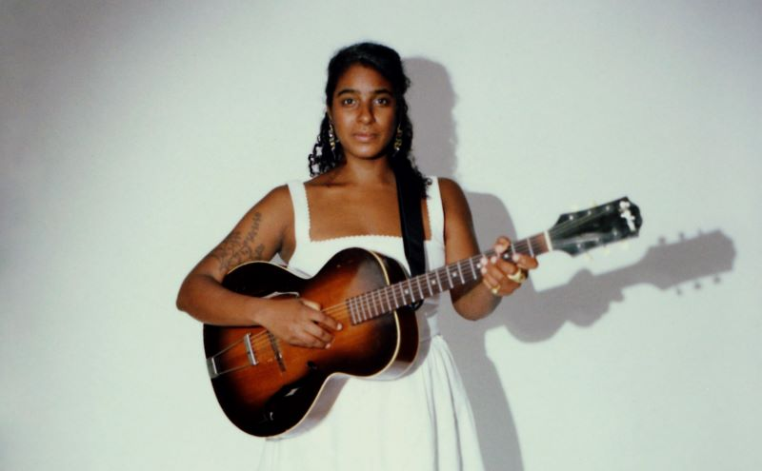
Photo Credit: Chris Scheurich
PERFORMING THIS SPRING AT CAYAMO, BIG EARS, HIGH WATER AND NEW ORLEANS JAZZ FESTIVAL
“It's an exhilarating thing, hearing a musical virtuoso explore her voice's unanticipated potential in all of the ways that Leyla McCalla does.. a singer-songwriter, tracing the intricate textures of post-colonial, pan-African experience with her poetic language of longing.” — NPR
""Scaled To Survive" yearns for personal independence, while the soulful "Tree" is illuminated by Leyla McCalla’s lilting vocal performance" — Clash on “Scaled to Survive” & “Tree”
"Haitian-American songwriter [Leyla McCalla} imagines an unloved woman turning herself into a tree. Swaying samba heats up to a rebellious howl of Tropicália fuzz guitar." — MOJO on "Tree"

A cover originally written and performed by Ethiopian artist and activist Ali Mohammed Birra, Leyla McCalla has shared her Tropicalia-inflected version of “Love We Had” today. Serving as an African Diasporic declaration of sonic freedom in the face of all that has kept us apart from one another, listen to the track below. Listen to “Love We Had”: https://www.youtube.com/watch?v=yoGDnjWKY2c
“Love We Had” is featured on McCalla’s new album and fifth studio recording, ‘Sun Without the Heat’. Throughout ‘Sun Without the Heat’’s ten tracks, McCalla is playful and full of joy while holding the pain and tension of transformation. She achieves a balance of heaviness and light with melodies and rhythms derived from various forms of Afro-diasporic music including Afrobeat, Ethiopian modalities, Brazilian Tropicalismo, and American folk and blues. “I like it when music feels urgent,” McCalla says, “but I also wanted the new album to be playful and fun. I wanted that levity to come through.”
‘Sun Without the Heat’ was recorded in an intense nine-day session at Dockside Studies in New Orleans. Produced by Maryam Qudus, McCalla was joined by longtime bandmates and collaborators Shawn Myers on percussion and drums, Pete Olynciw on electric bass and piano, and Nahum Zdybel on guitars. Qudus is featured on synthesizers, organs and backing vocals.
“Usually, I go into the studio and have the songs and the framework already in mind,” says McCalla. “But with this album, we built the frame in real time. It was an intimidating process, but it also helped me realize how held I am by the musicians I work with.”
The result is a transcendent collection of songs that hold the personal and universal, carrying grief and joy at once. Through this album, McCalla explores the elements of transformation and the heat necessary to move from darkness toward light.
This spring McCalla will be performing at a slew of music festivals, including Cayamo, Big Ears, High Water, New Orleans Jazz and more. She will also have headlining shows around the album’s release in New Orleans, DC, New York City and more. All upcoming dates are listed below.

TOUR DATES
3/1 - 3/8 - Miami, FL @ Cayamo
3/22 - 3/24 - Knoxville, TN @ Big Ears Festival
4/9 - New Orleans, LA @ Broadside
4/11 - Washington, DC @ The Kennedy Center
4/12 - New York, NY @ Joe’s Pub
4/13 - Albany, NY @ The Egg
4/28 - Tallahassee, FL @ Word of South Festival
4/20 - North Charleston, SC @ High Water Festival
4/26 - New Orleans, LA @ New Orleans Jazz & Heritage Festival
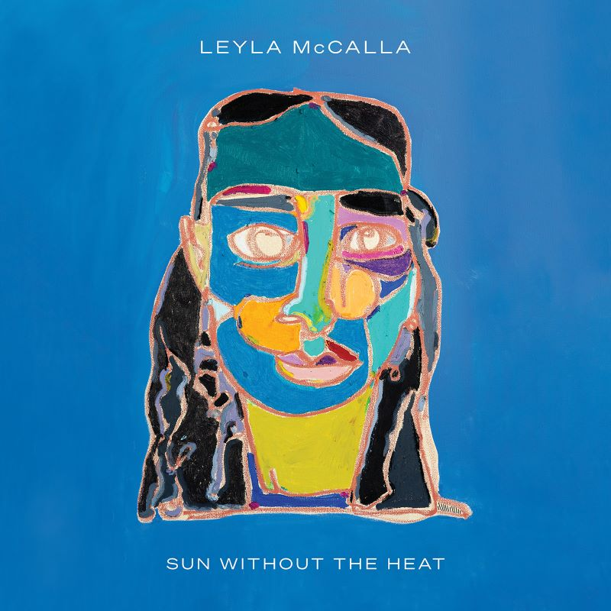
Pre-Order ‘Sun Without the Heat’
1. Open the Road
2. Scaled to Survive
3. Take Me Away
4. So I’ll Go
5. Tree
6. Sun Without the Heat
7. Tower
8. Love We Had
9. Give Yourself a Break
10. I Want to Believe
https://leylamccalla.com/
Facebook | Instagram | Twitter
For More Info on Leyla McCalla, Contact:
Kelly Kettering | ANTI- Records Publicity | kelly@epitaph.com

