August 1, 2022
For Immediate Release

Son Little Releases New Single, “6 AM”

From New Album, Like Neptune, Out Sept. 9th via ANTI-

Tickets for North American Tour On Sale Now

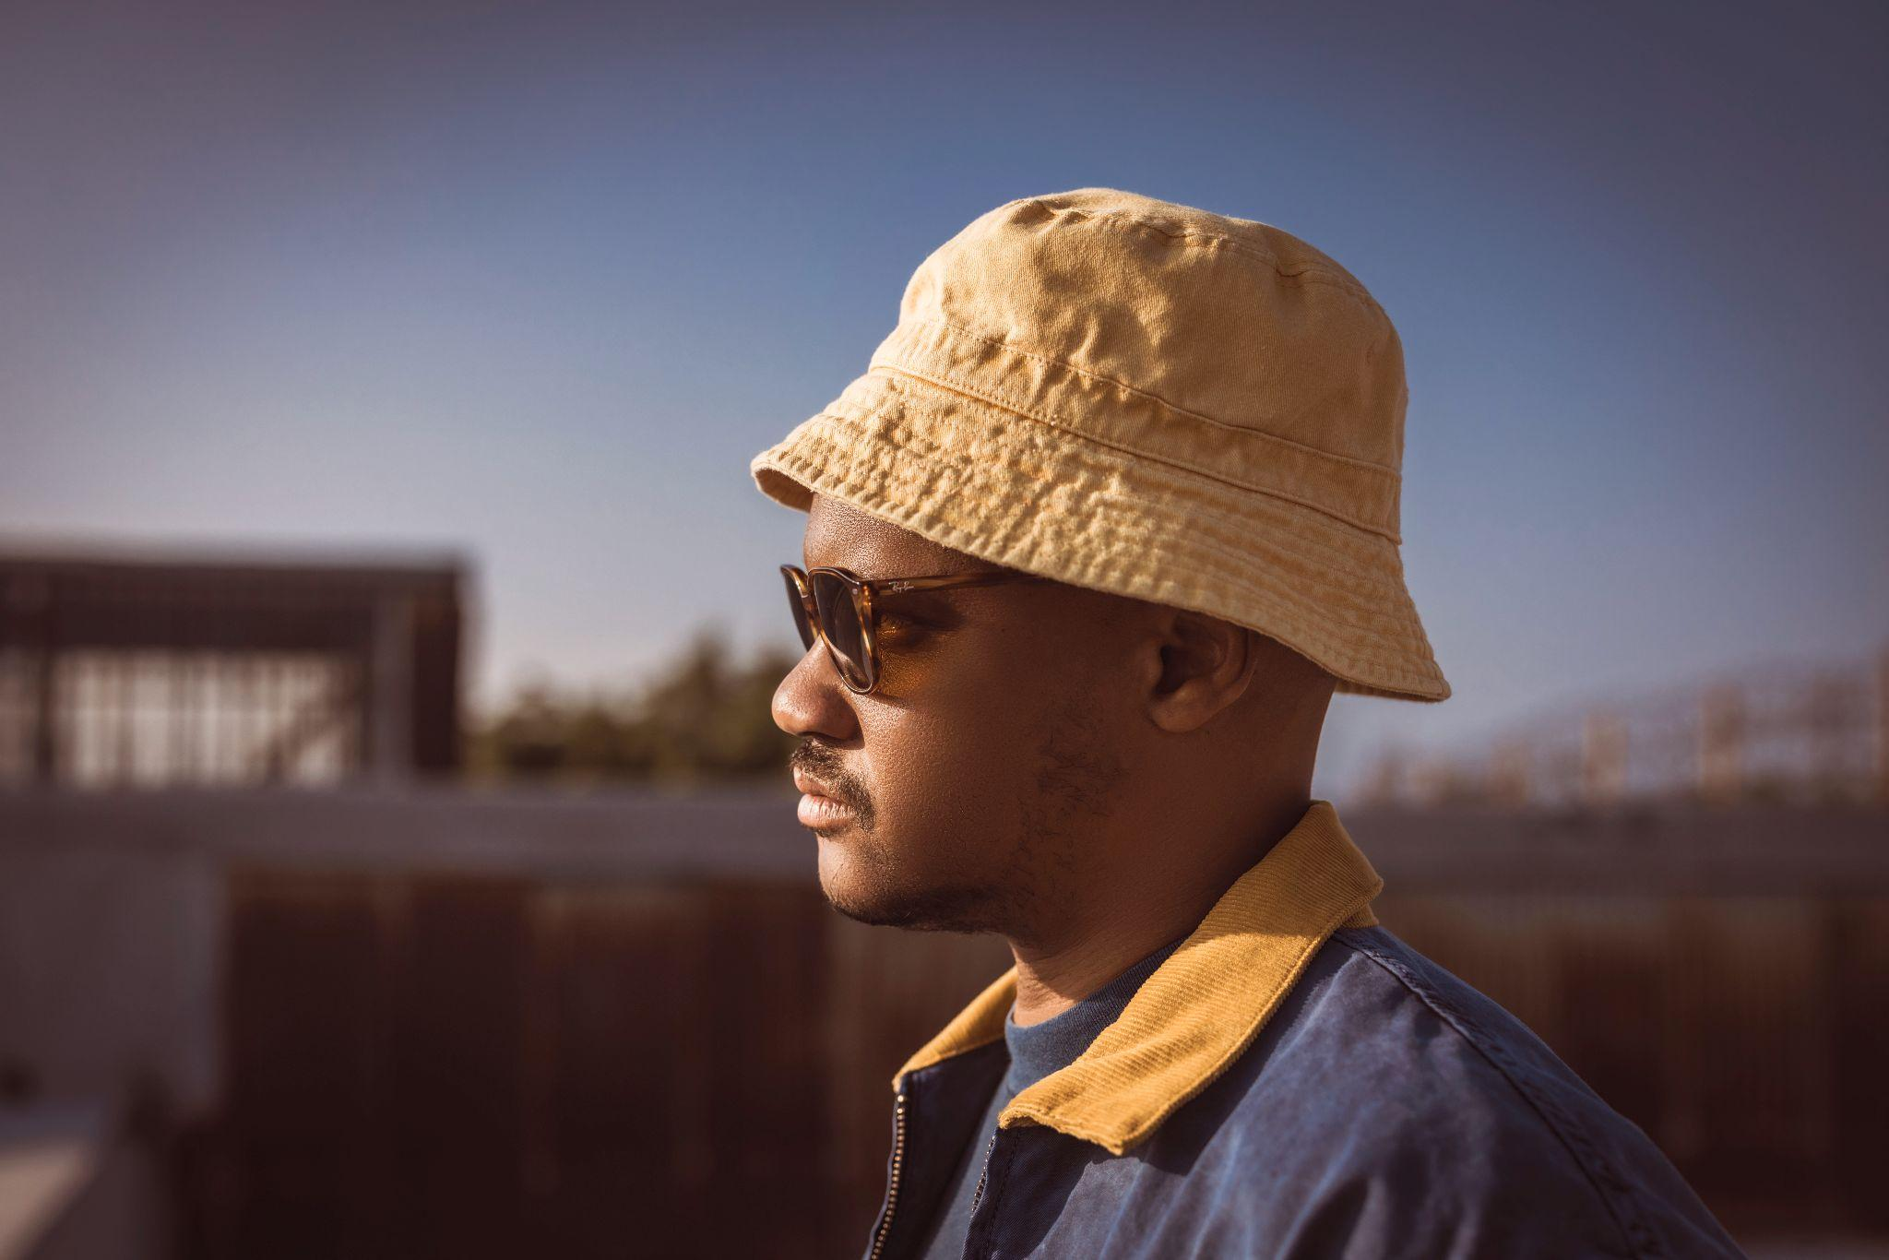
(Photo Credit: Cynthia Perez)

“Both ‘Deeper’ and ‘Stoned Love’ burrow into gauzy, psychedelic soul.” - Philadelphia Inquirer

“[‘deeper’ is] a lovely, soulful ballad with some interesting production choices – the beat that constantly seems to be on the verge of breaking down, the burping electric bass notes, and the almost narcotic haze of the electronics that surround his voice.” - WNYC’s New Sounds

Son Little presents a new single, “6 AM,” off of his forthcoming album, Like Neptune, out September 9th on ANTI-. Like early singles “deeper” and “stoned love,” “6 AM” is noticeably confident from the opening note, with Son Little prioritizing his signature rasp as the chief instrument. Describing Like Neptune as “my inner R&B Boy Band” where “a different version of me takes lead on each song,” “6 AM” invokes the anxious worrisome version, the one who stays up all night worrying they’ll sleep through the alarm, and describes a constant effort to repair a fraught relationship with sleep.

“‘Dawn’ is my favorite Octavia Butler book,” says Aaron Livingston (aka Son Little). “It’s also my favorite time of the day— the time I have my clearest most exciting ideas and also the time when I sometimes spiral into emotional/mental chaos. Wrote a song about it.”

Listen to Son Little’s “6 AM”

Conceived in a cabin overlooking the Delaware River in upstate New York, Like Neptune is an open and vulnerable portrayal of unbridled joy and self-acceptance. In this verdant space of freedom, Son Little transmutes the chronic pain of self-doubt into a beautiful opus about overcoming generational trauma, decorating the altar of the primordial blues and elevating the labor of healing to high art.

"In the beginning of lockdown, I went into a closet full of junk and found a couple of boxes full of my old writing books,” Livingston explained. “There turned out to be 72 books in there. The oldest book I got as a Christmas present when I was 9. In it, I wrote letters to myself about what was happening in my life. One page refers to a neighbor in Queens who abused me sexually around age 5. It was the first and only time I’d ever acknowledge this fact until after my 19th birthday, when I told my mother what had happened. She begged me to go to therapy. I went under protest. My attempt wasn’t sincere. I wasn’t ready. I thought I could just power through it.” Years of anxiety, depression, panic attacks and existential dread ensued, often dulled or numbed by the effects of alcohol, drugs, or sex. Following a car crash and arrest finally led him back into therapy in 2017. Aggressively employing progressive methods like EMDR and somatic healing, Livingston, with the help of a trusted therapist, began identifying the roots of his trauma, and where it lives in the body. But the biggest breakthrough came from Internal Family Systems, a methodology that recognizes responses to trauma triggers as distinct entities or ‘parts’ within the person, and requires the patient essentially have conversations with the different traumatized personalities within them.

Delving into his journals and happily cooped up inside due to the pandemic, Son Little returned to beat making to craft the core of Like Neptune using apps on his iPad— a method originally tasked with satisfying the nagging urge to create on a daily basis on the road; later he fleshed out the programming and added live instrumentation in Ableton live— while micro dosing LSD and immersing himself in the sounds of ‘70s era David Bowie and psychedelic Amazonian cumbia of the same period. Like Neptune establishes Son Little as the polyglot translator and rightful torchbearer of the celebrated musical tradition known as rhythm and blues. With it, he completes the daunting tasks of confronting himself and pushing his sound to completion. The result is a timeless body of work reflective of his deep internal desire to inhabit the most radiant version of himself and become a positive force in the lives of people around him.

Listen to “deeper” by Son Little

Listen to “stoned love” by Son Little

Pre-order Like Neptune

Son Little Tour Dates
Fri. Sept. 2 - Madrid, ES @ Sala Clamores
Sat. Sept. 3 - Zaragoza, ES @ Rock & Blues Cafe
Sun. Sept. 4 - Barcelona, ES @ La Nau Locales de Ensayo
Wed. Sept. 7 - Hamburg, DE @ Bahnhof Pauli
Thu. Sept. 8 - Berlin, DE @ Privatclub
Fri. Sept. 9 - Köln, DE @ Helios 37
Sat. Sept. 10 - Zürich, CH @ Exil
Mon. Sept. 12 - Antwerpen, BE @ Kavka
Wed. Sept. 14 - Amsterdam, NL @ Paradiso
Thu. Sept. 15 - Rotterdam, NL @ Bird
Fri. Sept. 16 - Paris, FR @ La Maroquinerie
Sat. Sept. 17 - London, UK @ The Garage
Sun. Sept. 18 - Brighton, UK @ The Hope & Ruin
Tue. Nov. 1 - Los Angeles, CA @ Troubadour
Wed. Nov. 2 - San Diego, CA @ Soda Bar
Fri. Nov. 4 - San Francisco, CA @ Great American Music Hall
Sat. Nov. 5 - Santa Cruz, CA @ Moe’s Alley
Mon. Nov. 7 - Seattle, WA @ Neumos
Wed. Nov. 9 - Portland, OR @ Doug Fir Lounge
Thu. Nov. 10 - Boise, ID @ The Olympic
Fri. Nov. 11 - Salt Lake City, UT @ The State Room
Sat. Nov. 12 - Denver, CO @ Bluebird Theater
Tue. Nov. 15 - Dallas, TX @ The Kessler Theater
Wed. Nov. 16 - Austin, TX @ 3TEN ACL Live
Fri. Nov. 18 - Memphis, TN @ Railgarten
Sat. Nov. 19 - Nashville, TN @ The Blue Room at Third Man Records
Thu. Dec. 1 - Charleston, SC @ The Pour House
Fri. Dec. 2 - Atlanta, GA @ Smith’s Olde Bar
Sat. Dec. 3 - Lake Wales, FL @ Orange Blossom Revue
Sun. Dec. 4 - Tampa, FL @ The Attic
Wed. Dec. 7 - Milwaukee, WI @ Back Room at Colectivo
Thu. Dec. 8 - St. Paul, MN @ Turf Club
Fri. Dec. 9 - Chicago, IL @ Chop Shop
Sat. Dec. 10 - Ferndale, MI @ The Loving Touch
Wed. Dec. 14 - Boston, MA @ The Sinclair
Thu. Dec. 15 - Sheffield, MA @ Race Brook Lodge
Fri. Dec. 16 - Brooklyn, NY @ Elsewhere
Sat. Dec. 17 - Philadelphia, PA @ Underground Arts

Download album art & hi-res images of Son Little

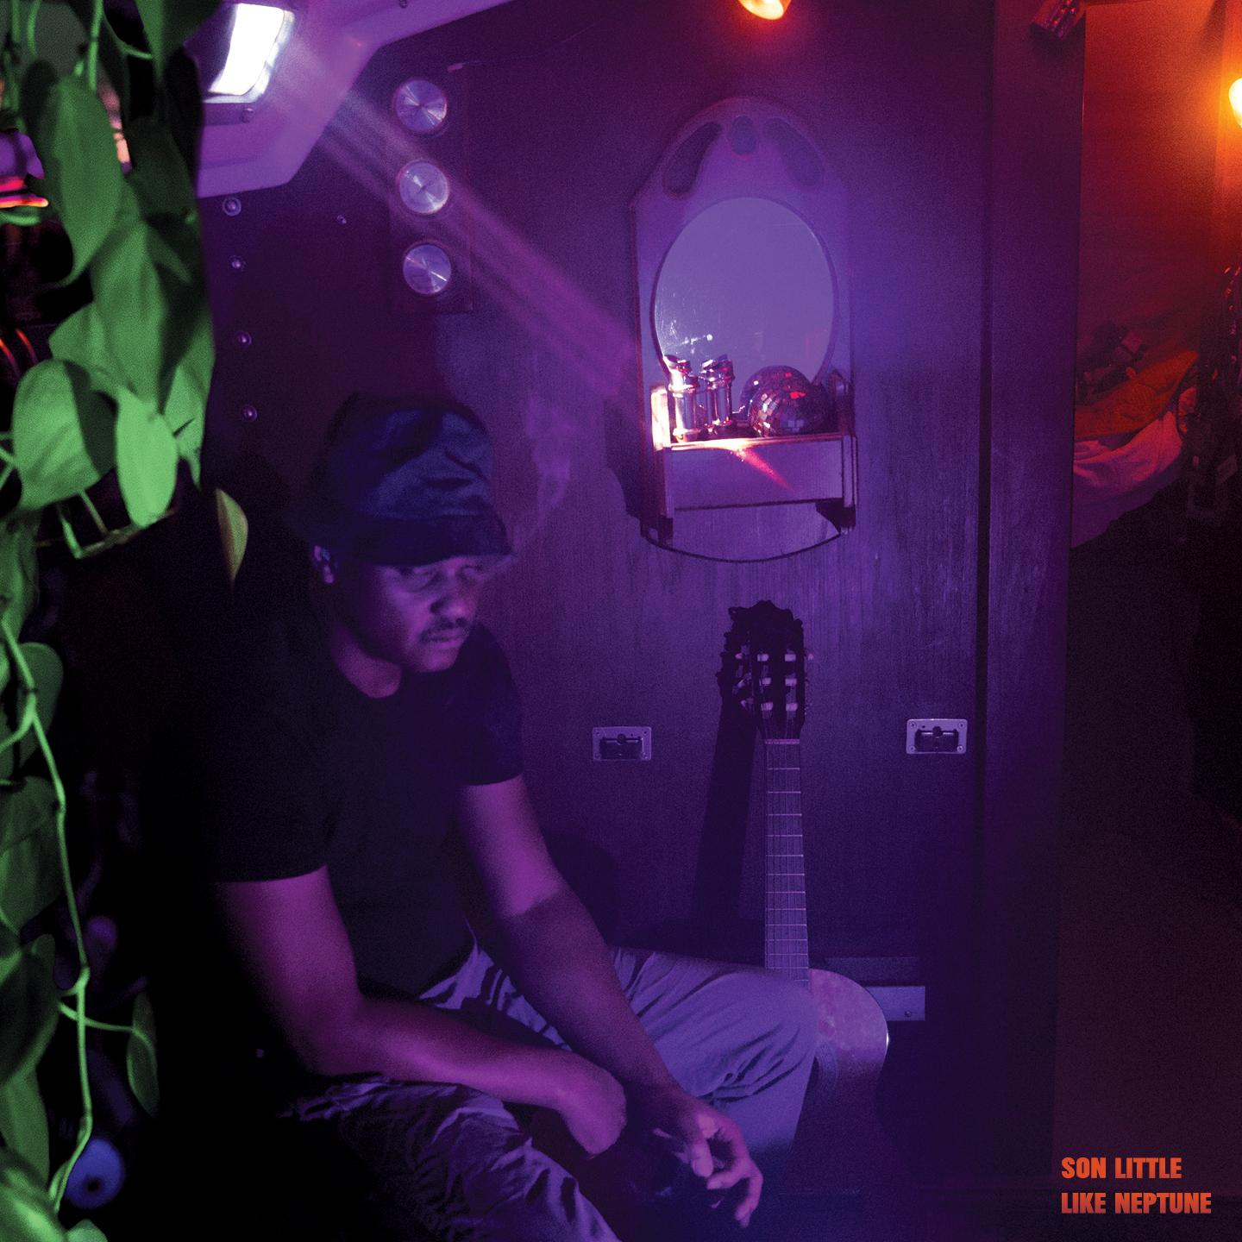
(Like Neptune Cover Artwork)

Artist Site | Facebook | Twitter | Instagram | Youtube | ANTI-

For more information, contact:
Sam McAllister | Pitch Perfect PR - sam@pitchperfectpr.com, 773-942-6573

###

