THE DRUMS ANNOUNCE NEW ALBUM JONNY
ARRIVING OCTOBER 13TH VIA ANTI- RECORDS

AVAILABLE FOR PRE-ORDER NOW HERE

LISTEN TO THE NEW SONG “BETTER” HERE

NORTH AMERICAN SUMMER TOUR
KICKS OFF TONIGHT

The Drums - “Jonny” (Album Artwork)

July 12, 2023 (LOS ANGELES, CA) - The Drums have officially announced Jonny; founding-member Jonny Pierce’s forthcoming sixth studio album that will arrive October 13th, 2023 via ANTI- Records. Heartbreaking, playful, raucous, and serene all in turn, Jonny is a body of work confronts the deep-rooted childhood trauma Pierce experienced growing up in a cult-like religious community in upstate New York, and triumphs over the long shadow it cast on his life and relationships for years. Alongside the announcement today arrives “Better”: the latest song from the project, which drapes a glimmering hook over lyrics about lurching out of codependency and retreating back into reliable arms of loneliness.

PRE-ORDER JONNY HERE
LISTEN TO “BETTER” HERE

“When I finished “Jonny”, I listened to it, and I heard my soul reflected back at me,” says Pierce about the record. “It is devastating and triumphant, it is lost and found, it is confused and certain, it is wise and foolish. It is male and female, it is hard and gentle. To encapsulate ones' whole self in an album, to honor each and every part of you - even the parts that feel at odds with each other, is to make something deeply human, and because my religion is humanism, the album becomes a sacred place for me to worship. Each feeling a different pew, each song a hymn to the human heart.”

On Jonny, Pierce doesn't just conquer the darkness that haunted his childhood and the subsequent unworthiness that loomed for decades after – he absolves and loves it for what it was. In doing so, the record unearths a true sense of hope, optimism and joy that’s existed just beyond his fingertips for most of his life. An embrace of the mess of life in all its facets, Jonny offers an invitation to dissolve all the hard lines that separate us from ourselves and, by extension, each other -- to soften our shells, to let some tenderness in. Always finding the balance between aching melancholy and irresistible pop sensibilities, the album finds Pierce peering through a kaleidoscope of shimmering guitars, reverb, modular synthesizers and drum machines: a sonic identity that has been uniquely, and wholly The Drums since their emergence 15 years ago.

Jonny serves as a love letter to a galaxy of Pierce’s younger selves. The toddler who endured life-rippling trauma; the teenager who reflexively built up an armor to the outside world; the on-stage performer; the dancer; the lover. Each version of himself that, for much of his life, he felt was never enough. Channeled within tracks like “Better,” as well as the recently released “Obvious”, “I Want It All” and “Plastic Envelope / Protect Him Always,” the record is filled with self-reflective indie pop songs as well a series of minute-long vignettes that ground the album in gentle introspection as Pierce sings directly to his younger selves.

The album is a reclamation a lifetime in the making, even down to the intimate album and single artwork – a series of naked self-portraits snapped when he returned to his childhood home in New York a decade ago. Feeling a need to drive upstate one day while he knew his parents would be at service, he took a photo in prayer-pose in his father’s church office chair among other places in the house where something significant or traumatic happened to him as a kid. It was an experience he couldn’t make sense of in the moment, let alone share with the outside world, but the feeling of putting his nude body into the spaces where others had so often made him feel powerless was a triumph he would discover years later during the making of Jonny.

“JONNY” TRACKLIST
- I Want It All
- Isolette
- I’m Still Scared
- Better
- Harms
- Little Jonny
- Plastic Envelope
- Protect Him Always
- Be Gentle
- Dying
- Green Grass
- Obvious
- The Flowers
- Teach My Body
- Pool God
- I Used to Want To Die

The Drums will bring songs from Jonny to life on stage for the first time ever on a full-length North American tour, which kicks off tonight in San Diego, CA and will run through the end of the summer. For dates and complete ticketing information, visit HERE.

Soaring to alt-pop prestige nearly fifteen years ago with a renowned self-titled debut, The Drums continue to thrive, influence and reinvent with every project. Pierce initially conceived of the band back in 2008 and what resulted was a string of six studio albums and worldwide acclaim. Their music remains timeless, as evidenced by the recent explosion of their song “Money,” which first appeared on their breakout sophomore album Portamento. Transforming into a viral sensation earlier this year – over a decade since it was first released – the song has since bloomed with a second life, eclipsing over 230 million streams on Spotify alone, achieving RIAA Gold-certification, and reaching #1 on the Alternative Global Shazam chart and the #2 TikTok Global Hashtag.

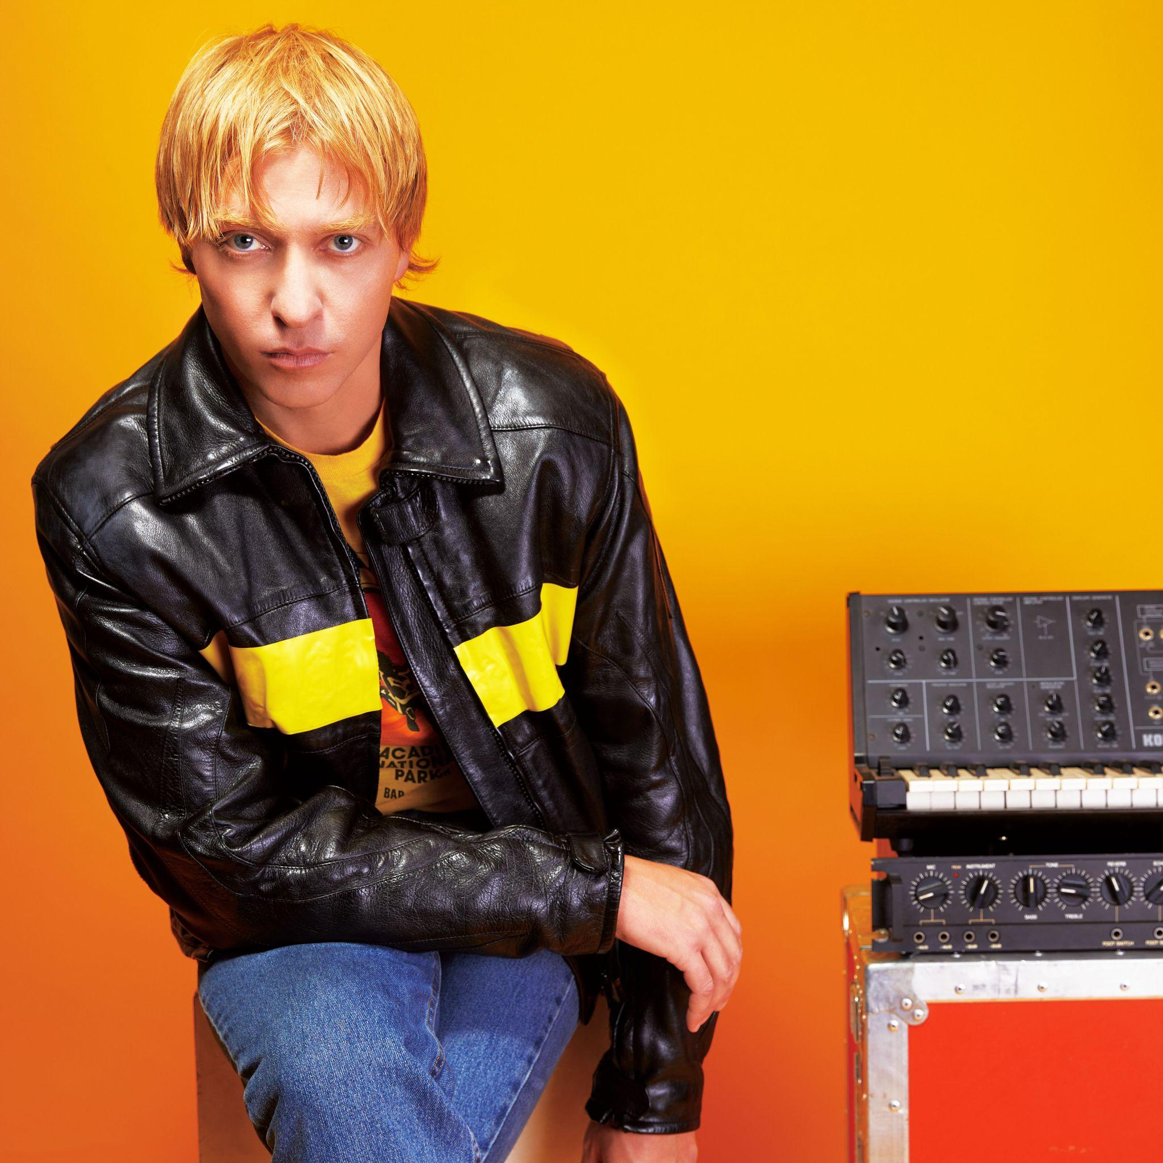
The Drums (Photo Credit: Qiao Meng)

###

For More Information:

Jaime Rosenberg / 2b Entertainment
jaime@2bentertainment.net

Peter Quinn / 2b Entertainment
peter@2bentertainment.net

Kelly Kettering / ANTI- Records
kelly@epitaph.com

