THE DRUMS BARE IT ALL ON NEW ALBUM JONNY
LISTEN HERE

WATCH VIDEO FOR “DYING” FEATURING
RICO NASTY HERE

October 13, 2023 (Los Angeles, CA) - The Drums have released their highly anticipated new album, Jonny, out now via ANTI- Records. The 16-track album dives deep into lead singer Jonny Pierce’s experiences growing up in a cult-like religious community in upstate New York. Throughout the album Jonny unpacks his deep-seated childhood trauma, with this confrontation allowing him to ultimately reach a place of self-love and acceptance. Along with the album, The Drums have released a hauntingly beautiful music video for “Dying” featuring Rico Nasty.

Listen to Jonny HERE and watch the video for “Dying” (feat. Rico Nasty) HERE.

On the atmospheric track “Dying,” Jonny desperately looks for a way to escape the isolation he experienced. Jonny’s floaty vocals convey the feeling that he’s already a ghost, performing the track from beyond the grave. Rico Nasty’s verse builds on the emotions of the song, candidly expressing her own fear of being alone. The accompanying music video portrays Jonny’s funeral, which features a horde of fans filling the pews alongside Rico Nasty. Ironically, Jonny is only able to find companionship after he’s already dead and can no longer experience the joys of connection. The emotional video is made even more impactful thanks to the band’s decision to include genuine fans to act as the crowd.

On collaborating with Rico Nasty, Jonny explains, “For much of my life, I have felt like a ghost floating outside of my own body, outside of my own experiences, outside of my own relationships. The song and video portray that frustrating disconnection to self, and how that disconnect plays a part in how others have sometimes seen and experienced me, leading to a feeling of loneliness without hope. If I can’t be in my body, and know myself, how can I learn to love myself? And if I can’t learn to love myself, how can I be truly known and loved by anyone else? Dying all my life… ”

Rico Nasty also shared her experience working with Jonny, gushing, “Working with Jonny has been a dream. He has such a vulnerable soul… the song came about pretty simply. We’ve been showing love to each other throughout the years and our schedules finally allowed us time to make something beautiful together. The song is about spending all your life dying for love.”

Several vignettes are carefully woven into the album’s structure, which allow Jonny to speak candidly about the pain he endured. On “Harms,'' he reaches out to those who have experienced similar suffering, echoing, “To all the motherless sons, I can’t speak for you / I only hold my stories / I only hold my harms / But I’m angry for you / And I’m angry for me.” These vignettes provide clearer windows into the depths of Jonny’s trauma, inviting us to feel his anguish as he speaks directly to his younger self.

Also featured on the album are recent singles “The Flowers,” “Better,” “Obvious”, “I Want It All”, “Isolette” and “Plastic Envelope / Protect Him Always.” The tracks have been met to high praise from fans, along with nods from Rolling Stone, Stereogum, Brooklyn Vegan, FLOOD, Billboard, Consequence, and more.

Soaring to alt-pop prestige nearly fifteen years ago with a renowned self-titled debut, The Drums continue to thrive, influence and reinvent with every project. Pierce initially conceived of the band back in 2008 and what resulted was worldwide acclaim and a string of five studio albums that deftly walk the line of aching melancholy and irresistible pop sensibilities, presented through a kaleidoscope of pastel guitars, reverb, modular synthesizers and drum machines. It’s a sound that’s wholly unique, and unmistakably The Drums.

The Drums’ music remains timeless, as evidenced by the recent explosion of their song “Money,” which first appeared on their breakout sophomore album Portamento. Transforming into a viral sensation earlier this year – over a decade since it was first released – the song has since bloomed with a second life, eclipsing over 230 million streams on Spotify alone, achieving RIAA Gold-certification, and reaching #1 on the Alternative Global Shazam chart and the #2 TikTok Global Hashtag.

“JONNY” TRACKLIST
- I Want It All
- Isolette
- I’m Still Scared
- Better
- Harms
- Little Jonny
- Plastic Envelope
- Protect Him Always
- Be Gentle
- Dying (feat. Rico Nasty)
- Green Grass
- Obvious
- The Flowers
- Teach My Body
- Pool God
- I Used to Want To Die

Upcoming Tour Dates
October 13, 2023 - Masonic Lodge at Hollywood Forever Cemetery - Los Angeles, CA
October 14, 2023 - Tecate Coordenada Festival - Guadalajara, MX
October 18, 2023 - Pabellón Cuervo - Mexico City, MX
October 20, 2023 - Showcenter Complex - Monterrey, MX

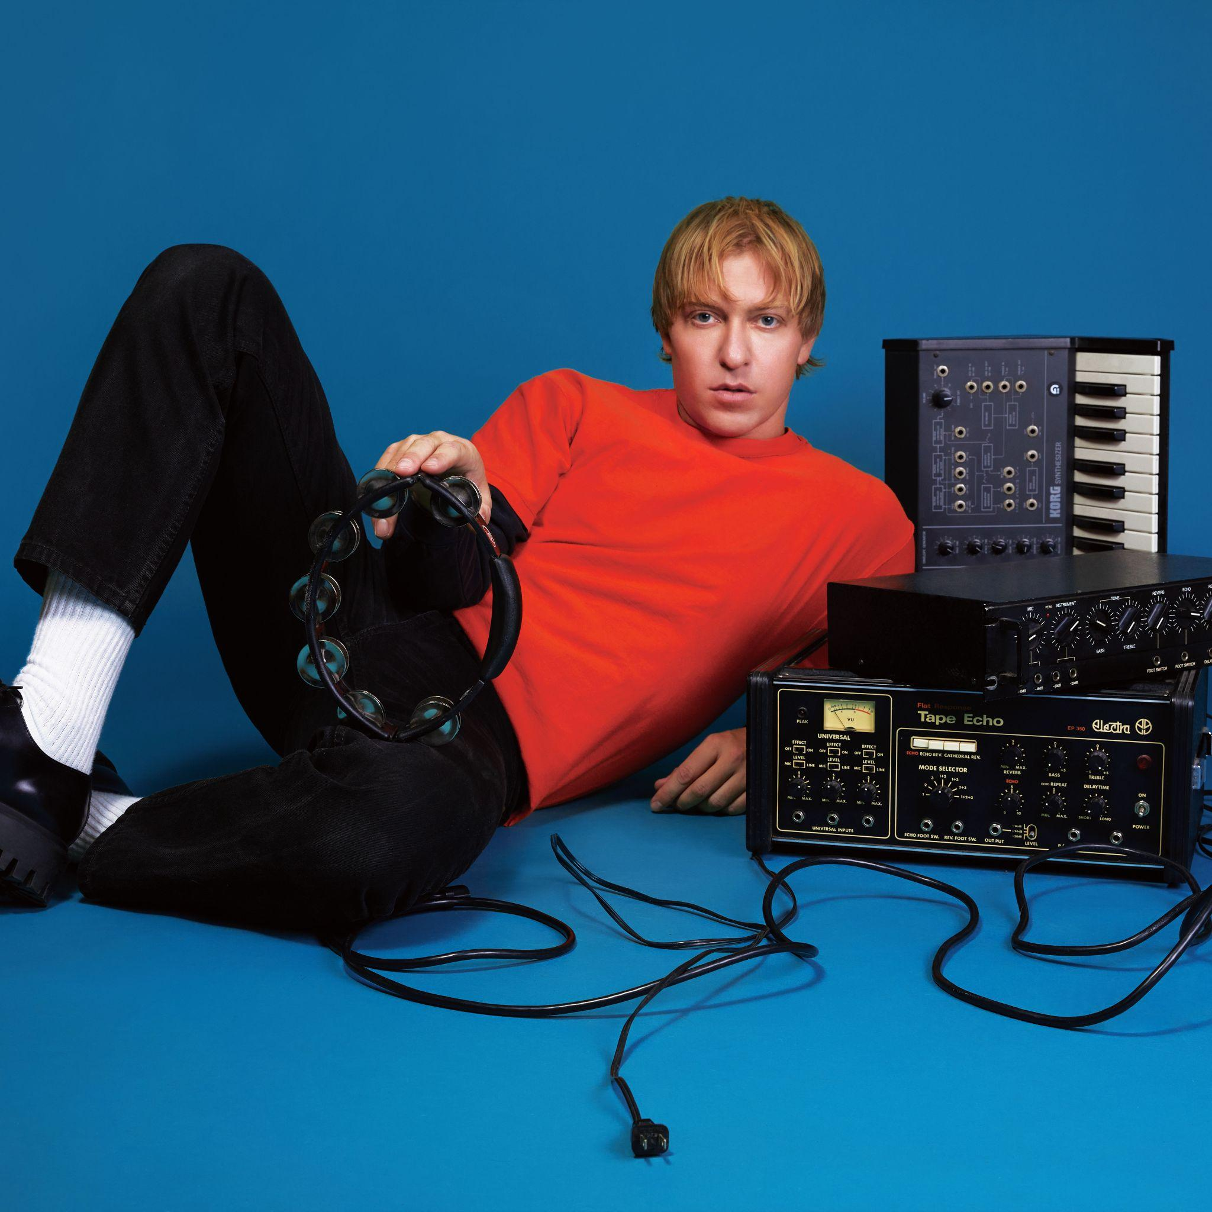
The Drums (Photo Credit: Qiao Meng)

###

For More Information:

Jaime Rosenberg / 2b Entertainment
jaime@2bentertainment.net

Bailey Katler / 2b Entertainment
bailey@2bentertainment.net

Kelly Kettering / ANTI- Records
kelly@epitaph.com

