THE DRUMS RELEASE NEW SONG “THE FLOWERS” AHEAD OF HIGHLY-ANTICIPATED NEW ALBUM JONNY OUT OCTOBER 13 ON ANTI-.

LISTEN TO “THE FLOWERS” HERE

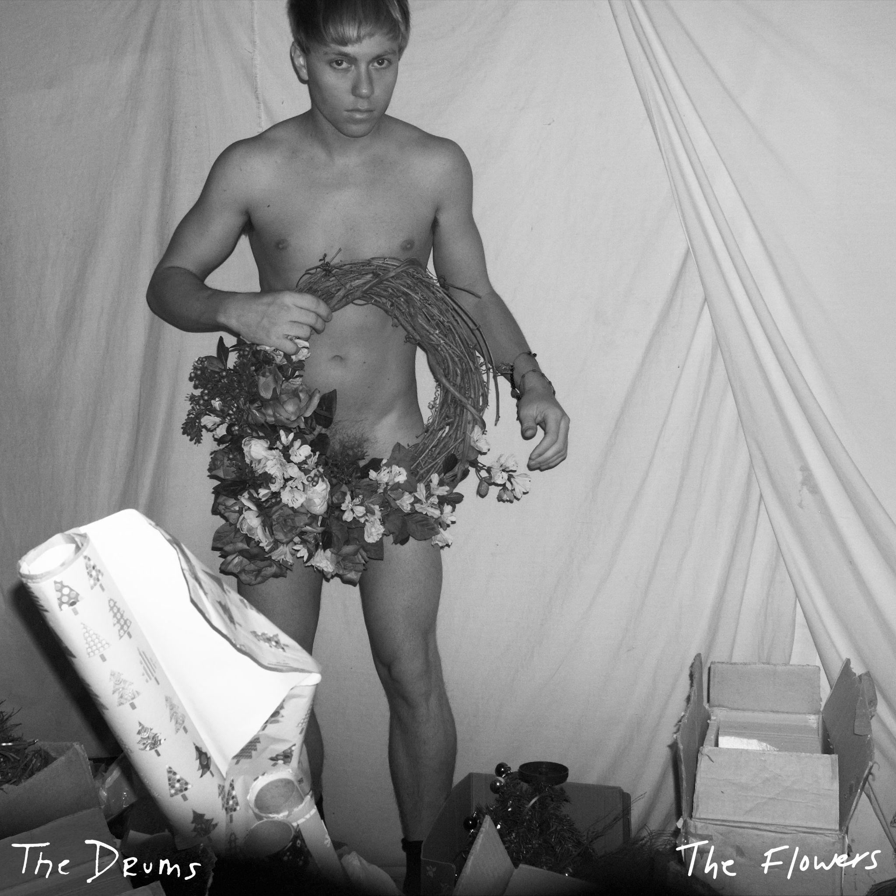

September 20, 2023 (LOS ANGELES, CA) - Today, The Drums share “The Flowers,” the final sneak peak of the highly-anticipated new studio album Jonny out October 13. The 16-track album beautifully chronicles lead singer Jonny Pierce’s journey confronting the deep-rooted childhood trauma he experienced growing up in a cult-like religious community in upstate New York, and ultimately coming through the other side to a place of newfound self-understanding and self-love.
Listen to “The Flowers” now here, and pre-order Jonny now here ahead of its release on October 13, 2023 via ANTI- Records.

On “The Flowers,” Jonny sees how the truest love is found in small moments of tenderness. Pierce clarifies, “With “The Flowers” I explain how slowing down and being tender saved my life and how it became the key to loving myself, building confidence in myself, and being able to love another in a meaningful way. To love from a place that isn't desperate, but from a place that is centered, calm, and gentle and sweet. "

Jonny is filled with self-reflective songs as well a series of minute-long vignettes that ground the album in gentle introspection as Pierce sings directly to his younger selves. Always finding the balance between aching melancholy and irresistible pop sensibilities, the album finds Pierce peering through a kaleidoscope of shimmering guitars, reverb, modular synthesizers and drum machines: a sonic identity that has been uniquely, and wholly The Drums since their emergence 15 years ago. In addition to “The Flowers”, Jonny features the recent string of tracks including “Better,” “Obvious”, “I Want It All”, “Isolette” and “Plastic Envelope / Protect Him Always, all of which have become instant fan favorites on The Drums’ recent sold-out headline tour across North America.

Soaring to alt-pop prestige nearly fifteen years ago with a renowned self-titled debut, The Drums continue to thrive, influence and reinvent with every project. Pierce initially conceived of the band back in 2008 and what resulted was a string of six studio albums and worldwide acclaim. Their music remains timeless, as evidenced by the recent explosion of their song “Money,” which first appeared on their breakout sophomore album Portamento. Transforming into a viral sensation earlier this year – over a decade since it was first released – the song has since bloomed with a second life, eclipsing over 230 million streams on Spotify alone, achieving RIAA Gold-certification, and reaching #1 on the Alternative Global Shazam chart and the #2 TikTok Global Hashtag.

“JONNY” TRACKLIST
- I Want It All
- Isolette
- I’m Still Scared
- Better
- Harms
- Little Jonny
- Plastic Envelope
- Protect Him Always
- Be Gentle
- Dying
- Green Grass
- Obvious
- The Flowers
- Teach My Body
- Pool God
- I Used to Want To Die

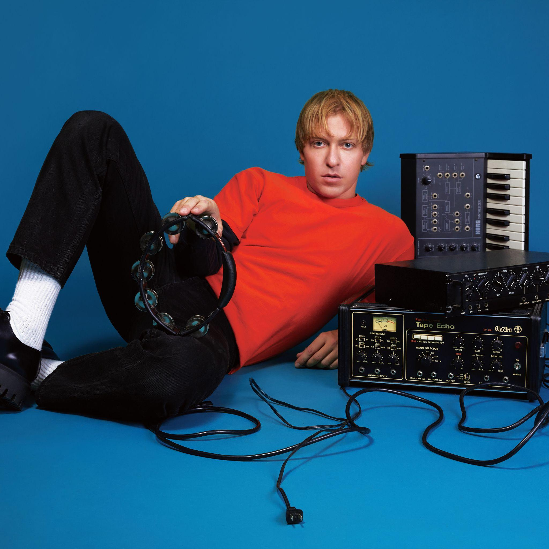
The Drums (Photo Credit: Qiao Meng)

