WAXAHATCHEE
RELEASES NEW SINGLE “365”
ALONGSIDE A ONE-SHOT MUSIC VIDEO

NEW ALBUM TIGERS BLOOD OUT MARCH 22ND ON ANTI-

WORLD TOUR ANNOUNCED

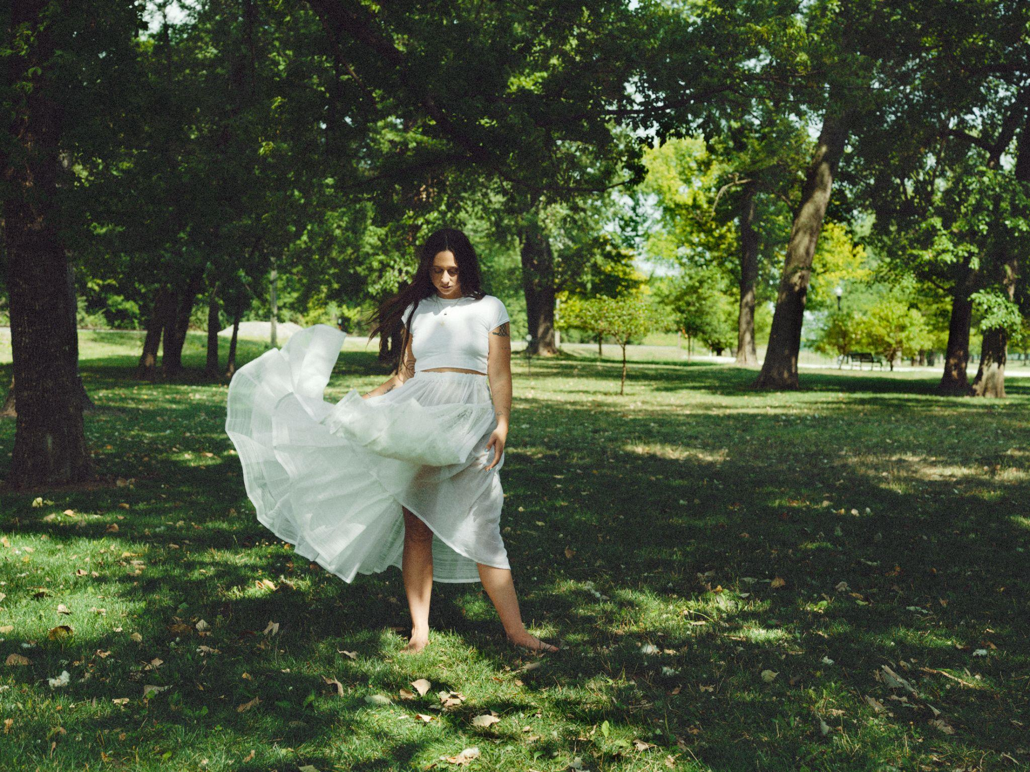
Photo Credit: Molly Matalon | download high-res here

Waxahatchee shares “365,” the latest from her highly anticipated upcoming album, Tigers Blood, out March 22nd on ANTI- Records. The song, which features a phenomenal vocal performance, is released alongside a gorgeous one-shot music video directed by frequent collaborators Corbett Jones & Nick Simonite. “‘365’ is a song about codependency as it pertains to addiction and relationships with addicts. It’s something I’ve dealt with a lot in my life and I really wanted to distill the nerves and emotions down to their purest form in this song,” Katie Crutchfield explains. “Brad Cook and I had a lot of ideas we tried for this one, but in the end, we tracked it live just him, Jake Lenderman and myself running the song a couple of times together in the room."

Pitchfork, who profiled Crutchfield today in their first cover story of 2024, saying that the album takes Waxahatchee “to an even higher level” and that “it includes stories of late-night fights with loved ones, friendships frayed beyond repair, and elegies for an idyllic past that may never have existed in the first place. Even the radiant love song at its peak is about coming to terms with exhaustion and despair.”

Waxahatchee will be on tour in North America, Europe and the UK this spring and summer in support of Tigers Blood and additionally, has also announced a series of Tigers Blood listening parties, starting on March 21st and hosted at independent record stores worldwide. Listening party details here. All tour dates below.

On Tigers Blood, Crutchfield emerges as a powerhouse – an ethnologist of the self – forever dedicated to revisiting her wins and losses. Tigers Blood also finds Crutchfield folding new collaborators into her world, with performances on the album by MJ Lenderman, Spencer Tweedy and Phil Cook as well as trusted collaborator / producer Brad Cook, whom she also worked with on her groundbreaking album Saint Cloud.

Crutchfield says that she wrote most of the songs on Tigers Blood during a “hot hand spell” while on tour in 2022. And when it came time to record, Crutchfield returned to her trusted producer Brad Cook and the Sonic Ranch in the border town Tornillo, Texas, a collaborator and place that also helped bring her sound to a groundbreaking turning point on 2020’s Saint Cloud.

Saint Cloud was a breakthrough album for Waxahatchee, and despite being released in the height of the pandemic it entered #1 on Billboard’s Heatseekers Chart & Top 10 on the Emerging Artist chart. It was a welcome musical escape for many and cemented her status as an important voice in the indie-Americana scene. Now with Tigers Blood we see Crutchfield dig even deeper, the result is a complex and beautiful album that is sure to find a special place in people’s hearts once again.

World Tour Dates:
April 18 – Kansas City, MO – Uptown Theater ^
April 19 – St. Paul, MN – Palace Theatre ^
April 20 – Chicago, IL – Salt Shed ^ – SOLD OUT
April 21 – Detroit, MI – Majestic Theatre ^
April 23 – Toronto, ON – Massey Hall ^
April 25 – New Haven, CT – Toad's Place ^
April 26 – Boston, MA – Orpheum Theatre ^
April 27 – Brooklyn, NY – Brooklyn Paramount Theatre ^ – SOLD OUT
April 28 – Richmond, VA – The National ^
April 30 – Asheville, NC – The Orange Peel ^
May 1 – Nashville, TN – Ryman Auditorium ^
May 3 – St. Petersburg, FL – Jannus Live ^
May 4 – Orlando, FL – The Beacham Theater ^
May 5 – Atlanta, GA – Shaky Knees Festival
May 6 – Birmingham, AL – Lyric Theatre ^
May 8 – Tulsa, OK – Cain's Ballroom ^
May 9 – Fort Worth, TX – Tannahill's Tavern & Music Hall ^
May 10 – Houston, TX – The Heights Theater ^
May 11 – Austin, TX – ACL Live at the Moody Theater ^
May 13 – Phoenix, AZ – The Van Buren ^
May 14 – San Diego, CA – The Observatory North Park ^
May 16 – Los Angeles, CA – Hollywood Palladium ^
May 17 – Paso Robles, CA – Barrelhouse Brewing Co. ^
May 18 – Oakland, CA – Fox Theater ^
May 19 – Sonoma, CA – Gundlach Bundschu Winery ^ – SOLD OUT
May 21 – Salt Lake City, UT – The Depot ^
May 23 – Denver, CO – The Mission Ballroom ^
July 11 – Amsterdam, NL – Paradiso ~
July 12 – Köln, DE – Gebäude 9 ~
July 13 – Hamburg, DE – Mojo Club ~
July 14 – Bruges, BE – CactusfestivalJuly 15 – Berlin, DE – Festsaal Kreuzberg ~
July 17 – Schorndorf, DE – Club Manufaktur ~
July 18 – Feldkirch, AT – Poolbar Festival ~
July 19 – Sittersdorf, AT – Acoustic Lakeside Festival
July 21 – Zurich, CH – Bogen F ~
July 22 – Paris, FR – La Maroquinerie ~
July 24 – Brighton, UK – Chalk ~
July 25 – London, UK – O2 Forum Kentish Town ~
July 26 – Southwold, UK – Latitude Festival
July 27 – Manchester, UK – New Century ~
July 29 – Leeds, UK – The Leeds Irish Centre ~
July 30 – Glasgow, UK – Queen Margaret Union ~
July 31 – Belfast, UK – The Belfast Empire Music Hall ~
August 1 – Dublin, IE – Vicar Street ~
August 16 – Vancouver, BC – The Orpheum Theatre *
August 17 – Portland, OR – Pioneer Courthouse Square *
August 18 – Seattle, WA – Woodland Park Zoo Amphitheater *
August 19 – Boise, ID – Treefort Music Hall %
August 21 – Fort Collins, CO – Washington's %
August 23 – St. Louis, MO – The Pageant %
August 24 – Madison, WI – The Sylvee %
August 25 – Kalamazoo, MI – Bell's Beer Garden %
August 26 – Pittsburgh, PA – The Warhol at Carnegie Music Hall %
August 28 – New York, NY – Beacon Theatre
August 29 – South Deerfield, MA – Tree House Summer Stage &# – SOLD OUT
August 30 – Portland, ME – State Theater &#
August 31 – Accord, NY – Arrowood Farms &# – SOLD OUT
September 1 – Asbury Park, NJ – Stone Pony Summerstage &#
September 6 – Vienna, VA – Filene Center - Wolf Trap &#
September 7 – Philadelphia, PA – The Fillmore #@
September 8 – Philadelphia, PA – The Fillmore &+

^ w/ Good Morning
~ w/ Anna St. Louis
* w/ Woods
% w/ Tre Burt
# w/ Tim Heidecker
& w/ Snail Mail
+ w/ Greg Mendez
@ w/ Gladie

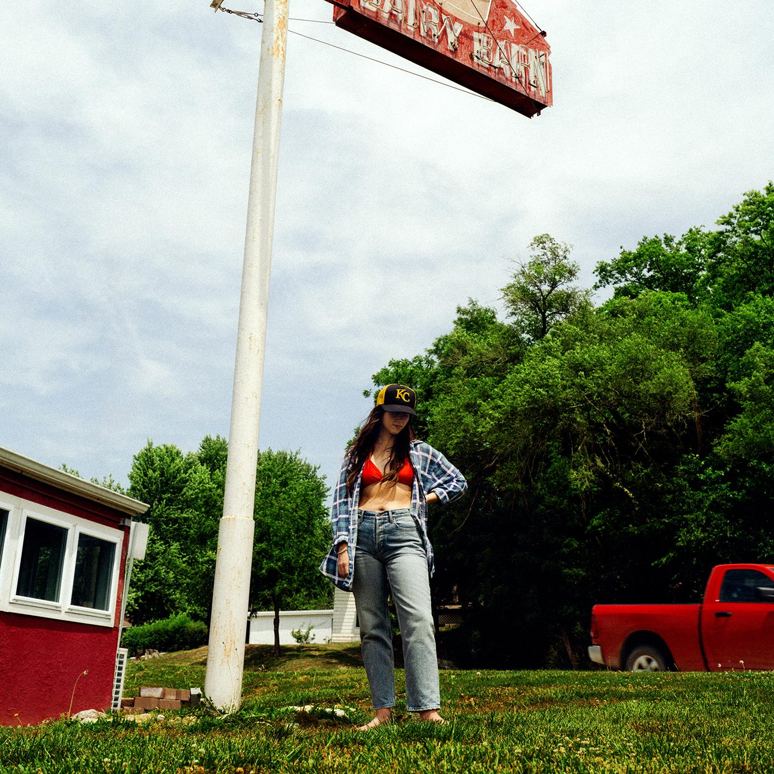
Album Art Credit: Molly Matalon | download hi-res here

1. 3 Sisters
2. Evil Spawn
3. Ice Cold
4. Right Back to It
5. Burns Out at Midnight
6. Bored
7. Lone Star Lake
8. Crimes of the Heart
9. Crowbar
10. 365
11. The Wolves
12. Tigers Blood

Follow Waxahatchee:
Website | Instagram | Facebook | Twitter

For more information please contact Grandstand Media & Management:
Eloy Lugo + Grace Jones

