WAXAHATCHEE
RELEASES NEW SONG + VIDEO
“BORED”

EXPANDS WORLD TOUR

NEW ALBUM TIGERS BLOOD OUT MARCH 22ND ON ANTI-

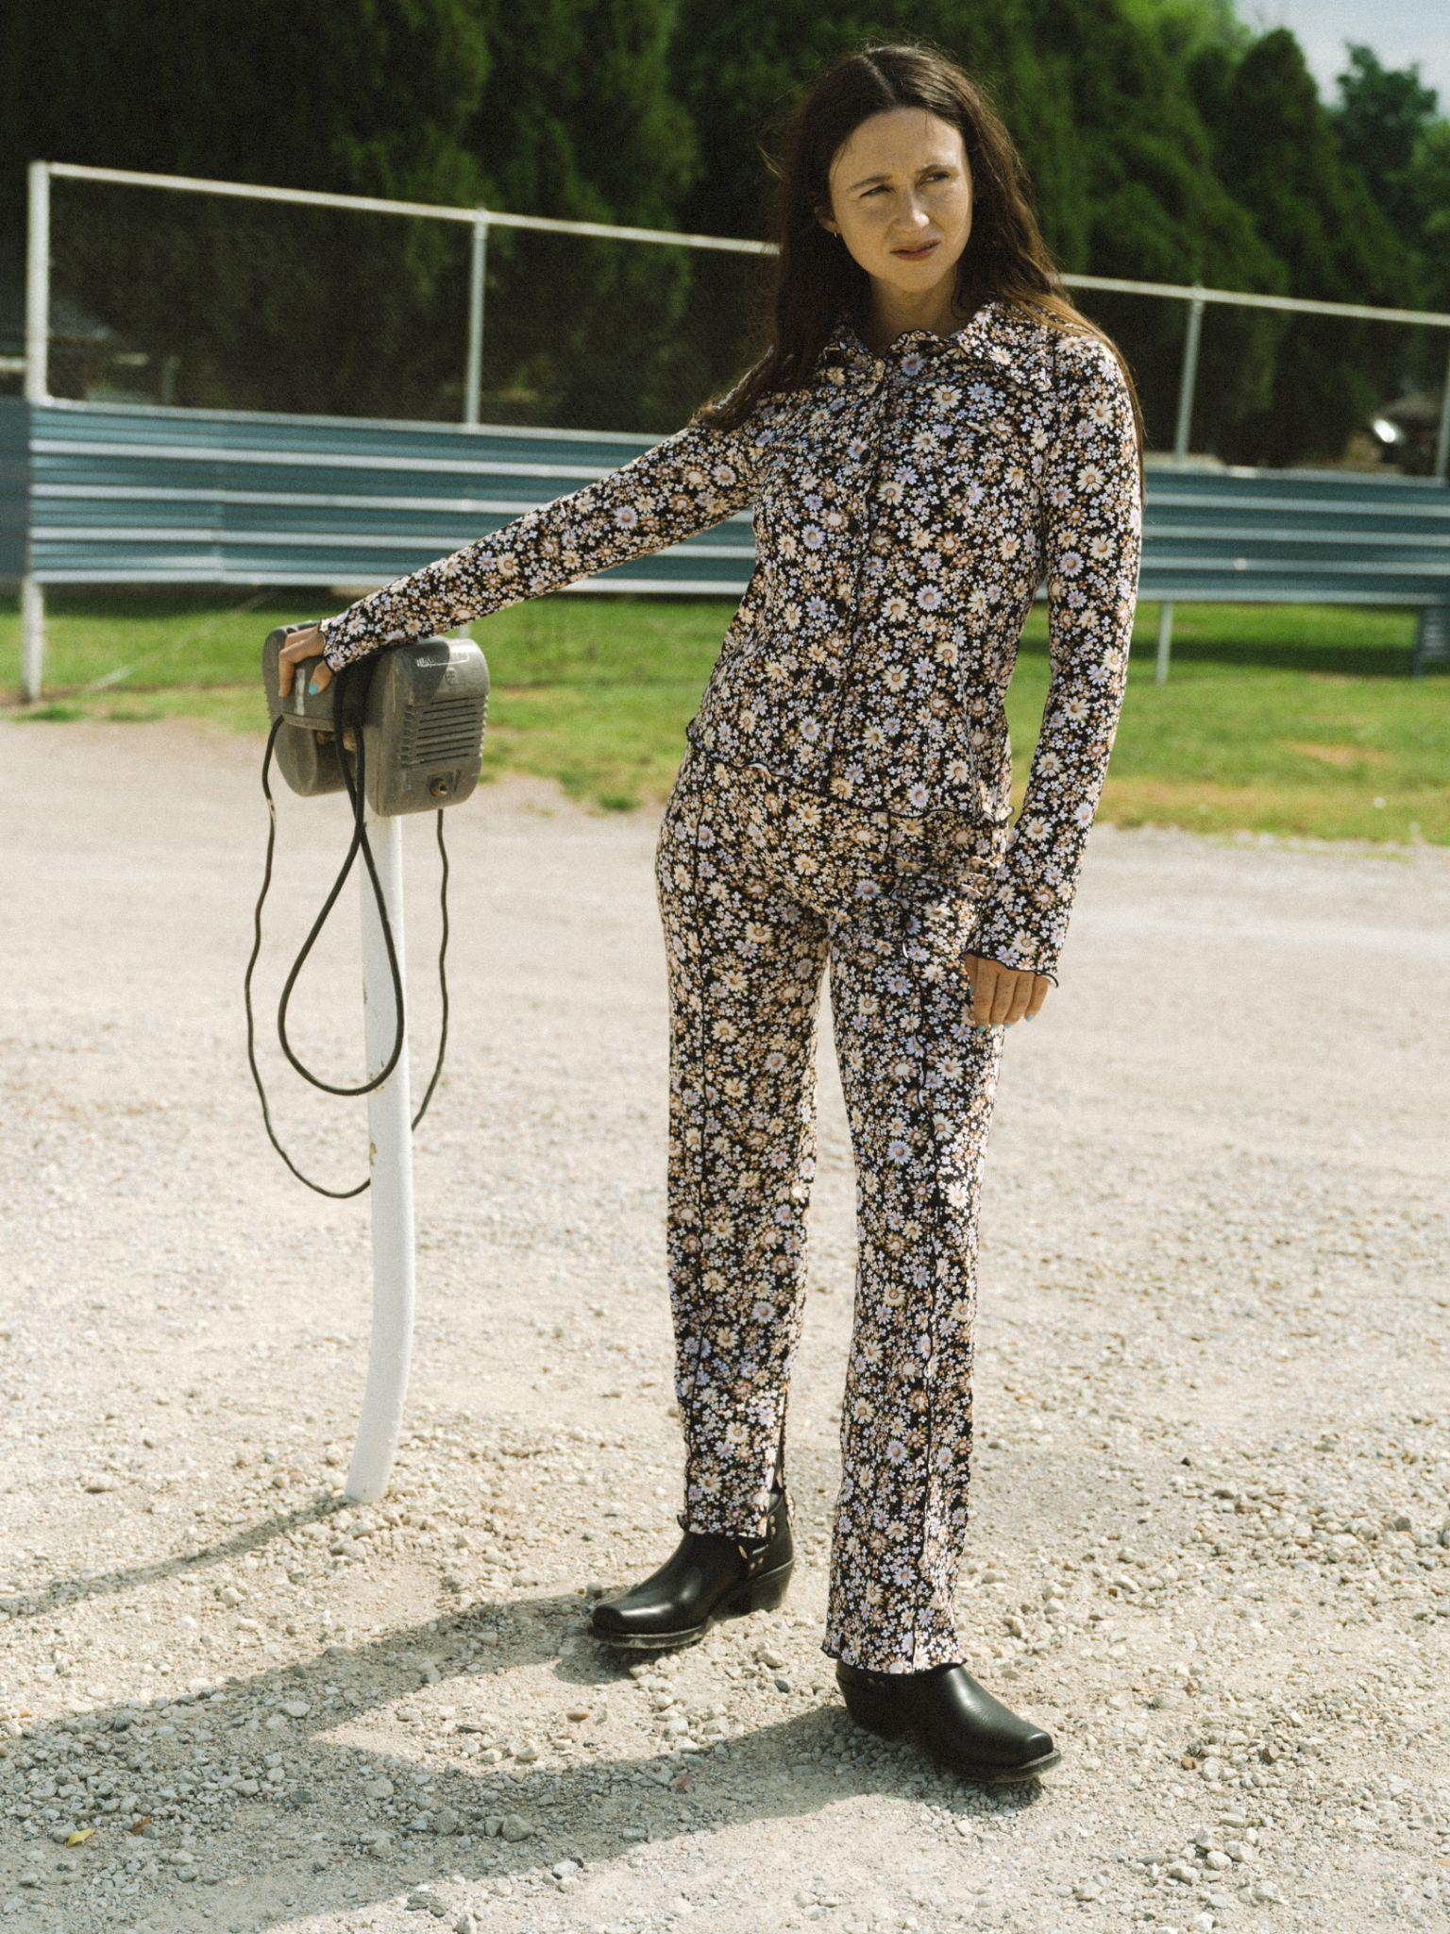
Photo Credit: Molly Matalon | download high-res here

Today, Waxahatchee shares “Bored,” the new single from her highly anticipated new album, Tigers Blood, out March 22nd on ANTI- Records. The song comes with a rollicking video shot at Devil's Backbone Tavern in Fischer, Texas, directed by Corbett Jones & Nick Simonite.

Of the song Crutchfield says: “I feel like my comfort zone when writing songs lies somewhere on the emotional spectrum of sadness and heartache. Writing from a place of happiness scares me. Too earnest. Anger scares me even more. I wrote “Bored” about one of those situations where anger was called for and was the only authentic place from which to write about what I was experiencing. It was a challenge for me and “Bored” is the end result.”

Additionally Waxahatchee announces a European tour, expanding on the Tigers Blood tour’s previously announced US tour dates. EU tickets go on sale Friday 2/16 at 10 am local time. All dates below.

WATCH THE “BORED” MUSIC VIDEO

Waxahatchee announced Tigers Blood last month with a video for “Right Back to It," which Pitchfork named Best New Track, and Rolling Stone called “an Americana burner full of tender twang.” On the album, Crutchfield emerges as a powerhouse – an ethnologist of the self – forever dedicated to revisiting her wins and losses. Tigers Blood also finds Crutchfield folding new collaborators into her world, with performances on the album by MJ Lenderman, Spencer Tweedy and Phil Cook as well as trusted collaborator / producer Brad Cook, whom she also worked with on her groundbreaking album Saint Cloud.

Crutchfield says that she wrote most of the songs on Tigers Blood during a “hot hand spell” while on tour in 2022. And when it came time to record, Crutchfield returned to her trusted producer Brad Cook and the Sonic Ranch in the border town Tornillo, Texas, a collaborator and place that also helped bring her sound to a groundbreaking turning point on 2020’s Saint Cloud.

Saint Cloud was a breakthrough album for Waxahatchee, and despite being released in the height of the pandemic it entered #1 on Billboard’s Heatseekers Chart & Top 10 on the Emerging Artist chart. It was a welcome musical escape for many and cemented her status as an important voice in the indie-Americana scene. Now with Tigers Blood we see Crutchfield dig even deeper, the result is a complex and beautiful album that is sure to find a special place in people’s hearts once again.

World Tour Dates:
April 18 – Kansas City, MO – Uptown Theater ^
April 19 – St. Paul, MN – Palace Theatre ^
April 20 – Chicago, IL – Salt Shed ^
April 21 – Detroit, MI – Majestic Theatre ^
April 23 – Toronto, ON – Massey Hall ^
April 25 – New Haven, CT – Toad's Place ^
April 26 – Boston, MA – Orpheum Theatre ^
April 27 – Brooklyn, NY – Brooklyn Paramount Theatre ^
April 28 – Richmond, VA – The National ^
April 30 – Asheville, NC – The Orange Peel ^
May 1 – Nashville, TN – Ryman Auditorium ^
May 3 – St. Petersburg, FL – Jannus Live ^
May 4 – Orlando, FL – The Beacham Theater ^
May 5 – Atlanta, GA – Shaky Knees Festival
May 6 – Birmingham, AL – Lyric Theatre ^
May 8 – Tulsa, OK – Cain's Ballroom ^
May 9 – Fort Worth, TX – Tannahill's Tavern & Music Hall ^
May 10 – Houston, TX – The Heights Theater ^
May 11 – Austin, TX – ACL Live at the Moody Theater ^
May 13 – Phoenix, AZ – The Van Buren ^
May 14 – San Diego, CA – The Observatory North Park ^
May 16 – Los Angeles, CA – Hollywood Palladium ^
May 17 – Paso Robles, CA – Barrelhouse Brewing Co. ^
May 18 – Oakland, CA – Fox Theater ^
May 19 – Sonoma, CA – Gundlach Bundschu Winery ^
May 21 – Salt Lake City, UT – The Depot ^
May 23 – Denver, CO – The Mission Ballroom ^
July 11 – Amsterdam NL – Paradiso
July 12 – Köln DE – Gebäude 9
July 13 – Hamburg DE – Mojo Club
July 14 – Bruges BE – Cactusfestival
July 15 – Berlin DE – Festsaal Kreuzberg
July 17 – Schorndorf DE – Club Manufaktur
July 18 – Feldkirch AT – Poolbar Festival
July 19 – Sittersdorf AT – Acoustic Lakeside Festival
July 21 – Zurich CH – Bogen F
July 22 – Paris FR – La Maroquinerie
July 24 – Brighton UK – Chalk
July 25 – London UK – O2 Forum Kentish Town
July 26 – Southwold UK – Latitude Festival
July 27 – Manchester UK – New Century
July 29 – Leeds UK – The Leeds Irish Centre
July 30 – Glasgow UK – Queen Margaret Union
July 31 – Belfast UK – The Belfast Empire Music Hall
August 1 – Dublin IE – Vicar Street
August 19 – Boise, ID – Treefort Music Hall %
August 21 – Fort Collins, CO – Washington's %
August 23 – St. Louis, MO – The Pageant %
August 24 – Madison, WI – The Sylvee %
August 25 – Kalamazoo, MI – Bell's Beer Garden %
August 26 – Pittsburgh, PA – The Warhol at Carnegie Music Hall %
August 28 – New York, NY – Beacon Theatre
August 29 – South Deerfield, MA – Tree House Summer Stage &#
August 30 – Portland, ME – State Theater &#
August 31 – Accord, NY – Arrowood Farms &#
September 1 – Asbury Park, NJ – Stone Pony Summerstage &#
September 6 – Vienna, VA – Filene Center - Wolf Trap &#
September 7 – Philadelphia, PA – The Fillmore #@
September 8 – Philadelphia, PA – The Fillmore &+

^ w/ Good Morning
% w/ Tre Burt
# w/ Tim Heidecker
& w/ Snail Mail
+ w/ Greg Mendez
@ w/ Gladie

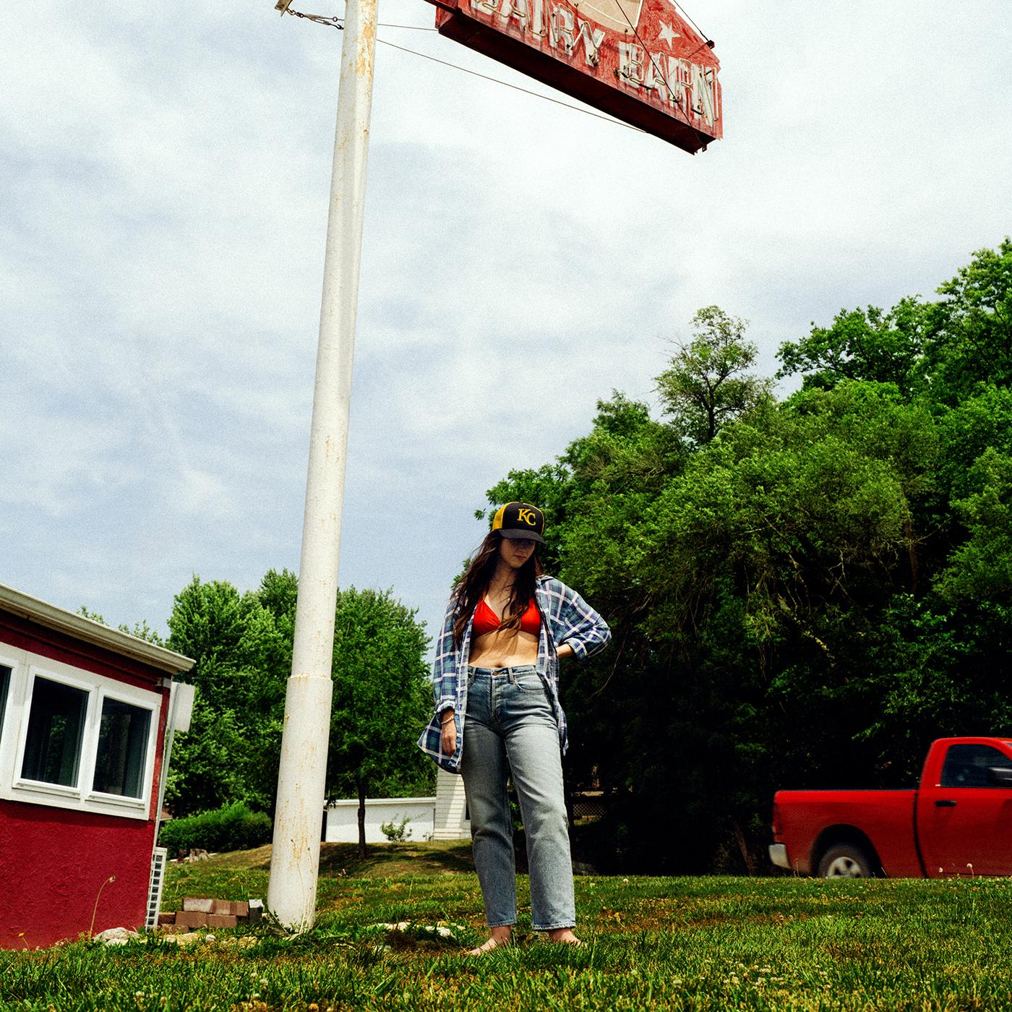
Album Art Credit: Molly Matalon | download hi-res here

1. 3 Sisters
2. Evil Spawn
3. Ice Cold
4. Right Back to It
5. Burns Out at Midnight
6. Bored
7. Lone Star Lake
8. Crimes of the Heart
9. Crowbar
10. 365
11. The Wolves
12. Tigers Blood

Follow Waxahatchee:
Website | Instagram | Facebook | Twitter

For more information please contact Grandstand Media & Management:
Eloy Lugo + Grace Jones

