October 23, 2023
For Immediate Release

Andy Shauf Releases Video for Norm’s “Halloween Store”
And Announces 2024 Solo Tour of Intimate Venues

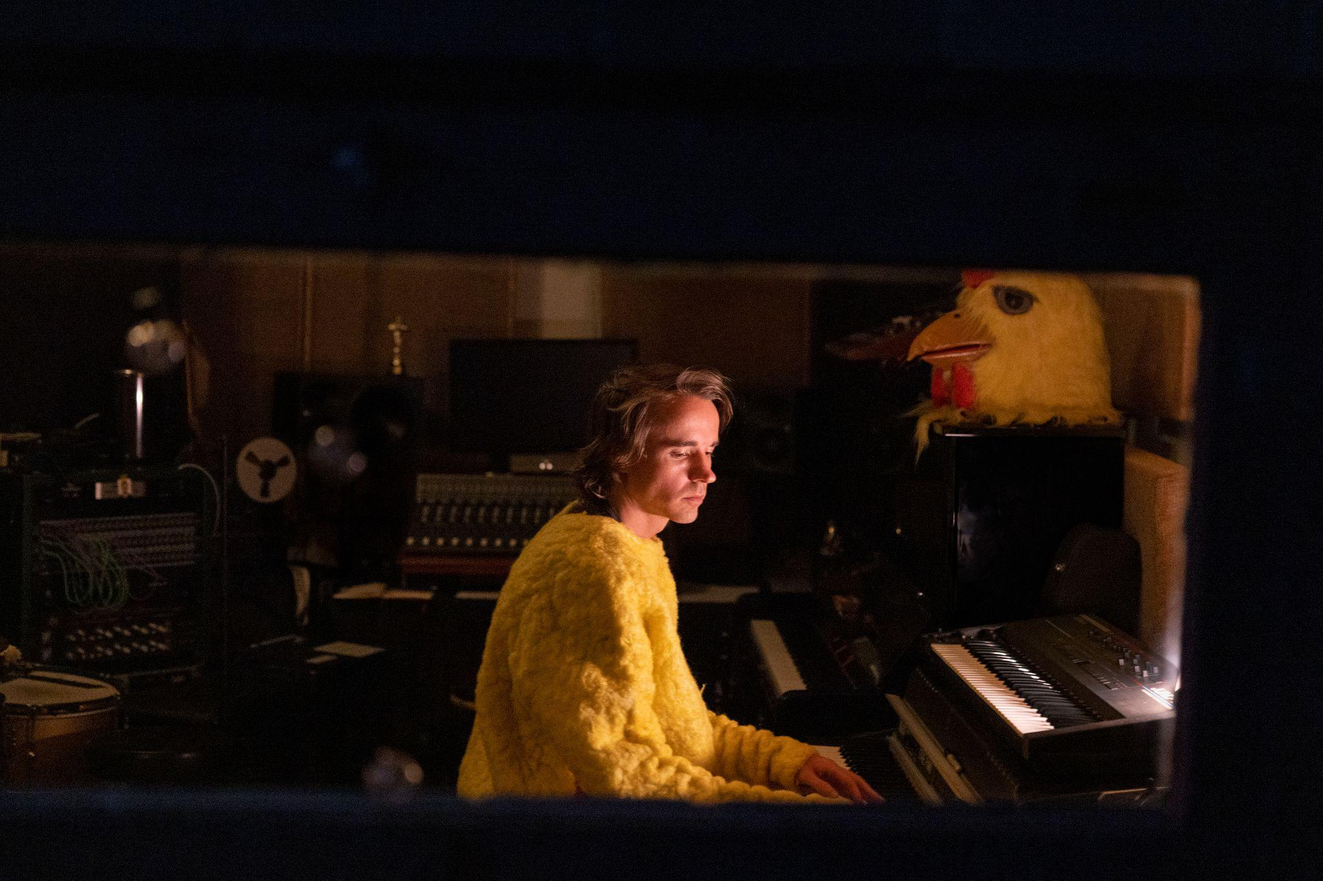
Photo Credit: Angela Lewis

Today, Andy Shauf presents a music video for “Halloween Store” — one of “the best two songs on [Norm]…grounded by acoustic guitar but [featuring] lush instrumental breaks and repeating hooks” (Variety) – and announces a 2024 solo tour. In an enlightening interview with Stereogum in which he shared the story behind every song on the album, Shauf revealed “Halloween Store” was one of the first written for Norm, mulled over and reworked from when he envisioned it as a disco record. “It’s definitely a Halloween story,” he said, “I was hoping to put it out around Halloween, but I missed deadlines.” Now, with Halloween just around the corner, Shauf shines a flashlight on the much-adored Norm standout and “the album’s peak” (Treble). The hand-drawn “Halloween Store” video is charming and timely, a perfect visual accompaniment for the fast-approaching holiday.

Next spring, Shauf will embark on a North American solo tour, bringing his beloved live set to a slew of intimate venues in major cities and smaller markets, including Boston, Brooklyn, Asheville, Evanston, Big Sur, Portland, Los Angeles, Santa Fe, Seattle, and more. A full list of dates are below, and tickets are on-sale this Friday at 10am ET.

Watch Andy Shauf’s “Halloween Store” Video

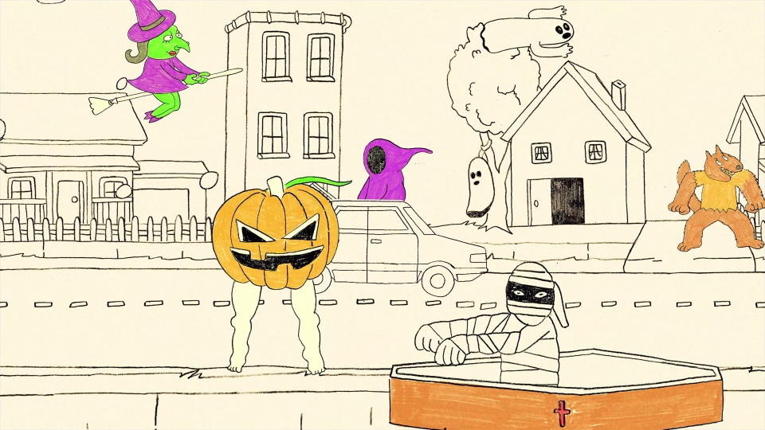
“Halloween Store” video still

Recently, Denmark’s Brodie Sessions released a special performance by Shauf and his band performing Norm’s title track, “Halloween Store” and “Sunset.” This was shot on 16mm and filmed at H.C. Ørsted Power Station in Copenhagen.

Watch And Shauf Perform “Norm,” “Halloween Store” and “Sunset” for Brodie Sessions

As hailed by Pitchfork, "[Shauf's] eighth album, Norm, is his most meticulous and beguiling, straying from his semi-autobiographical past work to span three perspectives and tactfully downplaying its philosophical quandaries with his lushest arrangements to date.” It was released earlier this year via ANTI- to a wealth of praise. Shauf wrote, performed and recorded the album in its entirety and enlisted Neal Pogue (Outkast, Tyler, The Creator) to mix. Pogue took the music’s sonic framework in a new direction, one with a greater sense of clarity and lots of space. Listen closely, and deep in the music, a shift happens as the world goes sideways. The tempo slows, vertigo slips in, or a discordant note appears. An uneasy clarinet phrase devolves into a busy signal. A lyric veers from a bird’s-eye-view to intimate thoughts. The result is a recognizable Shauf production, but with a flowing landscape of suppressed grooves propelling the songs toward uncertain destinations. He’s driving us out to a wild and dangerous place.

Purchase/Stream Norm

Watch the “Wasted On You” Video

Watch the “Catch Your Eye” Video

Watch the “Telephone” Video

Andy Shauf Tour Dates
Sun. Oct. 22 - Dublin, IE @ The Sugar Club
Mon. Oct. 23 - Cork, IE @ St. Luke's
Wed. Oct. 25 - Toulouse, FR @ Le Metronum
Thu. Oct. 26 - Barcelona, ES @ La Nau
Fri. Oct. 27 - Zaragoza, ES @ La Lata De Bombillas
Sun. Oct. 29 - Madrid, ES @ El Sol
Mon. Oct. 30 - Porto, PT @ Mouco
Wed. Nov. 1 - Kortrijk, BE @ De Kreun
Thu. Nov. 2 - Liège, BE @ Reflektor
Fri. Nov. 24 - Seoul, KR @ Musinsa Garage
Mon. Nov. 27 - Tokyo, JP @ Club Quattro
Tue. Nov. 28 - Osaka, JP @ Club Quattro
Wed. Nov. 29 - Aichi, JP @ Club Quattro
Sat. Dec. 2 - Hong Kong, HK @ Clockenflap Music Festival
Thu. Mar. 21 - Homer, NY @ Center For The Arts
Fri. Mar. 22 - Woodstock, NY @ Levon Helm Studios
Sat. Mar. 23 - Portland, ME @ First Parish Church
Mon. Mar. 25 - Boston, MA @ First Church Cambridge
Tue. Mar. 26 - South Deerfield, MA @ Tree House Brewing
Thu. Mar. 28 - Brooklyn, NY @ Murmrr
Fri. Mar. 29 - Arden, DE @ The Gild Hall
Sat. Mar. 30 - Vienna, VA @ The Barns @ Wolf Trap
Mon. Apr. 1 - Asheville, NC @ Asheville Masonic Temple
Wed. Apr. 3 - Nashville, TN @ Third Man Records
Sat. Apr. 6 - Eau Claire, WI @ Pablo Center
Sun. Apr. 7 - Evanston, IL @ SPACE
Sat. Apr. 8 - Evanston, IL @ SPACE
Sat. Apr. 20 - Boulder, CO @ Bluebird Music Festival
Sun. Apr. 21 - Boulder, CO @ Bluebird Music Festival
Mon. Apr. 22 - Santa Fe, NM @ St. Francis Auditorium
Thu. Apr. 25 - Los Angeles, CA @ Pico Union Project
Fri. Apr. 26 - Los Angeles, CA @ Pico Union Project
Sat. Apr. 27 - Ojai, CA @ Ojai Women’s Club
Sun. Apr. 28 - Big Sur, CA @ Henry Miller Library
Tue. Apr. 30 - San Francisco, CA @ The Chapel
Wed. May 1 - San Francisco, CA @ The Chapel
Fri. May 3 - Seattle, WA @ Washington Hall
Sat. May 4 - Portland, OR @ The Old Church
Sun. May 5 - Portland, OR @ The Old Church
Wed. May 8 - Bend, OR @ Old Saint Francis
Thu. May 9 - Boise, ID @ El Korah Shrine
Sat. May 11 - Aspen, CO @ Belly Up Tavern

Praise for Andy Shauf and Norm:

"Norm is a gorgeously produced collection of short folk-fiction. When given closer attention, the album unfurls into an anthology of dark, interconnected tales of loss, unrequited love and casual brushes with the divine." — Variety

"Shauf has a knack for those sorts of observational details, and he approaches writing lyrics a bit like writing fiction." — Vanity Fair

"Andy Shauf is a master at capturing the tragedy in the minutiae of human interactions." — The FADER

"Even at their most obscure, Shauf’s songs are as alive and full of mystery as the stranger beside you at checkout." — Pitchfork

“A dreamlike serenity is undercut with unsettling desperation in ‘Catch Your Eye’” - New York Times

"[Andy Shauf is] just such a phenomenal storyteller." — NPR Music

"Rather than connecting the dots of its characters’ lore, Norm questions the format of the concept album in the first place, presenting pieces of evidence and asking the listener to find the story and draw their own conclusions" — Paste

"Like any good story, Norm rewards multiple listens. Its most indelible moments are enriched with Shauf’s curious details: The Price Is Right soundtracking a divinely hallucinogenic vision, a movie theater as a haven for peeping, and a climactic trip to a Halloween store." — MTV News

"Andy Shauf is the music world’s Wes Anderson." — Slug Mag

"With his delicate touch and keen eye for detail, Shauf weaves together a rich tapestry of sounds and lyrics to create an atmosphere that is at once dreamy and introspective.” — Glide

Download cover art and hi-res images of Andy Shauf

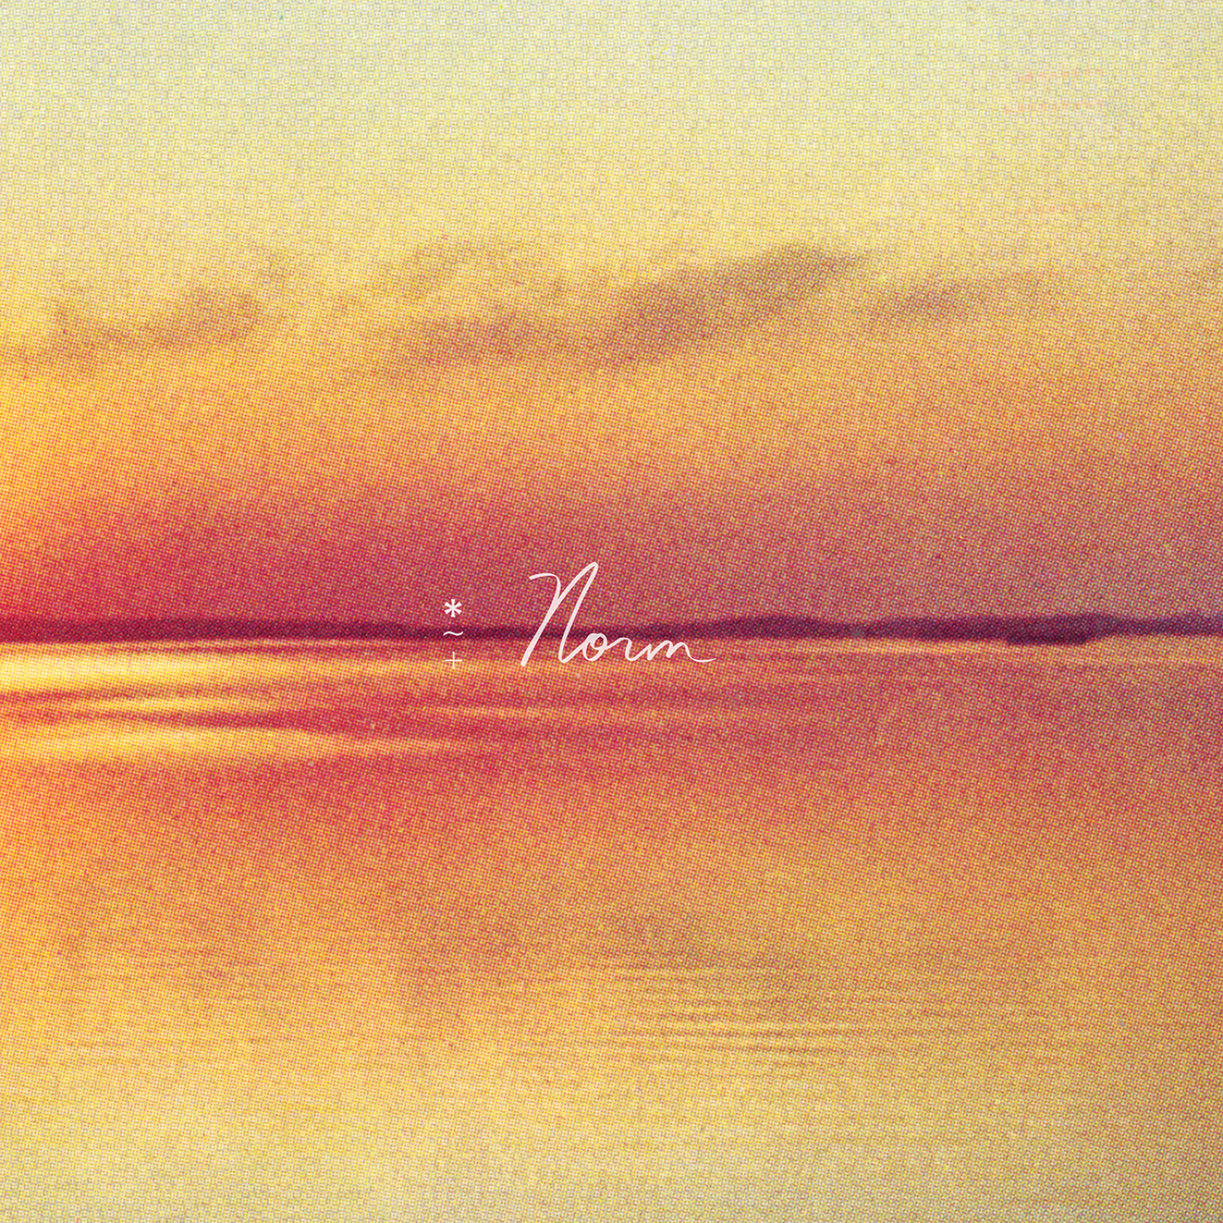
Norm Cover Artwork

Andy Shauf Online
Website | ANTI- | Instagram | Facebook | Twitter | Bandcamp

For more information, contact:
Jessica Linker & Patrick Tilley | Pitch Perfect PR – jessica@pitchperfectpr.com, patrick@pitchperfectpr.com, 773-942-6954

