Art Moore Talk Debut LP w/ SPIN

Announce West Coast Tour Dates w/ Sour Widows & Rose Droll

S/T LP Out This Friday On ANTI-

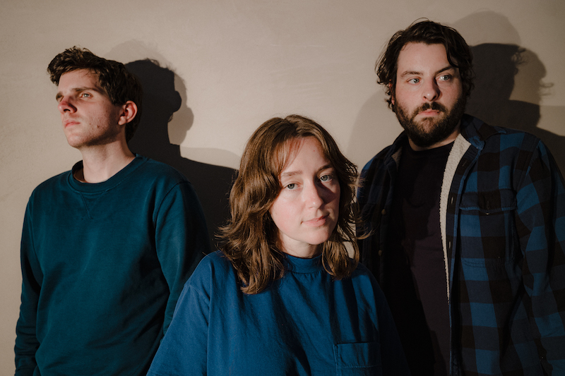
Photo Credit: Ulysses Ortega

"Quietly devastating...[Art Moore] paint empathetic portraits of experiences that are both tailored to an individual but which feel adaptable to others."
FADER

"Art Moore are eloquent indie pop daydreamers."
SPIN

"Languid but crisp, with tiny particulars zooming into view the more closely you listen."
MTV

"Art Moore's explorative approach to composition opens a vivid universe of storytelling through sound."
The Line of Best Fit

"Dreamy, atmospheric indie rock track that's instantly addictive."
BrooklynVegan

"Art Moore construct an alternate reality that is dazzling in its simplicity."
Paste

LISTEN:
to Art Moore's S/T debut
HERE

The debut LP from Art Moore, a new group composed of Boy Scouts' Taylor Vick and Ezra Furman collaborators and bandmates Sam Duerkes and Trevor Brooks, will be released this Friday, August 5th via ANTI-. Ten tracks that are deft character studies, rich with detail and subtle wit, the album has seen praise so far from outlets like FADER, MTV, SPIN, BrooklynVegan, Paste and The Line of Best Fit among many others.

Ahead of the album's release Vick sat down with SPIN to speak about the band's formation, their new LP and some unlikely influences.

READ:
Art Moore's Spin interview
HERE

In addition to the band's fall tour supporting Ezra Furman, Art Moore have added West Coast dates to their run, playing San Francisco with Sour Widows and Los Angeles with Rose Droll. Full details can be found below.

Art Moore's s/t debut will be out August 5th via ANTI-. It is available for preorder here.

