BEN HARPER’S SOLO LAP STEEL ALBUM WINTER IS FOR LOVERS OUT TODAY (ANTI- RECORDS)

“VIRTUOSIC, HEARTFELT AND QUIETLY BUT COMPELLINGLY BRILLIANT” - UNCUT, 8 OUT OF 10 STARS

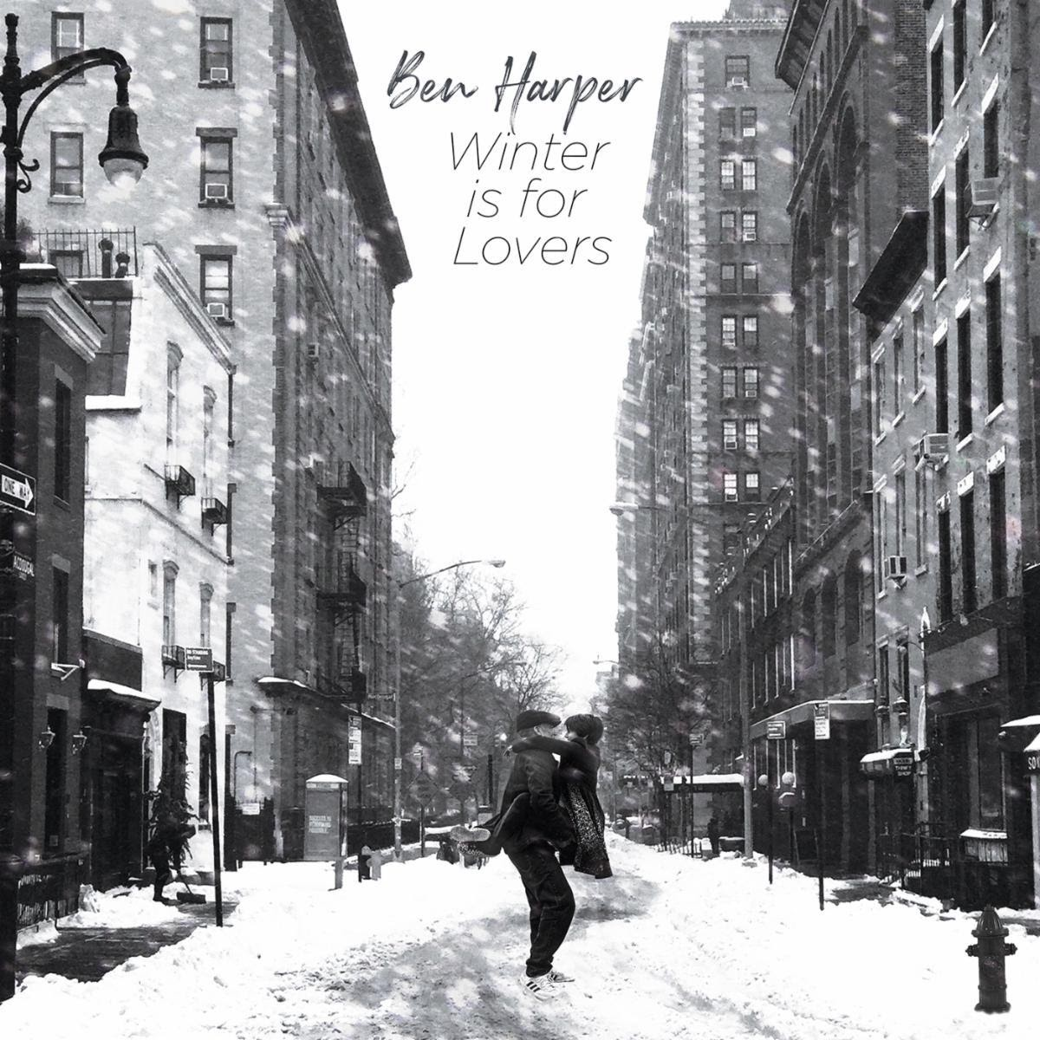

Today Ben Harper has released Winter Is For Lovers (ANTI- Records), an album that in many ways is a culmination of his entire musical life. The intimate and ambitious solo recording is his first-ever entirely instrumental project, 15 original compositions imagined as a symphony and performed by Harper on his lap steel guitar. The record captures a lifetime of musical inspirations and experiences, and has been deemed “virtuosic, heartfelt and quietly but compellingly brilliant” by Uncut Magazine in their 8 out of 10 star review. American Songwriter says it’s “a lovely, sweet, immaculately recorded and performed set perfect for Sunday morning coffee.”
This week, Harper appeared on WNYC’s All Of It arts and culture radio program to discuss the album’s origins and influences, just a month after his appearance on WNYC’s Soundcheck program, where he performed three selections from it. He was also on the September cover of Relix Magazine, alongside Rhiannon Giddens (they released a recording of Nick Drake’s “Black Eyed Dog” in July), and spoke at length about the “sublime” album’s key influences, spanning David Foster Wallace’s Infinite Jest, Taj Mahal, and John Fahey. Harper also released the single “Don’t Let Me Disappear” in May, and earlier in September appeared with Ziggy Marley on The Today Show and The Late Late Show with James Corden to perform “Play With Sky.”

Previously released singles from Winter Is For Lovers include “Paris,” “London,” and “Inland Empire,” which was covered by Rolling Stone, SPIN, Paste and beyond.

The music featured on Winter Is For Lovers is deeply ingrained in Harper’s DNA and leads directly back to The Folk Music Center, the influential California instrument shop his grandparents opened in the late 1950s where Harper filmed three of the videos for this record. It swirls with the music Harper heard growing up, listening to the blues, Hawaiian and classical guitar masters in his mother’s record collection. He gravitated early on to the distinct wail of the slide guitar, learning finger picking from the great Taj Mahal and later studying with Chris Darrow of Nitty Gritty Dirt Band - a lap steel virtuoso who had a major influence on Harper’s lifelong embrace of the instrument.

The first pressing of a 2,000-piece limited edition vinyl of Winter Is For Lovers sold out in just 24 hours, but fans can order both digital and additional physical versions of Winter Is For Lovers here.

Winter is For Lovers Tracklist:
1. Istanbul
2. Manhattan
3. Joshua Tree
4. Inland Empire
5. Harlem
6. Lebanon
7. London
8. Toronto
9. Verona
10. Brittany
11. Montreal
12. Bizanet
13. Toronto (Reprise)
14. Islip
15. Paris

