BONNY DOON
.
RELEASE TITLE TRACK FROM NEW ALBUM
“LET THERE BE MUSIC”

ANNOUNCE SUMMER TOUR DATES

LET THERE BE MUSIC OUT JUNE 16 VIA ANTI- RECORDS
.
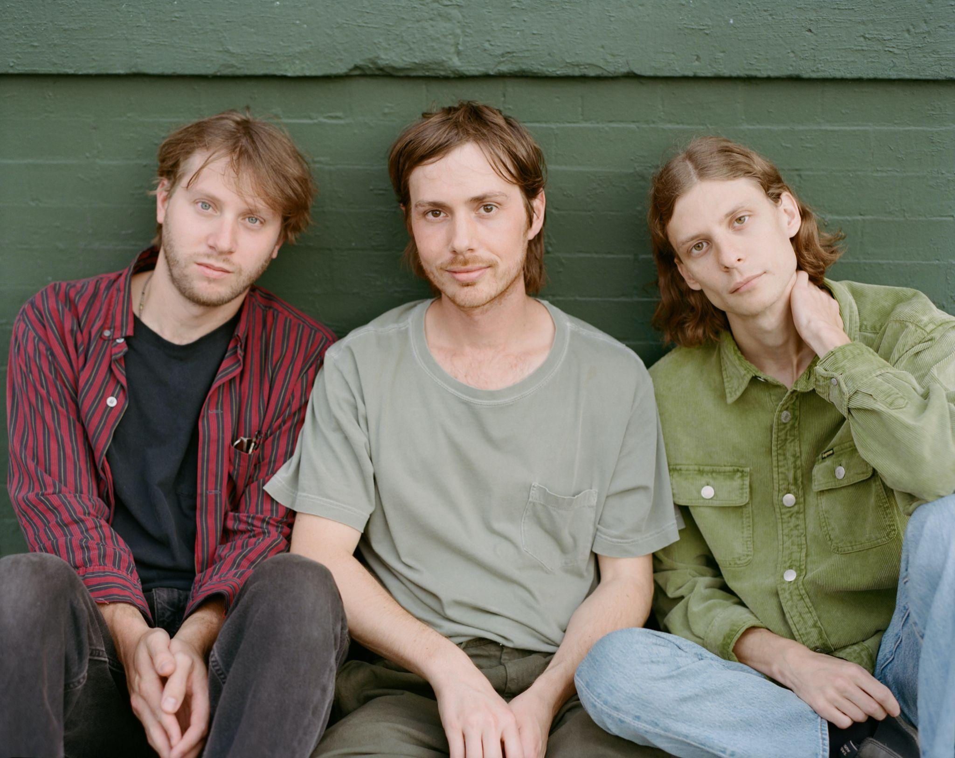
Photo Credit: Andi Kerr (download hi-res)
“Masters of midwestern chill”
-Rolling Stone

“Detroit’s Bonny Doon recline deep in the kind of alternative folk music that gives off its own warmth, wise enough to sit back with some guitars and watch the world crumble.”
-Pitchfork

“Heroes of ambling, melancholy, poetic indie rock”
-Stereogum

“Folk rock with some alt-country sprinklings—but the band’s more spontaneous approach lends it a scrappiness that feels fresh. Rather than rein these songs in to the point of suffocation, the band allows them to breathe, rambling and untangling themselves in unexpected ways.”
-FLOOD

Bonny Doon release “Let There Be Music,” the jovial title track from their recently announced new album, out June 16th via ANTI- Records.

"We’re really attracted to simplicity. We’re always trying to reduce an idea to its essence, but this one was so simple that it felt like it was pushing that practice farther, which was exciting to us,” Bobby Colombo explains. “We’ve rarely had as much fun tracking a song, and I think that’s probably how it became the title track. It just felt like the energetic center."

“Let There Be Music,” is perhaps the most unabashedly affirming song Bonny Doon has created to date. Driven again by piano and Kmiecik’s elated drumming style, the song pairs a simple melody with a simple sentiment - the power of music. While there is plenty of humor and nuance to be found in the lyrics elsewhere on the record, Colombo and Lennox treat this matter with childlike earnestness. By the end of the song, the band is playing it fast and loose, cutting friend Michael Malis free on the piano to crescendo in joyful exuberance. In both its sincerity and simplicity, “Let There Be Music” reflects the essence of Bonny Doon.
Bonny Doon has also announced a US summer tour in addition to their previously announced west coast run in May. Tickets for the new dates will be available on Friday 4/14 via the band’s website.

LISTEN TO “LET THERE BE MUSIC”

After extensively touring their 2018 sleeper cult-classic Longwave by supporting Band of Horses, Snail Mail and Waxahatchee, Lennox and Bobby Colombo were invited by Katie Crutchfield to collaborate on Waxahatchee’s critically acclaimed album Saint Cloud. “The experience raised the ceiling on our imagination,” Colombo said. Soon after, Colombo and Jake Kmiecik, whose steady percussion and devotion to the songs creates a container for the indelible guitar lines, both entered a time of serious healing, Jake tending to complications of his Crohn’s disease and Bobby to a brain injury and undiagnosed Lyme disease. While these detours of doctors’ appointments and experimental care were taking place, the members of Bonny Doon were also Waxahatchee’s backing band on the Saint Cloud tour. These obstacles and commitments drew out the making of Let There Be Music for several additional years, and in the process, redefined the record as an achievement in perseverance for the band.

On their long-awaited third album, we get a glimpse into the pure joy of Bonny Doon. The album serves as less of one conceptual story, and each song as their own Individual offerings of putting words to the ordinary experience of being alive. The band is at their most dynamic and the songwriting deftly explores new terrain. Let There Be Music is brimming with small truths - both profound and mundane, comforting and difficult - and we are invited to revel in them all.

Bonny Doon is Bill Lennox, Bobby Colombo and Jake Kmiecik.

Tour Dates:
5/9 - Vista, CA @ Booze Bros Brewing Co.
5/10 - Los Angeles, CA @ Gold Diggers
5/11 - Los Angeles, CA @ Gold Diggers
5/12 - Ojai, CA @ Ojai Women’s Club
6/17 - Cleveland, OH @ Beachland Tavern
6/18 - Philadelphia, PA @ PhilaMOCA
6/20 - New York, NY @ Bowery Ballroom
6/21 - Kingston, NY @ Tubby's
6/22 - Washington, DC @ Comet Ping Pong
6/23 - Carrboro, NC @ Cat's Cradle
6/24 - Atlanta, GA @ 529
6/26 - Houston, TX @ White Oak Music Hall
6/27 - Austin, TX @ Empire
6/28 - Denton, TX @ Rubber Gloves
6/30 - Tucson, AZ @ Club Congress
7/1 - Phoenix, AZ @ Valley Bar
7/2 - San Diego, CA @ Casbah
7/6 - San Francisco, CA @ The Chapel
7/8 - Portland, OR @ Doug Fir
7/9 - Seattle, WA @ Barboza
7/13 - Minneapolis, MN @ 7th St. Entry
7/14 - Chicago, IL @ Thalia Hall

LISTEN TO PREVIOUSLY RELEASED SINGLES
“NATURALLY,” “CROOKED CREEK” & “SAN FRANCISCO”

In a world of urgency, there’s little regard to the spiritual, emotional, or physical well-being of musicians. The creative process, often hidden from the listeners, remains a mystery, though we may pick up clues in the songs themselves. Throughout the ten tracks in their new album Let There Be Music, you can hear the spaciousness Bonny Doon allowed themselves since 2018’s Longwave. Their latest musical journey is one that has big payoffs for devoted followers and undeniable rewards for anyone just stumbling across the band for the first time.
In the past five years Bonny Doon has shifted from being a Detroit band to an outfit spread between California and Michigan, and now Michigan and New York. Despite the new challenge of distance, members Bill Lennox (guitar and vocals), Bobby Colombo (guitar and vocals), and Jake Kmiecik (drums) leaned on their friendship to sustain the collaboration, which has blossomed more than ever on their third album. While many songwriters work in solitude, the back and forth magic of Colombo and Lennox's process is what gives Bonny Doon their unique voice. The two write and compose each song together, planning writing retreats throughout the year - to gather ideas, edit songs, and give each other feedback, continuing to dedicate themselves to the collaborative effort of being a songwriting team.

“San Francisco”, the big city next to Colombo’s rural home of Lagunitas, offers a glimpse into the way this band sees the world - with both critical eyes and hope. Backup vocals from Crutchfield, who has become a continued collaborator, lend to the essence of the song’s building finale. “Crooked Creek” boasts a robustness and thundering pulse that energizes the album with its presence. The playful imagery nods to the spiritual in an authentic but self-aware way - If you’re stepping in shit, you’re probably on the path.

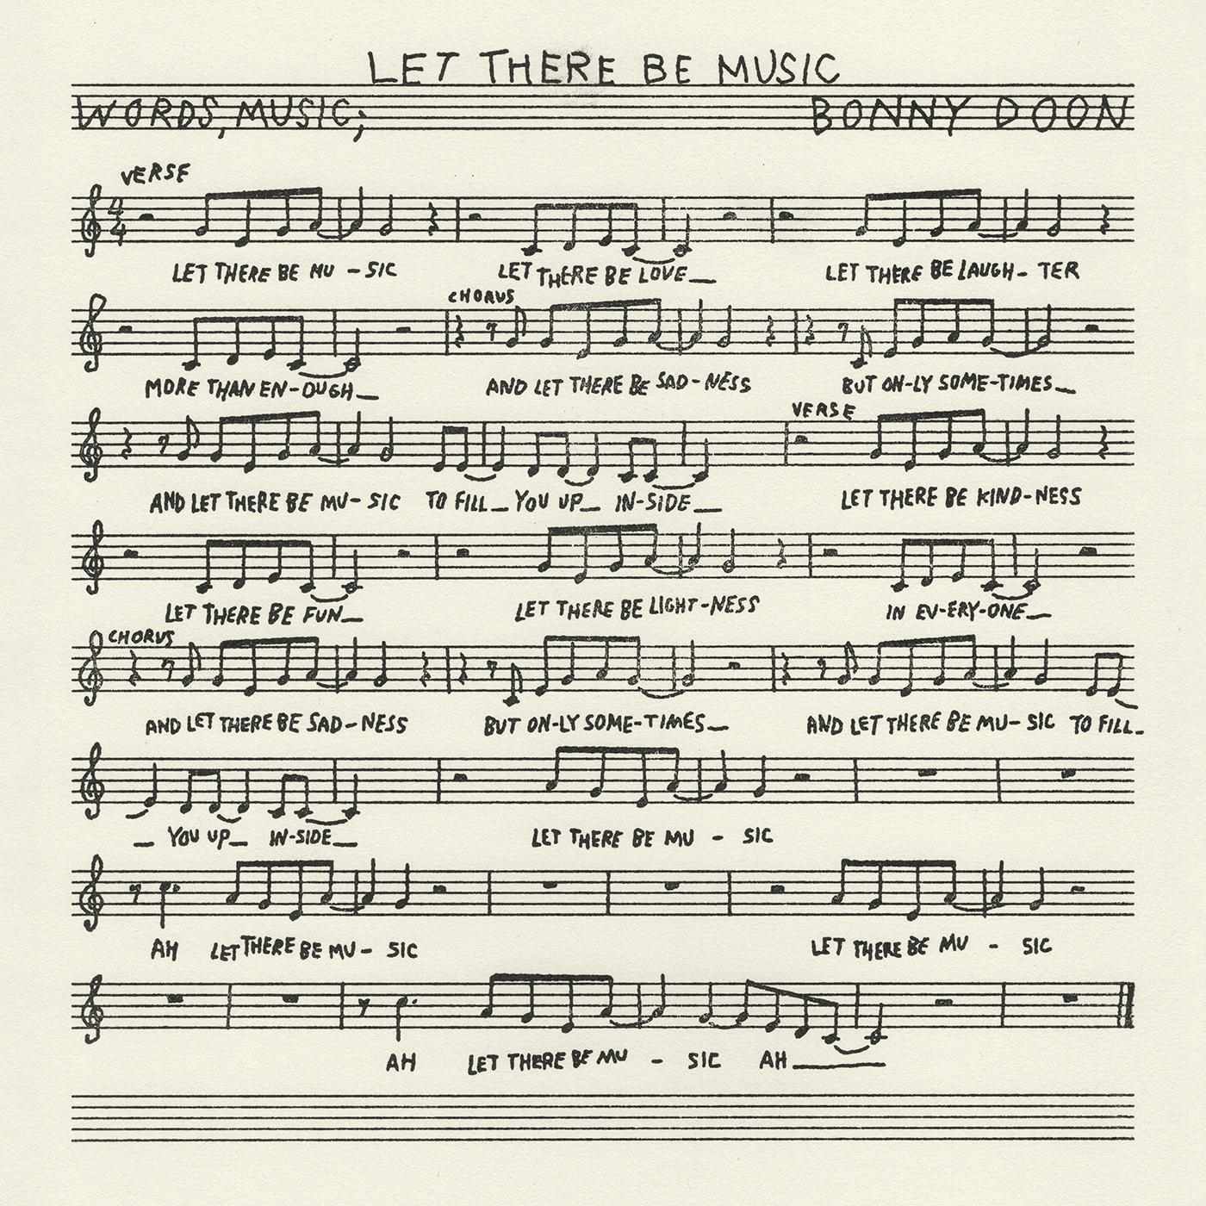
(download hi-res)

1. San Francisco
2. Naturally
3. Crooked Creek
4. Let There Be Music
5. Maybe Today
6. You Can’t Stay The Same
7. Roxanne
8. On My Mind
9. Fine Afternoon
10. Famous Piano

FOLLOW BONNY DOON
Bandcamp | Spotify | YouTube | Twitter | Instagram | Facebook

