BONNY DOON
.
NEW ALBUM
LET THERE BE MUSIC
OUT THIS FRIDAY ON ANTI- RECORDS

RELEASE ANIMATED VIDEO FOR ALBUM’S TITLE TRACK
“LET THERE BE MUSIC”

SUMMER TOUR KICKS OFF THIS WEEKEND
.
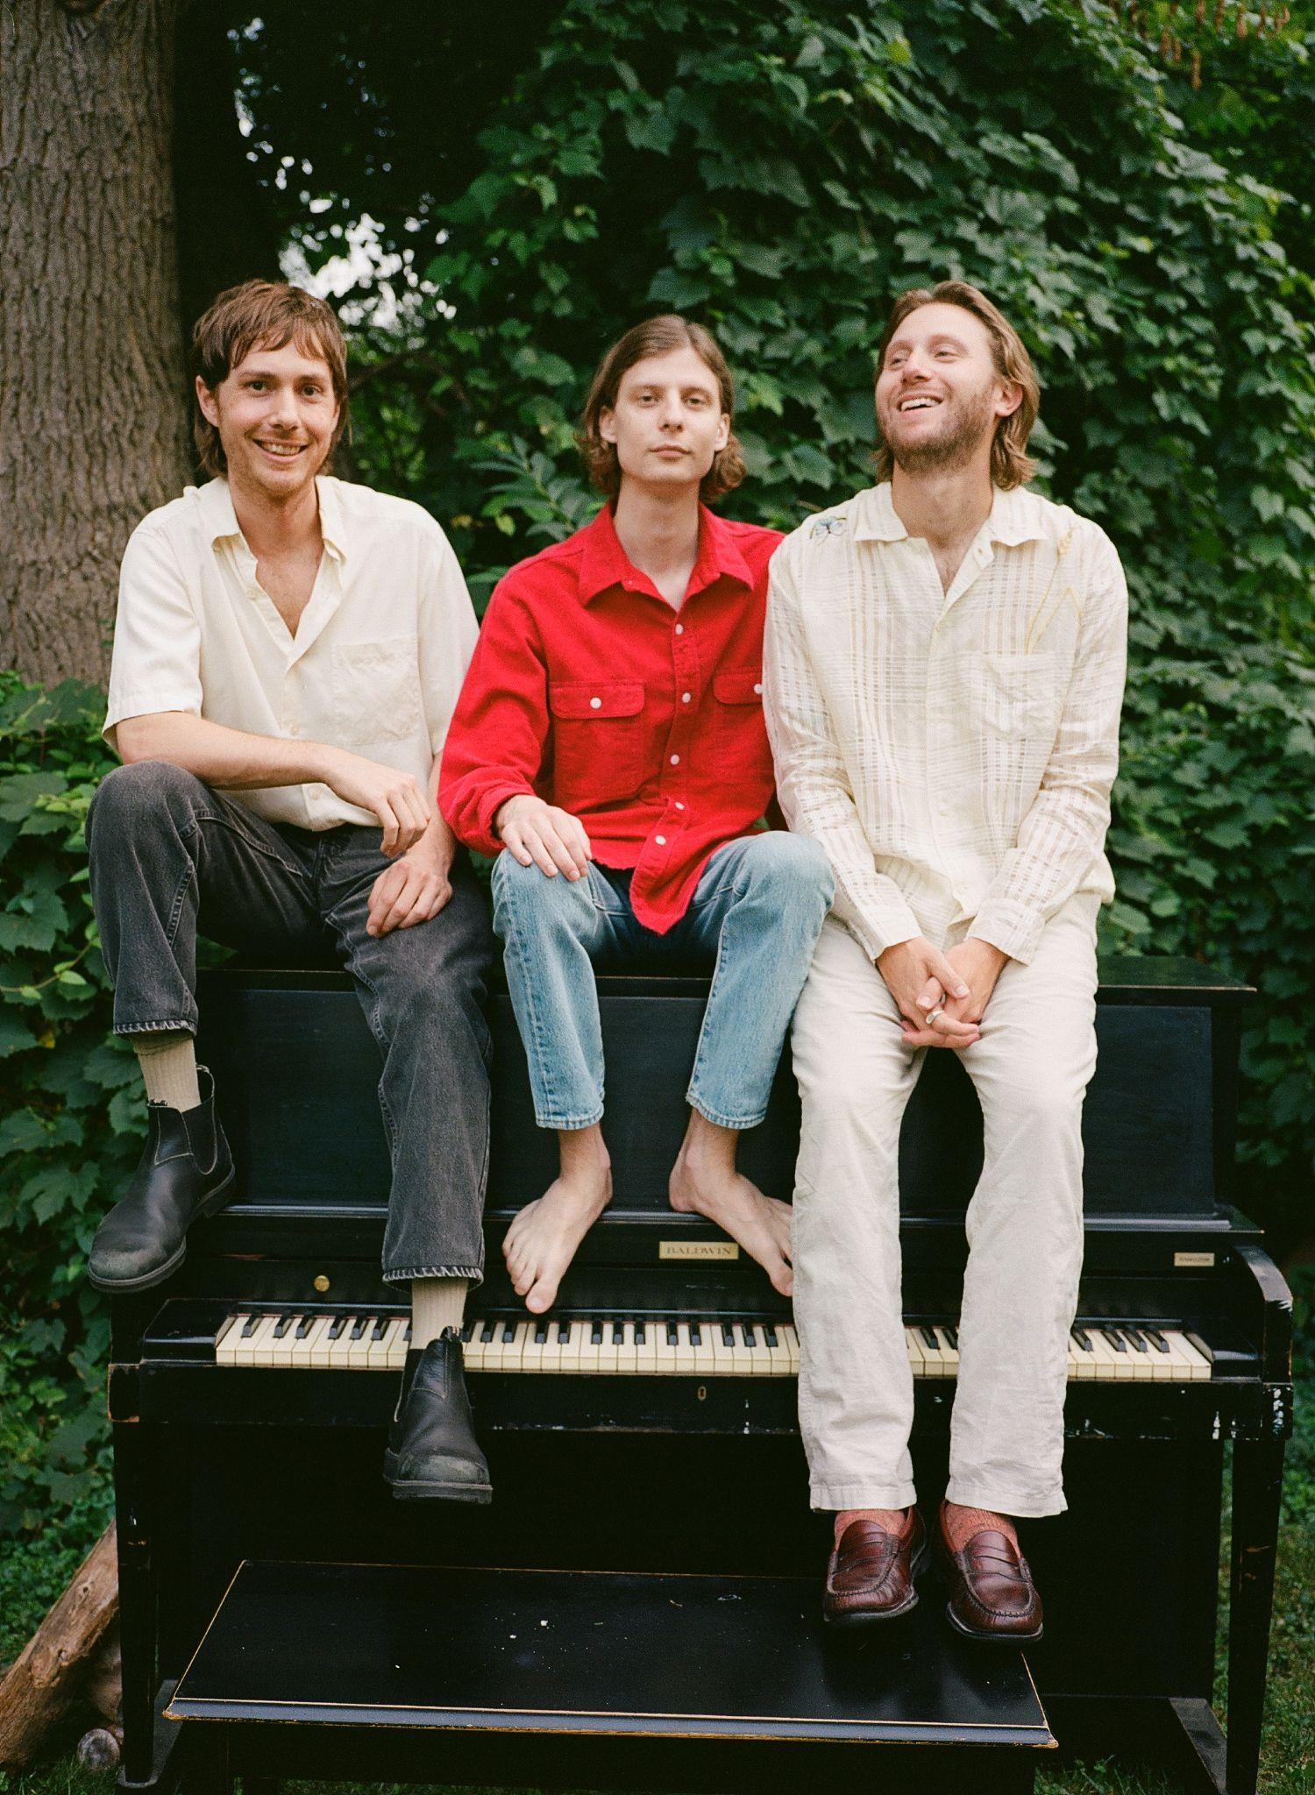
Photo Credit: Trevor Naud (download hi-res)

“Waxahatchee-approved and unbowed by misfortune, these dudes from Detroit are here to soundtrack your summer”
-Rolling Stone

“Detroit’s Bonny Doon recline deep in the kind of alternative folk music that gives off its own warmth, wise enough to sit back with some guitars and watch the world crumble.”
-Pitchfork

“Understated and thoughtful… Their most refined and joyous work to date."
-UPROXX

"[An] achievement in jangle-pop... Let There Be Music is an expression of gratitude for being alive and being together."
-Paste

“Heroes of ambling, melancholy, poetic indie rock”
-Stereogum

“Folk rock with some alt-country sprinklings—but the band’s more spontaneous approach lends it a scrappiness that feels fresh. Rather than rein these songs in to the point of suffocation, the band allows them to breathe, rambling and untangling themselves in unexpected ways.”
-FLOOD

“Let There Be Music distills exuberant songs to their essence”
-Aquarium Drunkard

Detroit, MI trio Bonny Doon are gearing up to release their new album Let There Be Music this Friday via Anti- Records. The album has been named one of the most anticipated albums of the summer by Pitchfork and Rolling Stone called it their “finest LP to date,” saying “to listen to Let There Be Music in 2023 is to experience Bonny Doon’s immaculately textured, Seventies-inspired California dreaming as an almost radical chillness, an album that’s so committed to its own zen aesthetics during these decidedly non-zen times that it can feel like a provocation.”

Ahead of its release the band has shared a music video for the album’s title track “Let There Be Music,” animated by Nora Rodriguez.
Bonny Doon’s summer tour in support of Let There Be Music kicks off this Friday in Detroit Michigan and runs through July 14th. The band has also announced the first ever UK and EU shows. Tickets are available via the band’s website. All dates below.

WATCH THE “LET THERE BE MUSIC” VIDEO
After extensively touring their 2018 sleeper cult-classic Longwave by supporting Band of Horses, Snail Mail and Waxahatchee, Lennox and Bobby Colombo were invited by Katie Crutchfield to collaborate on Waxahatchee’s critically acclaimed album Saint Cloud. “The experience raised the ceiling on our imagination,” Colombo said. Soon after, Colombo and Jake Kmiecik, whose steady percussion and devotion to the songs creates a container for the indelible guitar lines, both entered a time of serious healing, Jake tending to complications of his Crohn’s disease and Bobby to a brain injury and undiagnosed Lyme disease. While these detours of doctors’ appointments and experimental care were taking place, the members of Bonny Doon were also Waxahatchee’s backing band on the Saint Cloud tour. These obstacles and commitments drew out the making of Let There Be Music for several additional years, and in the process, redefined the record as an achievement in perseverance for the band.

On their long-awaited third album, we get a glimpse into the pure joy of Bonny Doon. The album serves as less of one conceptual story, and each song as their own Individual offerings of putting words to the ordinary experience of being alive. The band is at their most dynamic and the songwriting deftly explores new terrain. Let There Be Music is brimming with small truths - both profound and mundane, comforting and difficult - and we are invited to revel in them all.

Bonny Doon is Bill Lennox, Bobby Colombo and Jake Kmiecik.

Tour Dates:
6/16 - Detroit, MI @ MOCAD *
6/17 - Cleveland, OH @ Beachland Tavern *
6/18 - Philadelphia, PA @ PhilaMOCA ^
6/20 - New York, NY @ Bowery Ballroom ^
6/21 - Kingston, NY @ Tubby's ^
6/22 - Washington, DC @ Comet Ping Pong ^
6/23 - Carrboro, NC @ Cat's Cradle ^
6/24 - Atlanta, GA @ 529 ^
6/26 - Houston, TX @ White Oak Music Hall ~
6/27 - Austin, TX @ Empire ~
6/28 - Denton, TX @ Rubber Gloves ~
6/30 - Tucson, AZ @ Club Congress ~
7/1 - Phoenix, AZ @ Valley Bar ~
7/2 - San Diego, CA @ Casbah ~
7/6 - San Francisco, CA @ Swedish American Hall ~
7/7 - Arcata, CA @ The Miniplex ~
7/8 - Portland, OR @ Doug Fir ~
7/9 - Seattle, WA @ Barboza ~
7/10 - Missoula, MT @ Zootown Art ~
7/13 - Minneapolis, MN @ 7th St. Entry ~
7/14 - Chicago, IL @ Thalia Hall ~
10/17 - Rotterdam, NL @ V11
10/19 - Leeds, UK @ Brudenell Social Club
10/20 - Glasgow, UK @ The Hug and Pint
10/21 - Manchester, UK @ YES
10/22 - Cardiff, UK @ Swn Fest
10/23 - Bristol, UK @ The Louisiana
10/24 - London, UK @ The Lexington
10/27 - Paris, FR @ L'international
10/28 - Amsterdam, NL @ London Calling

* w/ Neu Blume
^ w/ John Andrews & The Yawns
~ w/ Anna St. Louis

LISTEN TO PREVIOUSLY RELEASED SINGLES
“NATURALLY,” “CROOKED CREEK,”
“SAN FRANCISCO,” & “ON MY MIND”

In a world of urgency, there’s little regard to the spiritual, emotional, or physical well-being of musicians. The creative process, often hidden from the listeners, remains a mystery, though we may pick up clues in the songs themselves. Throughout the ten tracks in their new album Let There Be Music, you can hear the spaciousness Bonny Doon allowed themselves since 2018’s Longwave. Their latest musical journey is one that has big payoffs for devoted followers and undeniable rewards for anyone just stumbling across the band for the first time.
In the past five years Bonny Doon has shifted from being a Detroit band to an outfit spread between California and Michigan, and now Michigan and New York. Despite the new challenge of distance, members Bill Lennox (guitar and vocals), Bobby Colombo (guitar and vocals), and Jake Kmiecik (drums) leaned on their friendship to sustain the collaboration, which has blossomed more than ever on their third album. While many songwriters work in solitude, the back and forth magic of Colombo and Lennox's process is what gives Bonny Doon their unique voice. The two write and compose each song together, planning writing retreats throughout the year - to gather ideas, edit songs, and give each other feedback, continuing to dedicate themselves to the collaborative effort of being a songwriting team.

“San Francisco”, the big city next to Colombo’s rural home of Lagunitas, offers a glimpse into the way this band sees the world - with both critical eyes and hope. Backup vocals from Crutchfield, who has become a continued collaborator, lend to the essence of the song’s building finale. “Crooked Creek” boasts a robustness and thundering pulse that energizes the album with its presence. The playful imagery nods to the spiritual in an authentic but self-aware way - If you’re stepping in shit, you’re probably on the path.

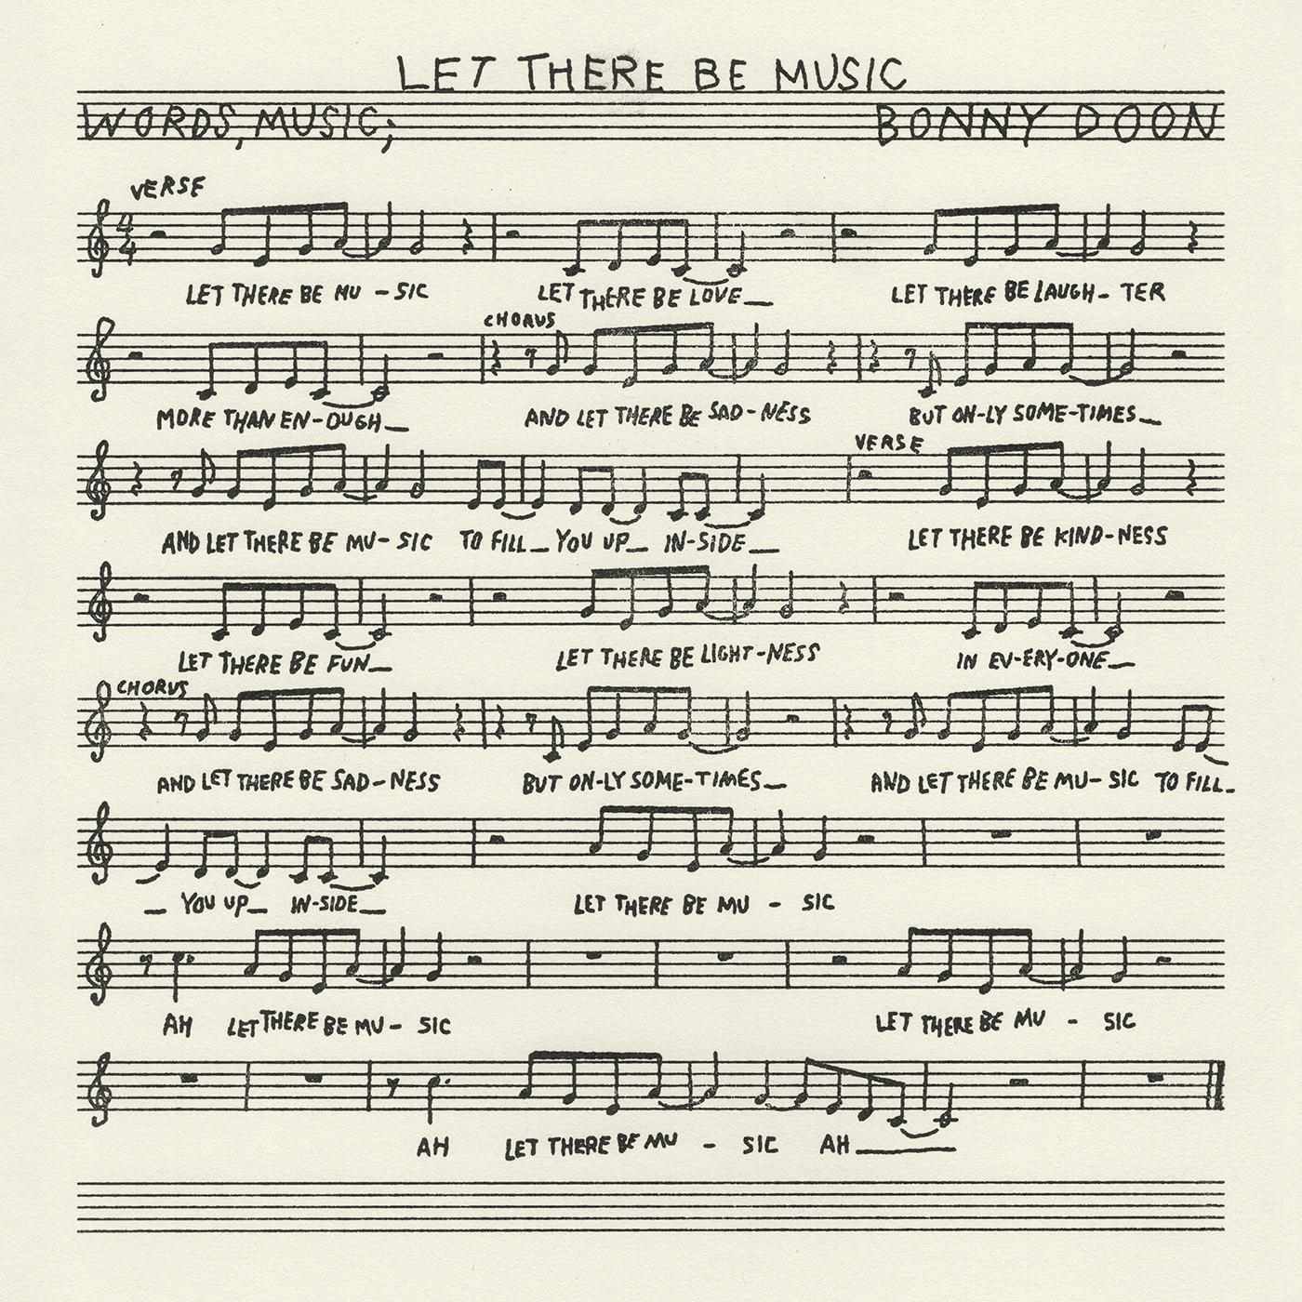
(download hi-res)

1. San Francisco
2. Naturally
3. Crooked Creek
4. Let There Be Music
5. Maybe Today
6. You Can’t Stay The Same
7. Roxanne
8. On My Mind
9. Fine Afternoon
10. Famous Piano

FOLLOW BONNY DOON
Bandcamp | Spotify | YouTube | Twitter | Instagram | Facebook

