DANNY ELFMAN RELEASES INNOVATIVE AI-GENERATED MUSIC VIDEO FOR “IN TIME”

WATCH NOW HERE

ELFMAN TO PERFORM AT COACHELLA VALLEY MUSIC AND ARTS FESTIVAL ON APRIL 16TH AND 23RD

EXCLUSIVE COLLECTOR’S EDITION BOX SET OF ACCLAIMED NEW ALBUM BIG MESS AVAILABLE
FOR PRE-ORDER NOW HERE

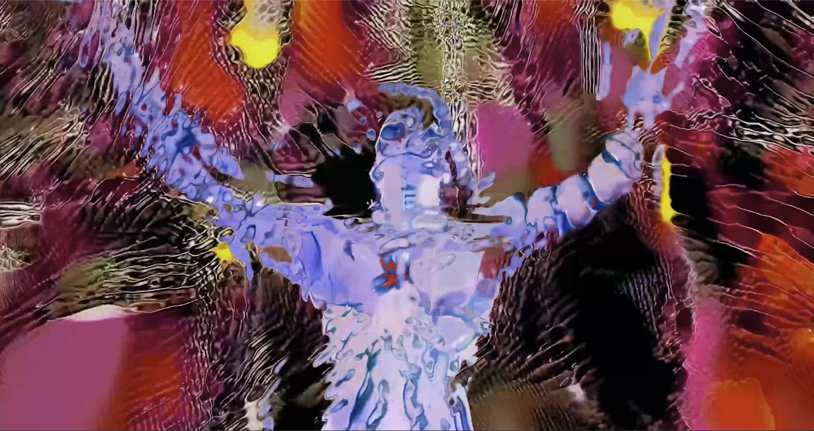
Danny Elfman - “In Time” Official Music Video (Courtesy of ANTI- / Epitaph Records)

January 19, 2022 (Los Angeles, CA) - Today, Danny Elfman has unveiled a brand new music video for “In Time,” the latest single from his acclaimed new album Big Mess. Directed by Zev Deans (St. Vincent, Chelsea Wolfe, HEALTH), the video features artificial-intelligence-generated visuals created by Italian media artist Lorem and was produced using source footage of Danny that was run through a GAN (generative adversarial network). The result is a hypnotic machine dream that collides the worlds of art and technology, melting and warping Elfman’s appearance through various colors, textures and backgrounds. Watch now HERE.

Preceded by music videos for the singles “Happy” (Aron Johnson), “Sorry” (Jesse Kanda), “Love In The Time of Covid” (Sven Gutjahr), “Kick Me” (Petros Papahadjopoulos), “True” (Sarah Sitkin), “Insects” (Sam & Andy Rolfes) and the reimagined duet version of “True” featuring Trent Reznor (Aron Johnson), “In Time” serves as a fittingly outlandish eighth chapter within the visual journey of Big Mess. Led overall by Elfman’s creative director Berit Gwendolyn Gilma, each of the video’s directors have created individual statements that shape a diverse but cohesive whole; all of which channel the feelings of anger, angst and frustration that pulse throughout the album.

The release of “In Time'' follows the recent announcement that Elfman will be a featured performer at this year’s Coachella Valley Music and Arts Festival on April 16th and April 23rd, 2022, where he will present Danny Elfman: From Boingo to Batman to Big Mess and Beyond! The 2020 festival notably served as the impetus for Big Mess over two years ago, when the cancellation and quarantine that followed triggered the creation of what would become the “Big Mess” double album.

Elfman officially unleashed ‘Big Mess’ in June 2021. Clocking in at 18 tracks, the expansive double album finds the 4x Oscar nominated, Grammy and Emmy Award-winning composer breaking bold new ground as both a songwriter and a performer. The songs on ‘Big Mess’ unite both harmonically complex arrangements and simple high energy driving music with biting, acerbic wit as they reckon with the chaos and confusion of the modern world. Joined on the album by drummer Josh Freese (Devo, Weezer, The Vandals), bassist Stu Brooks (Dub Trio, Lady Gaga, Lauryn Hill), and guitarists Robin Finck (Nine Inch Nails, Guns N’ Roses) and Nili Brosh (Tony MacAlpine, Paul Gilbert), the project has garnered widespread praise since its release including the LA Times, who called it a “a fiercely political work filled with bombastic peaks and strikingly meditative valleys.” The Big Mess album and visuals were produced by Danny Elfman and executive produced by Elfman’s longtime manager Laura Engel.

Just last month, Danny officially announced a brand new collector’s edition box set of Big Mess [ANTI- / Epitaph Records]. Limited to 1500 copies worldwide, the stunning release offers fans the ultimate window into the creation and visuals of the groundbreaking project and includes four LPs on exclusive color variants, featuring all 18 songs from Big Mess along with bonus discs containing unreleased reinterpretations of tracks from the album. In addition to the heralded duet version of "True" featuring Trent Reznor, the bonus discs will be comprised of new remixes from HEALTH, clipping. and more, as well as never-before-released songs with featured vocalists including Rebekah Del Rio, FEVER333, Blixa Bargeld and a second vocal collaboration with Reznor.

Each record is held in its own unique jacket featuring a 3D lenticular print on the cover and is accompanied by a 60 page, hardcover artbook containing never-before-seen renderings of the distinctively unsettling digital sculptures of Elfman done by Sarah Sitkin, who crafted the album’s original artwork. The special box set also includes a 20 page stitched soft cover lyric book with behind-the-scenes photos, a 12” x 9” art print signed by Danny himself, a detailed life-sized light up model of Elfman’s peculiar hand designed to be a stand-alone showpiece or one-of-a-kind night-light, and a code which provides downloadable digital audio files and a behind-the-scenes mini documentary on the making of Big Mess. All components are housed in a high quality two-piece box with liquid embossing on the cover and spot gloss embossing on the cover and sides.

The Big Mess collector’s edition box set is available for pre-order now here for $224.99, and will begin shipping in February 2022. See below for complete track-listing information, and visit Danny’s site here for more details.

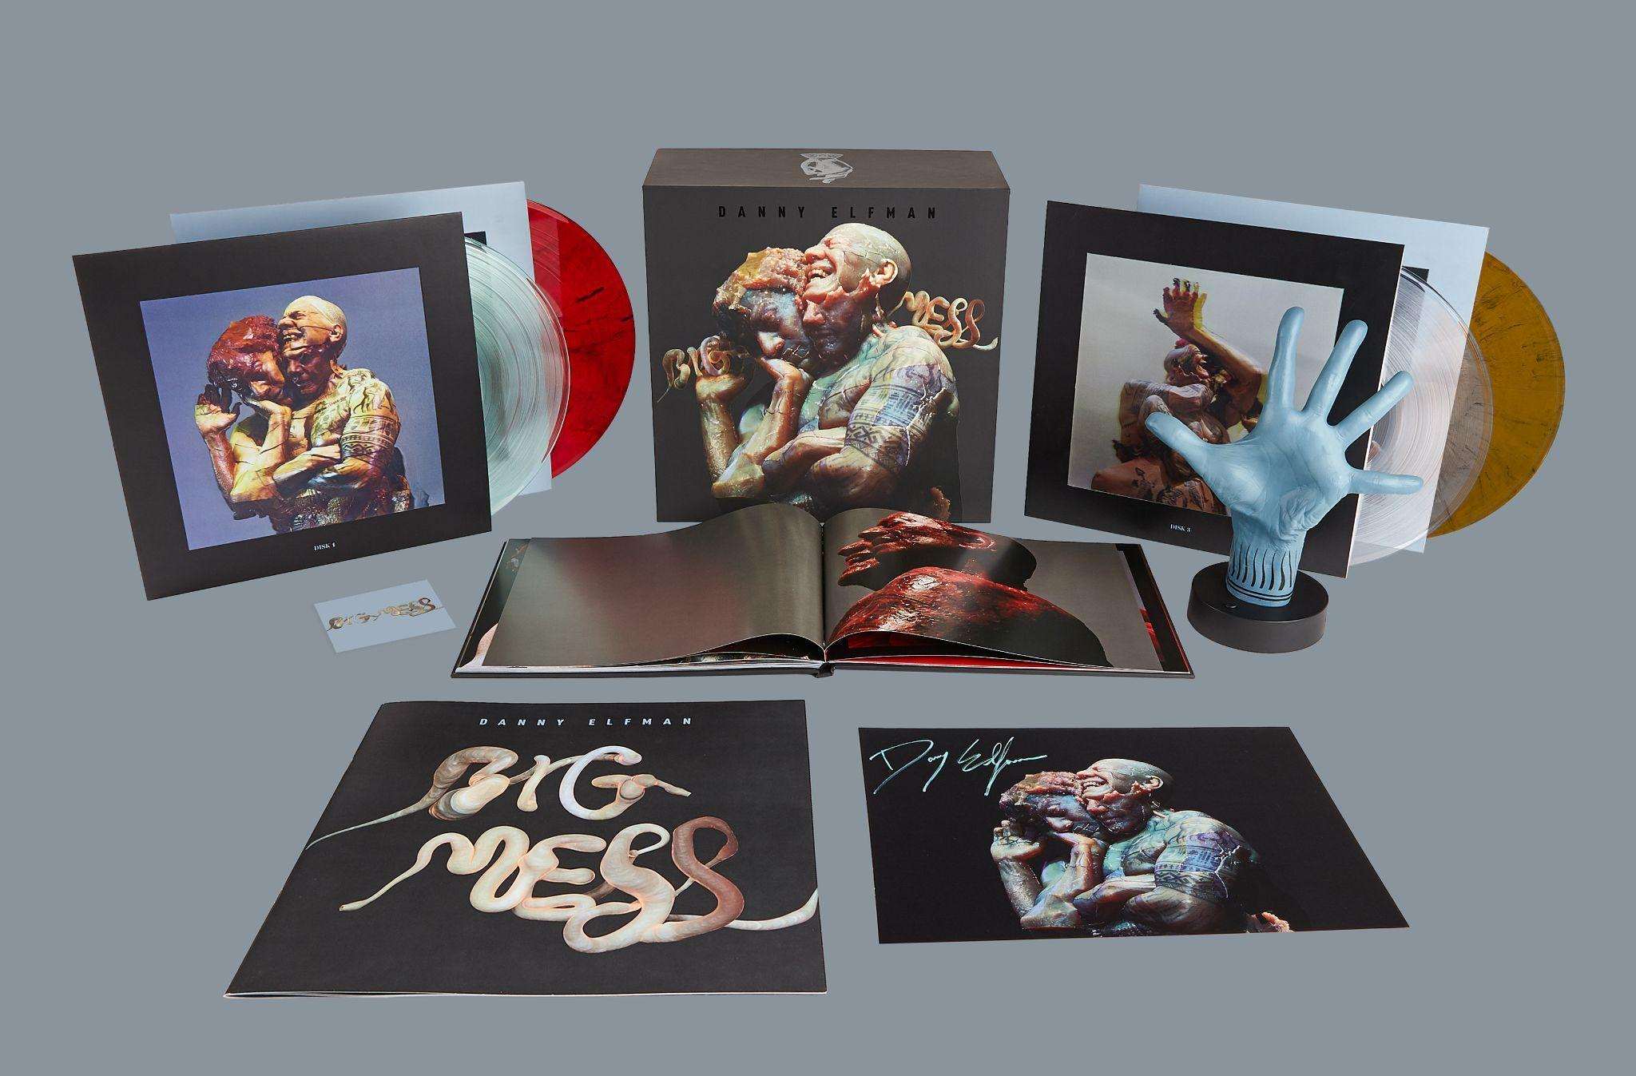
Danny Elfman - “Big Mess” Collector’s Edition Box Set

###

CONNECT WITH DANNY ELFMAN:
https://www.dannyelfman.com/
Instagram | Facebook | Twitter | Spotify

For More Info on Danny Elfman, Contact:
Kelly Kettering | ANTI- Records Publicity | Kelly@epitaph.com

Luke Burland / BB Gun Press / luke@bbgunpress.com
Peter Quinn / BB Gun Press / peter@bbgunpress.com

