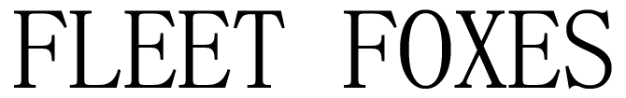

Fleet Foxes Announce:
‘A Very Lonely Solstice Livestream’
Robin Pecknold Performing Solo Acoustic from St. Ann & the Holy Trinity Church in Brooklyn, NY

December 21, 2020 @ 6pm PST / 9pm EST

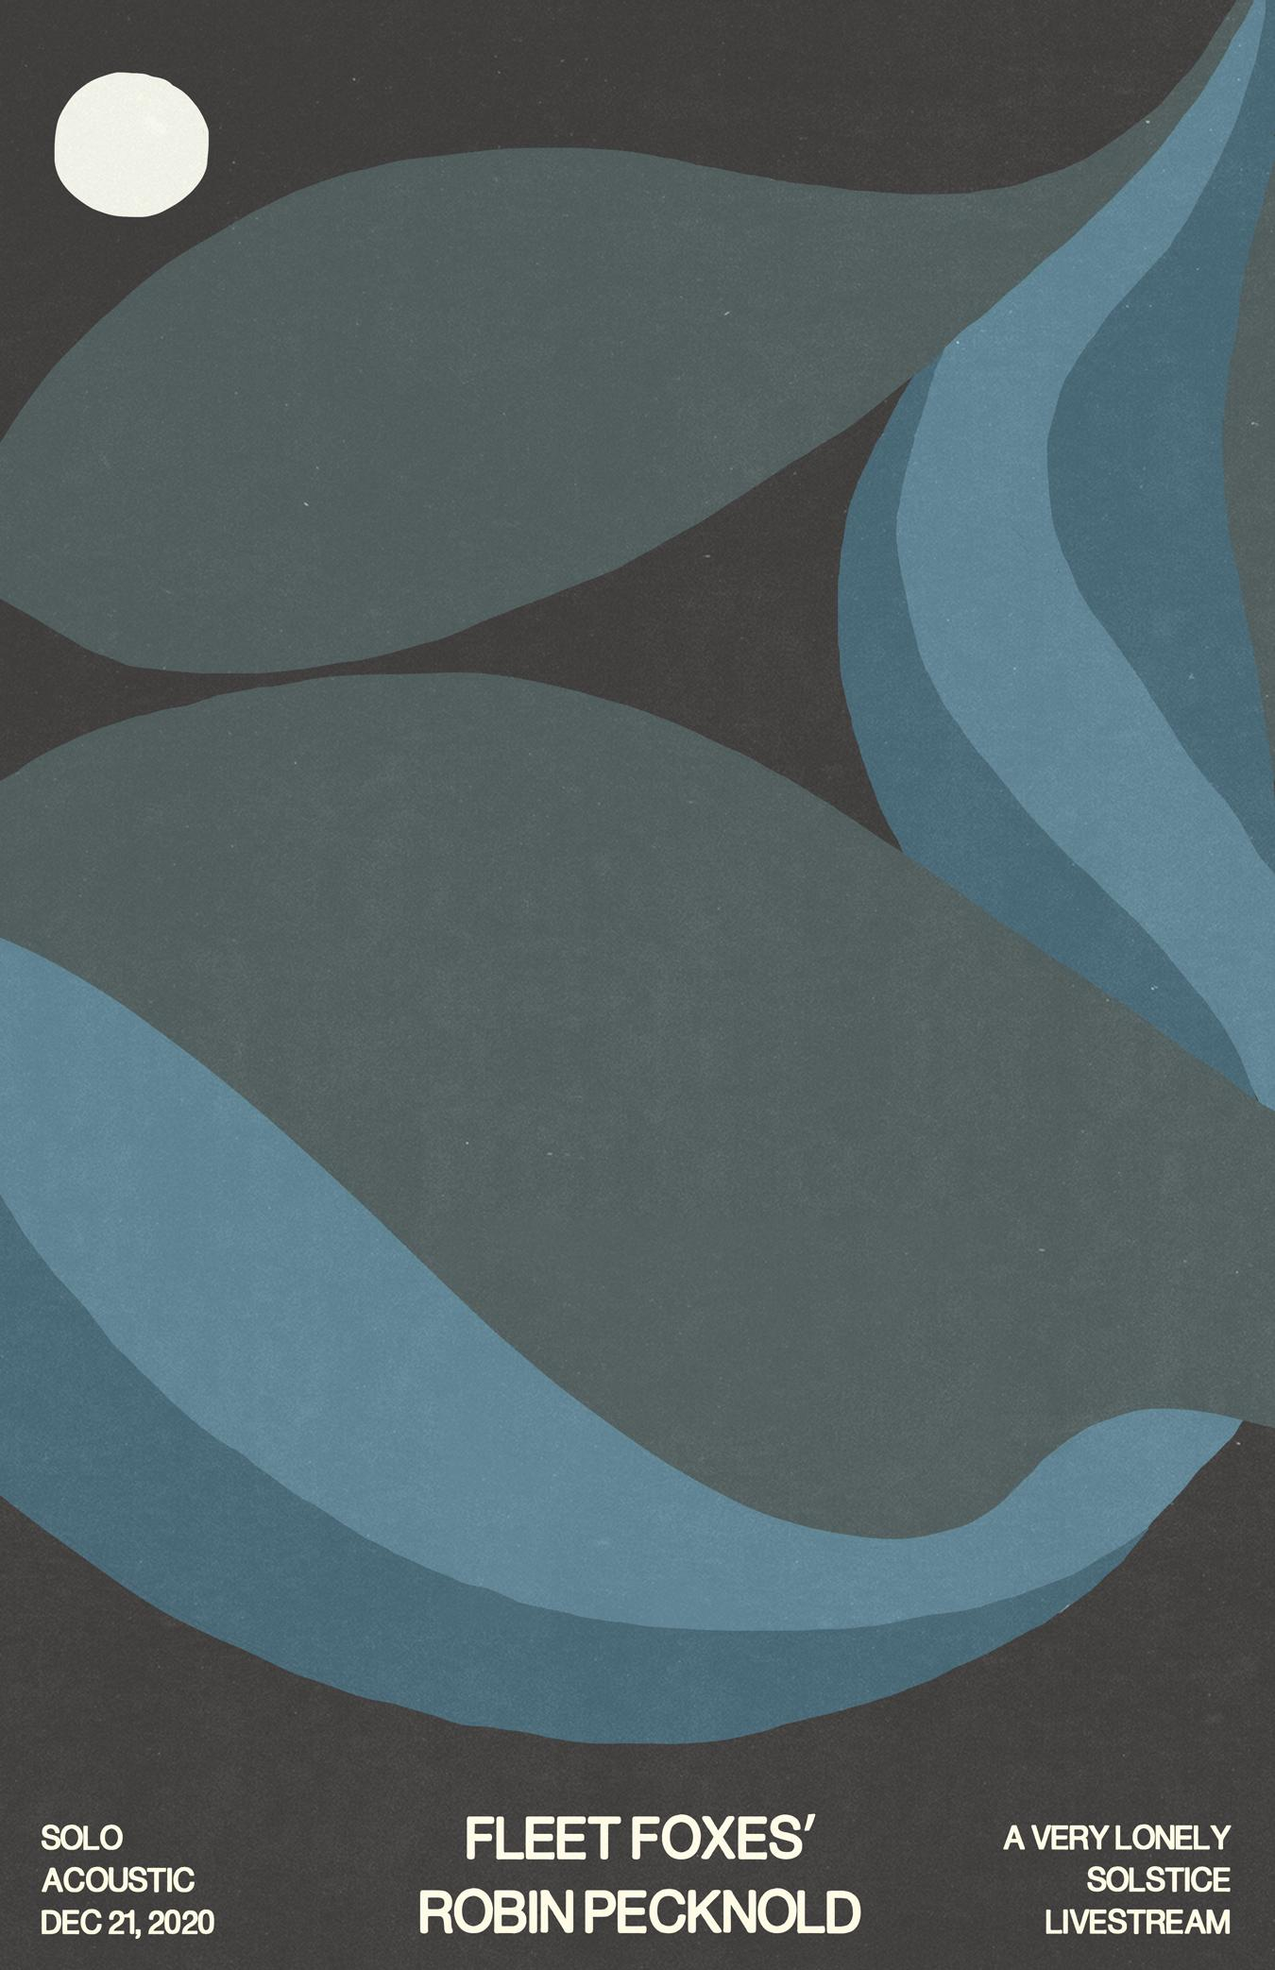

Shore Stems Available This Friday, December 4th
Exclusively on Bandcamp

Latest Album Shore Scores Top Positioning on
The New Yorker, Paste Magazine, Mojo, Uncut 6Music, and More Year-End Lists

[Tuesday, December 1, 2020] Today Fleet Foxes announced the first official livestream since the release of their celebrated fourth full length album, Shore. ‘A Very Lonely Solstice Livestream’ will take place on the Winter Solstice as the 2020 bookend to Shore, which was surprise-released digitally on, September 22nd, at 6:31 am PT/9:31 am ET, the Autumnal Equinox. The show will feature a solo acoustic performance by frontman and songwriter Robin Pecknold, with a one song guest appearance from the Resistance Revival Chorus (RRC). The Resistance Revival RRC is a collective of more than 60 women, and non-binary singers, who join together to breathe joy and song into the resistance, and to uplift and center women’s voices. Tickets for the livestream are available HERE.

In addition, the band will make available the stems for Shore this Friday, December 4th via Bandcamp.

“VERY excited to release all of the stems for Shore this Friday on Bandcamp,” commented Pecknold about the release of Shore’s stems. “This is eleven hours of all of the album’s isolated tracks, solo’d drums, vocals, horns, bass, guitars - every individual piece of every song untangled and laid bare. These aren’t royalty free, but any and all remixing / sampling / twisting / creative reuse and reimagining for your personal, non-commercial use is highly encouraged. And if you want to sample for commercial release, just get in touch.” Enjoy!”

Praised by critics upon release, Shore is topping year-end lists securing spots in the top 5 in Uncut, 6Music and Mojo, and #8 on The New Yorker’s list stateside. Shore is also finding strong support from non-comm radio having secured #1 on JBE non-comm chart for the 6th week in a row. Shore arrives on all physical formats (vinyl, CD and cassette) on February 5, 2021, and is available for preorder HERE.

Uncut: #2 in Top 75 Albums of the Year
“Shore was relentlessly sunny and optimistic, a celebration of nature, both wild and human”

6Music: #3 in Top 10 Albums of the Year
"The Seattle band delivered a light, experimental breath of fresh air that pays gentle reverence to the elements (we’re even treated to a birdsong-fade) on this lovely LP ”

MOJO: #5 in Top 75 Albums of the Year
“The best, most accessible FF set since their storied 2008 debut… the most inclusive and uplifting songs of his career.”

New Yorker. #8 in The Best Music of 2020
“Robin Pecknold reclaims the idea of thankfulness in the face of grief, giving the practice real dignity and grace”

Paste Magazine. #27 in The 50 Best Albums of 2020
“There are several elements that make a Fleet Foxes album great. Layered vocals, daring instrumental swells and vibrant, at times anxious, lyrics...These signifiers are all present on their new album Shore”

ACCLAIM FOR SHORE:
“Shore looks to the world and realizes there is already enough, as if staring into a darkness and responding with beauty, acceptance, and light." - PITCHFORK (BEST NEW MUSIC)

"A gorgeous folk-rock song cycle about life, death, and art, full of deep mourning and glimmers of relief on the other side. Track for track, Shore is the most immediately rewarding Fleet Foxes record since their brilliant 2008 debut." - ROLLING STONE (⅘ STARS)

“You soothe our worried minds and fraying souls with some gorgeous-as-fuck artisanal splendor." - ROLLING STONE (⅘ STARS)

"When you’ve got a song on your album called “Quiet Air/Gioia,” and it’s every bit as pretentious as that title suggests and yet in no way sucks, you’ve done your artistic betters proud." - ROLLING STONE (⅘ STARS)

"The gorgeous record found tonal balance amid the chaos of recent months, when the project suddenly seemed inconsequential to its creators and, therefore, more like a refuge. Though still primarily the creation of the band’s front man, Robin Pecknold, “Shore” is a collective effort that includes many contributors, and its glistening arrangements are reflective of the unburdening that collaboration fosters. " THE NEW YORKER

"The album is uniformly gorgeous, sometimes overwhelmingly so when taken in all at once...Every now and then there’s a moment of brightness, an actual good thing, that alleviates the darkness of the wretched year that is 2020. This is one of those good things." - STEREOGUM

"Fleet Foxes made the perfect album for this moment." - VULTURE

"Filled with epic, sweeping songs."- ENTERTAINMENT WEEKLY

"These 15 tracks are the work of an artist taking in everything dark and corrupt about this year, and choosing to craft an artifact of hope." - UPROXX

"There are lush soundscapes, fluttery brass cacophonies and subdividing rhythms...there is an acknowledgment of the past, but in a way that throws into sharp relief the potential that lies ahead and the legacy that is carried into the future" - ASSOCIATED PRESS

"Lucid, warm, and with no shortage of heart, Shore is a wonderful album to lead us into the concluding chapters of what has been a heartbreaker of a year." - CONSEQUENCE OF SOUND

"Shore is their most collaborative, most joyous album, and also one that transcends what Pecknold called the agrarian fantasies of their early days for an earnest plea to hear the call of the wild." THE RINGER

"Robin remains an extremely gifted songwriter, and these songs find him weaving in deceptively simple arrangements and some of the most instantly-satisfying melodies he's written yet." - BROOKLYN VEGAN

"Both vibrant and vital." UNDER THE RADAR

"Their most gorgeous full-length yet." NOISEY

"An absolute tour de force of rich melodies, heavenly hooks, luxurious production and songs packed to the brim with key/tempo/mood shifts that keep you constantly on your toes, it’s one of the most formidable albums we’ve heard this year, full stop." - GUITAR WORLD
Photo Credit: Emily Johnston

Follow Fleet Foxes:
Website - Instagram - Robin’s Instagram - Facebook

For more information on Fleet Foxes, please contact Grandstand Media:
Kate Jackson - katej@grandstandhq.com
Katie Nelson - katien@grandstandhq.com

