INTRODUCING…
PLAINS
NEW PROJECT FROM
WAXAHATCHEE’S KATIE CRUTCHFIELD & JESS WILLIAMSON

I WALKED WITH YOU A WAYS OUT 10/14 VIA ANTI-

WATCH VIDEO FOR LEAD SINGLE “PROBLEM WITH IT”

NORTH AMERICAN FALL TOUR ANNOUNCED

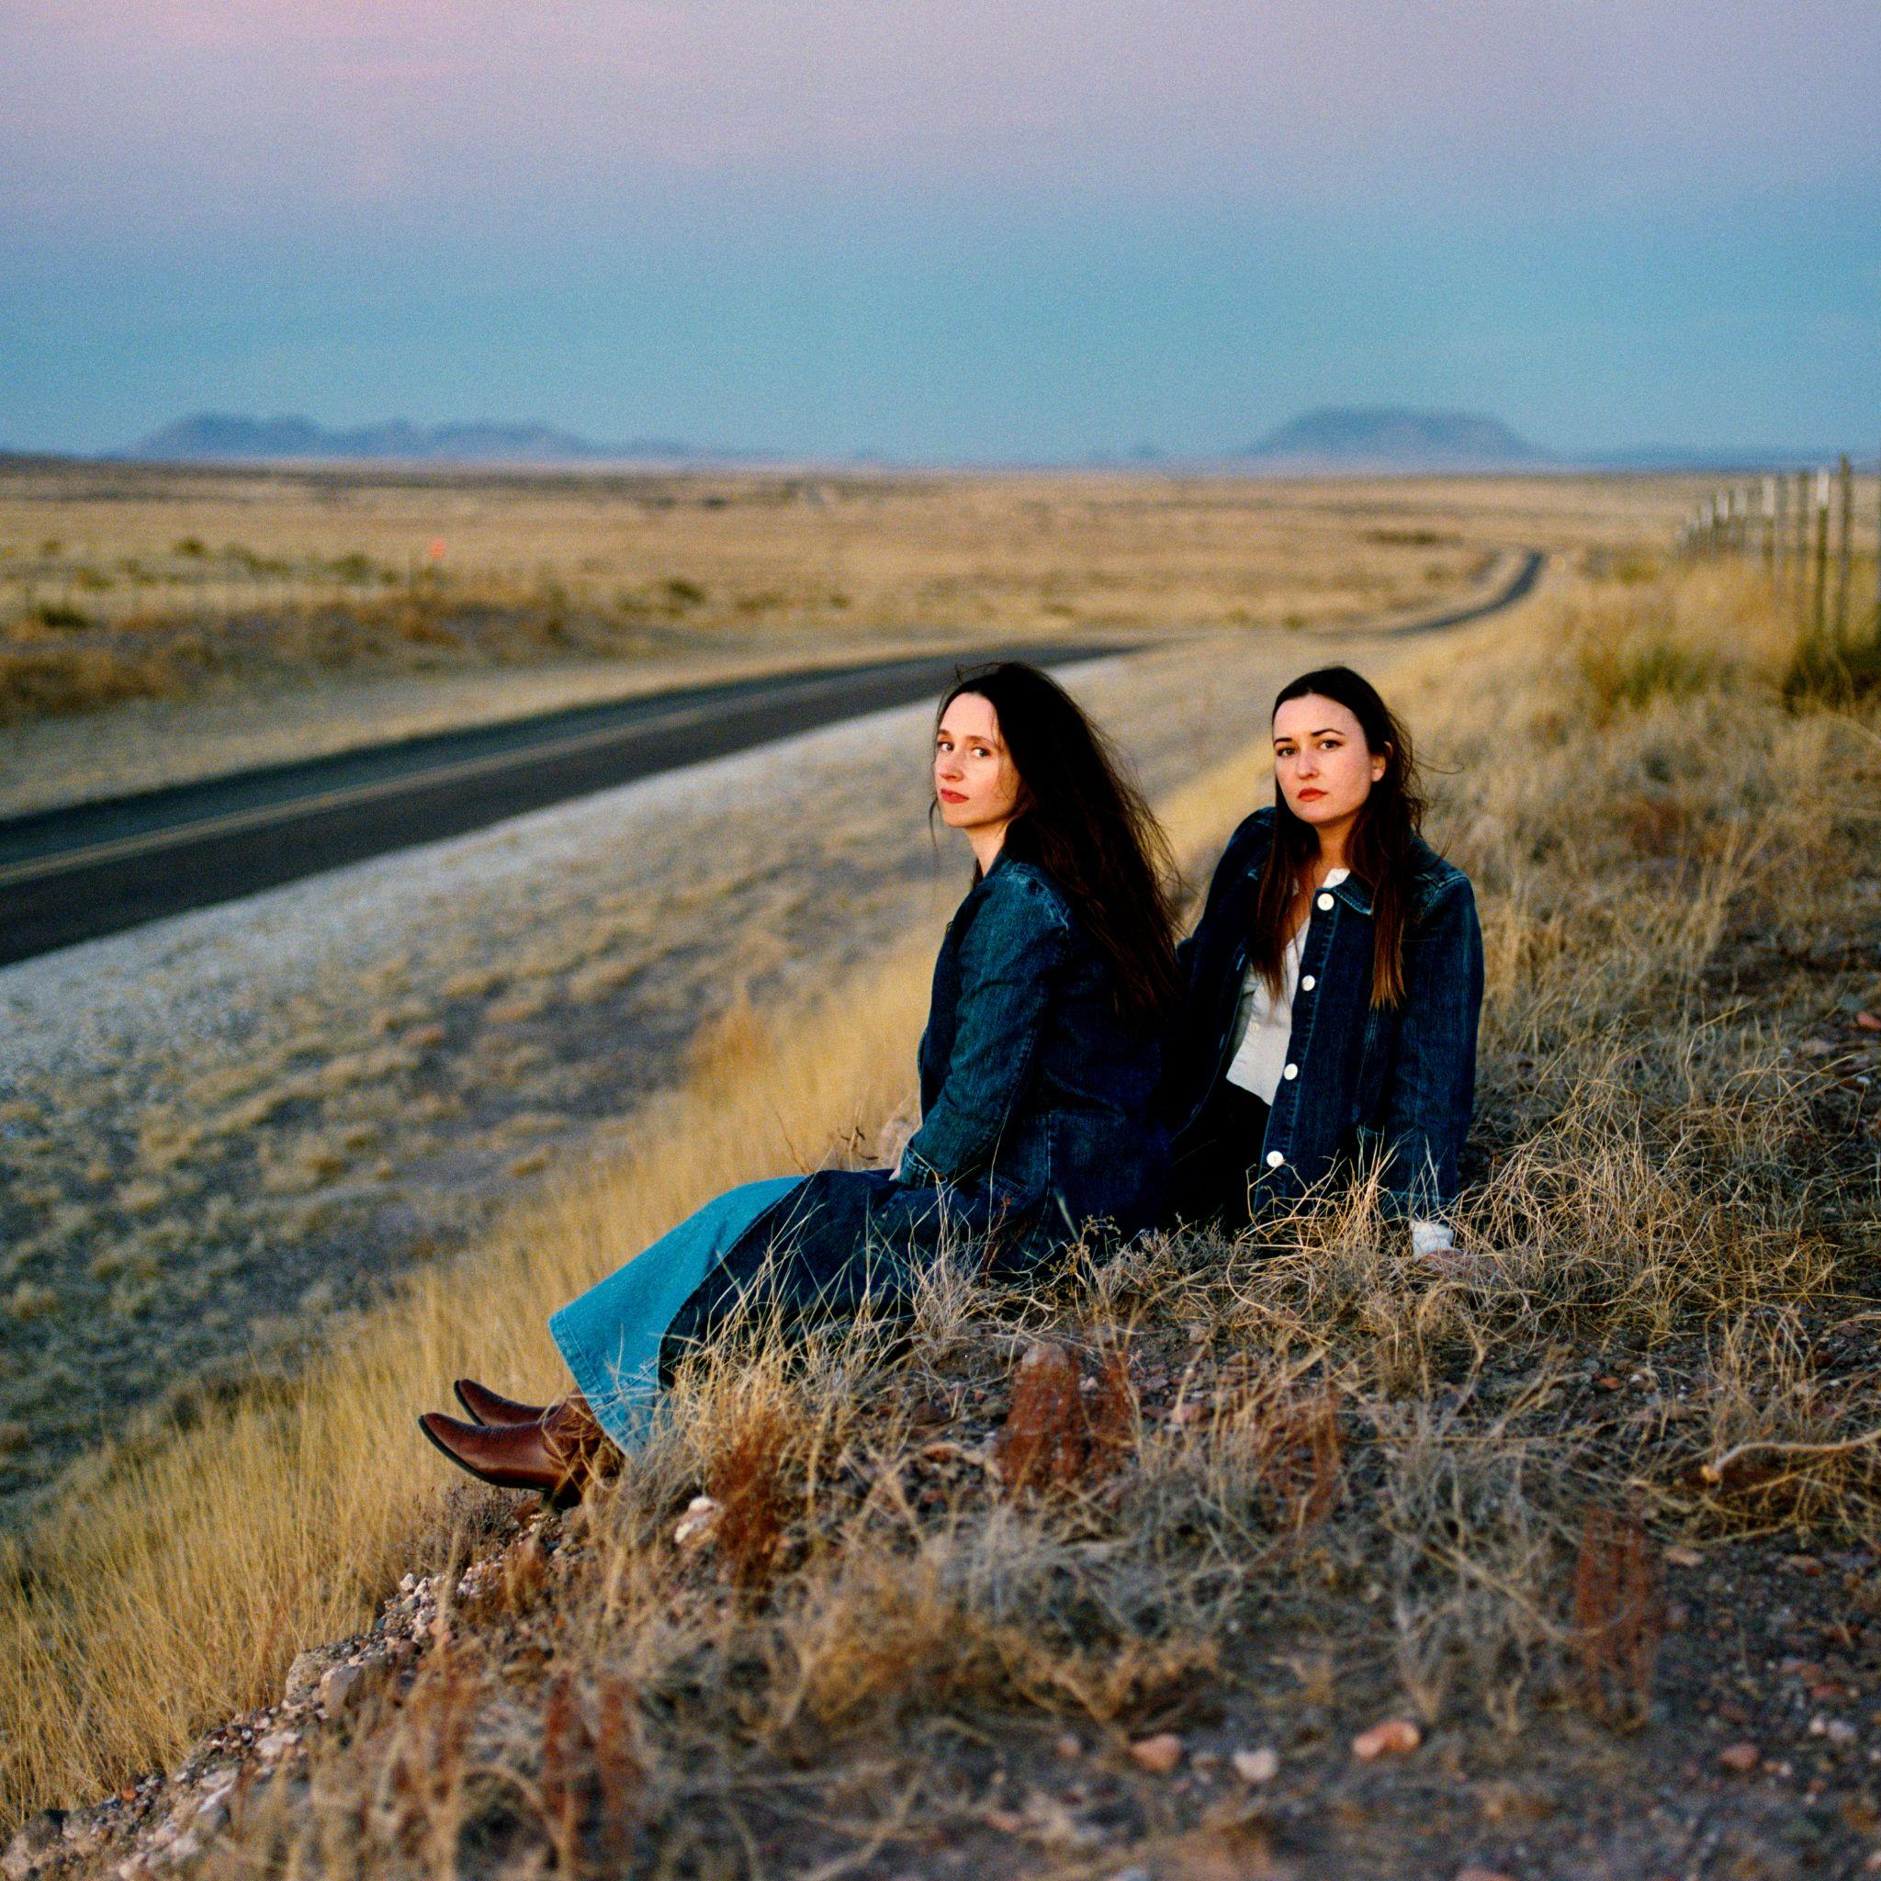
(download hi-res)

Today, Waxahatchee’s Katie Crutchfield and Jess Williamson announced an album titled I Walked With You A Ways for their new collaborative project, Plains, alongside the release of a video for the album’s lead single “Problem With It.” The record and its accompanying North American tour, also announced today, is a one time only collaboration, which makes Plains incredibly special. It’s a moment in time, to be enjoyed right now before the project evaporates forever.

Crutchfield tells us “I’m thrilled to announce this new project and album. I’ve felt a connection to Jess’s songwriting and a kinship with her since we met years ago. Getting to lean into the influence of the music we both grew up with while also making something that feels very current and fresh to me was a great experience and I’m so happy to finally share it.”

Williamson adds "Making this record with Katie was a deeply expansive experience for me as a songwriter. I really trust her ear and sensibilities, and she encouraged me to explore aspects of my songwriting that in the past I’ve shied away from. Katie’s support was so important for me as we wrote this album. We gave ourselves permission to lean into the music that raised us and write the kind of classic timeless songs that we both grew up singing along to. For me that was The Chicks and Dolly Parton, and having a place to channel those influences was an absolute blast. My hope with Plains was to tap into something Universal. I love the album we made, and I’m so excited to play it live."

In their solo endeavors you hear a specificity of experience that is so sharp and intimate that it brings the listener into a personal side of the experience of life. With Plains, we are invited into this spaciousness of story, to a shared narrative. There is an essence of their own friendship that clearly emerges that is just as much about joy and playfulness as it is about two people ushering each other through life’s great journeys.

Country music acts - from Waylon and Willie, to The Judds, The Chicks, Trio, and beyond - are groups that are formed out of family and friendship, which lyrically take their listeners on a voyage of sorrow and hope. Similarly, Crutchfield’s sharp, honest edge of truth telling paired with Williamson’s ability to paint the scene shine through on I Walked With You A Ways.

WATCH THE “PROBLEM WITH IT” VIDEO

Written between Kansas City, Los Angeles, and Marfa, the album was recorded in Durham, NC with collaborator and producer Brad Cook. The creative magic of only a few vocal takes, tracking with a band comprised of Spencer Tweedy and Phil Cook, gives the album a feel of fresh, on-the-spot conception. The trust and history of Crutchfield and Cook’s collaborations (Saint Cloud, Great Thunder EP) set the tone for this new container of spontaneity and experimentation.

Plains North American Tour
Fri Oct 21: Seattle WA @ The Neptune Theatre
Sat Oct 22: Portland OR @ Revolution Hall
Mon Oct 24: Sonoma CA @ Gundlach Bundschu Winery
Tue Oct 25: San Francisco CA @ The Regency Ballroom
Wed Oct 26: Los Angeles CA @ Belasco Theater
Fri Oct 28: Pioneertown CA @ Pappy and Harriet's
Sat Oct 29: Phoenix AZ @ Crescent Ballroom
Mon Oct 31: Dallas TX @ Studio at The Factory
Tue Nov 1: Austin TX @ Scoot Inn
Thu Nov 3: New Orleans LA @ Tipitina's
Fri Nov 4: Birmingham AL @ Saturn
Sat Nov 5: Nashville TN @ Brooklyn Bowl Nashville
Sun Nov 6: Atlanta GA @ Variety Playhouse
Mon Nov 7: Saxapahaw NC @ Haw River Ballroom
Wed Nov 9: Washington DC @ The Howard Theatre
Thu Nov 10: Philadelphia PA @ Union Transfer
Fri Nov 11: New York NY @ Webster Hall
Sat Nov 12: Jersey City NJ @ White Eagle Hall
Sun Nov 13: Boston MA @ Royale
Tue Nov 15: Toronto ON @ Danforth Music Hall
Wed Nov 16: Detroit MI @ Majestic Theatre
Thu Nov 17: Chicago IL @ Vic Theatre
Fri Nov 18: Minneapolis MN @ First Avenue
Sat Nov 19: Kansas City MO @ Knuckleheads Saloon

**All dates w/ MJ Lenderman.

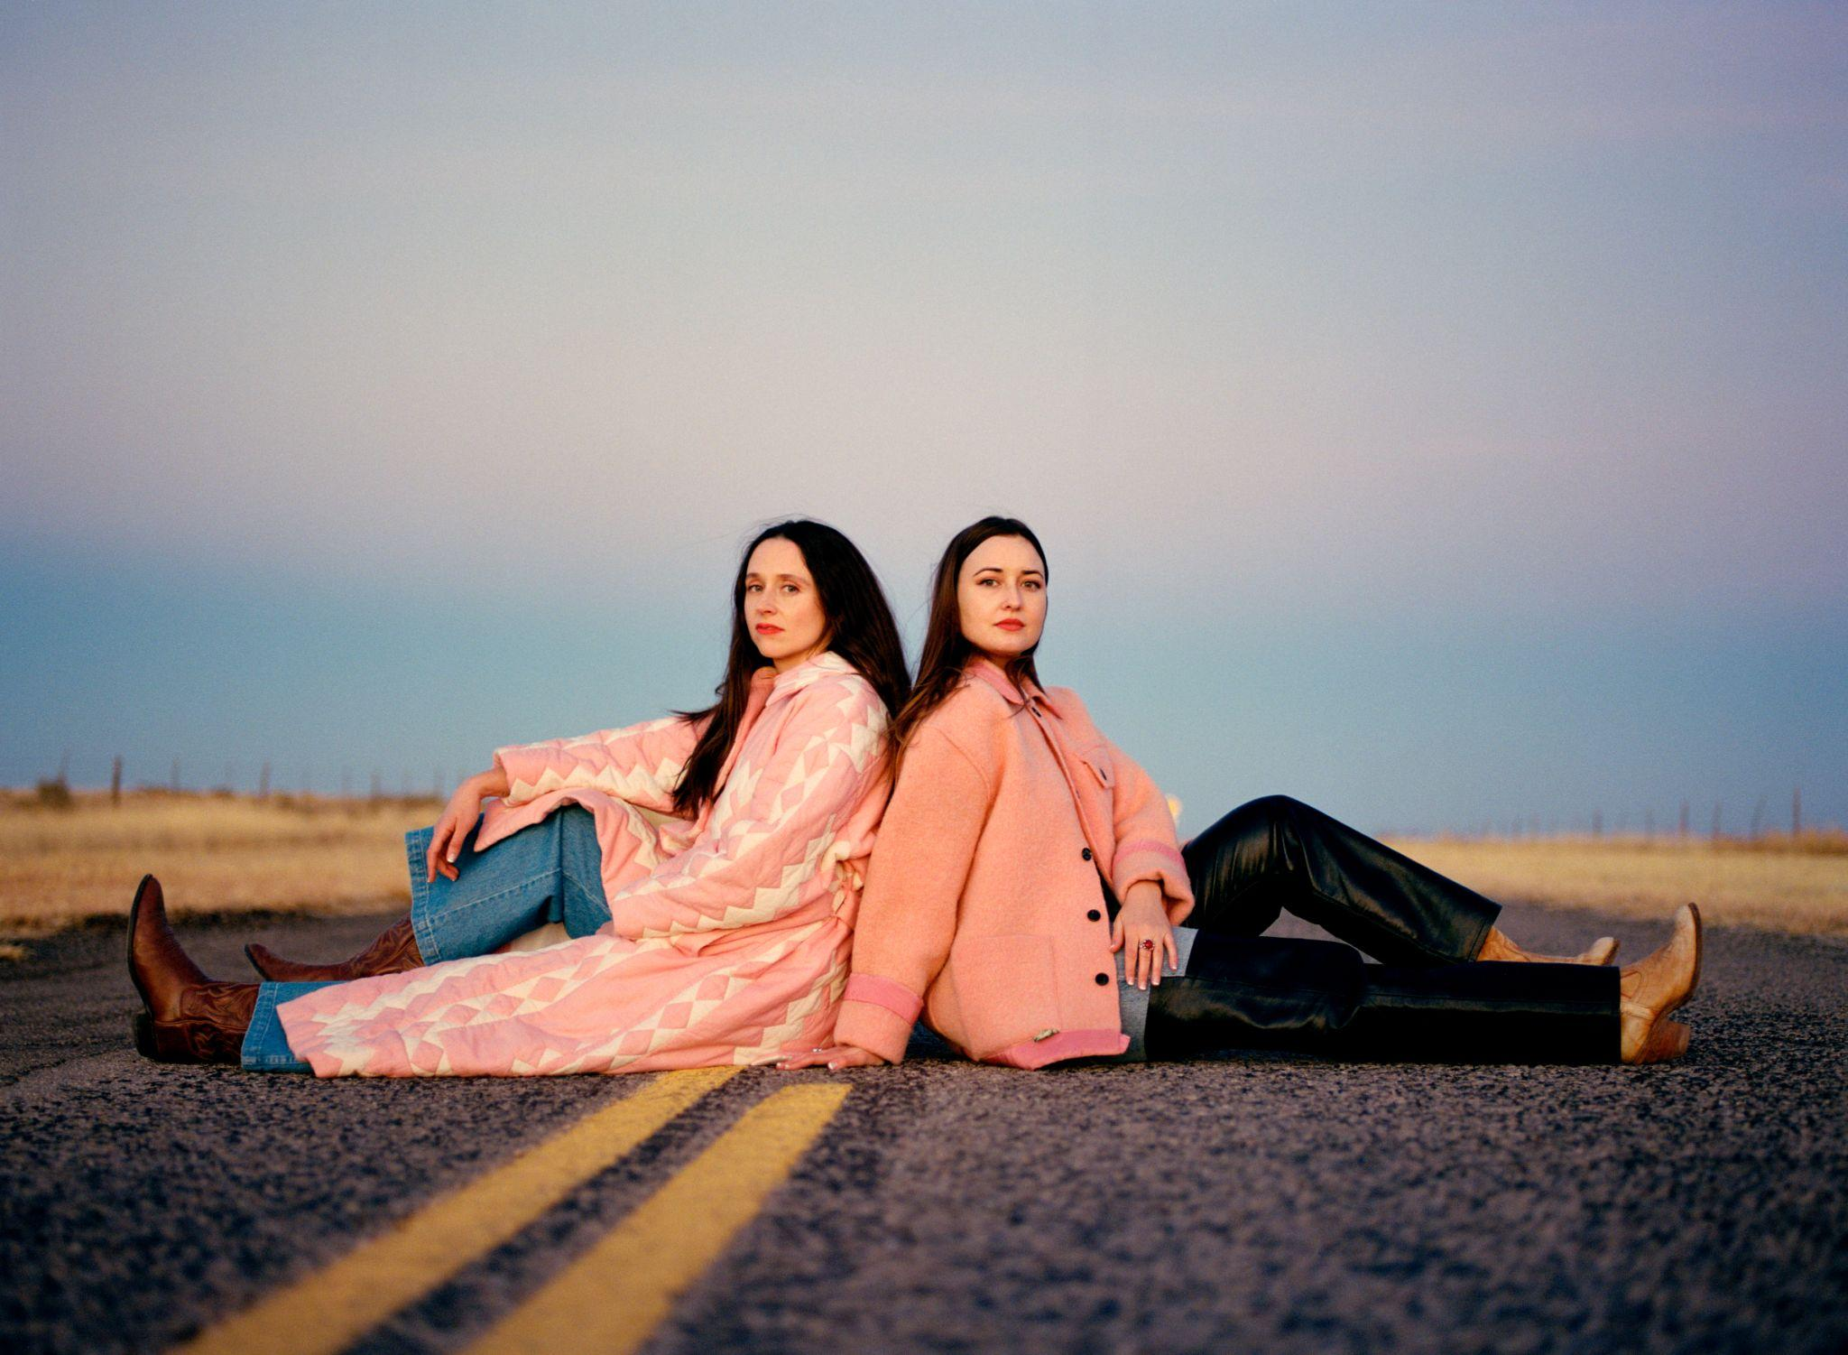
Photo Credit: Molly Matalon (download hi-res)

Track List:

1- Summer Sun
2- Problem With It
3- Line of Sight
4- Abeline
5- Hurricane
6- Bellafatima
7- Last 2 On Earth
8- Easy
9- No Record of Wrongs
10- I Walked With You A Ways

FOLLOW PLAINS
Website | Twitter | Instagram | Facebook | Spotify

FOLLOW WAXAHATCHEE
Website | Twitter | Instagram | Facebook | Spotify

FOLLOW JESS WILLIAMSON
Website | Twitter | Instagram | Facebook | Spotify

For more information please contact Grandstand Media & Management:
Eloy Lugo + Grace Jones
For tour related inquiries: Katie Nelson

