KRISTINE LESCHPER
FKA MOTHERS

ANNOUNCES NEW ALBUM
THE OPENING, OR CLOSING OF A DOOR
OUT MARCH 4TH VIA ANTI- RECORDS

SHARES VIDEO FOR LEAD SINGLE “RIBBON”

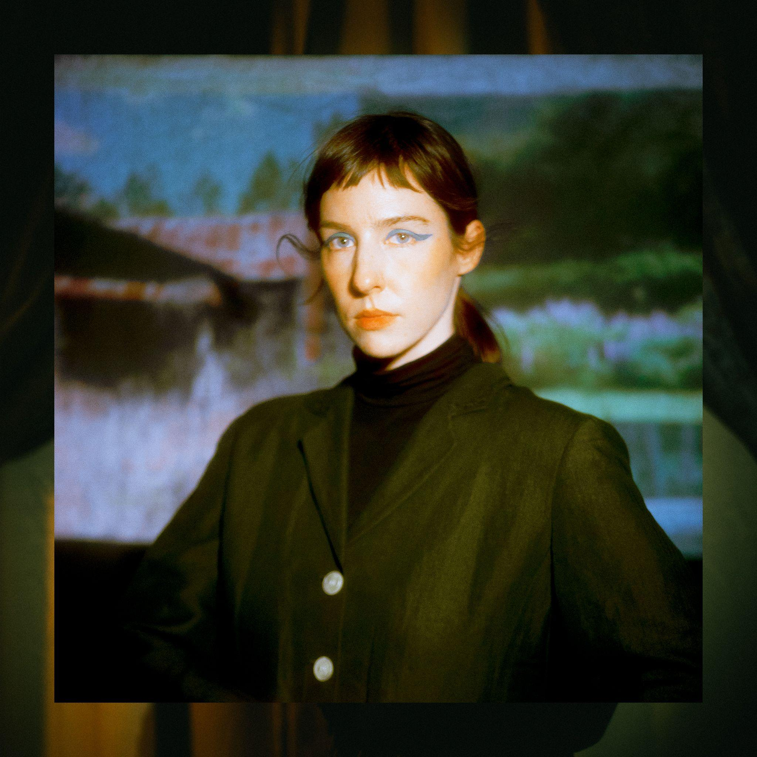
(download hi-res)

Kristine Leschper (fka Mothers) announces her new album, The Opening, Or Closing Of A Door, with a self-directed video for its lead single “Ribbon.” The Opening, Or Closing Of A Door is available for pre-order now and due March 4th via ANTI- Records.

“I found myself wanting to explore love songs, and this is really the framework of The Opening, Or Closing Of A Door,” says Leschper. “‘Ribbon’ is a love song that holds a certain tension -- it is the taut line of attempting to read the intentions of another, built with imagery of opposing materialities: a knife meets a ribbon, asking for a kind of vulnerability. A suggestion of something new emerging at this intersection.”

The Opening, Or Closing Of A Door is a paean to the sensory world. It’s the first Leschper has released under her given name, having retired the moniker Mothers after eight years of performing and releasing music under it. Though both projects are guided by Leschper’s idiosyncratic approach to songwriting, they couldn’t sound more different. While Mothers drew inspiration from the stark, skeletal sounds of post-punk and contemporary folk, Leschper’s new work is practically baroque, integrating an array of synthesizers, strings, woodwinds, and over a dozen percussive instruments.

WATCH THE “RIBBON” VIDEO
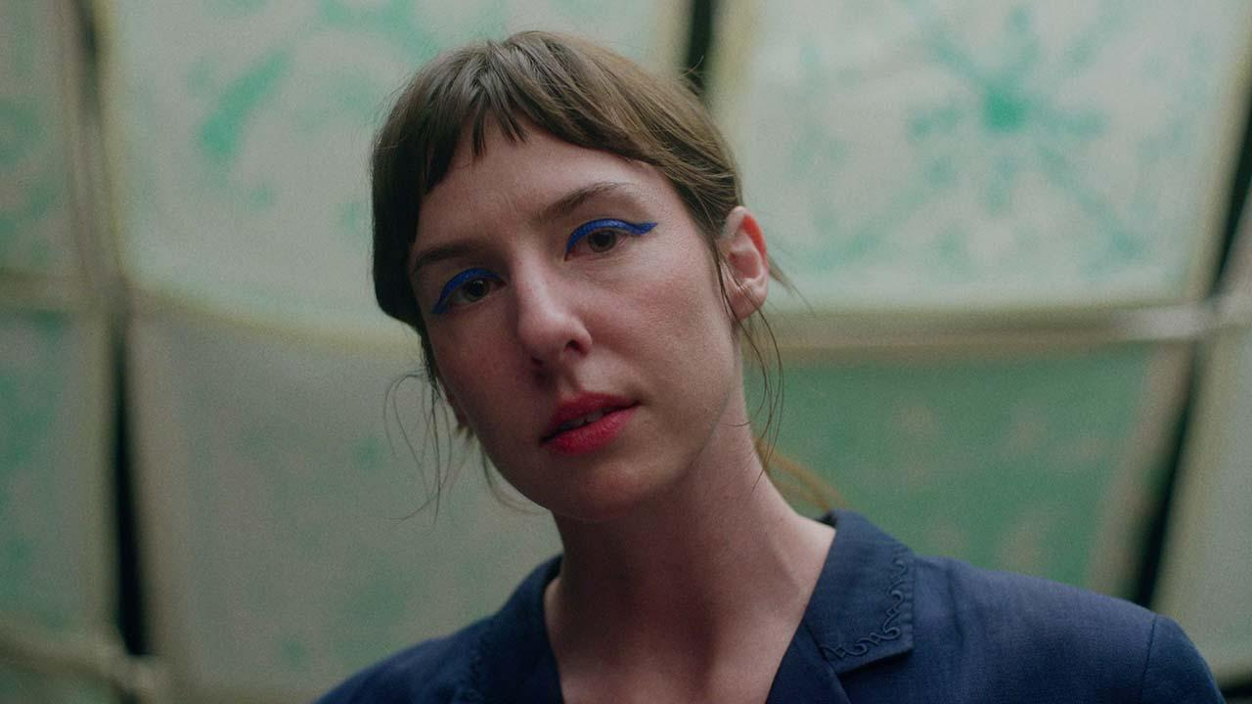

Of the video Leschper says “This was my first experience writing and directing a video, as well as designing and fabricating the set. I wanted to play with the perceived reality or unreality of a space, using an absolute economy of materials. When does an environment begin to lose its “realness” and slip into the imaginary? There’s something interesting in the posturing of lip sync in music videos -- I wanted to throw the microphone out of frame, as if to say: this is not a real performance, it is a performance of a performance, it’s pantomime! This is not a table, it is a painting of a table! Objects come and go, shifting between hard and soft, flat and dimensional, in a setting that provides little more than an abstraction of interior space.”

ABOUT THE OPENING, OR CLOSING OF A DOOR:
Out of chaos, the universe emerged, and from chaos a person can emerge, too. Kristine Leschper isn’t being hyperbolic when she describes a sensation of “being born” when a culmination of events, both personal and global, catalyzed in her “an understanding of how to relinquish control in a big way, and from that, a new sense of connectedness, transition, and impermanence.” She explains her desire to cultivate work in the spirit of the New World Poets, where in the words of June Jordan there exists “a reverence for the material world that begins with a reverence for human life, an intellectual trust in sensuality as a means of knowledge and of unity.”

“Earlier work didn’t involve recording as part of the writing process, recordings were simply made as a document of something that had been written and rehearsed. I have since discovered a deep affection for home recording and sound exploration, finding that I thrive in those rabbit holes of texture, timbre, rhythm, which can add so much complexity to the emotionality of a composition.”

The at-home recording process gave Leschper freedom to set her personal ethos to music divorced from the pressure of an audience. As she worked on The Opening, Or Closing Of A Door, the constellation of ideas that had guided her personal transformation began to cohere into something communicable through music. “My pleasure lives in the poetics of democracy -- in the liberatory words of June Jordan, in the humanitarian performances of Bread and Puppet Theatre. Puppetry, like poetry, is a distillation of complex ideas into absolute essentials. With these songs, I wanted to explore themes of longing, encouragement, connectedness, these things that are both straightforward and complex, ubiquitous and vital. It is the foundation of our personal lives that extends broadly into our political lives. I wondered, what might a love song to my friends look like? What might a love song to myself look like?”

“Lately my work centers on exploring joy in its wildness and complexity, the complicated ways that this joy intersects with an imperfect world,” Leschper says. “Circularity has become a major part of my belief system, the lens through which I watch the world -- observing cycles helps me make sense of my universe, both internally and externally. Popular culture loves to tell us stories about the importance of ‘growth’, personal growth, economic growth, what have you. It’s very linear. In work, as in life, I am making a conscious effort to center myself around something antithetical to that, because linear growth just doesn't exist in nature. If you zoom out far enough, everything is cyclical, everything is in a stage of transition! It becomes impossible to ignore the vast network of systems we inhabit, that we are in relationship with each other at all times.”

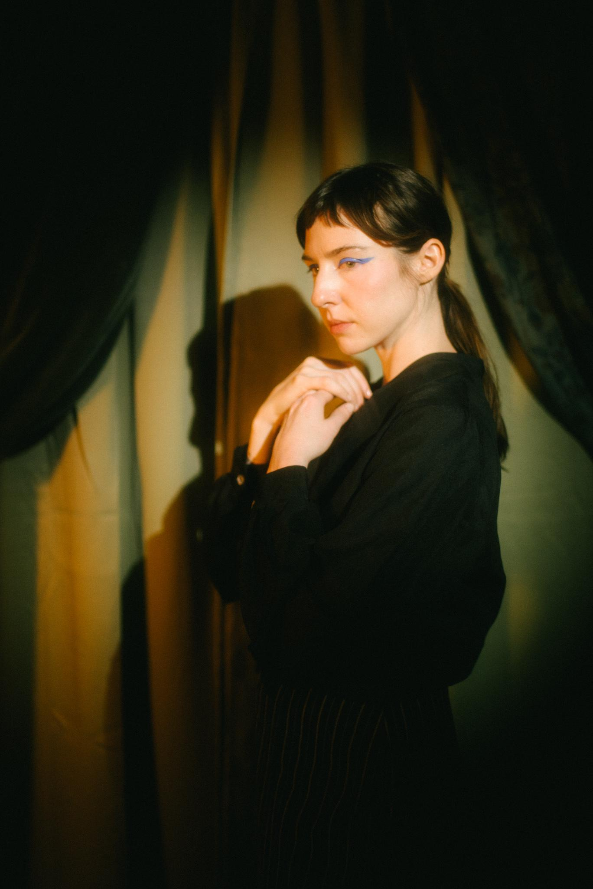
Photo Credit: Tyler Borchardt (download hi-res)
- This Animation
- Picture Window
- Figure and I
- Blue
- A Drop In That Bucket
- Writhe and Wrestle
- Carina
- Stairwell Song
- All That You Never Wanted
- Ribbon
- Compass
- The Opening Or Closing Of A Door
- Thank You

WEBSITE | BANDCAMP | SPOTIFY
TWITTER | INSTAGRAM | FACEBOOK

