June 28, 2023
For Immediate Release

Slow Pulp Announces New Album, Yard,
Out September 29th on ANTI-,
& North American/EU/UK Tour

Watch Video for Lead Single, “Slugs”
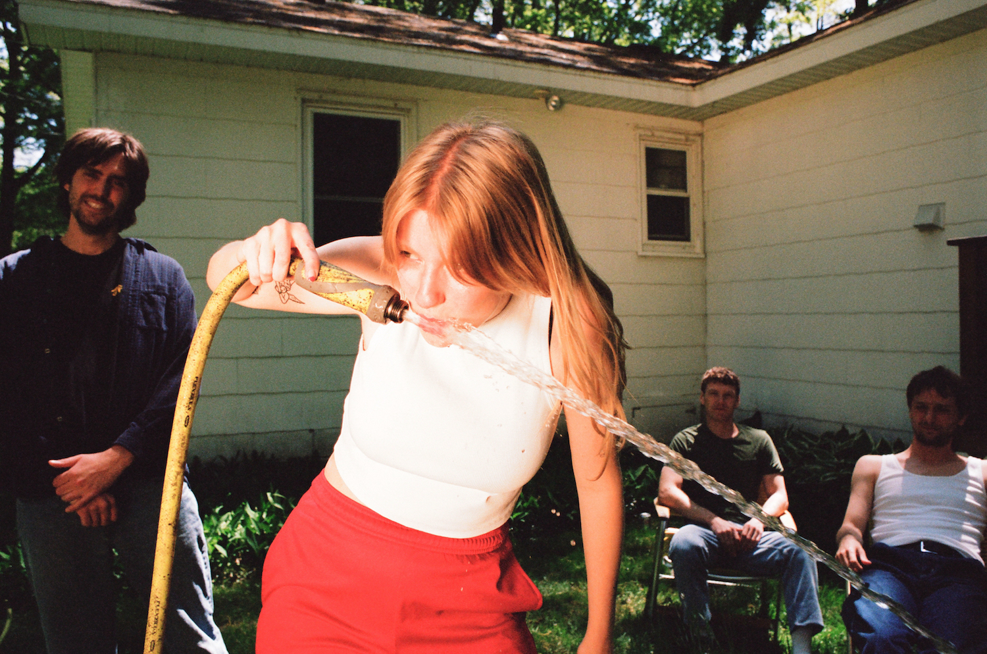
Photo Credit: Alexa Viscius

“Slow Pulp are indeed operating at a high level.” — Stereogum

“Slow Pulp’s future is awash with possibilities, and that future is now.” — Paste

Wisconsin-bred, Chicago-based Slow Pulp announces Yard, their new album and ANTI- debut out September 29th, an extensive North American/EU/UK tour, and new single/video, “Slugs.”
Emily Massey (vocals/guitar), Henry Stoehr (guitar/producer), Teddy Mathews (drums), and Alex Leeds (bass) have an electric chemistry, one that allows them to nimbly reach new sonic heights across Yard. Building upon the sticky hooks and dreamy rock seen in their earlier music, Yard crafts together a bigger sound. Through listless guitar, weepy americana, a raw-to-the-bone piano ballad, and belt-along worthy pop-punk, they tackle themes of isolation and the process of learning to be comfortable with yourself, along with the importance of learning to trust, love, and lean on others.

The chords to Yard’s addictive new single “Slugs” are from a song guitarist/producer Henry Stoehr wrote for his crush in the sixth grade, and one of the first songs he ever wrote. The Yard iteration of the song is, fittingly, also about a crush: “You’re a summer hit // I’m singing it,” Massey swoons over a warm wave of guitar fuzz and syrupy background vocals. “‘Slugs,’ put simply, is about falling in love in the summertime,” says Massey. “The song lives in that place where the newness and freshness of getting to know someone turns into a tinge of fear because you realize how much you have come to care about them. I tend to get so overtaken in feelings of uncertainty or impermanence when it comes to relationships. Probably due to having rocky foundations or complications in them in the past. But suddenly, for the first time, I found myself in something that felt safe, with healthy attachment and mutual admiration, and the inevitability of uncertainty became more easily accepted. I think it's so sweet that the song found this full circle moment in the timelessness of different types of firsts in love."

The accompanying “Slugs” video, created by Jakob Lazvick and Rich Smith, depicts a hazy desert road-trip, a perfect visual translation of this soon-to-be song of the summer.

Watch Slow Pulp’s “Slugs” Video

Slow Pulp is rooted in decade plus long friendships. Stoehr and Mathews attended elementary school together in Madison, and met Leeds through a local music program. Massey entered the fold in college, and with Leeds at university in Minneapolis and the other members in Madison, the quartet started recording, playing shows around the Midwest, and eventually released 2017’s EP2. It’s an intimate, restless, and decidedly lo-fi 17-minute debut, which picked up traction across YouTube channels and blogs. In 2018, the band relocated to Chicago, writing and recording most of their Big Day EP. As they put in the hours on stage and in the studio, they kept refining their work, and by 2019, they were touring with Alex G and working on their debut full-length record, Moveys. Due to Massey’s diagnosis of Lyme disease and chronic mono, and a serious car accident involving her parents, the band finished Moveys in isolation. Emily temporarily moved back home and recorded vocals with her dad, Michael, in his small home studio. It was their only option at the time, but the band opted to record the vocals with Michael again on Yard.

“Working together we can be very honest with each other in a way that I wouldn't be able to do with a stranger or a producer that's not my family,” says Massey. “He already has so much context for what the songs are about, knowing my life so intimately. He is able to be very direct, saying things I often don't want to hear but need to hear. I think it often leads to getting the best takes out of me.” That wasn’t the only lesson from Slow Pulp’s pandemic-era album creation that the band brought to their next record. Yard first started taking shape in February 2022 when Massey was staying alone at a friend’s family cabin in northern Wisconsin. Isolation was an important part of their process on Yard, but they were able to employ it strategically. “Part of what we discovered is that taking that time to be intentionally isolated is really important, as is being more collaborative at other times,” says Leeds. “We've learned a lot about balancing and being intentional about that through this process.”

Within Slow Pulp, this trust between members is evident in the playful collaboration that remains core to their creative process. Across Yard, they nestle comfortably into pockets of nuance, impressions, contradictions—sonics and lyrics finessed together to bottle the specific tension of a feeling you’ve never quite been able to find the right words for. Perhaps this spawns from the band’s own shared history and chemistry; in various ways, the four of them grew up—are still growing up—together.

Earlier this year, Slow Pulp released their fantastic single “Cramps,” “which captures that feeling of having big ambitions and not quite living up to the potential” (The FADER), ahead of tour dates opening for Death Cab for Cutie and the Pixies. This fall, they’ll bring their incredible live show across North America. A full list of dates can be found below and tickets are on sale Friday, June 30th at 10am local time here.

Watch the Video for “Cramps”

Pre-order Yard

Yard Tracklist
1. Gone 2
2. Doubt
3. Cramps
4. Slugs
5. Yard
6. Carina Phone 1000
7. Worm
8. MUD
9. Broadview
10. Fishes

Slow Pulp Tour Dates
Wed. Oct. 04 - Milwaukee, WI @ Colectivo - Backroom %
Thu. Oct. 05 - Minneapolis, MN @ Amsterdam Hall %
Fri. Oct 06 - Omaha, NE @ Slowdown %
Sun. Oct. 08 - Denver, CO @ Globe Hall %
Tue. Oct. 10 - Salt Lake City, UT @ Kilby Court %
Thu. Oct. 12 - Seattle, WA @ Neumos %
Fri. Oct. 13 - Vancouver, BC @ The Pearl on Granville %
Sat. Oct. 14 - Portland, OR @ Aladdin Theatre %
Mon. Oct. 16 - San Francisco, CA @ The Chapel %
Wed. Oct. 18 - Los Angeles, CA @ Teragram Ballroom %
Fri. Oct. 20 - San Diego, CA @ Voodoo %
Sat. Oct. 21 - Santa Ana, CA @ Constellation Room %
Sun. Oct. 22 - Phoenix, AZ @ Rebel Lounge %
Tue. Oct. 24 - Houston, TX @ White Oak Music Hall %
Wed. Oct. 25 - Dallas, TX @ Club Dada %
Thu. Oct. 26 - Austin, TX @ The Parish %
Sat. Oct. 28 - Atlanta, GA @ Purgatory %
Sun. Oct. 29 - Durham, NC @ Motoco %
Mon. Oct. 30 - Washington, DC @ Union Stage %
Tue. Oct. 31 - Philadelphia, PA @ The Foundry %
Wed. Nov. 1 - New York, NY @ Bowery Ballroom %
Fri. Nov. 3 - Boston, MA @ Brighton Music Hall %
Mon. Nov. 6 - Montreal, QC @ Bar Le Ritz %
Tue. Nov. 7 - Toronto, ON @ Horseshoe Tavern %
Fri. Nov. 10 - Madison, WI @ Majestic Theater %
Sat. Nov. 11 - Chicago, IL @ Thalia Hall %
Wed. Nov. 29 - Leeds, UK @ Brudenell Social Club #
Thu. Nov. 30 - Liverpool, UK @ Jimmy’s #
Fri. Dec. 1 - Glasgow, UK @ The Hug and Pint #
Sat. Dec. 2 - Dublin, IR @ The Workman's Club #
Mon. Dec. 4 - Manchester, UK @ YES (Basement) #
Tue. Dec. 5 - Bristol, UK @ Strange Brew #
Wed. Dec. 6 - London, UK @ MOTH Club #
Thu. Dec. 7 - Brighton, UK @ The Green Door Store #
Sat. Dec. 9 - Amsterdam, NL @ Paradiso Upstairs
Sun. Dec. 10 - Antwerp, BE @ TRIX #
Mon. Dec. 11 - Paris, FR @ L’International #
Wed. Dec. 13 - Berlin, DE @ Badehaus Szimpla #
Thu. Dec. 14 - Leipzig, DE @ Conne Island #
Fri. Dec. 15 - Schorndorf, DE @ Manufaktur #
Sat. Dec. 16 - Munster, DE @ Gleis 22 #

% w/ Babehoven
# w/ PACKS

Praise for Slow Pulp

“[Moveys] is a soundtrack for aimless afternoon walks and light existential crises, as the temperature drops and our hours spent outdoors shorten.” — Pitchfork

“[Moveys] is packed with a thousand deft little flourishes of texture which together add up to a deeply entrancing whole.” — NME

“Moveys keeps a sense of wonder and never loses its wry humour” — Gold Flake Paint

“[Moveys] feels custom-built for the autumnal period” — The FADER

Download cover art & hi-res images of Slow Pulp

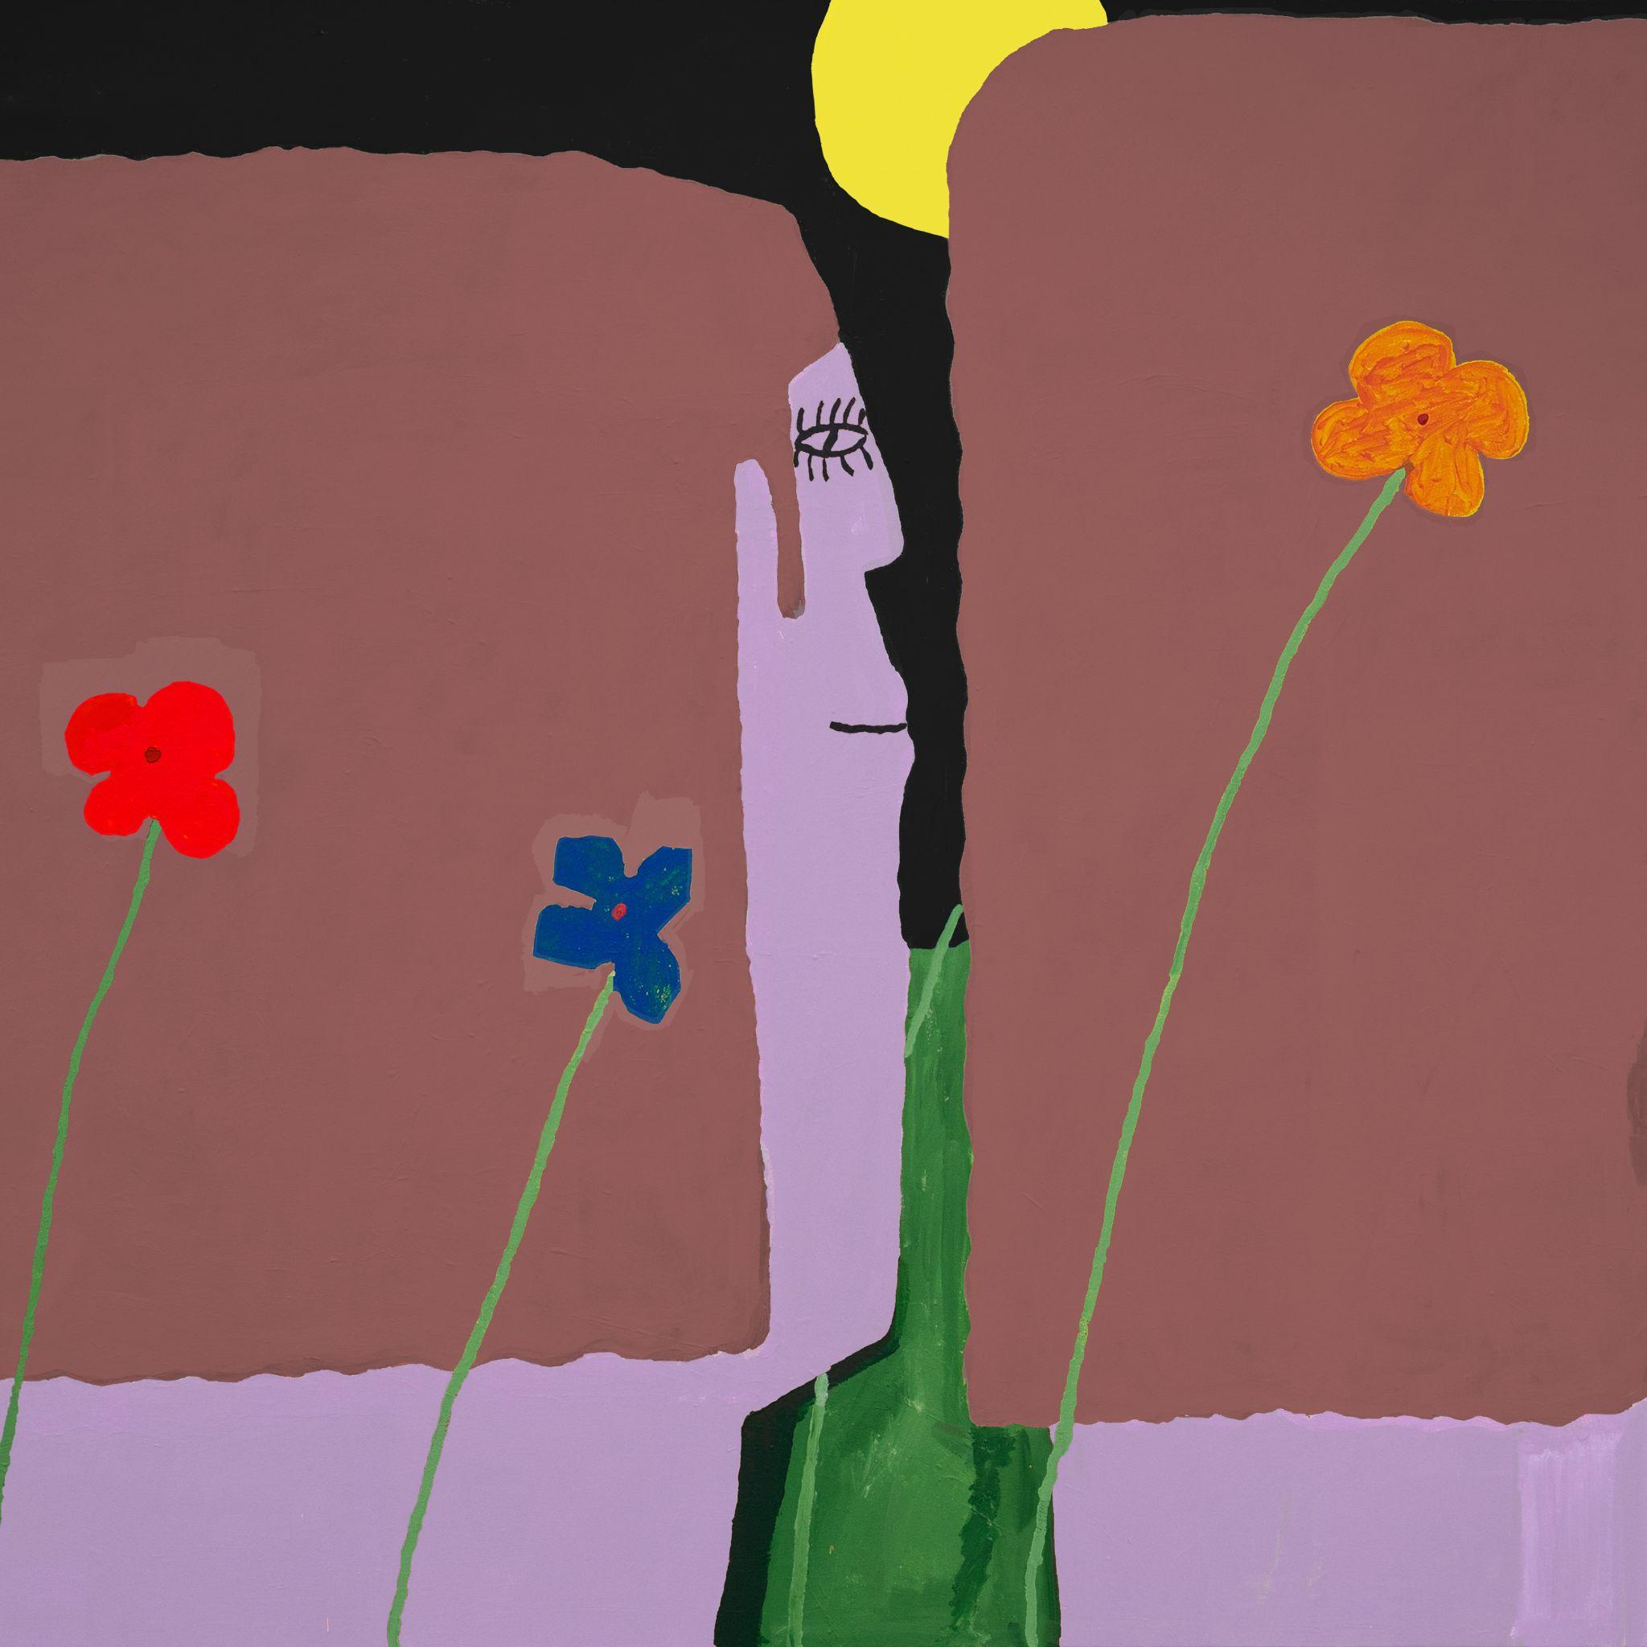
(Yard Cover Artwork by Henry Stoehr)

Slow Pulp Online:
Website | Instagram | Twitter | Facebook | Bandcamp | ANTI-

For more information, contact:
Patrick Tilley, Jaycee Rockhold | Pitch Perfect PR
patrick@pitchperfectpr.com, jaycee@pitchperfectpr.com

##

