August 22, 2023
For Immediate Release

Slow Pulp Presents New Single/Video, “Broadview”

New Album, Yard, Out September 29th On ANTI-

North American Tour October 4th — November 11th
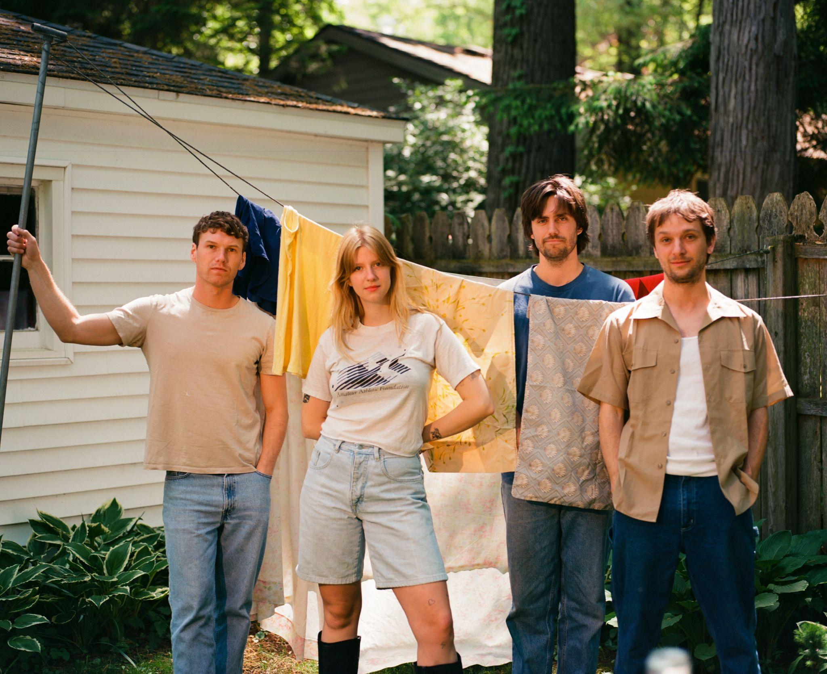
Photo Credit: Alexa Viscius

“[Yard] shows off their impressive range, which veers from alt-country to introspective folk to zippy guitar pop numbers.” — Uproxx

“'Doubt' is a tender and melodic song with a laid back vibe that masks its dark center.” — The FADER

“[‘Doubt’ calls] to mind the most endlessly replayable alt-radio gems of the early 2000s.” — Consequence

“Slow Pulp’s ‘Slugs’ was made for that hazy and sweet late summer crush.” — NYLON

Slow Pulp — the Chicago-via-Madison quartet composed of vocalist Emily Massey, guitarist/producer Henry Stoehr, bassist Alex Leeds, and drummer Teddy Mathews — presents the new single/visualizer, “Broadview,” from their highly anticipated new album, Yard, out September 29th on ANTI-. You can feel Massey reaching new vocal heights across Yard, particularly on “Broadview,” a weepy Americana ballad featuring pedal steel from Peter Briggs and Willie Christianson on the harmonica and banjo. “This song is about letting yourself fall in love for the first time in a long time,” Massey says. “After being hurt in previous relationships I was trying to decide if making the jump was worth it. Turns out it was.” The accompanying visualizer by Melanie Kleid is a stunning collage of animations that evoke late-night summer love.

Following a wide-ranging breadth of singles —the electric “Cramps,” syrupy lead single “Slugs,” and the recently-shared anthem “Doubt” — “Broadview” offers another beautiful glimpse of Yard’s vast sonic palette. Later this fall, Slow Pulp will embark on an extensive tour in support of Yard, with many dates — including New York City, Boston, Denver, and more — already sold out. All currently -announced dates are listed below and remaining tickets are on sale now.

Watch Slow Pulp’s “Broadview” Visualizer

Building upon the sticky hooks and dreamy rock seen in Slow Pulp’s earlier music, Yard crafts together a bigger sound. Through listless guitar, a raw-to-the-bone piano ballad, and belt-along worthy pop-punk, Slow Pulp tackles themes of isolation and the process of learning to be comfortable with yourself, along with the importance of learning to trust, love, and lean on others. The result is a lightning-in-a-bottle synthesis of what has made Slow Pulp one of the most beloved indie groups in recent memory.

Within Slow Pulp, trust between members is evident in the playful collaboration that remains core to their creative process. Like they did on their beloved 2020 debut, Moveys, Massey recorded vocals for Yard with her dad, Michael, in his small home studio. “Working together we can be very honest with each other in a way that I wouldn't be able to do with a stranger or a producer that's not my family,” says Massey. “He already has so much context for what the songs are about, knowing my life so intimately. He is able to be very direct, saying things I often don't want to hear but need to hear. I think it often leads to getting the best takes out of me.”

Across Yard, Slow Pulp nestles comfortably into pockets of nuance, impressions, contradictions—sonics and lyrics finessed together to bottle the specific tension of a feeling you’ve never quite been able to find the right words for. Perhaps this spawns from the band’s own shared history and chemistry; in various ways, the four of them grew up—are still growing up—together.

Pre-order Yard

Watch “Slugs” Video

Watch “Cramps” Video

Watch “Doubt” Visualizer

Slow Pulp Tour Dates:
Wed. Oct. 04 - Milwaukee, WI @ Colectivo - Backroom %
Thu. Oct. 05 - Minneapolis, MN @ Amsterdam Hall %
Fri. Oct 06 - Omaha, NE @ Slowdown %
Sun. Oct. 08 - Denver, CO @ Globe Hall % - SOLD OUT
Tue. Oct. 10 - Salt Lake City, UT @ Kilby Court & [Early Show]
Tue. Oct. 10 - Salt Lake City, UT @ Kilby Court % [Late Show] - SOLD OUT
Thu. Oct. 12 - Seattle, WA @ Neumos %
Fri. Oct. 13 - Vancouver, BC @ The Pearl on Granville %
Sat. Oct. 14 - Portland, OR @ Aladdin Theatre %
Mon. Oct. 16 - San Francisco, CA @ The Chapel %
Wed. Oct. 18 - Los Angeles, CA @ Teragram Ballroom %
Fri. Oct. 20 - San Diego, CA @ Voodoo % - SOLD OUT
Sat. Oct. 21 - Santa Ana, CA @ Constellation Room % - SOLD OUT
Sun. Oct. 22 - Phoenix, AZ @ Rebel Lounge %
Tue. Oct. 24 - Houston, TX @ White Oak Music Hall %
Wed. Oct. 25 - Dallas, TX @ Club Dada %
Thu. Oct. 26 - Austin, TX @ The Parish %
Sat. Oct. 28 - Atlanta, GA @ Purgatory %
Sun. Oct. 29 - Durham, NC @ Motoco %
Mon. Oct. 30 - Washington, DC @ Union Stage %
Tue. Oct. 31 - Philadelphia, PA @ The Foundry %
Wed. Nov. 1 - New York, NY @ Bowery Ballroom % - SOLD OUT
Fri. Nov. 3 - Boston, MA @ Brighton Music Hall % - SOLD OUT
Sat. Nov. 4 - New York, NY @ Bowery Ballroom %
Mon. Nov. 6 - Montreal, QC @ Bar Le Ritz %
Tue. Nov. 7 - Toronto, ON @ Horseshoe Tavern %
Fri. Nov. 10 - Madison, WI @ Majestic Theater %
Sat. Nov. 11 - Chicago, IL @ Thalia Hall %
Wed. Nov. 29 - Leeds, UK @ Brudenell Social Club #
Thu. Nov. 30 - Liverpool, UK @ Jimmy’s #
Fri. Dec. 1 - Glasgow, UK @ The Hug and Pint # - SOLD OUT
Sat. Dec. 2 - Dublin, IR @ The Workman's Club #
Mon. Dec. 4 - Manchester, UK @ YES (Basement) # - SOLD OUT
Tue. Dec. 5 - Bristol, UK @ Strange Brew #
Wed. Dec. 6 - London, UK @ The Garage #
Thu. Dec. 7 - Brighton, UK @ The Green Door Store #
Sat. Dec. 9 - Amsterdam, NL @ Paradiso Upstairs
Sun. Dec. 10 - Antwerp, BE @ TRIX #
Mon. Dec. 11 - Paris, FR @ L’International #
Wed. Dec. 13 - Berlin, DE @ Badehaus Szimpla #
Thu. Dec. 14 - Leipzig, DE @ Conne Island #
Fri. Dec. 15 - Schorndorf, DE @ Manufaktur #
Sat. Dec. 16 - Munster, DE @ Gleis 22 #

% w/ Babehoven
# w/ PACKS

Download cover art & hi-res images of Slow Pulp

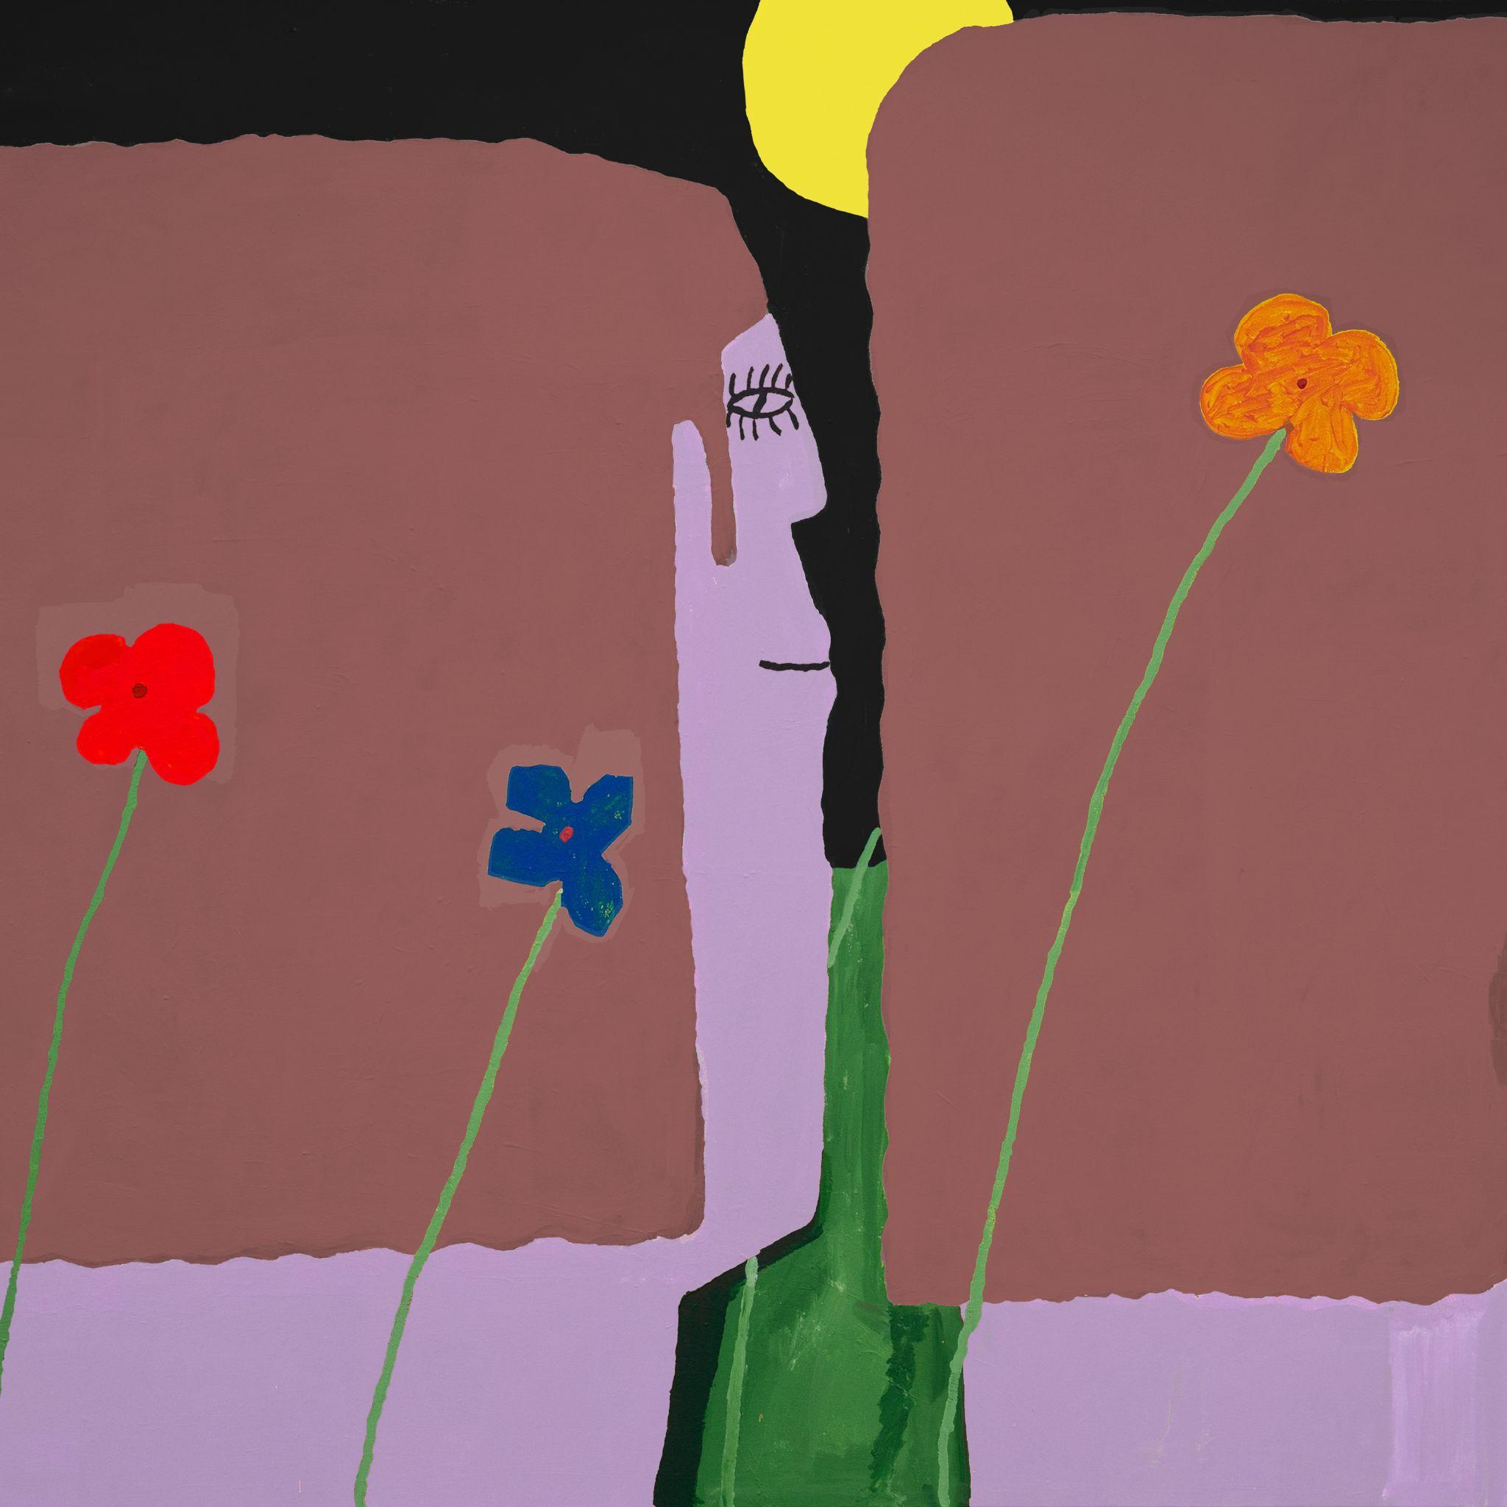
(Yard Cover Artwork by Henry Stoehr)

Slow Pulp Online:
Website | Instagram | Twitter | Facebook | Bandcamp | ANTI-

For more information, contact:
Patrick Tilley, Jaycee Rockhold | Pitch Perfect PR
patrick@pitchperfectpr.com, jaycee@pitchperfectpr.com

##

