***MEDIA ALERT***MEDIA ALERT***MEDIA ALERT***

THE DRUMS PREMIERE NEW
SONG “OBVIOUS”

LISTEN NOW HERE

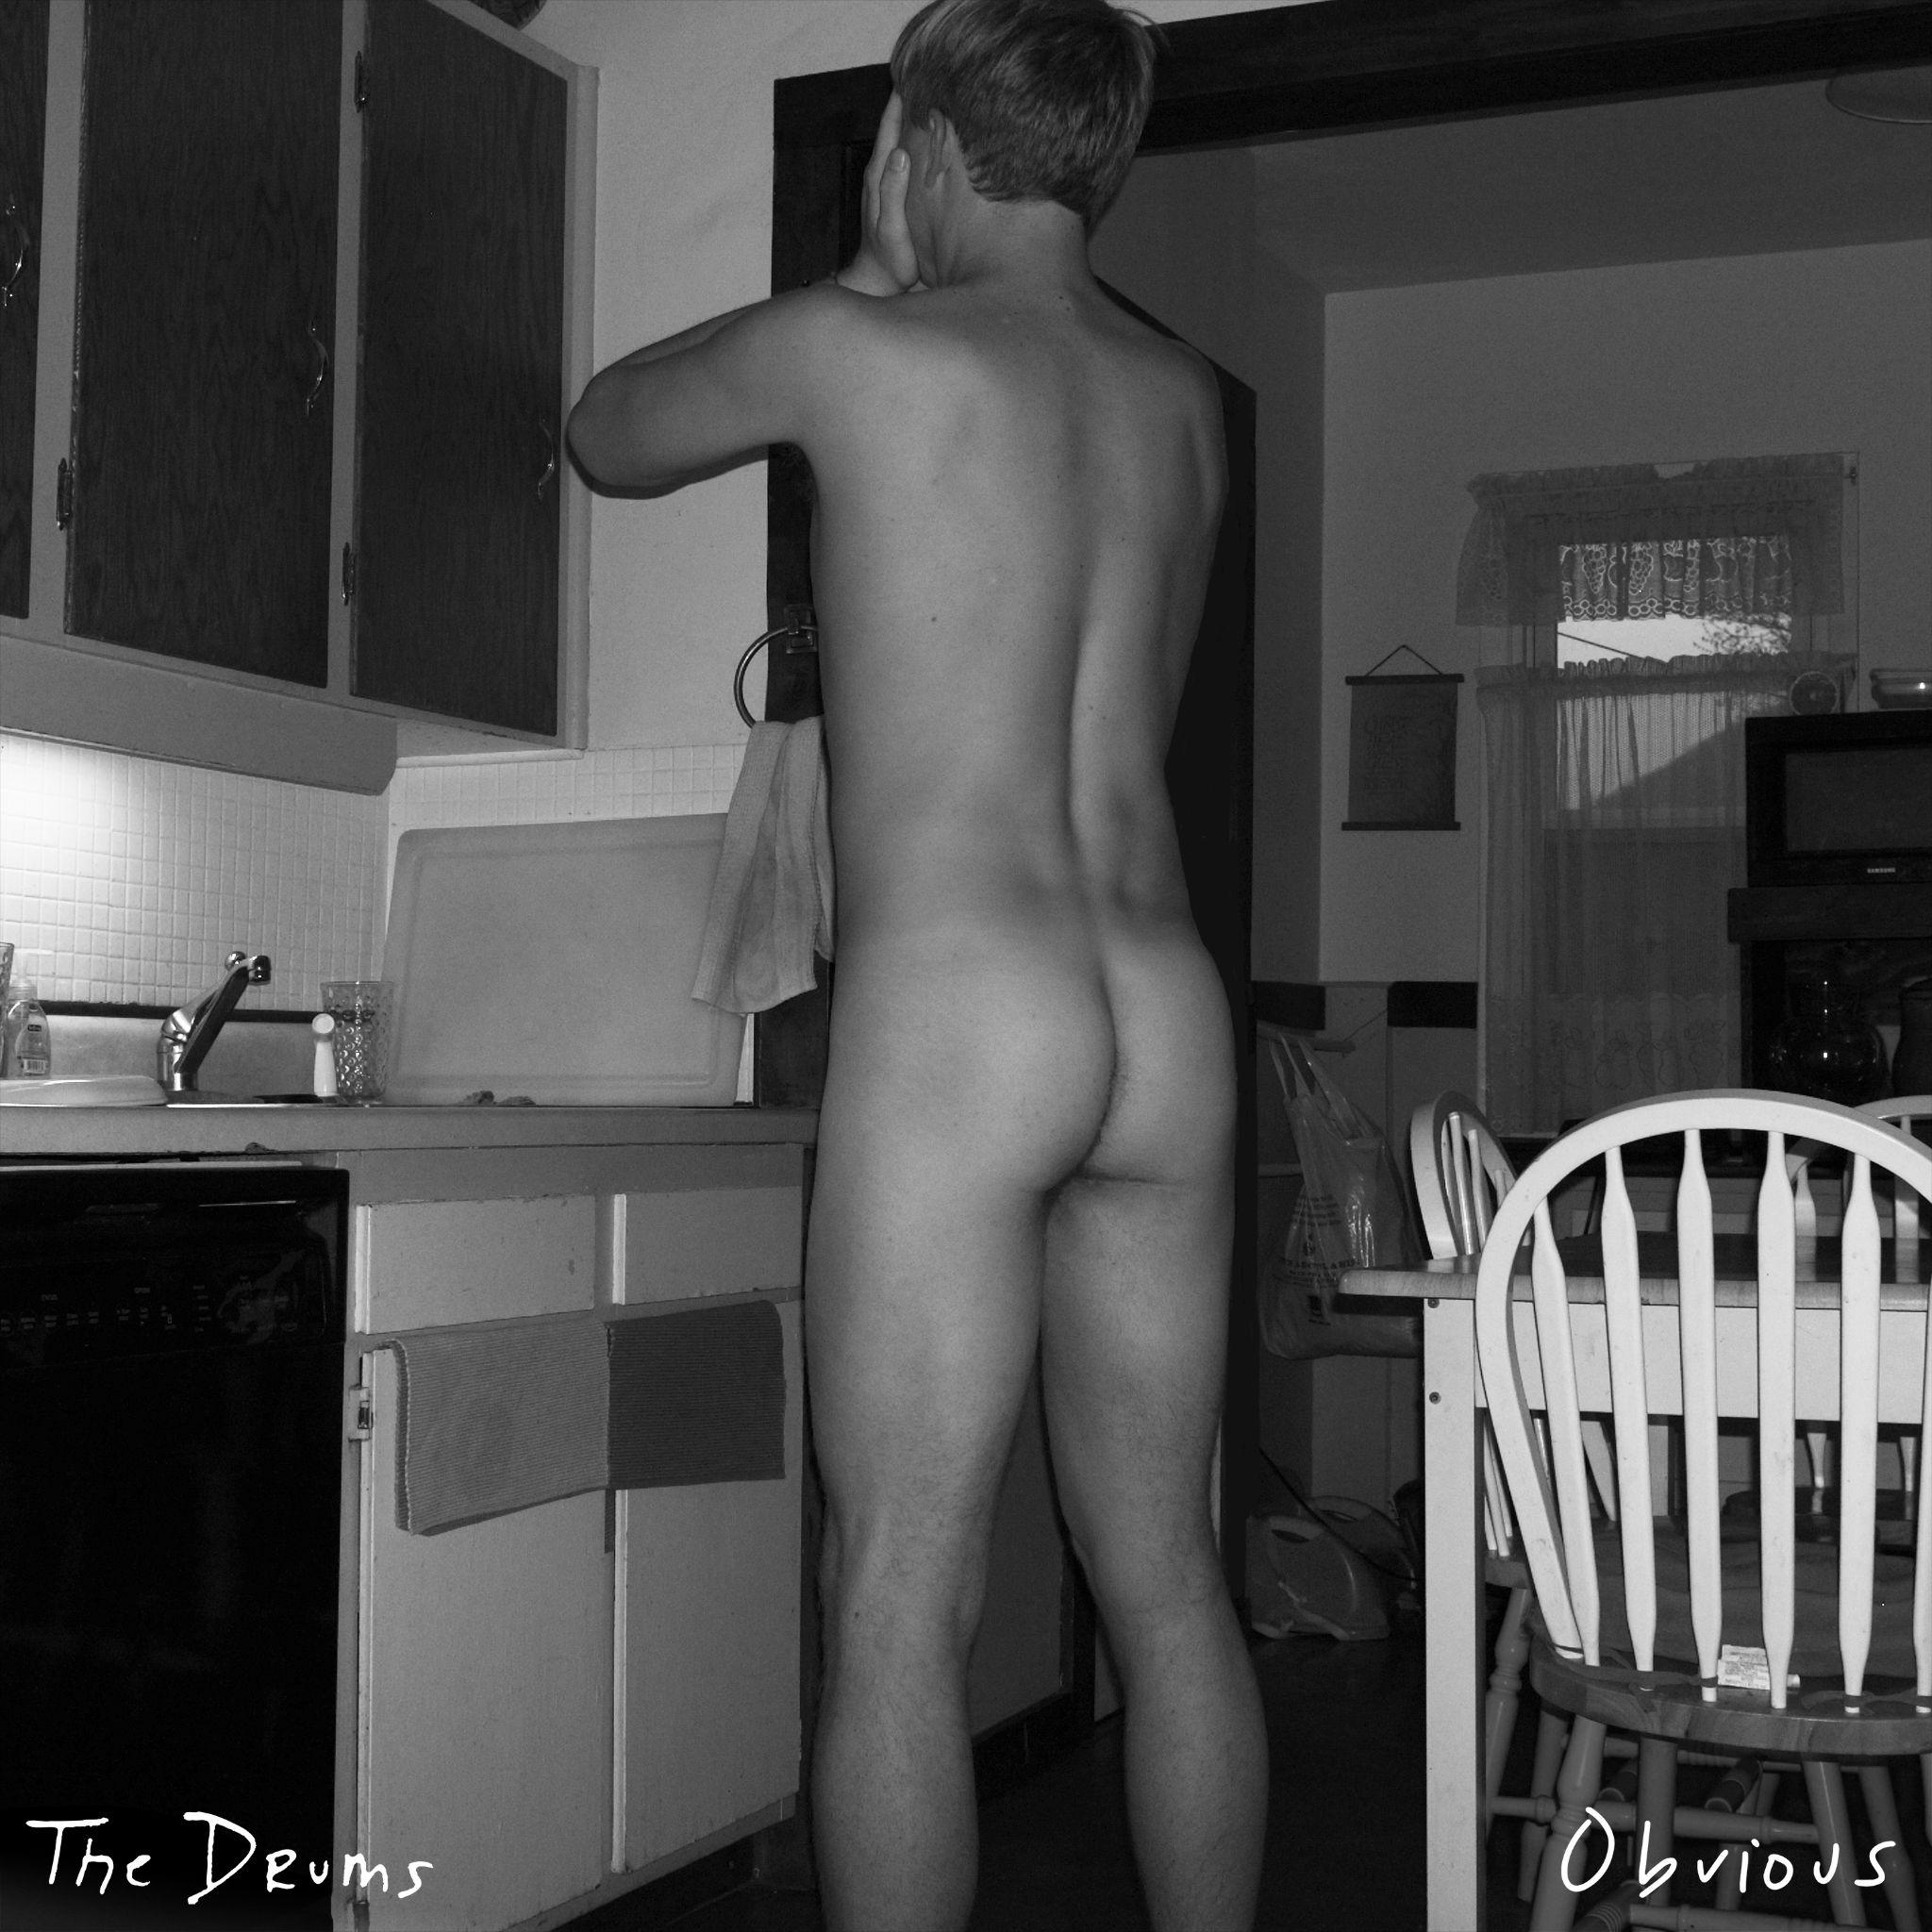
The Drums - “Obvious” (Single Artwork)

June 8, 2023 (LOS ANGELES, CA) - The Drums have premiered “Obvious” today, a blissful new song that finds founding-member Jonny Pierce steering himself into the beautiful interdependence that can flower when you neither lose yourself nor fortify yourself against another person. The latest preview from his forthcoming sixth studio album, the track builds upon a recent string of introspective releases including “I Want It All” and the interconnected song-and-vignette “Plastic Envelope / Protect Him Always.” Listen to “Obvious” now here via ANTI-.

“Unwavering love has shown itself to be stronger than any of my fears and self-protections,” adds Jonny Pierce. "Obvious" is a joyous song about that transformative moment, of finally lifting up my head, opening my eyes, and finding steadfast love surrounding me from all angles. It’s about the realization that I’ve been loved all along, but I am just now feeling safe enough to let myself see it.”

With The Drums’ forthcoming album and first studio project since 2019’s Brutalism on the horizon, Pierce initially teased the record with “I Want It All” in April. A work of art that’s as exposed as it is triumphant, the song weaves together a tapestry of soul-searching ruminations, confrontations of childhood trauma and epiphanies of self-acceptance. The single was followed by the symbiotic pair of tracks “Plastic Envelope” and “Protect Him Always.” Since their releases, the songs have landed on dozens of playlists and garnered coverage from the likes of Rolling Stone, Stereogum, FLOOD Magazine, Under The Radar, Brooklyn Vegan and more.

Pierce will bring his new music to life on the stage for the first time on The Drums’ forthcoming full-length North American tour. Kicking July 12th in San Diego, CA, the run will stop in various cities nationwide including The Shrine in Los Angeles and Webster Hall in New York. For complete ticketing information, visit HERE.

Soaring to alt-pop prestige nearly fifteen years ago with a renowned self-titled debut, The Drums continue to thrive, influence and reinvent with every project. Pierce initially conceived of the band back in 2008 and what resulted was worldwide acclaim and a string of five studio albums that deftly walk the line of aching melancholy and irresistible pop sensibilities, presented through a kaleidoscope of pastel guitars, reverb, modular synthesizers and drum machines. It’s a sound that’s wholly unique, and unmistakably The Drums.

The Drums’ music remains timeless, as evidenced by the recent explosion of their song “Money,” which first appeared on their breakout sophomore album Portamento. Transforming into a viral sensation earlier this year – over a decade since it was first released – the song has since bloomed with a second life, eclipsing over 230 million streams on Spotify alone, achieving RIAA Gold-certification, and reaching #1 on the Alternative Global Shazam chart and the #2 TikTok Global Hashtag.

THE DRUMS 2023 TOUR DATES
July 12, 2023 - San Diego, CA - House of Blues
July 14, 2023 - Los Angeles, CA - The Shrine
July 15, 2023 - Las Vegas, NV - Area 15
July 16, 2023 - Phoenix, AZ - Van Buren
July 17, 2023 - El Paso, TX - Lowbrow Palace
July 19, 2023 - Dallas, TX - Granada Theatre
July 20, 2023 - Austin, TX - Mohawk
July 21, 2023 - Houston, TX - White Oak Music Hall
July 22, 2023 - New Orleans, LA - House of Blues
July 24, 2023 - Atlanta, GA - Terminal West
July 25, 2023 - Nashville, TN - Basement East
July 27, 2023 - Carrboro, NC - Cat’s Cradle
July 28, 2023 - Washington, DC - 9:30 Club
July 29, 2023 - Philadelphia, PA - Theatre of Living Arts
July 31, 2023 - Boston, MA - Royale
August 3, 2023 - New York, NY - Webster Hall
August 5, 2023 - Detroit, MI - St. Andrew’s Hall
August 6, 2023 - Toronto, ON - Danforth Music Hall
August 8, 2023 - Chicago, IL - Metro
August 9, 2023 - Minneapolis, MN - Varsity
August 11, 2023 - Denver, CO - Bluebird
August 12, 2023 - Salt Lake City, UT - Psych Lake City at Urban Lounge
August 14, 2023 - Seattle, WA - The Showbox
August 15, 2023 - Vancouver, BC - Fortune Sound Club
August 16, 2023 - Portland, OR - Wonder Ballroom
August 18, 2023 - San Francisco, CA - The Regency Ballroom

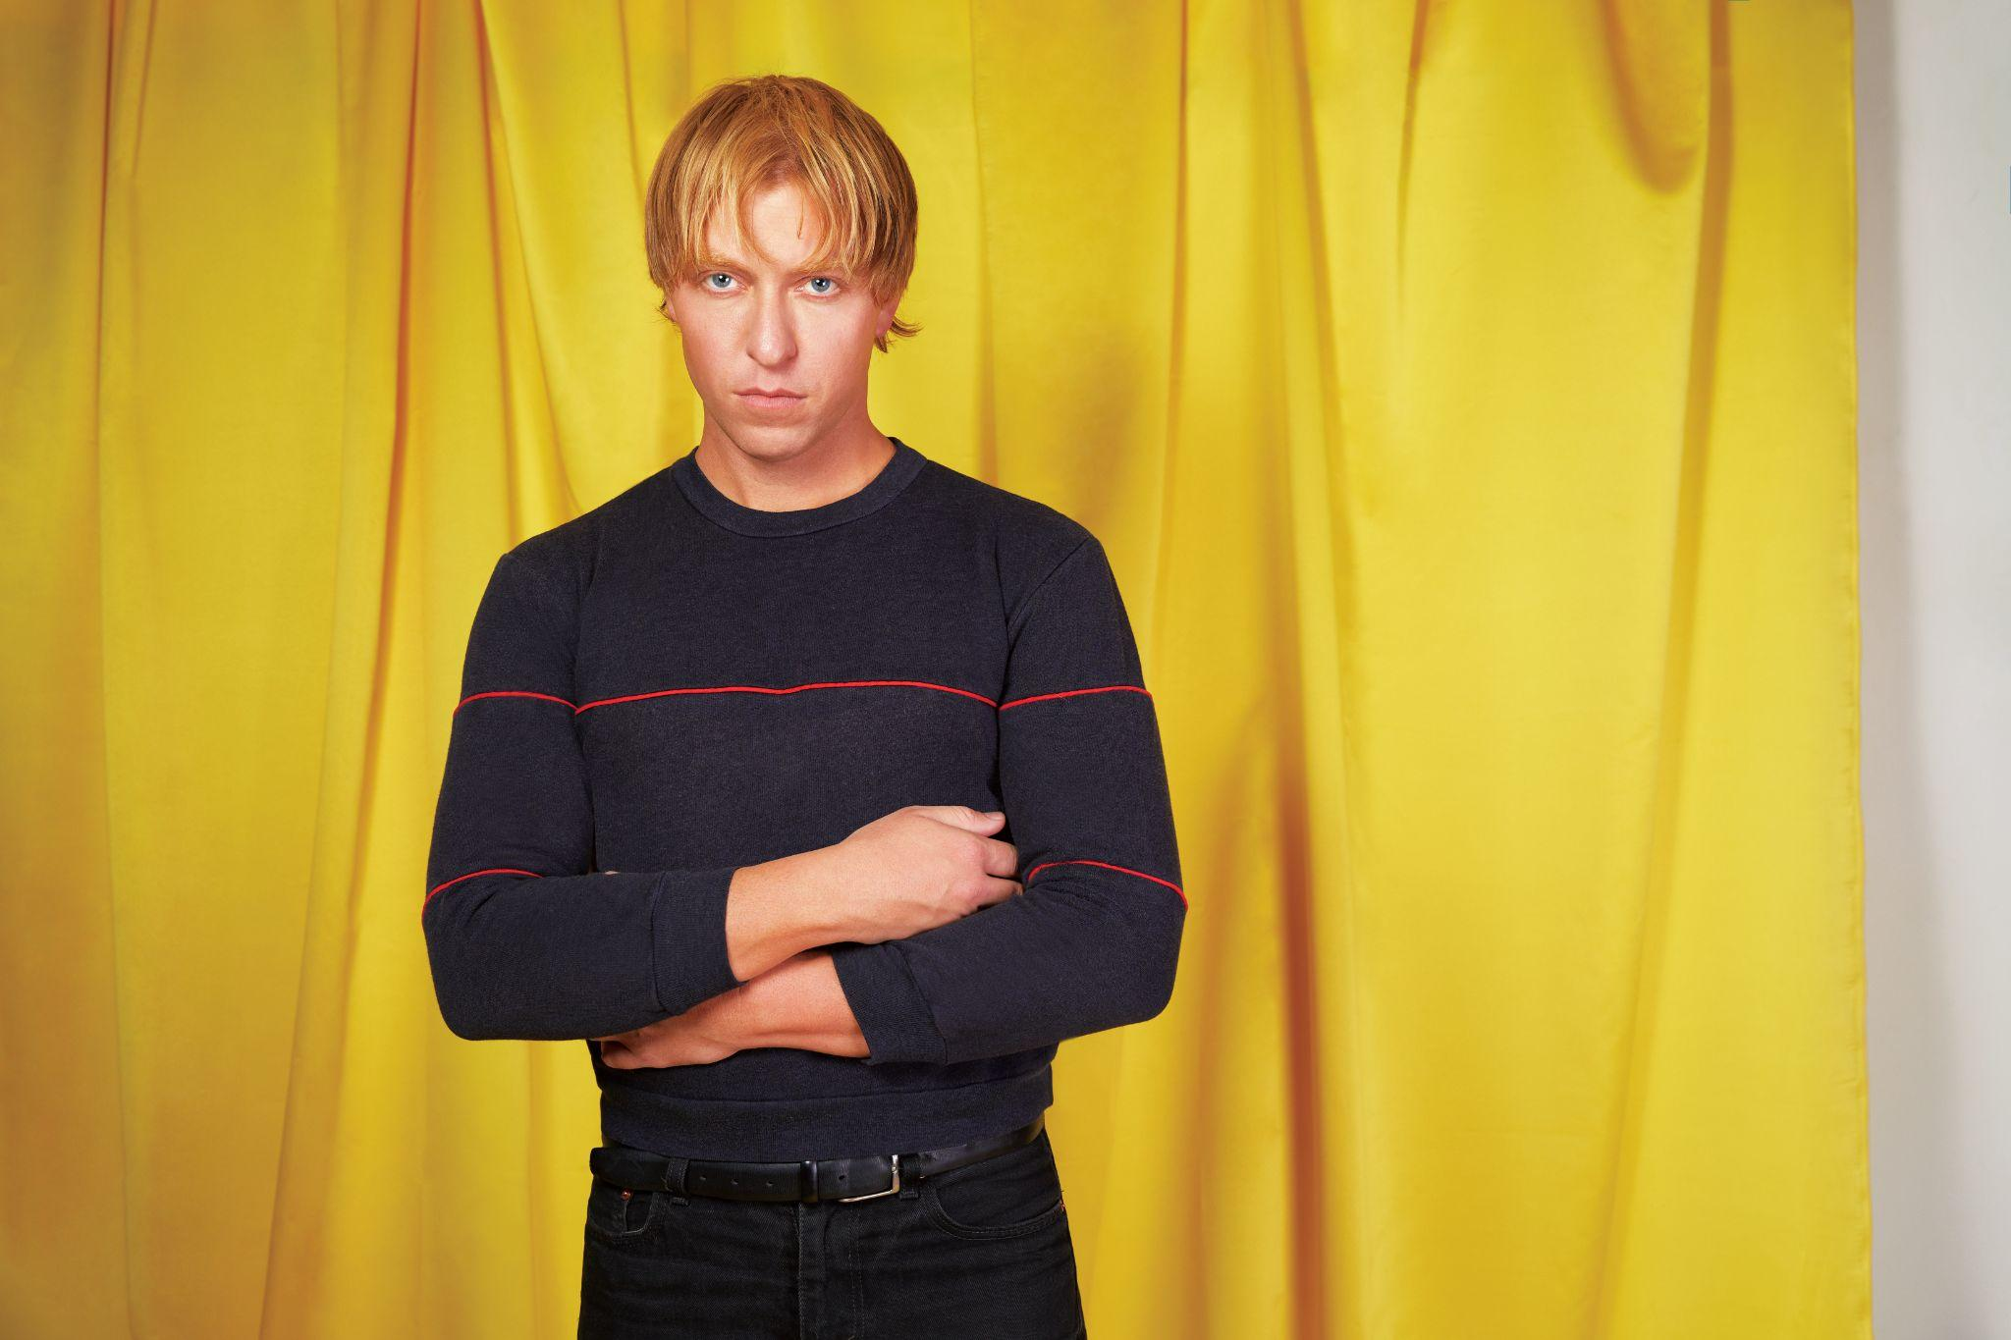
The Drums (Photo Credit: Qiao Meng)

###

For More Information:

Jaime Rosenberg / 2b Entertainment
jaime@2bentertainment.net

Peter Quinn / 2b Entertainment
peter@2bentertainment.net

Kelly Kettering / ANTI- Records
kelly@epitaph.com

