February 1, 2023
For Immediate Release

The Tallest Man On Earth Announces Henry St.,
First New Album in Four Years, Out April 14th Via ANTI-,
And Spring North American Tour Dates

Watch the Video for “Every Little Heart”

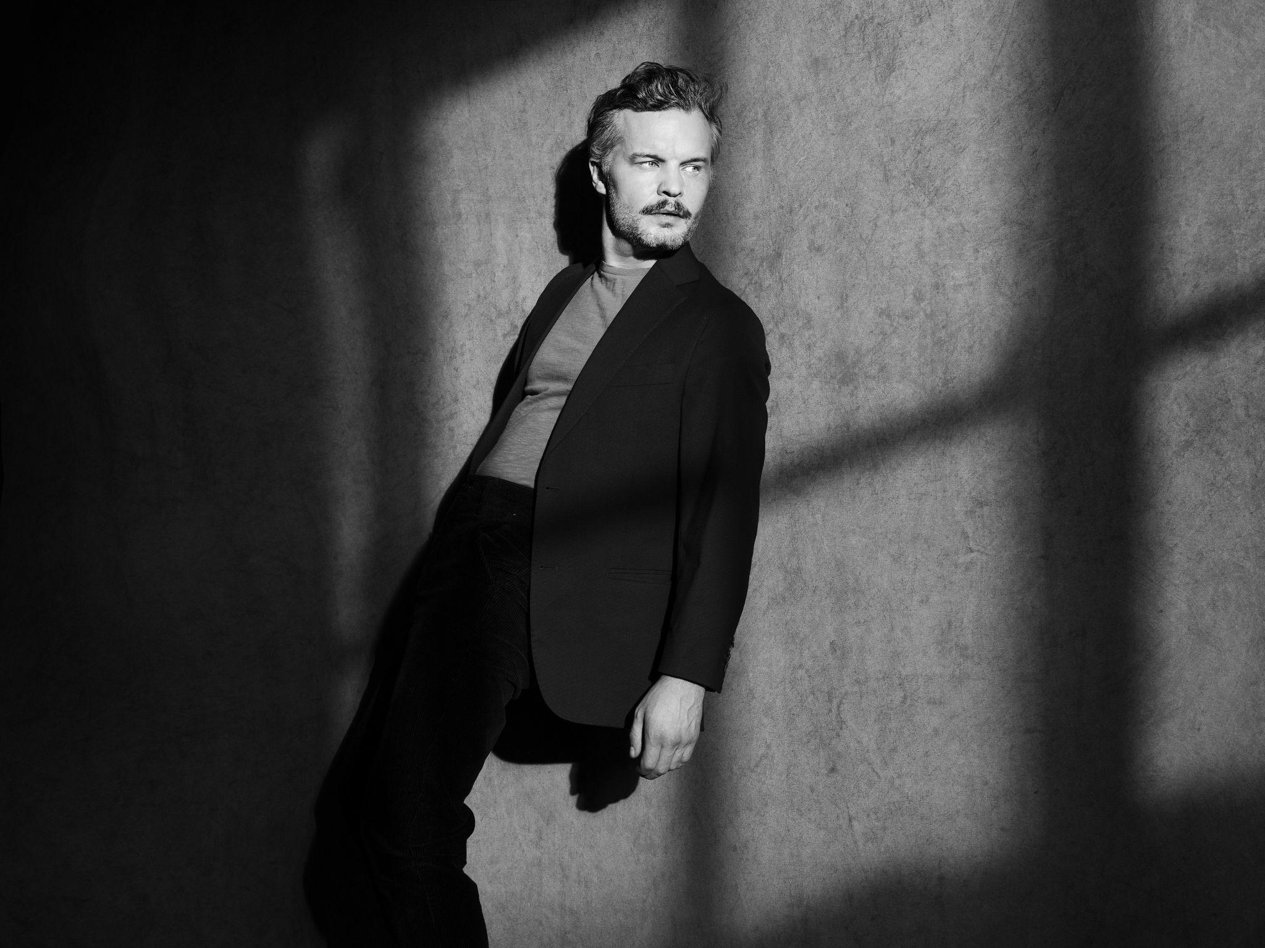
Photo Credit: Stephan Vanfleteren

The Tallest Man On Earth - project of Swedish musician Kristian Matsson - announces Henry St., his first new album in four years, out April 14th via ANTI-. Alongside the announcement, Matsson presents its lead single/video, “Every Little Heart,” and announces a spring run of intimate, special engagement shows in North America ahead of a full European tour (on sale now). Having spent much of the last decade touring around the world as The Tallest Man On Earth, Matsson has captivated audiences using “every inch of his long guitar cord to roam the stage: darting around, crouching, stretching, hip-twitching, perching briefly and jittering away…” (The New York Times). In 2020, Matsson left New York City and returned to his farm in Sweden where he drowned out his thoughts by manically growing vegetables in his garden. Imaginative writing did not come easily to Matsson during this time of collective forced solitude, and when it did, he found himself commenting on the darkness. It was only near the end of 2021, as he began to tour again, that the inspiration returned. “When I’m in motion, I can focus on my instinct, have my daydreams again. When I was finally able to tour again, I started writing like a madman.” He eventually had a collection of songs, revealing what would become Henry St, an album that sees Matsson exploring his own stubborn optimism and “how to be a person in this world.”

Following 2015’s Dark Bird Is A Home, his “most personal record… surreal and dreamlike” (Pitchfork) and the self-released I Love You, It’s a Fever Dream in 2019, The Tallest Man On Earth’s sixth album, Henry St., notably marks the first time Matsson recorded an album in a band setting. “My entire career I’ve been a DIY person, mostly fueled by the feeling that I didn’t know what I was doing, so I’d just do everything myself.” But now, longing for the energy that’s only released when creating together with others, Matsson invited his friends to come and play. Sylvan Esso’s Nick Sanborn produced the album, which includes contributions from Ryan Gustafson (guitar, lap steel, ukulele), TJ Maiani (drums), CJ Camerieri of Bon Iver (trumpet , French horn), Phil Cook (piano, organ), Rob Moose of Bon Iver, yMusic (strings) and Adam Schatz (saxophone), all supporting and surrounding Matsson on vocals and guitars. “They opened everything up, and understood what the songs that I’d written needed: sounds that I couldn’t ever have thought of or created myself. We recorded so many of the songs live in the studio, playing, having fun and being really open with each other.”

Today’s single, “Every Little Heart,” came from a feeling of fearlessness, a confidence in making music after two years of relative silence. “But of course I still have little demons inside of me. I wrote some key changes in the song that came natural to me, but I worried they might sound unnatural to others. When TJ Maiani heard it, he straightaway went into this drumbeat that shocked me a little at first, but came completely natural to him. It fit the song perfectly.” The “Every Little Heart” video is the first part of a trilogy. It was directed by Jeroen Dankers and shot on 16mm Kodak film. Dankers explains that the video, "portrays a conflict you can have with your inner child, which you sometimes still have inside you and you want to let go, but that isn’t always easy.”

Watch The Tallest Man On Earth’s Video for “Every Little Heart”

“Henry St. is the most playful, most me album yet, because it covers so many of the different noises in my head,” says Matsson. “When you overthink things, you get further away from your original ideas. And God knows I overthink things when I’m by myself.” The time in isolation also brought him some newfound peace of mind. “Having been away from it taught me that making music and performing is what I’m doing for the rest of my life, and I’m so grateful for it. It has given me new confidence and playfulness. This is what I do. It’s unconditional.”

Pre-order Henry St.

Henry St. Tracklist
1. Bless You
2. Looking for Love
3. Every Little Heart
4. Slowly Rivers Turn
5. Major League
6. Henry Street
7. In Your Garden Still
8. Goodbye (Goodbye Lonesome)
9. Italy
10. New Religion
11. Foothills

The Tallest Man On Earth Tour Dates:
Wed. March 22 - Los Angeles, CA @ Hollywood Forever Cemetery Masonic Lodge
Thu. March 23 - Los Angeles, CA @ Hollywood Forever Cemetery Masonic Lodge
Sat. March 25 - Denver, CO @ Mission Ballroom *
Sun. March 26 - Ft. Collins, CO @ Washington’s
Wed. March 29 - San Francisco, CA @ The Chapel
Thu. March 30 - San Francisco, CA @ The Chapel
Sat. April 1 - Pioneertown, CA @ Pappy & Harriets
Mon. April 3 - New York, NY @ Bowery Ballroom
Tue. April 4 - Brooklyn, NY @ Music Hall of Williamsburg
Wed. April 12 - Copenhagen, DK @ Amager Bio
Thu. April 13 - Aarhus, DK @ Voxhall
Sun. April 16 - Glasgow, UK @ QMU
Mon. April 17 - Dublin, IE @ Vicar Street
Tue. April 18 - Manchester, UK @ Manchester Cathedral
Wed. April 19 - Leeds, UK @ The Leeds Irish Centre
Fri. April 21 - London, UK @ O2 Forum
Sat. April 22 - Bristol, UK @ Trinity – SOLD OUT
Mon. April 24 - Amsterdam, NL @ Paradiso
Tue. April 25 - Antwerp, BE @ De Roma
Wed. April 26 - Paris, FR @ La Cigale
Thu. April 27 - Lausanne, CH @ Les Docks
Sat. April 29 - Milan, IT @ Fabrique
Sun. April 30 - Munich, DE @ Freiheitshalle
Mon. May 1 - Berlin, DE @ Metropol
Tue. May 2 - Hamburg, DE @ Uebel & Gefahlrlich
Wed. May 3 - Malmo, SE @ Plan B – SOLD OUT
Fri. May 5 - Oslo, NO @ Sentrum Scene
Sat. May 6 - Stockholm, SE @ Cirkus – SOLD OUT
Sun. May 7 - Stockholm, SE @ Cirkus
Mon. May 8 - Goteborg, SE @ Pustervik – SOLD OUT
Tue. May 9 - Goteborg, SE @ Pustervik – SOLD OUT

* = with Elephant Revival

Download hi-res images & jpegs of The Tallest Man On Earth

Henry St. Cover Artwork

Website | Instagram | Twitter

For more information, contact:
Jessica Linker | Pitch Perfect PR – jessica@pitchperfectpr.com, 773-942-6954
Yuri Kwon | Pitch Perfect PR – yuri@pitchperfectpr.com, 773-654-1477

