February 12, 2024
For Immediate Release

Watch Madi Diaz Perform “Everything Almost” on
The Tonight Show with Jimmy Fallon
In Support of New Album, Weird Faith, Now Out Via ANTI-

Madi Diaz Returns To CBS Saturday Morning This Weekend

North American Tour Kicks Off Next Week

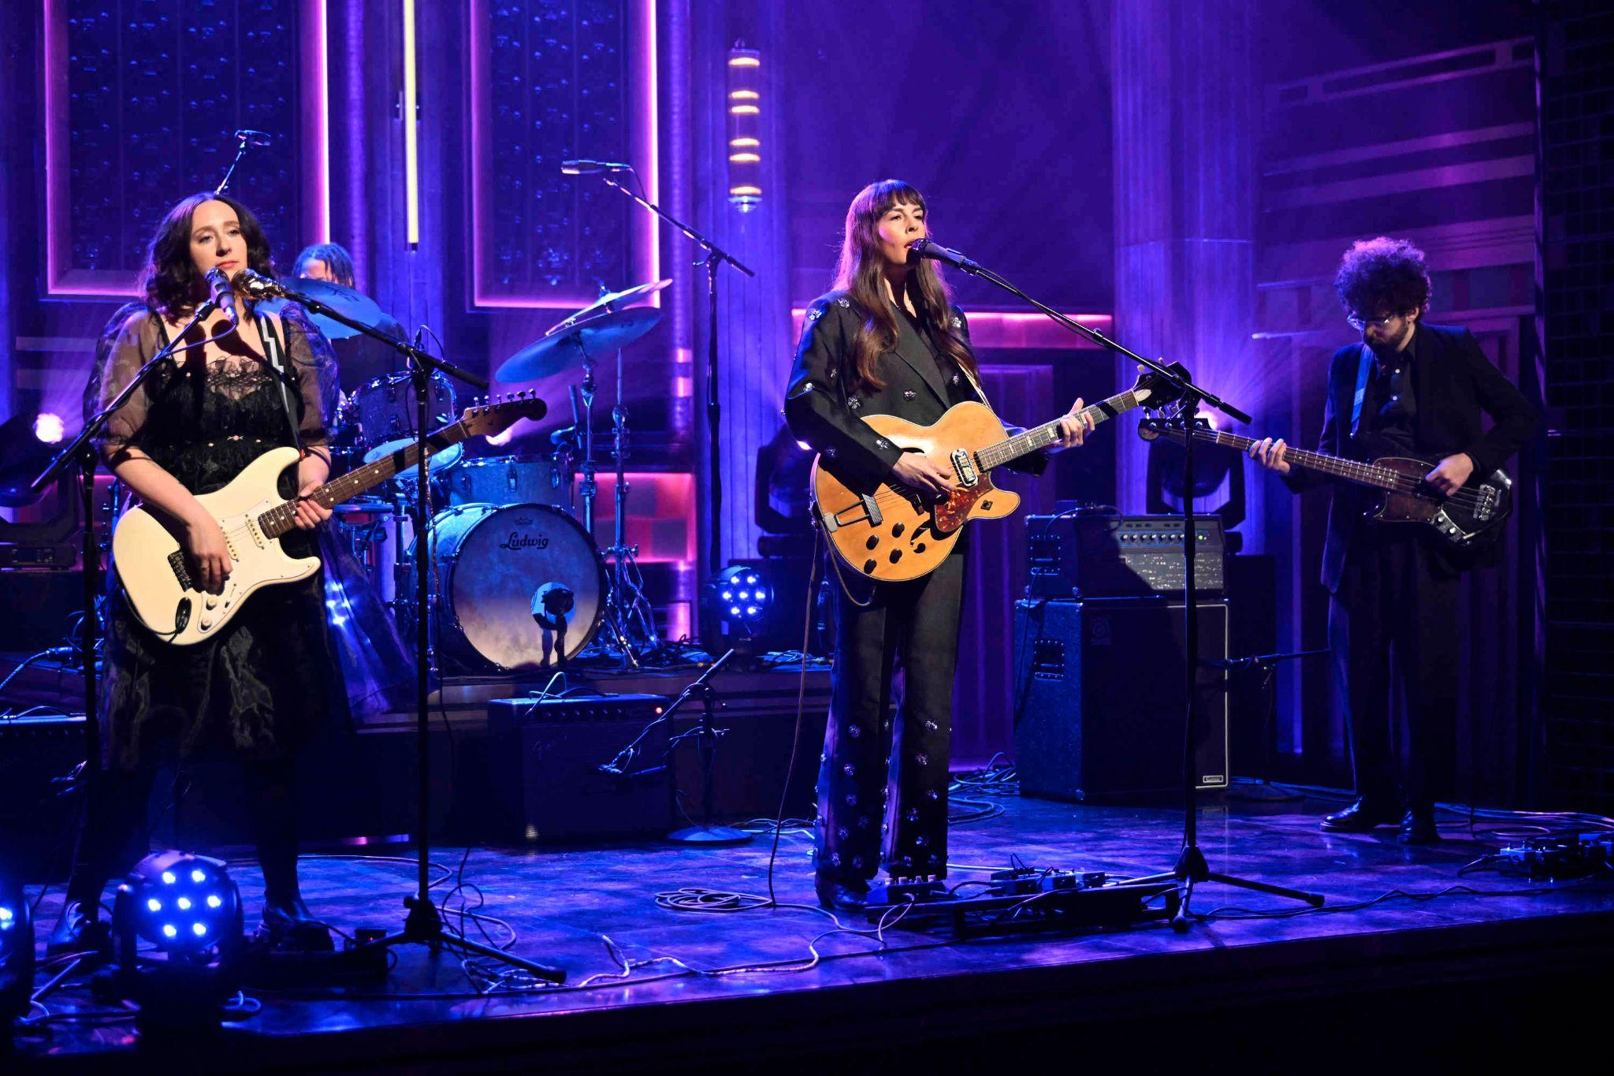
(Photo credit - Todd Owyoung/NBC)

“Madi Diaz is barreling toward stardom.” — Billboard

“Nashville’s secret weapon is leveling up with an LP full of folk-pop gold.” — Rolling Stone

“Madi Diaz fills Weird Faith… with crystal-clear, diamond-sharp writing on the rewards, anxieties, and humiliations of romance.” — Pitchfork

“Diaz is an excellent songwriter; her pop-folk earworms are honest and searching, giving them an earned emotional impact.” — Stereogum

Nashville’s Madi Diaz celebrated her new album, Weird Faith, last Friday with a release day debut on The Tonight Show Starring Jimmy Fallon. Backed by Allison Crutchfield (guitar, backing vocals), Brian Betancourt (bass) and Zoë Brecher (drums), Diaz (guitar, vocals) performed the “infectiously vibrant” (Paste) Weird Faith single, “Everything Almost.” Next weekend, Diaz will return to CBS Saturday Morning to perform other Weird Faith standouts before kicking off her North American tour.

Watch Madi Diaz Perform “Everything Almost” On The Tonight Show with Jimmy Fallon

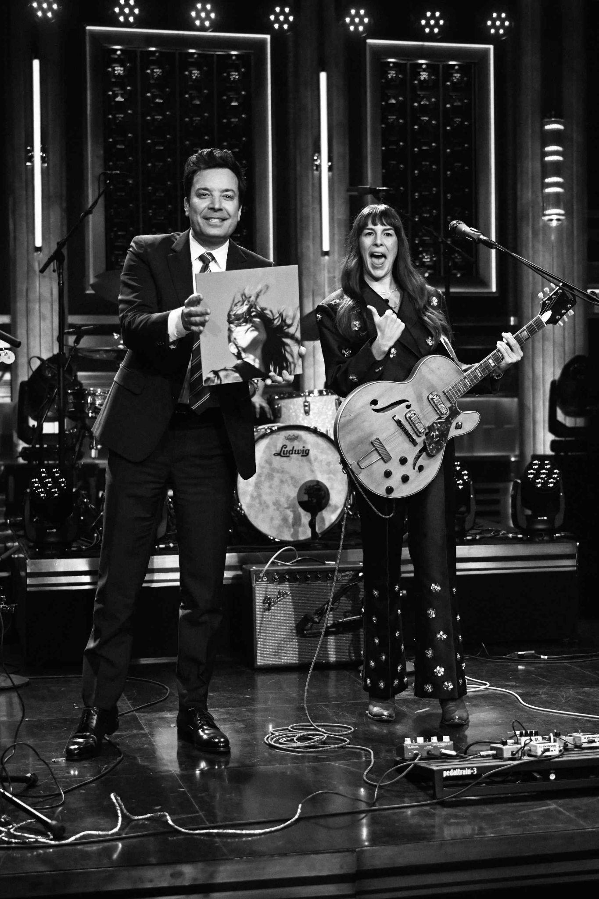
(Photo credit - Todd Owyoung/NBC)

While writing Weird Faith, Diaz came up against a problem that has dogged songwriters since time immemorial. How do you write about romance, or love, without making it sentimental, schlocky, or fake? For Diaz, the answer was to explore how anxiety-inducing, if not downright humiliating falling in love can be. Weird Faith answers these questions bluntly, and Diaz says the record “chronicles a new relationship, but also a new relationship to myself.” The result is a record that renders itself as a self-portrait, one that captures the Madi Diaz of a fleeting moment in time, hungrily alive and forever searching. Weird Faith highlights the human experience of spinning out on the fall into love, bold in its honesty, and aligned with the momentum of Madi Diaz.

Stream/Purchase Weird Faith
Watch Madi Diaz’s “Don’t Do Me Good” Video (Feat. Kacey Musgraves)
Watch Madi Diaz’s “Same Risk” Video
Watch Madi Diaz’s “Everything Almost” Video

Madi Diaz Tour Dates:
Wed. Feb. 21 - Atlanta, GA @ Terminal West *
Thu. Feb. 22 - Durham, NC @ Motorco Music Hall *
Fri. Feb. 23 - Charlotte, NC @ Neighborhood Theatre *
Sat. Feb. 24 - Charlottesville, VA @ Jefferson Theater *
Tue. Feb. 27 - Washington, DC @ The Atlantis *
Wed. Feb. 28 - Philadelphia, PA @ World Cafe Live *
Thu. Feb. 29 - Cambridge, MA @ The Sinclair *
Fri. Mar. 1 - Brooklyn, NY @ Music Hall of Williamsburg *
Sun. Mar. 3 - Toronto, ON @ The Danforth Music Hall *
Tue. Mar. 5 - Ann Arbor, MI @ The Ark #
Wed. Mar. 6 - Chicago, IL @ Lincoln Hall #
Thur. Mar. 7 - St. Louis, MO @ Off Broadway #
Fri. Mar. 8 - Nashville, TN @ Brooklyn Bowl #
Sat. Mar. 16 - Dallas, TX @ The Kessler Theater !
Tue. Mar. 19 - Denver, CO @ Bluebird Theater %
Wed. Mar. 20 - Fort Collins, CO @ Aggie Theatre %
Fri. Mar. 22 - Salt Lake City, UT @ The State Room %
Wed.-Sun. Mar. 20 - 24 Boise, ID Treefort Fest
Mon. Mar. 25 - Vancouver, BC @ Fox Cabaret %
Tue. Mar. 26 - Seattle, WA @ Madame Lou's %
Wed. Mar. 27 - Portland, OR @ Doug Fir Lounge %
Fri. Mar. 29 - Oakland, CA @ The New Parish %
Sat. Mar. 30 - Felton, CA @ Felton Music Hall %
Tue. Apr. 2 - San Diego, CA @ Music Box %
Thu. Apr. 4 - Los Angeles, CA @ Troubadour %
Fri. May 24 Boston, MA Boston Calling

With Special Guests:
* Olivia Barton
# Jack Van Cleaf
% Daniel Nunnelee
! Jackson Scribner

Praise for Madi Diaz’s Weird Faith:

“What starts with modest acoustic guitar strumming rises with an orchestral crescendo to match the urgency of her questions.” — New York Times on “Same Risk”

“[Madi and Kacey’s] voices beautifully intertwine and give what could be a solely devastating track a hint of an uplifting tone.” — PEOPLE on “Don’t Do Me Good”

“Weird Faith seems poised to cement Diaz’s place in the musical landscape of Americana.”
— them.

“[Madi Diaz] blends striking vulnerability with raw hopefulness on Weird Faith.”
— Garden & Gun

“[Weird Faith] feels like…a level up in every regard.” — Paste

“[Weird Faith] is a fraught meditation on love and unhealthy cycles, filled with bare-bone confessionals that find her circling her own neurotic habits, toxic thought patterns, and an ever-hopeful desire to be better.” — NYLON

“Diaz flexes her own particular It Factor with Weird Faith.” — Exclaim

Download hi-res images and jpegs of Madi Diaz

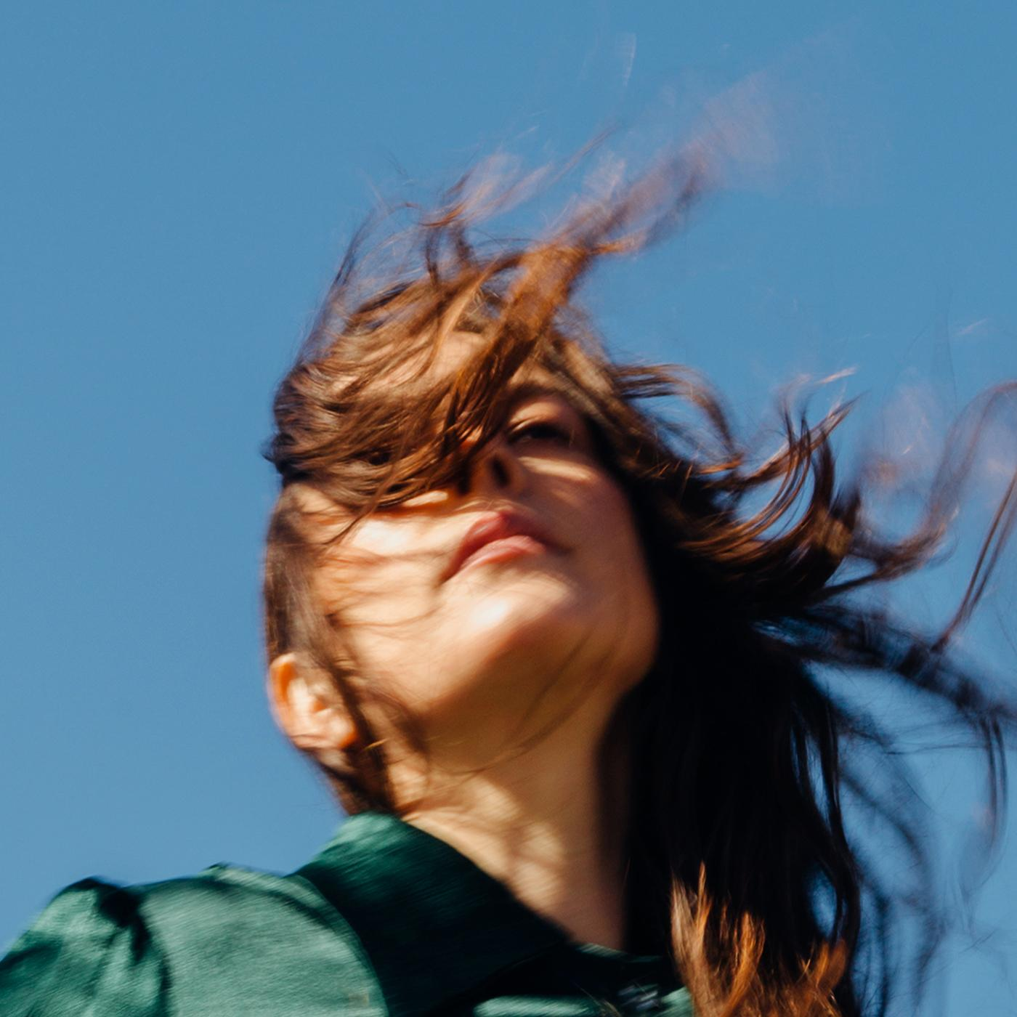
(Weird Faith Cover Artwork)

Madi Diaz Online:
Website | Instagram | Facebook | Twitter

For more information, contact:
Jessica Linker & Jaycee Rockhold | Pitch Perfect PR –
jessica@pitchperfectpr.com, jaycee@pitchperfectpr.com, 773-942-6954

