ALFA MIST - ‘VARIABLES’
NEW ALBUM OUT NOW VIA ANTI-
LISTEN HERE + WATCH ALBUM VISUALS HERE

SHARES NEW SINGLE “FOREWORD” - LISTEN HERE

INTERNATIONAL TOUR KICKS OFF IN THE U.S. ON APRIL 27;
RETURNING FOR NEWPORT JAZZ FESTIVAL THIS AUGUST

Photo credit: Kay Ibrahim / download here

“Epic” - UNCUT

"Variables finds Mist and his crew in an effortless groove, refusing to commit to a single disciple" - CRACK

“Lulling and hypnotic” - MOJO

Today, Alfa Mist releases Variables, his highly anticipated new album and second release via Anti-. The East London artist, producer and label founder will also launch his extensive international tour in support of Variables later this month in the U.S. before returning this August for a performance at the Newport Jazz Festival. The Variables tour will see him perform in venues throughout Japan, Australia, EU and the UK, in addition to the U.S. shows. Of the album, Alfa notes, “I’ve been focused on who I am in my music, but now I’m exploring where I am. I’m asking: how did I get here?” This is the journeying question that underpins his latest record, a collection that is expansive, soulful and moving, in both body and spirit. Listen to Variables in full now: https://alfamist.ffm.to/variables.

Alfa Mist also worked with Australian filmmaker and visual artist SPOD to create an accompanying visual release of the album, based off of the album artwork by Kaya Thomas-Dyke. Watch the full album visuals here: https://youtu.be/ZlMqTCa6aro.

Along with the album release, Alfa Mist has shared the focus track “Foreword.” The song brings absolute sublime jazz bliss: guitars traverse intricate drum rhythms and cascading piano that demonstrates the buzzing jazz artist’s grand ability to orchestrate challenging yet easy-to-love compositions. Listen to “Forward” here: https://youtu.be/liA11Leyuds.

On Variables, Alfa achieves his most fully-realized, expressive musical work to date, coupling his keen ear for looping, memorably emotive piano melodies with intuitive grooves and a free-flowing jazz improvisation. Variables sees Alfa Mist offer a diverse listening experience, as he dives into the argument of nature versus nurture on the rhythmic ‘Borderline’ to the airy, crystallic sounds of ‘Cycles’. The album’s standout features are captivating, with long-time collaborator and band’s bass player Kaya Thomas-Dyke’s gentle vocals adding an ethereal essence on ‘Aged Eyes’, whilst the South African folk singer Bongeziwe Mabandla drapes the vibrant backdrop and Jas Kayser’s frenetic drum playing with his crystalline falsetto on ‘Apho’. “4th Feb (Stay Awake)” is a lofi offering that pairs Alfa’s reflective bars with a groove-heavy production and “BC” is a colourful swell of expressive and unrestrained percussion, demonstrating the ingenuity of Alfa Mist and his close knit band.

Since the release of his first full-length project Nocturne in 2015, Alfa has established himself as one of the UK’s most focused, in-demand and distinct musical voices. He has worked with the likes of Jordan Rakei and Tom Misch. Artists look to him for his unique blend of intimate bedroom production and expansive jazz group orchestration, since Alfa is yet to be boxed into a specific genre. His music spans everything from hip-hop beat-making to producing for artists such as rapper Loyle Carner, composing neo-classical works for the London Contemporary Orchestra, and reworking tracks from composer Ólafur Arnalds and pioneering jazz label Blue Note.

‘VARIABLES’ TRACKLISTING
01 - Foreword
02 - Borderline
03 - Aged Eyes (feat. Kaya Thomas-Dyke)
04 - Cycles
05 - The Gist
06 - Genda (Go Away)
07 - Apho (feat. Bongeziwe Mabandla)
08 - Variables
09 - 4th Feb (Stay Awake)
10 - BC

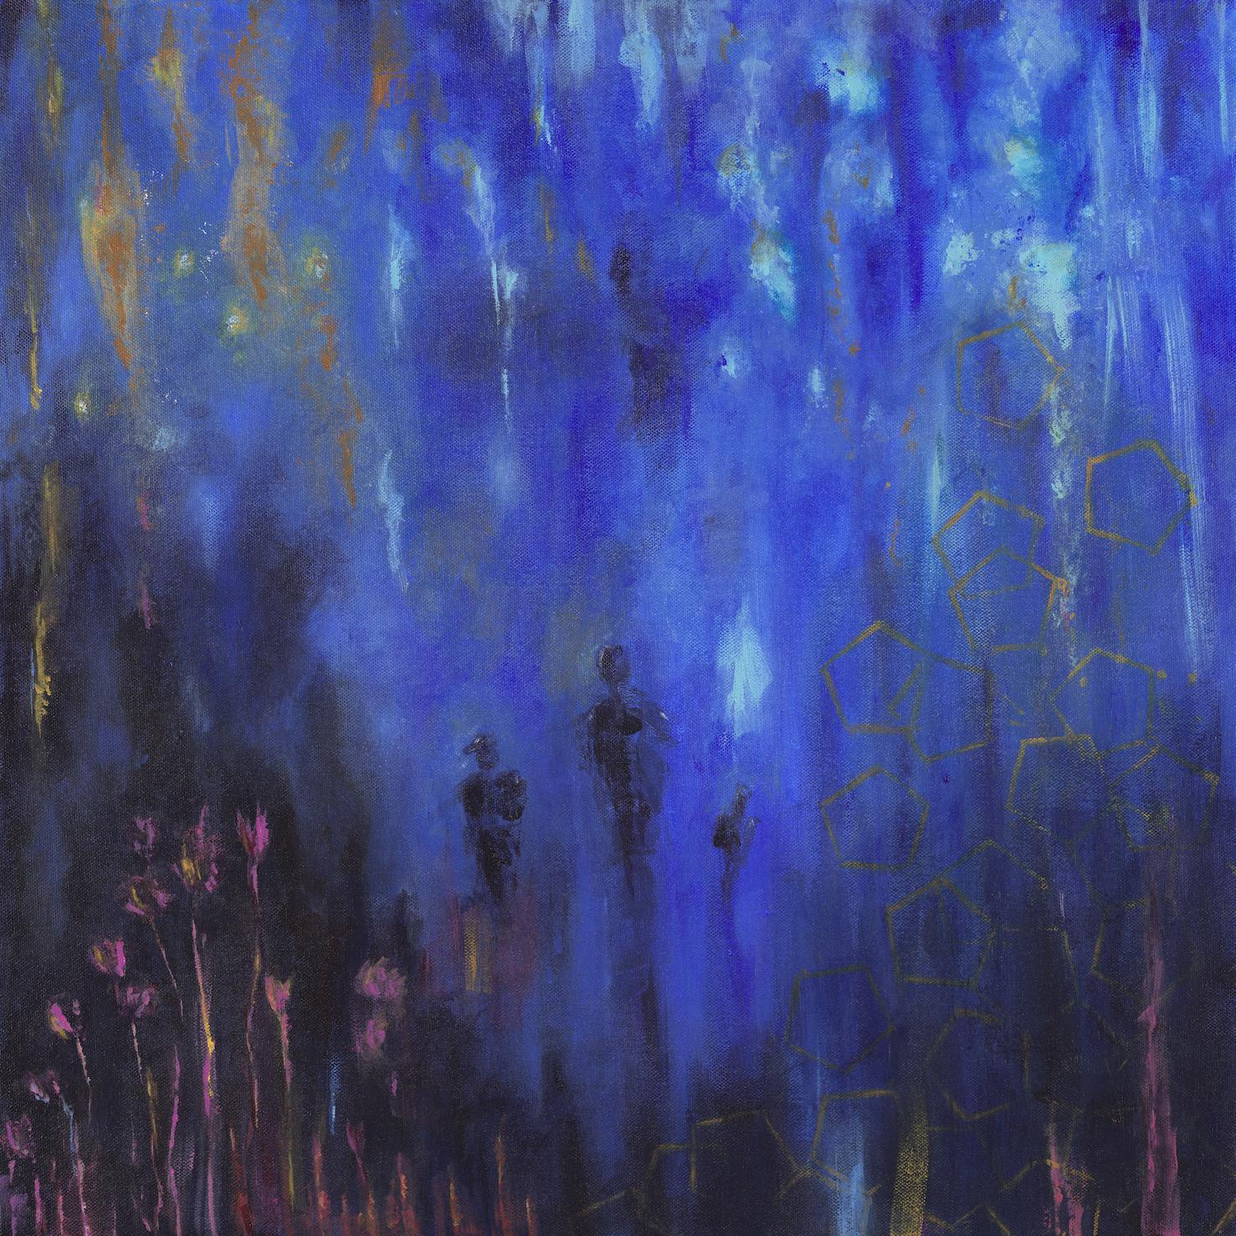
‘Variables’ artwork (Credit: Kaya Thomas-Dyke) / download here

ALFA MIST TOUR DATES
Apr 27 Philadelphia, PA - The Ardmore Music Hall
Apr 29 Brooklyn, NY - Music Hall of Williamsburg
Apr 30 New York, NY - Racket
May 02 Chicago, IL - Thalia Hall
May 04 Los Angeles, CA - Fonda Theatre
May 05 San Francisco, CA - August Hall
May 13 Berlin, Germany - XJAZZ! Festival
May 20 Norfolk, UK - Norfolk & Norwich Festival, Norwich
May 25 Liège, Belgium - Jazz a Liege Festival
May 28 London, UK - Cross The Tracks Festival
May 31 Sydney, Australia - Sydney Opera House (Vivid LIVE)
Jun 02 Adelaide, Australia - Burnside Ballroom
Jun 03 Melbourne, Australia - Croxton Bandroom
Jun 05 Osaka, Japan - Billboard Live (2x)
Jun 07 Tokyo, Japan - Billboard Live (2x)
Jun 08 Yokohama, Tokyo - Billboard Live (2x)
Jul 9 Istanbul, Turkey - İstanbul Caz Festivali
Jul 20 Sion, Switzerland - Palp Festival (Schlösser)
Jul 22 Marseille, France - Théâtre Silvain
Aug 04 Newport, RI - Newport Jazz Festival
Oct 4 Paris, France - La Cigale
Oct 09 The Hague, Netherlands - Paard Van Stal
Oct 10 Nijmegen, Netherlands - Doornroosje
Oct 11 Groningen, Netherlands - SPOT/De Oosterpoort
Oct 27 Budapest, Hungary - House of Magic
Oct 28 Prague, Czech Republic - Mladi Ladi Jazz Festival
Nov 16 Dublin, Ireland - Opium Rooms
Nov 18 Glasgow, UK - BAaD
Nov 19 Manchester, UK - RNCM Concert Hall
Nov 20 Bristol, UK - Trinity
Nov 22 London, UK - HERE at Outernet

Follow Alfa Mist
Twitter // Instagram // Spotify

