ALFA MIST

SHARES ‘LIVE IN INVADA’
WATCH HERE

EU/UK TOUR KICKS OFF THIS OCT
HEADLINE LONDON SHOW AT OUTERNET 22 NOVEMBER
BUY TICKETS HERE

VARIABLES ALBUM OUT NOW VIA ANTI- RECORDS
LISTEN / BUY HERE

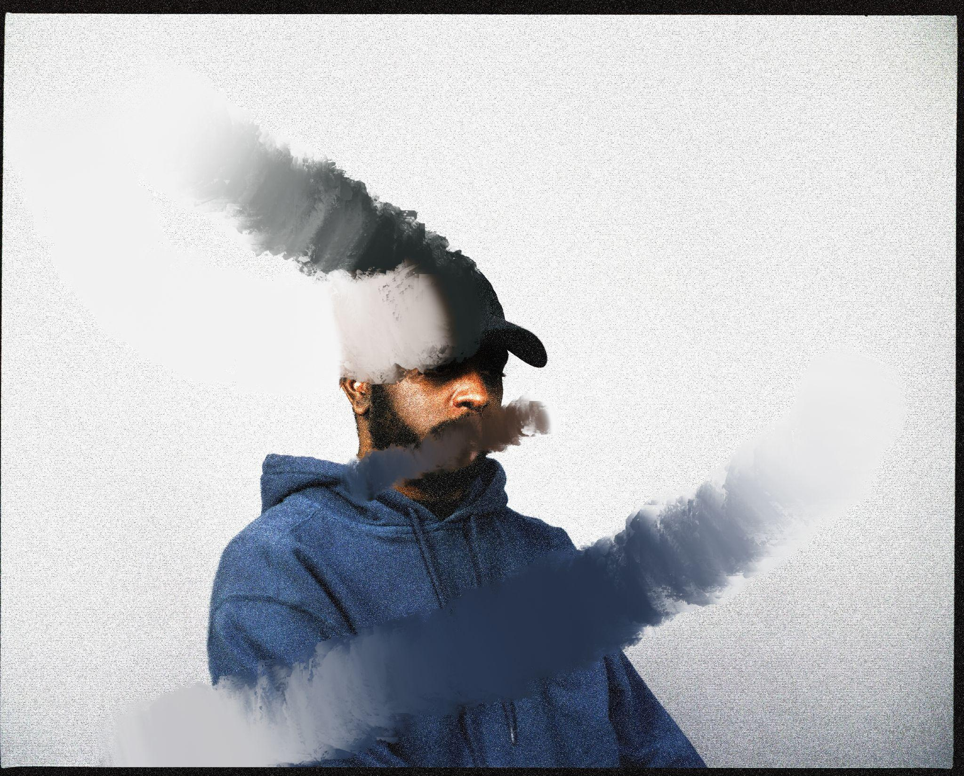
Photo credit: Kay Ibrahim
Download hi-res assets here

“Variables is unwavering in its brilliance.” - The Guardian

“Epic” - Uncut

"Variables finds Mist and his crew in an effortless groove, refusing to commit to a single disciple" - CRACK

“Lulling and hypnotic” - Mojo

“...some of the best UK hip-hop of its kind since Little Simz’s SIMBI” - Loud and Quiet

—

Today, East London artist, producer and label founder, Alfa Mist shares a sublime live session video shot at Invada Studios in Bristol with band members Kaya Thomas-Dyke on bass, Jas Kayser on drums, Jamie Leeming on Guitar, Johnny Woodham on Flugelhorn, Samuel Rapley - Sax & Bass Clarinet, with Alfa of course taking on keys. Coming in at just under 30 minutes, where jazz guitar traverses intricate drum rhythms and cascading piano, they perform tracks ‘The Gist’, ‘4th Feb (Stay Awake)’, ‘Variables’ and ‘BC’ from Alfa’s acclaimed album Variables released via ANTI- Records.

Continuing to collaborate with filmmaker SPOD, the live session is animated with mesmerising paintings and colours emerging into shot and morphing into band members. It’s in a constant, meditative flux with a psychedelic nature that the viewer can lose themselves in as they listen and watch Alfa and his crew perform to captivating effect.

Since the release of his first full-length project Nocturne in 2015, Alfa has established himself as one of the UK’s most focused, in-demand and distinct musical voices. He has worked with the likes of Jordan Rakei and Tom Misch. Artists look to him for his unique blend of intimate bedroom production and expansive jazz group orchestration, since Alfa is yet to be boxed into a specific genre. His music spans everything from hip-hop beat-making to producing for artists such as rapper Loyle Carner, composing neo-classical works for the London Contemporary Orchestra, and reworking tracks from composer Ólafur Arnalds and pioneering jazz label Blue Note. The return to live shows has been a welcome one for Alfa and this year has seen him on an epic tour of the world, taking his electrifying live show across the US, Japan, Australia to play at some of the most prestigious and iconic venues and festivals such as LA’s Fonda Theatre, Newport Jazz Festival and Sydney Opera House. This October he’ll kick off the highly anticipated EU and UK leg of the tour, closing this huge run of dates in his home city at one of London’s most exciting new venues, The Outernet on Wednesday, 22nd November.

Alfa Mist – EU/UK tour dates:
04 Oct - La Cigale - Paris, France
05 Oct - De Roma - Antwerp, Belgium
09 Oct - Paard - The Hague, Netherlands
10 Oct - Doornroosje - Nijmegen, Netherlands
11 Oct - SPOT/De Oosterpoort - Groningen, Netherlands
18 Oct - Slaktkyrkan - Stockholm, Sweden
19 Oct - Cosmopolite - Oslo, Norway
20 Oct - VoxHall - Aarhus, Denmark
21 Oct - DR Koncerthuset, Studio 2 - Copenhagen, Denmark
22 Oct - Korjaama - Helsinki, Finland
27 Oct - House of Music - Budapest, Hungary
28 Oct - Mladi ladi jazz Festival - Prague, Czech Republic
30 Oct - Flex - Vienna, Austria
31 Oct - Gruenspan - Hamburg, Germany
1 Nov - JazzOnze+ Festival - Lausanne, Switzerland
3 Nov - L’Aeronef (Club Room) - Lille, France
4 Nov - La Lune des Pirates - Amiens, France
5 Nov - La Sirene - La Rochelle, France
8 Nov - Paral .lel 62 - Barcelona, Spain
10 Nov - Bologna Jazz - Bologna, Italy
11 Nov - Volo del Jazz - Sacile, Italy
16 Nov - Opium Rooms - Dublin, Ireland
18 Nov - BAaD - Glasgow, UK
19 Nov - RNCM Concert Hall - Manchester, UK
20 Nov - Trinity - Bristol, UK
22 Nov - HERE at Outernet - London, UK

Buy tickets here

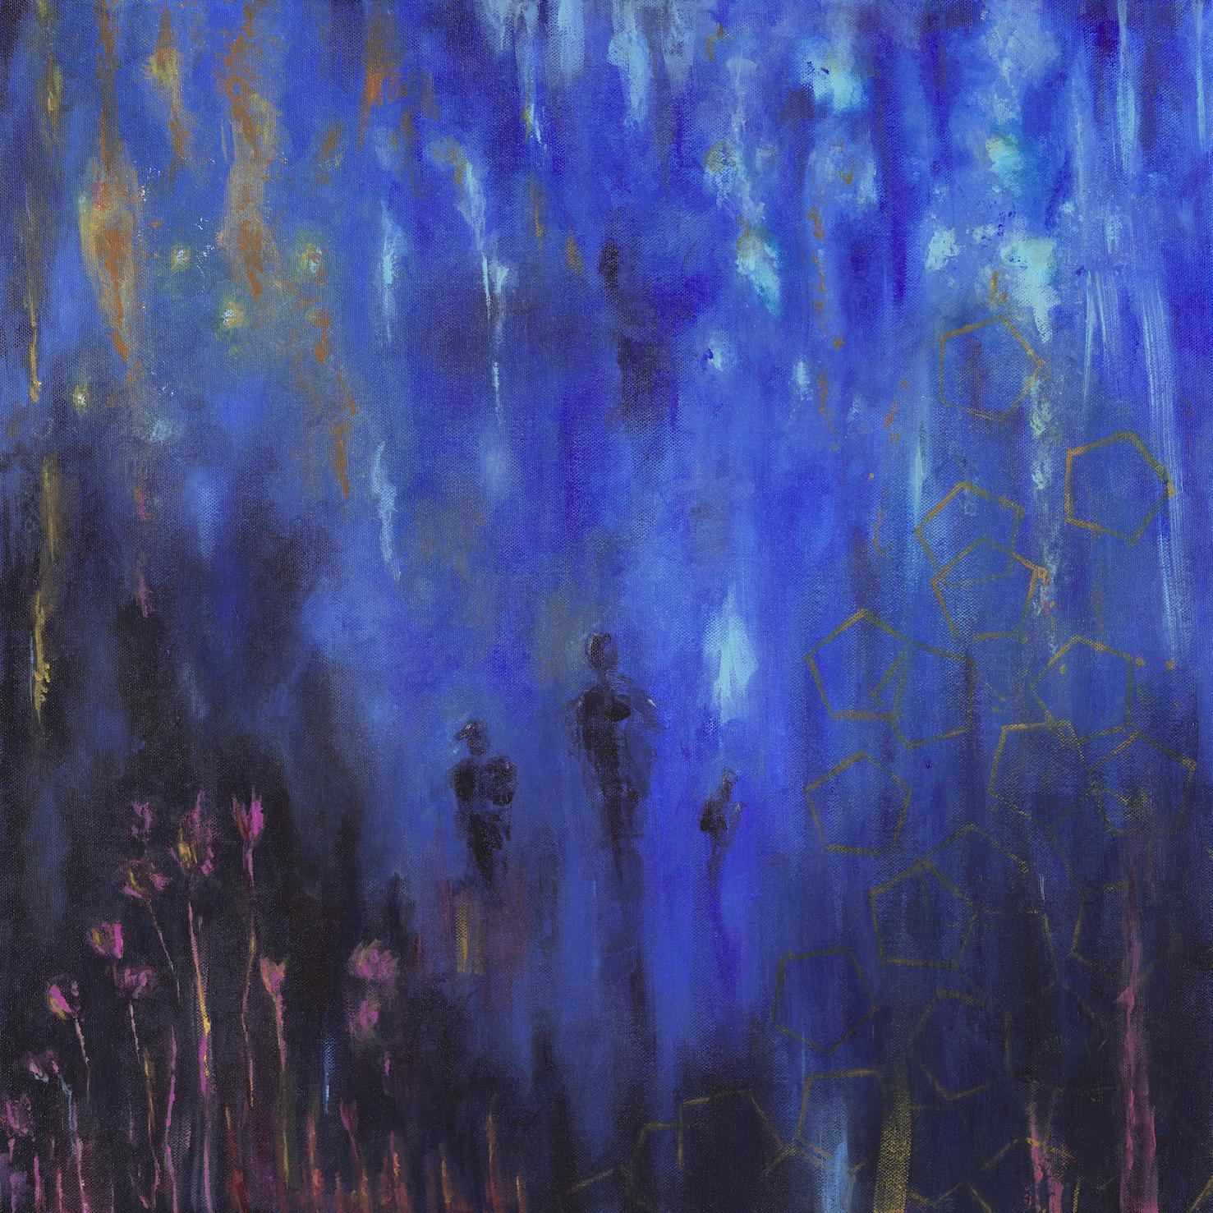
Variables artwork
Credit: Kaya Thomas-Dyke

“I’ve been focused on who I am in my music, but now I’m exploring where I am,” Alfa Mist says. “I’m asking: how did I get here?” This is the journeying question that underpins Alfa’s fifth album, Variables. Traversing luscious, big band swing, head-nodding boom-bap rhythms and yearning vocal melodies, the record is expansive, soulful and moving, in both body and spirit. On Variables, Alfa achieves his most fully-realised, expressive musical work to date, coupling his keen ear for looping, memorably emotive piano melodies with intuitive grooves and a free-flowing jazz improvisation.

Variables sees Alfa Mist offer a diverse listening experience, as he dives into the argument of nature versus nurture on the rhythmic ‘Borderline’ to the airy, crystallic sounds of ‘Cycles’. The album’s standout features are captivating, with long-time collaborator and band’s bass player Kaya Thomas-Dyke’s gentle vocals adding an ethereal essence on ‘Aged Eyes’, whilst the South African folk singer Bongeziwe Mabandla drapes the vibrant backdrop and Jas Kayser’s frenetic drum playing with his crystalline falsetto on ‘Apho’. “4th Feb (Stay Awake)” is a lofi offering that pairs Alfa’s reflective bars with a groove-heavy production and “BC” is a colourful swell of expressive and unrestrained percussion, demonstrating the ingenuity of Alfa Mist and his close knit band.

Follow Alfa Mist
Twitter // Instagram // Spotify

For more information contact:
nisa@lonepr.com

