ALFA MIST

SHARES NEW SINGLE “APHO”
FT. BONGEZIWE MABANDLA

LISTEN HERE

NEW ALBUM VARIABLES OUT APRIL 21 VIA ANTI-

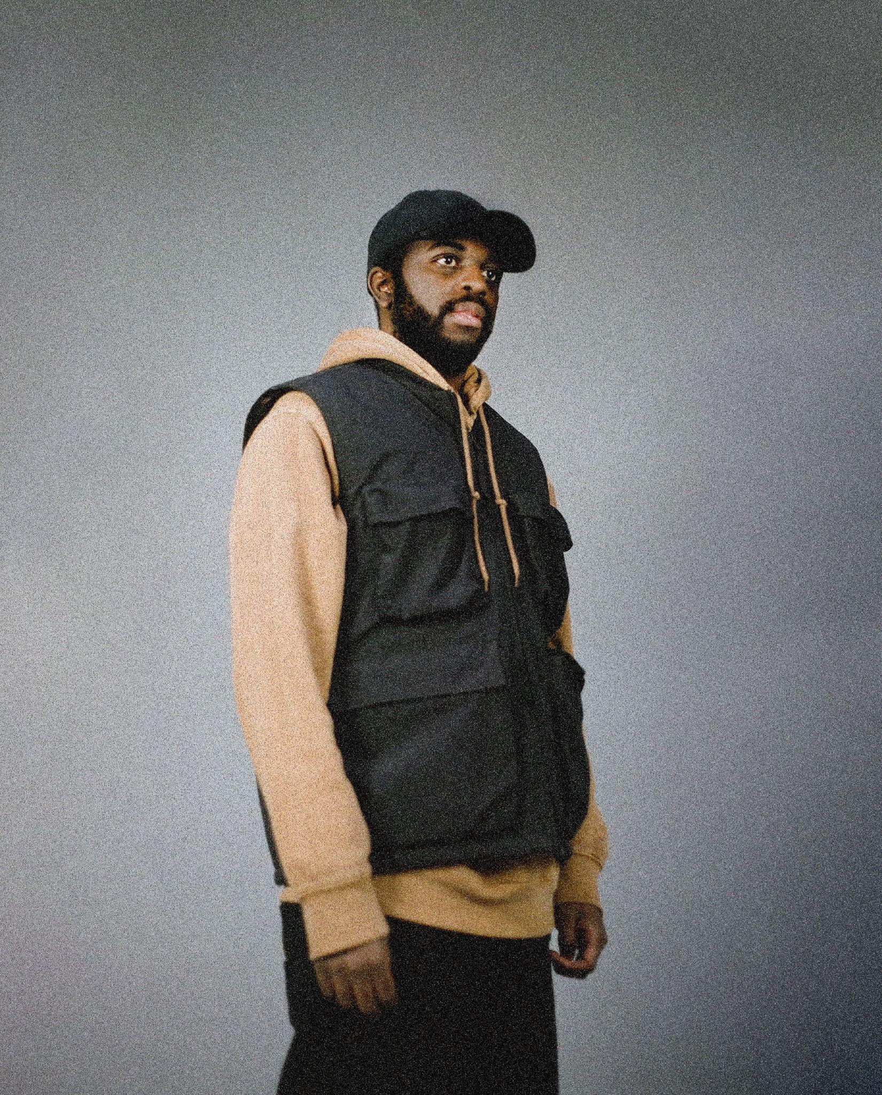
Photo credit: Kay Ibrahim | Download here

Today, East London musician, producer, composer and rapper Alfa Mist shares another single titled “Apho” from his highly anticipated forthcoming album Variables out April 21st on ANTI-.

“Apho”’ features South African folk singer Bongeziwe Mabandla who pens the yearning love song to Alfa’s spellbinding guitar led arrangement. Intricately layered with the deep, grounding sounds of the cello and Mabandla’s crystalline falsetto that skips over drummer Jas Kayser’s frenetic beat, “Apho” offers a swirl of emotions, taking you on a melancholic yet thrilling journey.

The video by Australian filmmaker, SPOD is based on the album artwork painted by the band's bass player, Kaya Thomas-Dyke. In constant motion - shapes, figures and rich tones of blue and purple morph into each other throughout to captivating affect.

LISTEN TO / WATCH “APHO” FT. BONGEZIWE MABANDLA

“I’ve been focused on who I am in my music, but now I’m exploring where I am,” Alfa Mist says of the new single. “I’m asking: how did I get here?”

This is the journeying question that underpins Alfa’s fifth album, Variables. Traversing luscious, big band swing, head-nodding boom-bap rhythms and yearning vocal melodies, the record is expansive, soulful and moving, in both body and spirit. On Variables, his second release for ANTI-, Alfa achieves his most fully-realized, expressive musical work to date, coupling his keen ear for looping, memorably emotive piano melodies with intuitive grooves and a free-flowing jazz improvisation.

Since the release of his first full-length project Nocturne in 2015, Alfa has established himself as one of the UK’s most focused, in-demand and distinct musical voices. He has worked with the likes of Jordan Rakei and Tom Misch. Artists look to him for his unique blend of intimate bedroom production and expansive jazz group orchestration, since Alfa is yet to be boxed into a specific genre. His music spans everything from hip-hop beat-making to producing for artists such as rapper Loyle Carner, composing neo-classical works for the London Contemporary Orchestra, and reworking tracks from composer Ólafur Arnalds and pioneering jazz label Blue Note.

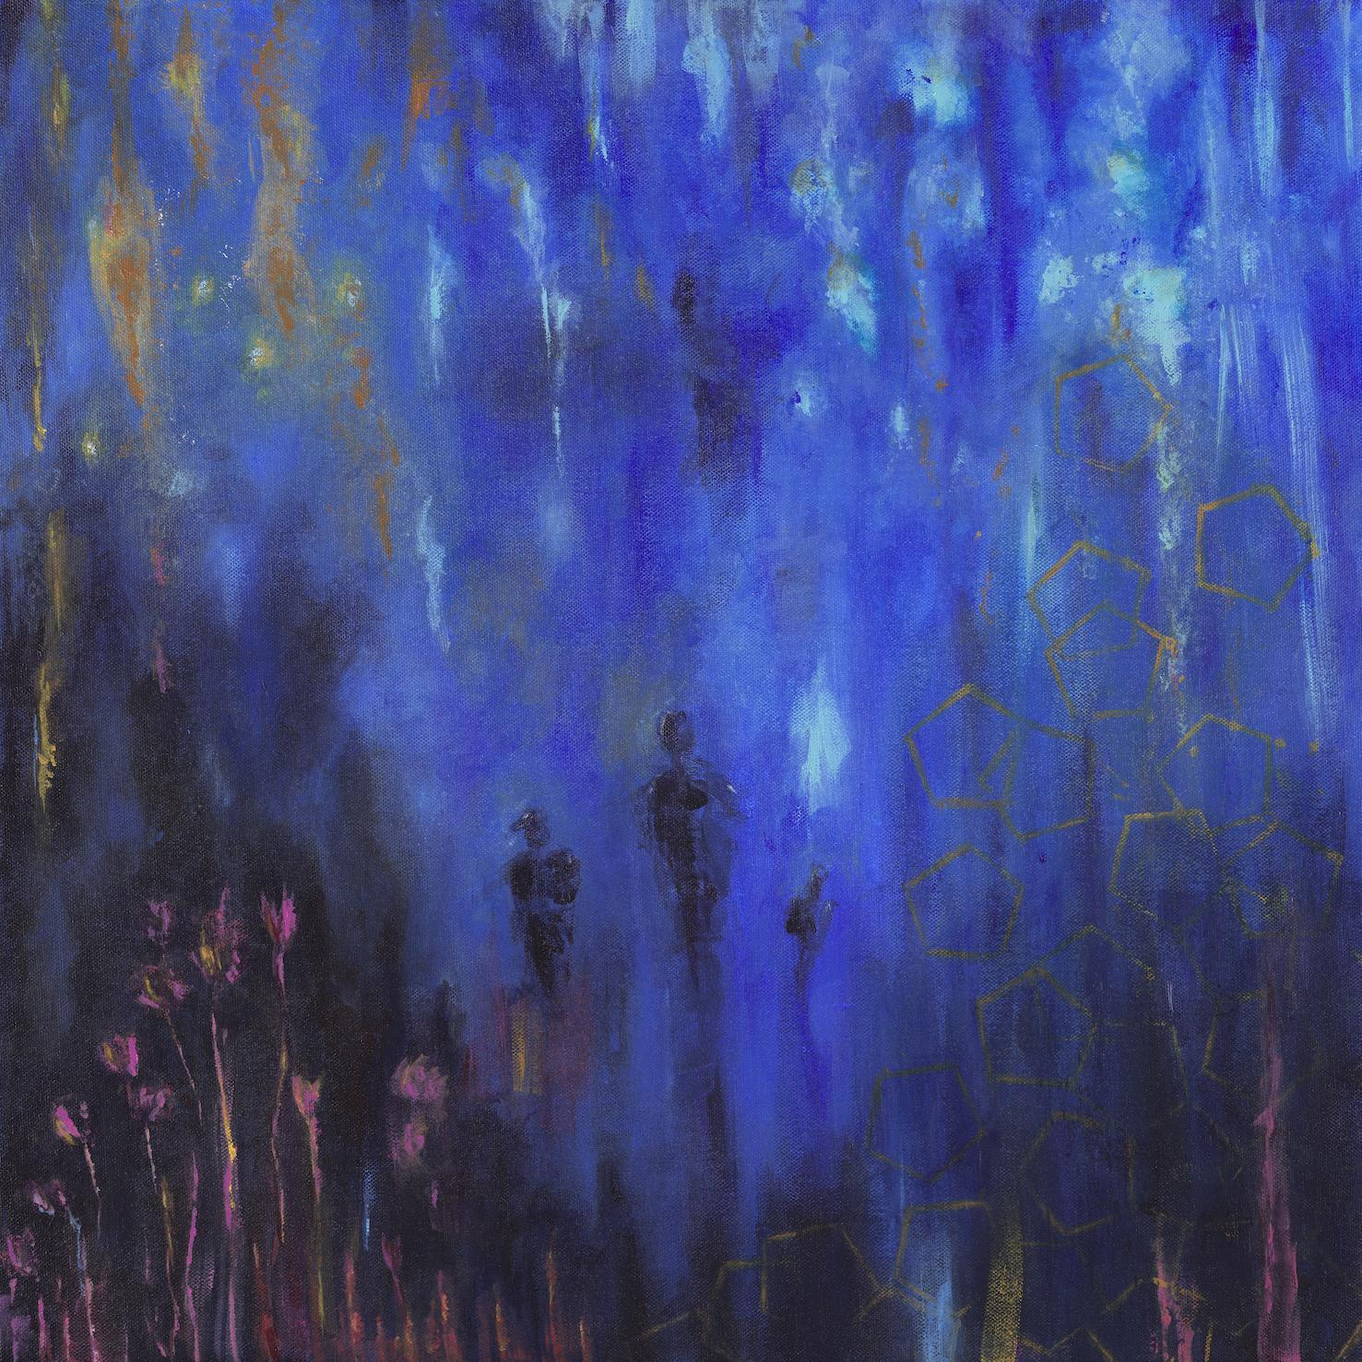
‘Variables’ artwork by Kaya Thomas-Dyke / download here

Variables tracklisting
- Foreword
- Borderline
- Aged Eyes (feat. Kaya Thomas-Dyke)
- Cycles
- The Gist
- Genda (Go Away)
- Apho (feat. Bongeziwe Mabandla)
- Variables
- 4th Feb (Stay Awake)
- BC

ALFA MIST TOUR DATES
4/1 - Transition Festival - Utrecht, Netherlands
4/27 - The Ardmore Music Hall - Philadelphia, US
4/29 - Music Hall of Williamsburg - New York, US
4/30 - Racket - New York, US
5/2 - Thalia Hall - Chicago, US
5/4 - Fonda Theatre - Los Angeles, US
5/5 - August Hall - San Francisco, US
5/13- XJAZZ! Festival - Berlin, Germany
5/20 - Norfolk & Norwich Festival - Norwich, UK
5/25 - Jazz A Liege - Liège, Belgium
5/28 - Cross The Tracks Festival - London, UK
5/31 - Sydney Opera House (Vivid LIVE) - Sydney, Australia
7/9 - İstanbul Caz Festivali - Istanbul, Turkey
7/22 - Théâtre Silvain - Marseille, France
8/4 August - Newport Jazz Festival - Newport, US
10/4 - La Cigale - Paris, France
10/9 - Paard Van Stal - The Hague, Netherlands
10/10 - Doornroosje - Nijmegen, Netherlands
10/11 October - SPOT/De Oosterpoort - Groningen, Netherlands
10/27 - House of Magic, Budapest, Hungary
10/28 - Mladi Ladi Jazz Festival - Prague, Czech Republic
11/16 - Opium Rooms - Dublin, Ireland
11/18 - BAaD - Glasgow, UK
11/19 - RNCM Concert Hall - Manchester, UK
11/20 - November - Trinity - Bristol, UK
11/22 - November - Outernet - London, UK

Buy tickets here

Follow Alfa Mist
Twitter // Instagram // Spotify

For more information, please contact Grandstand Media:
Shazila Mohammed - shazm@grandstandhq.com
Zoe Hines - zoeh@grandstandhq.com

