January 27, 2020
For Immediate Release

Andy Shauf Makes Daytime Television Debut On CBS This Morning: Saturday In Support of The Neon Skyline, Out Now on ANTI-;

Releases Video for “Neon Skyline”

North American Tour Kicks Off Next Week
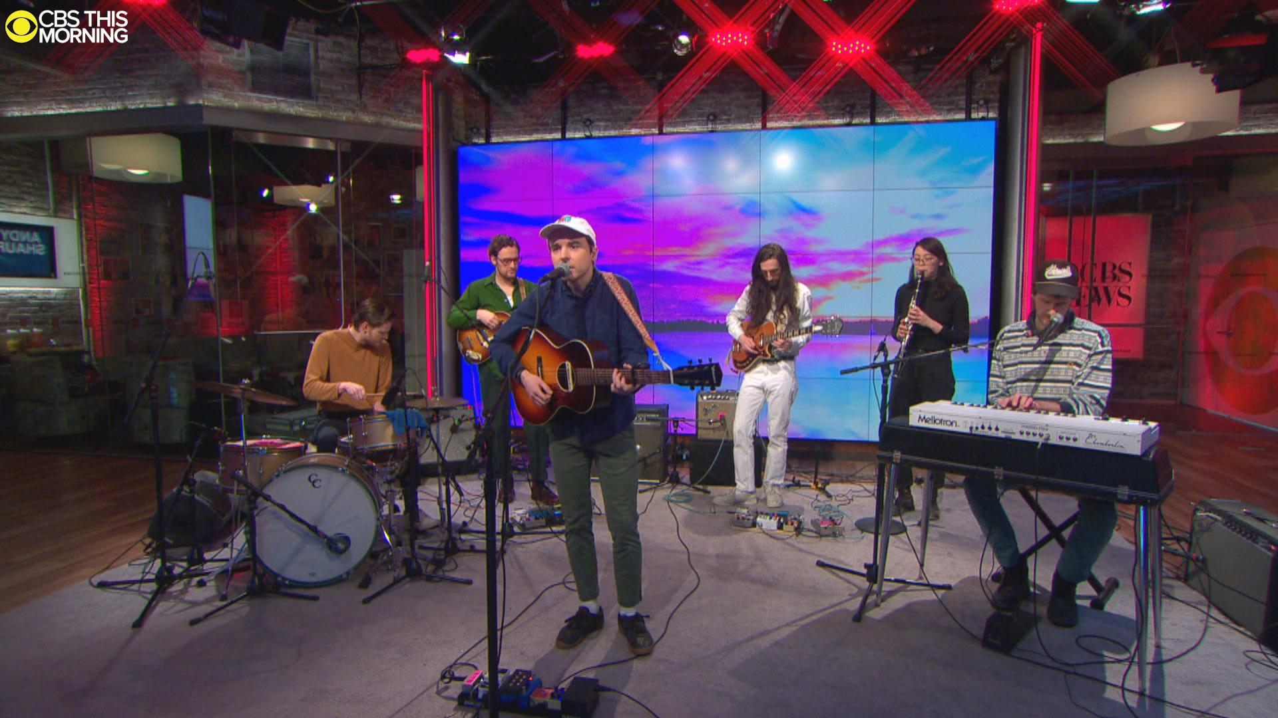
Photo Courtesy of CBS This Morning: Saturday

“Not many songwriters can get away with piling on the dialogue and forgoing choruses almost entirely, but Shauf draws you in with all those canny musical flourishes and maintains a hypnotic presence . . . The closer you pay attention to the breezy facade, the deeper you’re drawn into his vignette.” - Stereogum, Album of the Week

“A gifted singer-songwriter. More than that, a gifted storyteller.” - NPR Music

“A beguiling soft rock universe” - UPROXX

Following last Friday’s release of his new album, The Neon Skyline, Andy Shauf made his daytime television debut on CBS This Morning: Saturday. Shauf gave a riveting performance of three tracks - “Try Again,” “Living Room,” and “Neon Skyline.” Onstage, he was joined by five other players - Karen Ng (woodwinds), Colin Nealis (keys), Joshua Daignault (bass), Chris Bezant (guitar), and Sean Mullins (drums). This marks his first television appearance since his performance on The Late Late Show with James Corden in 2017, and previews his North American tour, which kicks off next week at Columbus’ Ace of Cups. Tickets are available now and a full list of dates can be found below.

Watch Andy Shauf Perform on CBS This Morning: Saturday:
“Try Again”
“Living Room”
“Neon Skyline”

Additionally, Shauf released a new video for “Neon Skyline,” which was directed by Colin Medley and features Shauf in his studio in Toronto. “Over the course of the last few years I'd come by and take photos and listen to whatever new songs he'd been working on,” says Medley. “Sometimes we'd go to the Skyline, but quite often we'd never leave the studio, staying up all night turning each other on to different songs. At some point Andy put up a dartboard. I guess I just tried to capture those nights and pay tribute to Parkdale, the neighbourhood where we both live.”

Watch the “Neon Skyline” Video --
https://youtu.be/Ao22GlYHBqU

The Neon Skyline is out now on ANTI-. The interconnected songs on the album were all written, performed, arranged and produced by Shauf, and follow a simple plot: the narrator goes to his neighborhood dive, finds out his ex is back in town, and she eventually shows up. It’s densely layered with an abundance of charming moments. His characters are all sympathetic here, people who share countless inside jokes, shots, and life-or-death musings when the night gets hazy.

Stream/Purchase The Neon Skyline --
https://andyshauf.ffm.to/theneonskyline

Watch/Listen/Share:
“Try Again” Video - https://youtu.be/thiHFeIw_5U
“Living Room” Stream - https://youtu.be/qixF-nQX7WM
“Things I Do” Stream - https://youtu.be/MF9DjpLsZWM

Andy Shauf Tour Dates:
Fri. Feb. 7 - Columbus, OH @ Ace of Cups *
Sat. Feb. 8 - Lexington, KY @ The Burl *
Sun. Feb. 9 - Knoxville, TN @ Barley’s Taproom *
Tue. Feb. 11 - Nashville, TN @ Exit/In *
Thu. Feb. 13 - Houston, TX @ White Oak Music Hall *
Fri. Feb. 14 - Austin, TX @ Mohawk *
Sat. Feb. 15 - Dallas, TX @ Deep Ellum Art Co. *
Tue. Feb. 18 - Phoenix, AZ @ Crescent Ballroom *
Thu. Feb. 20 - Los Angeles, CA @ Fonda Theater *
Fri. Feb. 21 - San Francisco, CA @ August Hall *
Sat. Feb. 22 - Sacramento, CA @ Harlow’s *
Mon. Feb. 24 - Portland, OR @ Revolution Hall *
Tue. Feb. 25 - Seattle, WA @ Neumos *
Wed. Feb. 26 - Vancouver, BC @ Commodore Ballroom *
Fri. Feb. 28 - Calgary, AB @ Bella Concert Hall *
Sat. Feb. 29 - Edmonton, AB @ The Starlite Room *
Mon. March 2 - Saskatoon, SK @ Broadway Theatre *
Tue. March 3 - Regina, SK @ The Exchange *
Wed. March 4 - Winnipeg, MB @ Park Theatre *
Thu. March 5 - Minneapolis, MN @ Fine Line Music Hall *
Fri. March 6 - Milwaukee, WI @ Colectivo *
Sat. March 7 - Chicago, IL @ Thalia Hall *
Fri. March 13 - Lyon, FR @ Epicerie Moderne *
Sat. March 14 - Bordeaux, FR @ Krakatoa *
Tue. March 17 - Birmingham, UK @ Hare and Hounds *
Wed. March 18 - Glasgow, UK @ Mono *
Thu. March 19 - Manchester, UK @ Gorilla *
Fri. March 20 - Leeds, UK @ Brudenell Social Club *
Sat. March 21 - Bristol, UK @ Fiddlers *
Sun. March 22 - Brighton, UK @ Chalk *
Wed. March 25 - Brussels, BE @ Botanique Orangerie *
Thu. March 26 - Utrecht, NL @ TivoliVredenburg *
Fri. March 27 - Rotterdam, NL @ Rotown *
Sat. March 28 - Nijmegen, NL @ Doornroosje *
Mon. March 30 - Hamburg, DE @ Elbphilharmonie *
Tue. March 31 - Copenhagen, DK @ Loppen *
Wed. April 1 - Stockholm, SE @ Nalen Klubb *
Thu. April 2 - Oslo, NO @ Ingensteds *
Sat. April 4 - Berlin, DE @ Silent Green *
Sun. April 5 - Cologne, DE @ Luxor *
Mon. April 6 - Rouen, FR @ Le 106 *
Tue. April 7 - Paris, FR @ Trianon *
Wed. April 8 - London, UK @ Shepherds Bush Empire *
Thu. April 23 - Toronto, ON @ Danforth Music Hall ^
Fri. April 24 - Toronto, ON @ Danforth Music Hall ^ - SOLD OUT
Sat. April 25 - Montreal, QC @ Corona Theatre ^
Sun. April 26 - Sheffield, MA @ Race Brook Lodge ^
Tue. April 28 - Boston, MA @ Paradise Rock Club ^
Thu. April 30 - Brooklyn, NY @ Warsaw ^
Fri. May 1 - Philadelphia, PA @ Union Transfer ^
Sat. May 2 - Washington, DC @ Black Cat ^
Mon. May 4 - Charlottesville, NC @ The Southern ^
Tue. May 5 - Carrboro, NC @ Cat’s Cradle ^
Wed. May 6 - Asheville, NC @ The Grey Eagle ^
Fri. May 8 - Atlanta, GA @ Terminal West ^
Sat. May 9 - New Orleans, LA @ One Eyed Jacks ^
Sun. May 10 - Birmingham, AL @ Saturn ^
Tue. May 12 - Indianapolis, IN @ Hi-Fi ^
Wed. May 13 - Pittsburgh, PA @ Andy Warhol Museum ^
Fri. May 15 - Asbury Park, NJ @ House of Independents ^
Sat. May 16 - Woodstock, NY @ Colony Cafe ^

*= w/ Molly Sarlé
^ = w/ Faye Webster

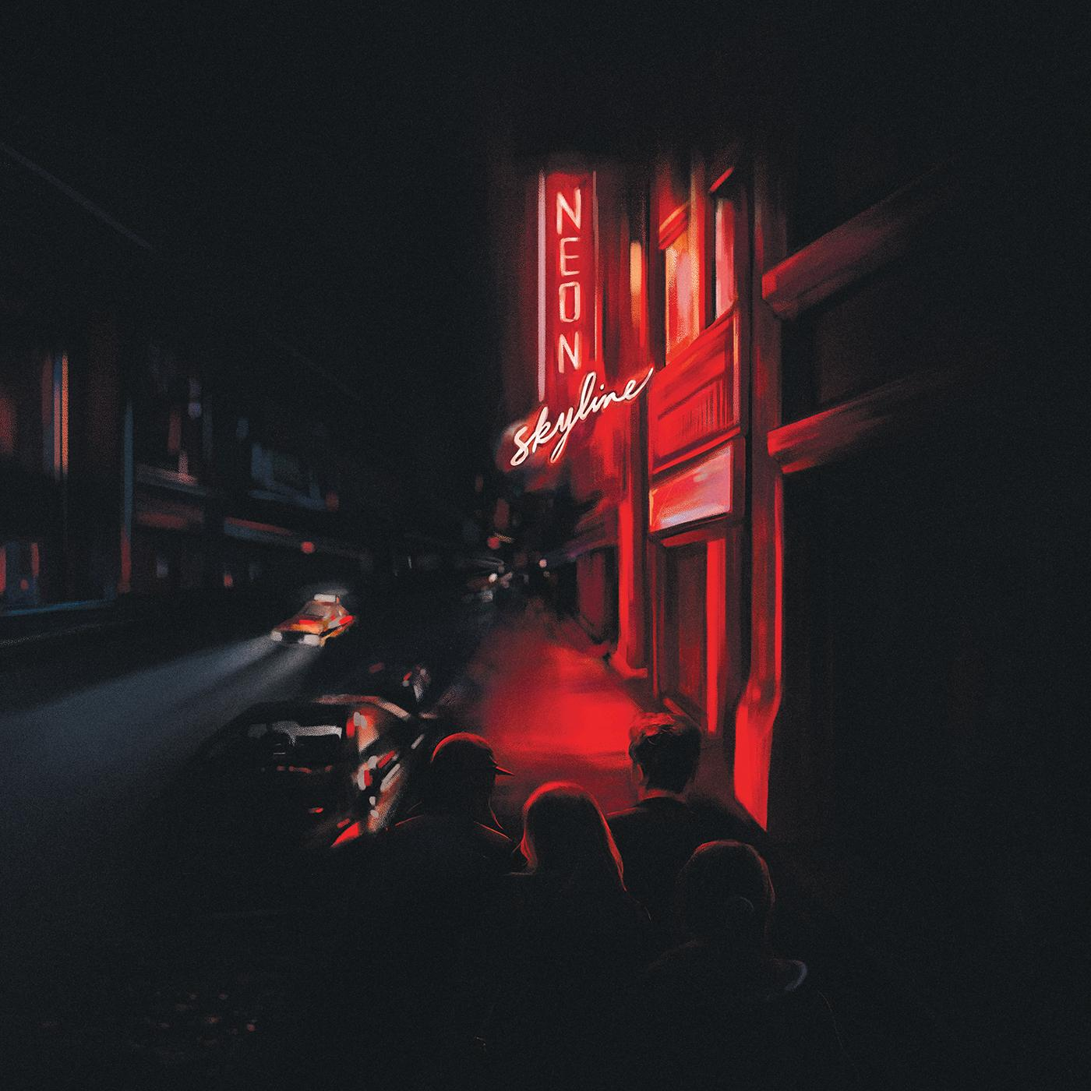
The Neon Skyline Cover Artwork

Website | ANTI- | Instagram | Facebook | Twitter | Bandcamp

For more information, contact:
Jessica Linker & Patrick Tilley | Pitch Perfect PR –
jessica@pitchperfectpr.com, patrick@pitchperfectpr.com

##

