BEN HARPER REVEALS OCTOBER 23 RELEASE DATE FOR SOLO LAP STEEL GUITAR ALBUM WINTER IS FOR LOVERS (ANTI-RECORDS)

UNVEILS NEW SONG “LONDON”

LISTEN / WATCH HERE
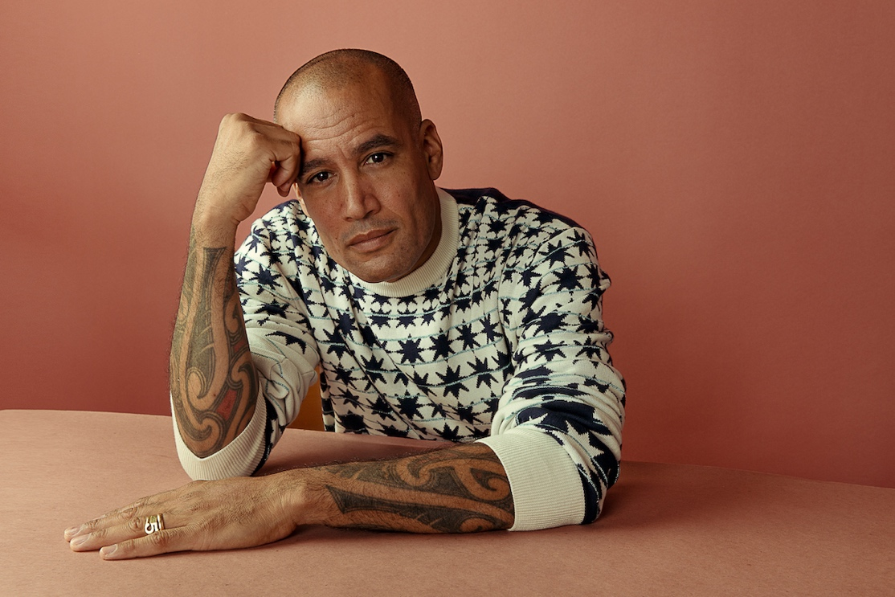

Ben Harper has released “London,” a new preview of his forthcoming album Winter is For Lovers (ANTI- Records). Along with the single, Harper has confirmed the album’s release date for October 23rd. The album is Harper’s first-ever entirely instrumental project, and in many ways his entire musical life has culminated in this moment: a 15-song solo recording of original compositions imagined as a symphony on his lap steel guitar.

The first pressing of a limited edition vinyl has already sold out, but fans can still pre-order both digital and additional physical versions of Winter Is For Lovers here.

Watch Harper perform a live version of “London” that was just filmed at The Folk Music Store, the influential California instrument shop his grandparents opened in the 1950s.

Watch/listen here: https://youtu.be/7E0gtRWiJQE

"The track 'London' for me is influenced by the great British guitar players, such as Richard Thompson, Nick Drake, John Martyn, Jimmy Page. It’s got that driving British push and pulse, a jingling jangling rumble that I tried to get that sound on that track and to me it felt like London specifically," Harper says of the track.

Meditative and affecting, the music featured on Winter Is For Lovers is deeply ingrained in Harper’s DNA and leads directly back to The Folk Music Store, which has hosted luminaries of all stripes, including Sonny Terry, Brownie McGhee, the Rev. Gary Davis, Doc Watson and John Fahey. While Harper worked in the shop throughout his childhood, he met iconic players like Leonard Cohen, Taj Mahal, David Lindley and Jackson Browne.

Winter Is For Lovers is filled with the music Harper heard growing up, listening to the blues, Hawaiian and classical guitar masters in his mother’s record collection. He gravitated early on to the distinct wail of the slide guitar, learning finger picking from the great Taj Mahal and later studying with Chris Darrow of Nitty Gritty Dirt Band - a lap steel virtuoso who had a major influence on Harper’s lifelong embrace of the instrument.

Harper has pushed musical boundaries since his 1994 debut and his lap steel guitar has played a tremendous role in his distinct sound throughout his career. But he’s never made an album that so purely distills his reverence for the instrument, and his mastery of it.

Listen to the previously released ”Inland Empire” here, which was covered by Rolling Stone, SPIN, Paste and others: https://benharper.ffm.to/wifl

Winter Is For Lovers tracklist:
1. Istanbul
2. Manhattan
3. Joshua Tree
4. Inland Empire
5. Harlem
6. Lebanon
7. London
8. Toronto
9. Verona
10. Brittany
11. Montreal
12. Bizanet
13. Toronto (Reprise)
14. Islip
15. Paris

