April 26, 2022
For Immediate Release

Cass McCombs Releases New Single, “Belong To Heaven”

Touring California This June
Photo Credit: Giovanni Duca

Today, Cass McCombs, “a woodsy abstractionist-turned-master-of-vernacular” (Rolling Stone), releases “Belong To Heaven,” a new single further cementing this sentiment. “Belong To Heaven” redirects McCombs, following a chapter of collaborations. Since the release of 2019’s Tip of the Sphere, McCombs has released a pair of singles with Steve Gunn, re-released his “Don’t Vote” as “Don’t (Just) Vote” with contributions from Angel Olsen, Bob Weir and Noam Chomsky, recorded with Tinariwen, co-wrote many songs on Blake Mills’ Mutable Set, formed a band with Wynonna Judd, contributed to music by Tomberlin, published Toy Fabels, a book of poetry via Spurl Editions, as well as compiled and co-produced the Karen Black collection, Dreaming Of You (1971-1976). In the weeks ahead, McCombs will play shows throughout California.

For “Belong To Heaven,” McCombs reunited with producer Ariel Rechtshaid, with whom he worked on Catacombs, WIT’S END, and Humor Risk. McCombs, on vocals, guitars, piano and percussion, is joined by Danielle Haim on drums and vocals, The Chapin Sisters on additional vocals, Shahzad Ismaily on bass, keys and piano, Frank LoCastro on keys and Buddy Ross on hammond organ. The song’s lyrics, beautiful and melancholy, navigate the loss of a close friend:

I remember you on the street at night
All glitter and chainmail but no time to fight
A grease fire burning bright
Now you belong to Heaven

Always stealing from the plebs
A rosary of Dos Equis beads
Instant film from the grocery
Now you belong to Heaven

Music was all we needed
Yeah, you’ve got to give it away to keep it
You surrendered undefeated
Now you belong to Heaven

Now you belong to Heaven
Now you belong to Heaven
Now you belong to Heaven

You were totally lunar
You had a gallows at City Hall and gallows humor
Wish I had met you sooner
Now you belong to Heaven

For all the questions I want to ask
I hope that you find peace at last
While the world keeps turning fast

So far away from Heaven
So far away from Heaven
So far away from Heaven
So far away from Heaven

So far away from all that now
I guess it doesn’t matter anyhow
How now, brown cow? How’s Heaven?

Through all your madness and magic and stuff
I wonder if Heaven has finally called your bluff
Call me anytime for bail
From the jail
In Heaven

Now you belong to Heaven
Now you belong to Heaven
Now you belong to Heaven

Listen to Cass McCombs’ “Belong To Heaven”

Cass McCombs Tour Dates:
Sat. May 21 - Guadalajara, MX @ Corona Capital Festival Guadalajara
Tue. June 14 - Santa Ana, CA @ Constellation Room
Wed. June 15 - San Diego, CA @ Casbah
Fri. June 17 - Los Angeles, CA @ Lodge Room
Sat. June 18 - San Francisco, CA @ The Chapel
Sun. June 19 - Cayucos, CA @ Schooner’s

Download hi-res press images
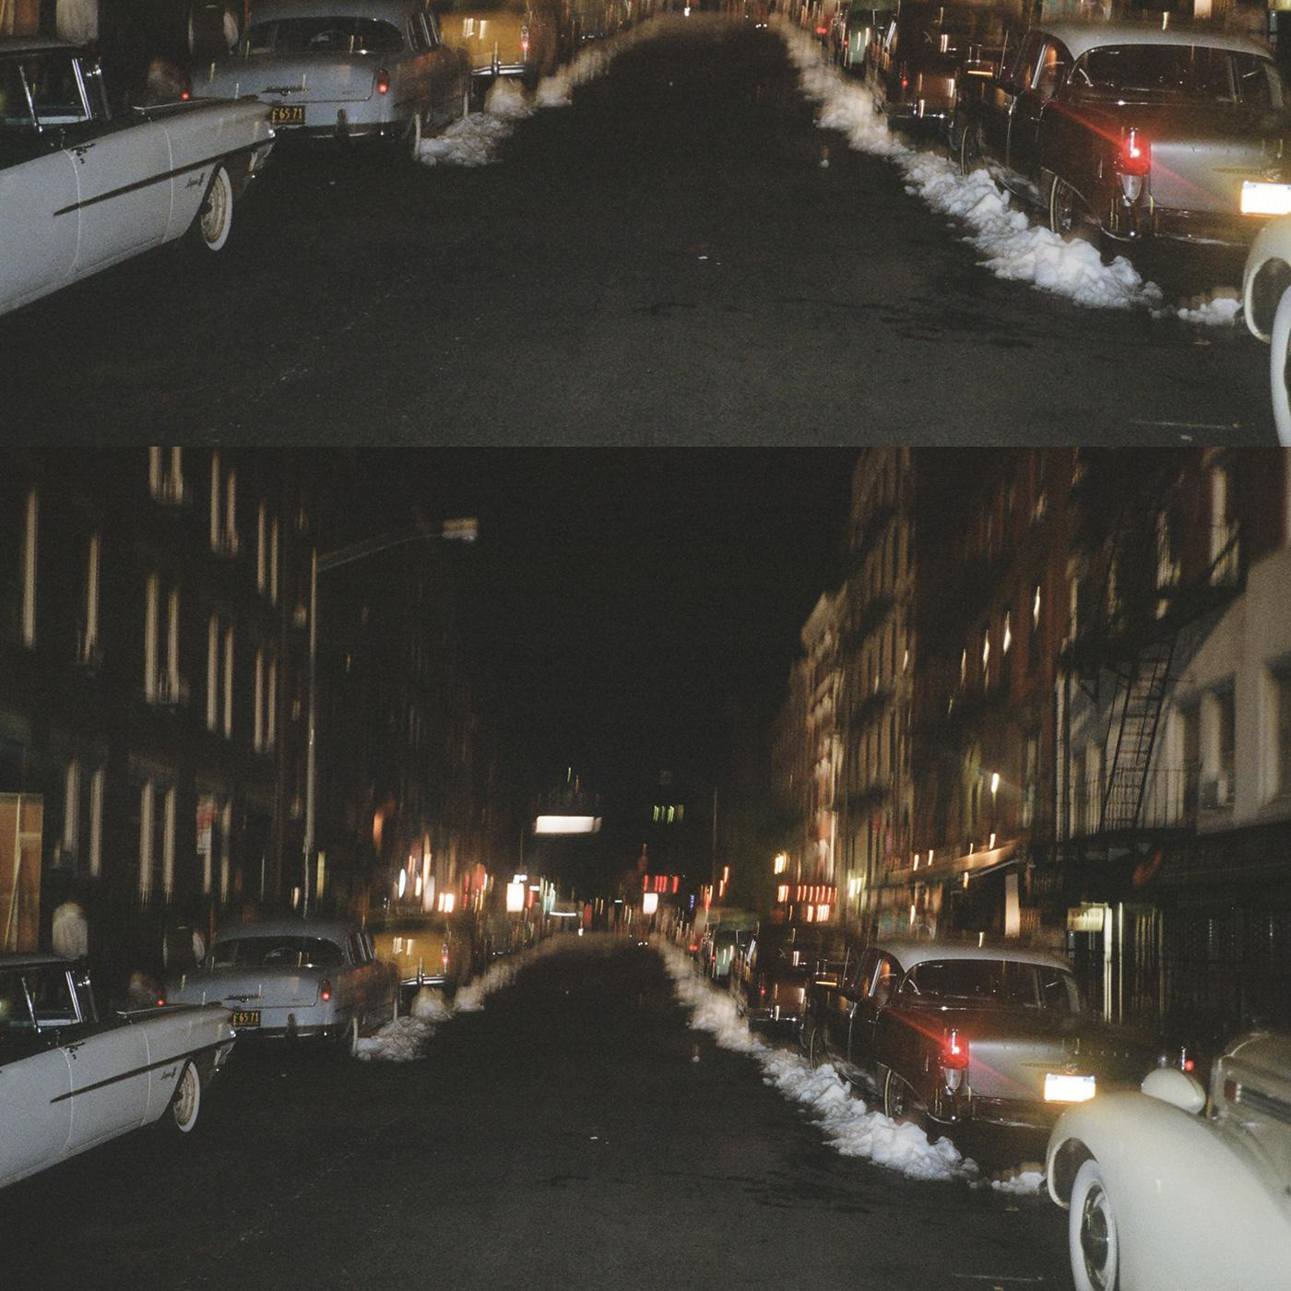
“Belong To Heaven” Track Artwork

Website | Facebook | Instagram | Twitter

For more information, contact:
Jessica Linker | Pitch Perfect PR – jessica@pitchperfectpr.com, 773-942-6954

