***MEDIA ALERT***MEDIA ALERT***MEDIA ALERT***

DANNY ELFMAN OFFICIALLY RELEASES NEW
ALBUM BIGGER. MESSIER. TODAY

INCLUDES 21 REMIXED AND REIMAGINED VERSIONS OF SONGS FROM HIS ACCLAIMED ALBUM BIG MESS, WITH GUEST COLLABORATIONS & FEATURES FROM TRENT REZNOR, IGGY POP, HEALTH, KAITLYN AURELIA SMITH, ZACH HILL OF DEATH GRIPS, XIU XIU, SQUAREPUSHER & MORE

ELFMAN RELEASES BRAND NEW ARTIFICIAL-INTELLIGENCE-GENERATED MUSIC VIDEO TODAY FOR “IN TIME (FEATURING BLIXA BARGELD)”

WATCH NOW HERE

Bigger. Messier. (Official Artwork Courtesy of ANTI- Epitaph Records)

August 12, 2022 (Los Angeles, CA) - Today, Danny Elfman has released Bigger. Messier. – a brand new genre-defying album of remixed and reimagined versions of songs from his acclaimed 2021 record Big Mess via ANTI- / Epitaph Records. The 21-track project is comprised of collaborations and guest vocal features from a sprawling array of artists including Trent Reznor, Iggy Pop, HEALTH, Kaitlyn Aurelia Smith, Zach Hill of Death Grips, Xiu Xiu, Squarepusher, Ghostemane and many more. With the help of his collaborators Stu Brooks and Berit Gwendolyn Gilma, Elfman enlisted a unique arsenal of artists to use the original Big Mess songs as their canvases and experiment in their own distinct voices.

“This record was all about the joy of experimentation. I really wanted to enjoy the experience of completely relinquishing control of my work, which is something that I’d never done before,” says Elfman about the project. “The only input I gave any of the artists was to be themselves and have no concerns about putting their own unique spins on the music, as every artist on this project were ones I already respected and whose music I enjoyed. Not only was I surprised at everyone who wanted to participate, but simply blown away by what they all contributed. There’s a tremendous amount of diversity represented throughout.”

The release of the album is ushered in by Blixa Bargeld’s reimagining of “In Time,” a brand new re-interpretation of the song by the lead singer and founding member of the iconic German band Einstürzende Neubauten. The track arrives today alongside a phantasmagoric accompanying video, which was brought to life through synthetic AI systems. Created by Lorem, the Italian audiovisual artist whom Elfman and Gilma collaborated with for the original “In Time” music video, designed the piece by feeding the lyrics of the song into a new artificial intelligence system. The result is both dreamlike and nightmarish at the same time, making for an unsettling fantasy realm that aptly compliments Blixa & Danny’s soundscape. Watch the video now HERE.

“Danny and Blixa are both true artistic souls. They both started with similar interests, and just due to their cultural contexts went very different journeys. By introducing them to each other, I thought something magical could happen – and it did,” adds Gilma, the co-executive producer, co-curator and creative director of Bigger. Messier. “I have worked with Lorem before and love his art. Both Blixa and Danny were excited about the idea to let an artificial intelligence “dream“ the video using the lyrics. The outcome is an endless moving pull through a dreamscape of an AI trying to make sense of what was given to it.”

“In Time (ft. Blixa Bargeld)” was preceded by a string of dynamic singles that have previously been released from the album, including Elfman’s momentous collaborations with Trent Reznor for “True” and “Native Intelligence”, as well as additional remixes from Kid606 (“Sorry”), Zach Hill of Death Grips (“Kick Me”), Squarepusher (“We Belong”)”, Xiu Xiu (“Serious Ground”) and most recently Ghostemane’s interpretation of “Native Intelligence (ft. Trent Reznor)”. Ghostemane’s version was released in tandem with a hypnotizing video filled with manga-inspired animation that channels the track’s electronic glitches and breakneck percussion. Executive produced by Stu Brooks and Elfman’s longtime manager Laura Engel, Bigger. Messier. is available now HERE in vinyl, CD and digital formats, with two exclusive bonus tracks featured on the digital edition. See below for complete track-listing information.

BIGGER. MESSIER. TRACK-LISTING
- We Belong (Squarepusher Remix) - 7:13
- Happy (LITTLE SNAKE DYING IN THE CLUB EDITION) - 2:47
- Happy (33EMYBW Remix) - 3:00
- Sorry (Kid606 Remix) - 6:09
- We Belong (Rafiq Bhatia Remix) - 3:38
- Kick Me (Zach Hill Remix) - 3:03
- Insects (Machine Girl Insecticidal Tendencies Remix) - 4:29
- Serious Ground (Xiu Xiu Remix) - 5:15
- Cruel Compensation (The Locust Remix) - 2:21
- Everybody Loves You (Boris Remix) - 5:38
- True (feat. Trent Reznor) - 5:18
- In Time (feat. Blixa Bargeld) - 4:41
- In Time (Kaitlyn Aurelia Smith Remix) - 3:10
- Native Intelligence (feat. Trent Reznor) - 4:29
- Kick Me (feat. Iggy Pop) - 3:37
- Kick Me (feat. Fever333) - 2:05
- In Time (HEALTH Remix) - 4:58
- Native Intelligence (feat. Trent Reznor - Ghostemane Natural Selection Remix) - 3:33
- Happy (Boy Harsher Remix) - 4:48
- True (feat. Trent Reznor - Stu Brooks Remix) - 5:59
- Happy (LITTLE SNAKE LUNAR CLIMAX EDITION) - 4:26
- Serious Dub (Scientist Remix) (Digital Bonus Track) - 5:00
- Happy (A. Fruit Remix) (Digital Bonus Track) - 3:17

Having architected one of music’s most prolific and eclectic careers, Bigger. Messier. finds Elfman delivering the unexpected yet again and building upon a monstrous year that’s already proven to be a showcase of his unparalleled versatility as an artist. The album boasts a radically diverse range of styles, with a tracklist that leaps between experimental electronic music, blitzing industrial rock, dark wave pop and beyond.

Bigger. Messier. channels the thrilling unpredictability that has pulsed through all of Elfman’s projects to-date, from his early days with the theatrical Mystic Knights to the rock band Oingo Boingo, to his prolific work scoring over 100 films & television series including Marvel’s new blockbuster Doctor Strange in the Multiverse of Madness, his symphonic classical Violin, Cello and Percussion concertos, and even his recent internet-shattering performances at both weekends of Coachella Valley Music & Arts Festival 2022. Titled Danny Elfman: From Boingo to Batman to Big Mess and Beyond!, the heralded sets saw him perform tracks from Big Mess live for the first time ever along with retooled Oingo Boingo songs, which he has not performed since their 1995 farewell tour, as well as other music spanning his entire career. The performances drew accolades across the board and went down as one of the festival’s most talked-about appearances:

“One of the most delightfully strange sets in Coachella history” - Rolling Stone

"Danny Elfman’s set at Coachella on Saturday might very well go down in history as one of the festival’s all-time defining moments.” - Consequence

“Nobody else even came close to bringing that level of chaotic pageantry to Coachella." - Vulture

“The most badass moment of 2022 so far” - Louder Sound

"A powerful set" - Variety

“Extremely memorable” - Stereogum

Officially unleashed in June 2021, the original Big Mess album clocks in at 18 tracks and finds the 4x Oscar nominated, Grammy and Emmy Award-winning composer breaking bold new ground as both a songwriter and a performer. Joined on the album by drummer Josh Freese (Devo, Weezer, The Vandals), bassist Stu Brooks (Dub Trio, Lady Gaga, Lauryn Hill), and guitarists Robin Finck (Nine Inch Nails, Guns N’ Roses) and Nili Brosh (Tony MacAlpine, Paul Gilbert), the project has garnered widespread praise since its release including the LA Times, who called it a “a fiercely political work filled with bombastic peaks and strikingly meditative valleys.”
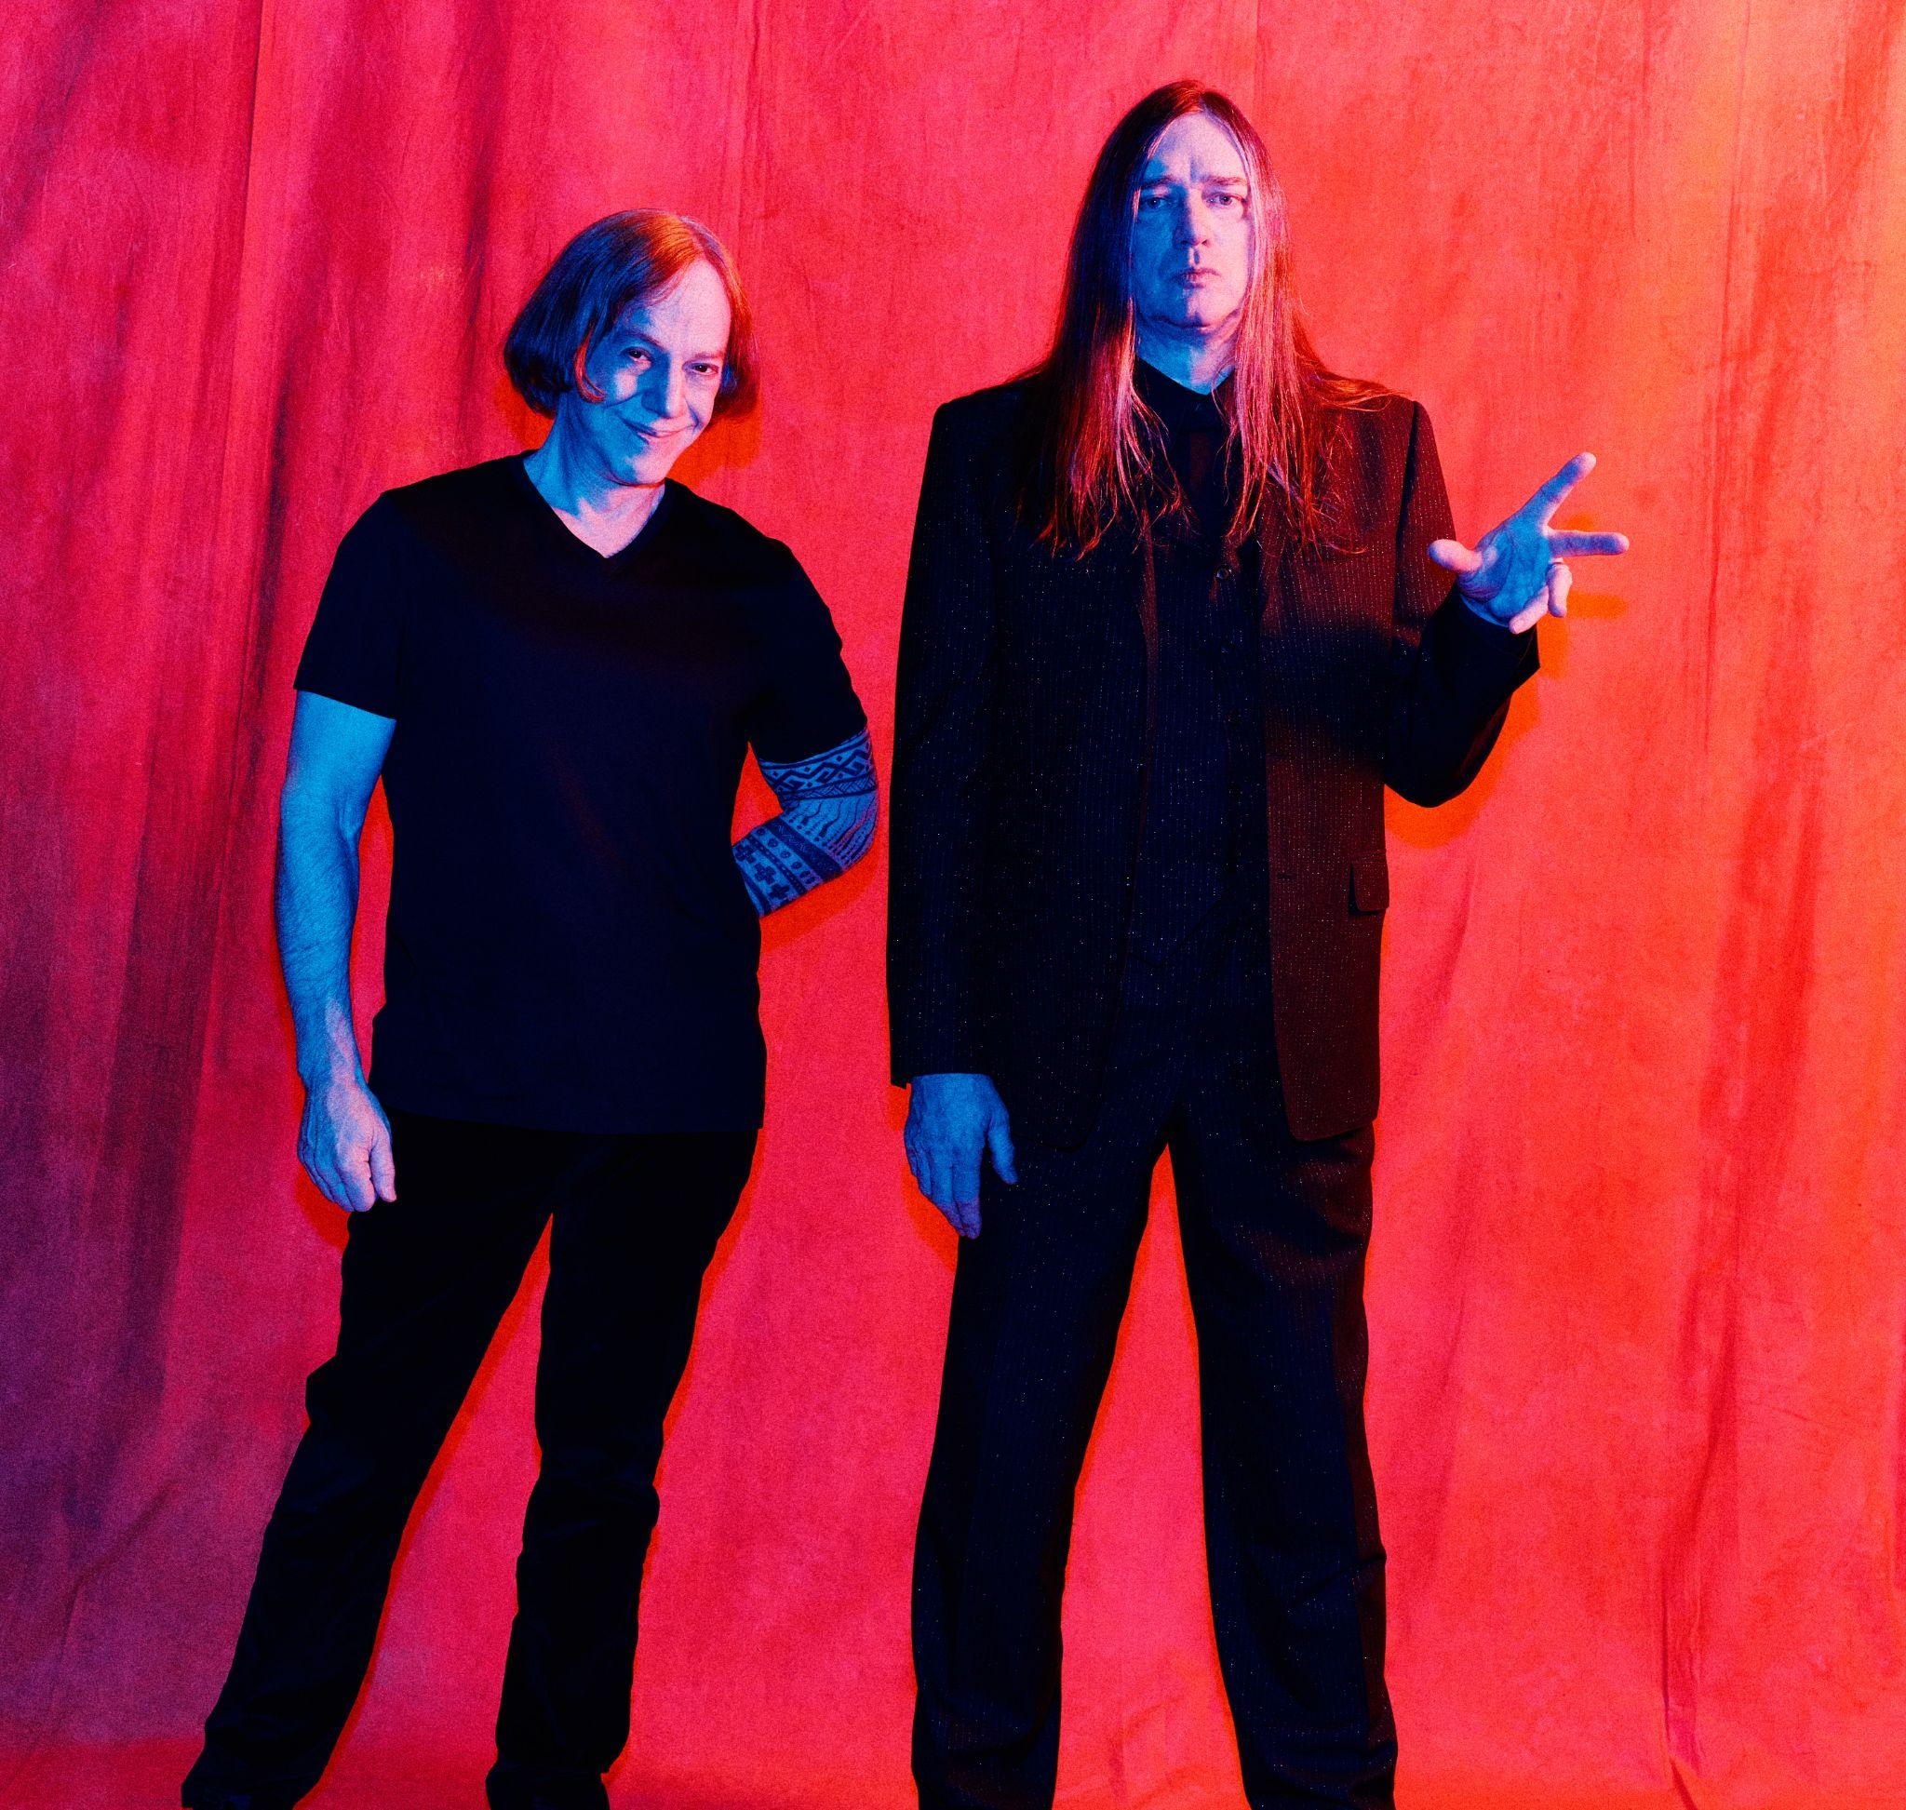
Danny Elfman & Blixa Bargeld (Photo Credit: Stini Röhrs)

###

CONNECT WITH DANNY ELFMAN:
https://www.dannyelfman.com/
Instagram | Facebook | Twitter | Spotify

For More Info on Danny Elfman, Contact:
Kelly Kettering | ANTI- Records Publicity | Kelly@epitaph.com
Luke Burland / BB Gun Press / luke@bbgunpress.com
Peter Quinn / BB Gun Press / peter@bbgunpress.com

