May 10, 2022
For Immediate Release

Ezra Furman Announces New Record,
All of Us Flames, Out August 26th via ANTI-

Shares Lead Single/Video, “Forever In Sunset”

Photo Credit: Tonje Thilesen

Ezra Furman announces her new record, All of Us Flames, out August 26th via ANTI-, and unveils the cathartic lead single, “Forever In Sunset.” Inside the world of All of Us Flames, the end of the patriarchal capitalist empire seems both imminent and inevitable, a turn down a path we can’t see yet but can’t avoid, either. Produced by John Congleton, All of Us Flames unleashes Furman’s songwriting in an open, vivid sound whose boldness heightens the music’s urgency. Following previous singles “Book Of Our Names” and “Point Me Toward The Real,” “Forever In Sunset” peers past the scorch of the apocalypse into a vision of collective survival, tracing the ways outcast people can make each other real through mutual belief. The synth-streaked rallying call is presented alongside a gorgeous and tender video directed by Noel Paul.

Watch Ezra Furman’s “Forever In Sunset” Video

“The biggest influence on the lyrics of this song is a conversation I had with a friend of mine. When Covid was first hitting, she was talking to me a lot about how ready she felt. She was like, ‘people who have been comfortable in life are freaking out right now. But queer people like me have been in crisis before. I grew up poor and my family kicked me out when I was a teenager. My world has already ended plenty of times before, and we queers know what to do: we take care of each other, we help each other out, we have a network of support for the crises we know will hit us from time to time.’

And then she lost her job and ended up moving in with me and my family for like three months. And she was right, we were okay and we were taking care of each other.

That influenced a lot of what the whole record is about. But ‘Forever in Sunset’ is specifically a woman who’s been through some shit speaking to a new lover who is becoming attached to them, trying to warn the lover about how she is trouble, about how she has been through crises and they will come again. And that’s just how she lives, never settled, never safe, but also never defeated/finished - "forever in sunset."

Sometimes it feels like crisis is hitting more and more of the general population. They think the world is ending. But people who have been through a personal apocalypse or two have something to teach them. The world doesn’t end, shit just happens and if we don’t die we have to take care of each other.” – Ezra Furman on “Forever In Sunset”

A singer, songwriter, and author whose incendiary music has soundtracked the Netflix show Sex Education, Furman has for years woven together stories of queer discontent and unlikely, fragile intimacies. All of Us Flames is the third installment in a trilogy of albums, beginning with 2018's Springsteen-inflected road saga Transangelic Exodus and continuing with the punk rock fury of 2019's Twelve Nudes. Furman has a knack for zeroing in on the light that sparks when struggling people find each other and ease each other's course. "I started to think of trans women as a secret society across the world: scattered everywhere, but so obviously bound together, both in being vulnerable and having a shared vision to change a fundamental building block of patriarchal society," she says. "I've been building my world of queer pals, and it feels like we're forming a gang."

Furman wrote much of Flames during the early months of the pandemic. "I had no time alone anymore; my house was super crowded," she says. She drove to seek solitude, parked in arbitrary quiet spots around Massachusetts, and began to write. The songs that came flowed toward ideas of communality and networks of care, systems of survival cultivated by necessity among people who have been historically deprived of them. “This is a first person plural album," Furman says. "It's a queer album for the stage of life when you start to understand that you are not a lone wolf, but depend on finding your family, your people, how you work as part of a larger whole. I wanted to make songs for use by threatened communities, and particularly the ones I belong to: trans people and Jews." With Furman’s widened focus, All of Us Flames paints transformative connections among people who unsettle the stories power tells to sustain itself.

On All of Us Flames, the heat of a different world throbs just behind the skin of this one; all around us, openings to it flicker. They vanish almost as soon as they've appeared. But they keep appearing, as if daring us to hold them open, to widen them until they turn into a way.

Pre-Order All of Us Flames

Watch Ezra Furman’s “Book Of Our Names” Visualizer

Watch Ezra Furman’s “Point Me Toward the Real” Visualizer

All of Us Flames Tracklist
1. Train Comes Through
2. Throne
3. Dressed in Black
4. Forever in Sunset
5. Book Of Our Names
6. Point Me Toward the Real
7. Lilac and Black
8. Ally Sheedy in The Breakfast Club
9. Poor Girl A Long Way From Heaven
10. Temple Of Broken Dreams
11. I Saw the Truth Undressing
12. Come Close

Ezra Furman Tour Dates
Thu. May 19 - Los Angeles, CA @ Teragram Ballroom *
Sat. May 21 - San Francisco, CA @ August Hall *
Mon. May 23 - Seattle, WA @ The Crocodile *
Tue. May 24 - Vancouver, BC @ Hollywood Theatre *
Wed. May 25 - Portland, OR @ Wonder Ballroom *
Thu. May 26 - Boise, ID @ Visual Arts Collective *
Sat. May 28 - Denver, CO @ Gothic Theatre *
Mon. May 30 - Des Moines, IA @ Gas Lamp *
Tue. May 31 - Minneapolis, MN @ Fine Line *
Wed. Jun. 1 - Chicago, IL @ Thalia Hall *
Thu. Jun. 9 - Somerville, MA @ Crystal Ballroom (Ezra Solo)
Thu. Jul. 21 - Valencia, ES @ Diversity Festival
Sun. Jul. 24 - Hertfordshire, UK @ Standon Calling Festival
Sun. Aug. 14 - Des Moines, IA @ Val Air Ballroom ^
Tues. Aug. 16 - Milwaukee, WI @ UWM Panther Arena ^
Wed. Aug. 17 - Indianapolis, IN @ TCU Amphitheater at White River State Park ^
Thu. Aug. 18 - Crickhowell, UK @ Green Man Festival
Tues. Aug 23 - Edinburgh, UK @ Edinburgh International Festival
Mon. Sep. 12 - Montreal, QC @ La Sala Rosa !
Tue. Sep. 13 - Toronto, ON @ Rec Room !
Wed. Sep. 14 - Detroit, MI @ The Loving Touch !
Thu. Sep. 15 - Pittsburgh, PA @ Mr Small's !
Fri. Sep. 16 - Baltimore, MD @ Ottobar !
Sun. Sep. 18 - Philadelphia, PA @ Underground Arts !
Mon. Sep. 19 - Providence, RI @ Fete Ballroom !
Tue. Sep. 20 - Boston, MA @ The Sinclair !
Wed. Sep. 21 - New York, NY @ Webster Hall !
Thu. Sep. 22 - Dover, DE @ Firefly Festival
Mon. Oct. 31 - Bruges, BE @ Cactus Club
Tue. Nov. 1 - Paris, FR @ Le Trabendo
Wed. Nov. 2 - Utrecht, NL @ Tivoli Vredenburg
Thu. Nov. 3 - Hamburg, DE @ Uebel & Gefährlich
Sat. Nov. 5 - Cologne, DE @ Kulturkirche
Sun. Nov. 6 - Berlin, DE @ Festsaaal Kreutzberg
Mon. Nov. 7 - Prague, CZ @ Roxy
Tue. Nov. 8 - Vienna, AT @ Arena Wien
Wed. Nov. 9 - Graz, AT @ Dom Im Berg
Sat. Nov. 12 - Fribourg, CH @ Fri-Son
Sun. Nov. 13 - Munich, DE @ Freiheitshalle
Mon. Nov. 14 - Frankfurt, DE @ Zoom
Wed. Nov. 16 - Brighton, UK @ St Georges Church
Thu. Nov. 17 - London, UK @ The Roundhouse
Sat. Nov. 19 - Birmingham, UK @ The Mill
Mon. Nov. 21 - Manchester, UK @ O2 Ritz

* w/ Grace Cummings
^ w/ Jack White
! w/ Art Moore

Download cover art & hi-res images of Ezra Furman
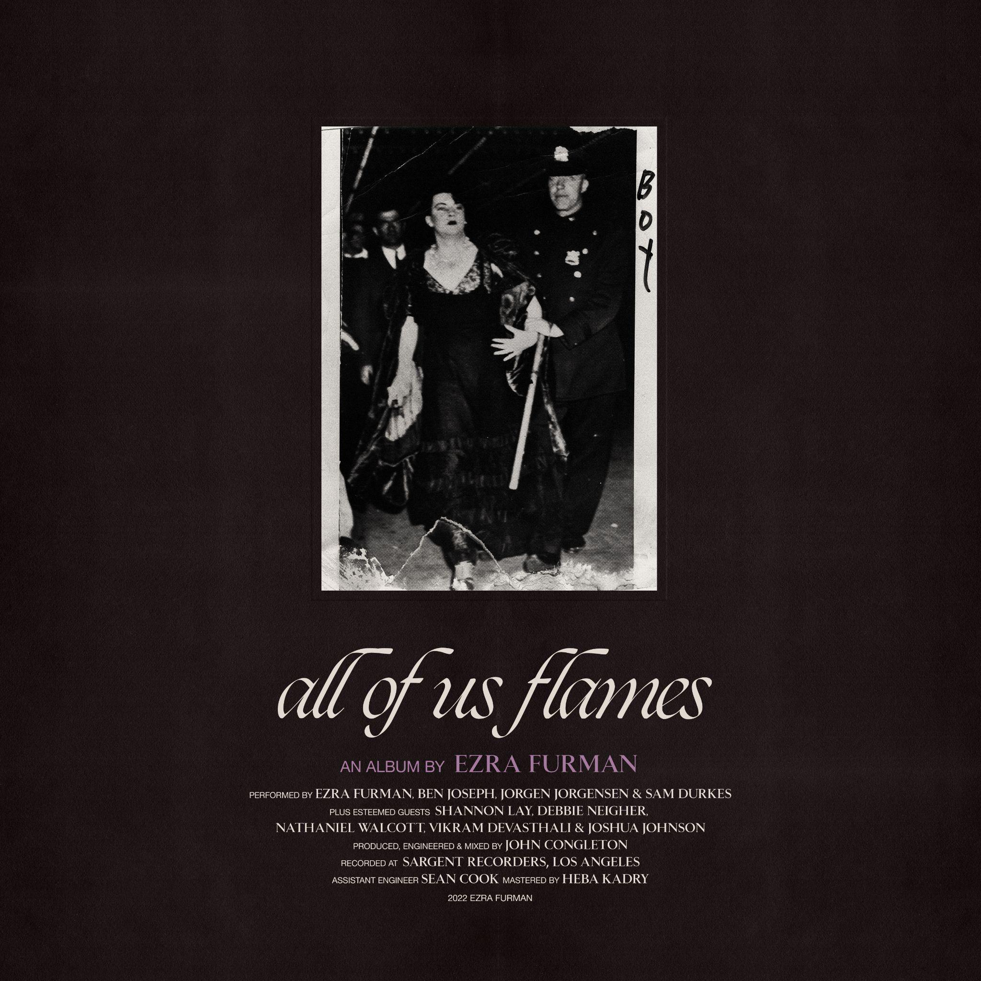
All of Us Flames Cover Artwork

Ezra Furman Online:
Official Site | Facebook | Twitter | Instagram

For more information, please contact:
Yuri Kwon | Pitch Perfect PR – yuri@pitchperfectpr.com, 773-654-1477
Sam McAllister | Pitch Perfect PR - sam@pitchperfectpr.com, 773-942-6573

###

