July 12, 2022
For Immediate Release

Ezra Furman Unveils New Single, “Lilac and Black”

New Album, All of Us Flames, Out August 26th via ANTI-/Bella Union

Photo Credit: Tonje Thilesen

“With influences from Sixties girl groups to Bob Dylan’s Eighties records, [Furman] wrote the album during the early days of the pandemic, meshing growling vocals with songs about building communities in the ashes of a hostile world.” — Rolling Stone

"Ezra Furman is ready to get away from all of the bulls–t.” — Billboard

“[‘Book Of Our Names’ is a] queer liberation protest song” — them.

Ezra Furman unveils a new single “Lilac and Black” off her forthcoming record, All of Us Flames, out August 26th via ANTI- & Bella Union. Produced by John Congleton, All of Us Flames unleashes Furman’s songwriting in an open, vivid sound whose boldness heightens the music’s urgency. “We’ve been alone too long / We belong together with our weapons drawn,” Furman sings on “Lilac and Black,” detailing a revenge plot where she and her “queer girl gang” drive out their oppressors and claim a hostile city for themselves.

Furman elaborates, “I’ve started to think of us trans women as a kind of secret gang, scattered across the world. Or that we could be that. So I wrote this theme song for us, and gave us some gang colors: lilac and black. Unfortunately, being trans usually comes with some kind of threat to one’s well-being or even one’s life. The hostility toward us right now is intense and the stakes are high. This song is an expression of deep solidarity and willingness to defend our lives.Being an inherently peaceful person, I hate to imagine it, but there are times that violent self-defense, or defense of others, is the moral and necessary path. This song is about being ready for that.” Furman continues, “It’s also about how being trans so often feels like a war we never asked for. On top of the seemingly endless social stigma and barriers to our general thriving, various governments have now set in motion a concerted movement to virtually outlaw healthy trans existence. Let it be known: we demand safety, resources and dignity, and we are ready to fight for our lives and the lives of others.”

Watch Ezra Furman’s “Lilac and Black” Visualizer

All of Us Flames is the third installment in a trilogy of albums, beginning with 2018's Springsteen-inflected road saga Transangelic Exodus and continuing with the punk rock fury of 2019's Twelve Nudes. Writing much of Flames during the early months of the pandemic, Furman drove to seek solitude, parked in arbitrary quiet spots around Massachusetts, and began to write. The songs that came flowed toward ideas of communality and networks of care, systems of survival cultivated by necessity among people who have been historically deprived of them. With Furman’s widened focus, All of Us Flames paints transformative connections among people who unsettle the stories power tells to sustain itself.

A singer, songwriter, and author whose incendiary music has soundtracked the Netflix show Sex Education, Furman has for years woven together stories of queer discontent and unlikely, fragile intimacies. All of Us Flames is “a queer album for the stage of life when you start to understand that you are not a lone wolf, but depend on finding your family, your people, how you work as part of a larger whole. I wanted to make songs for use by threatened communities, and particularly the ones I belong to: trans people and Jews.”

Pre-Order All of Us Flames

Watch the “Forever In Sunset” Video

Watch the “Book Of Our Names” Visualizer

Watch the “Point Me Toward the Real” Visualizer

Ezra Furman Tour Dates
Thu. Jul. 21 - Valencia, ES @ Diversity Festival
Sun. Jul. 24 - Hertfordshire, UK @ Standon Calling Festival
Sun. Aug. 14 - Des Moines, IA @ Val Air Ballroom ^
Tues. Aug. 16 - Milwaukee, WI @ UWM Panther Arena ^
Wed. Aug. 17 - Indianapolis, IN @ TCU Amphitheater at White River State Park ^
Thu. Aug. 18 - Crickhowell, UK @ Green Man Festival
Tues. Aug 23 - Edinburgh, UK @ Edinburgh International Festival
Wed. Aug 24 - Leeds, UK @ Brudenell Social Club
Mon. Sep. 12 - Montreal, QC @ La Sala Rosa !
Tue. Sep. 13 - Toronto, ON @ Rec Room !
Wed. Sep. 14 - Detroit, MI @ The Loving Touch !
Thu. Sep. 15 - Pittsburgh, PA @ Mr Small's !
Fri. Sep. 16 - Baltimore, MD @ Ottobar !
Sun. Sep. 18 - Philadelphia, PA @ Underground Arts !
Mon. Sep. 19 - Providence, RI @ Fete Ballroom !
Tue. Sep. 20 - Boston, MA @ The Sinclair !
Wed. Sep. 21 - New York, NY @ Webster Hall !
Thu. Sep. 22 - Dover, DE @ Firefly Festival
Mon. Oct. 31 - Bruges, BE @ Cactus Club *
Tue. Nov. 1 - Paris, FR @ Le Trabendo *
Wed. Nov. 2 - Utrecht, NL @ Tivoli Vredenburg *
Thu. Nov. 3 - Hamburg, DE @ Uebel & Gefährlich *
Sat. Nov. 5 - Cologne, DE @ Kulturkirche *
Sun. Nov. 6 - Berlin, DE @ Festsaaal Kreutzberg *
Mon. Nov. 7 - Prague, CZ @ Roxy *
Tue. Nov. 8 - Vienna, AT @ Arena Wien *
Wed. Nov. 9 - Graz, AT @ Dom Im Berg *
Thurs. Nov 10 - Leipzig, DE @ Transcentiry Update Festival
Sat. Nov. 12 - Fribourg, CH @ Fri-Son *
Sun. Nov. 13 - Munich, DE @ Freiheitshalle *
Mon. Nov. 14 - Frankfurt, DE @ Zoom *
Wed. Nov. 16 - Brighton, UK @ St Georges Church *
Thu. Nov. 17 - London, UK @ The Roundhouse *
Sat. Nov. 19 - Birmingham, UK @ The Mill *
Mon. Nov. 21 - Manchester, UK @ O2 Ritz *

^ w/ Jack White
! w/ Art Moore
*w/ The Golden Dregs

Download cover art & hi-res images of Ezra Furman
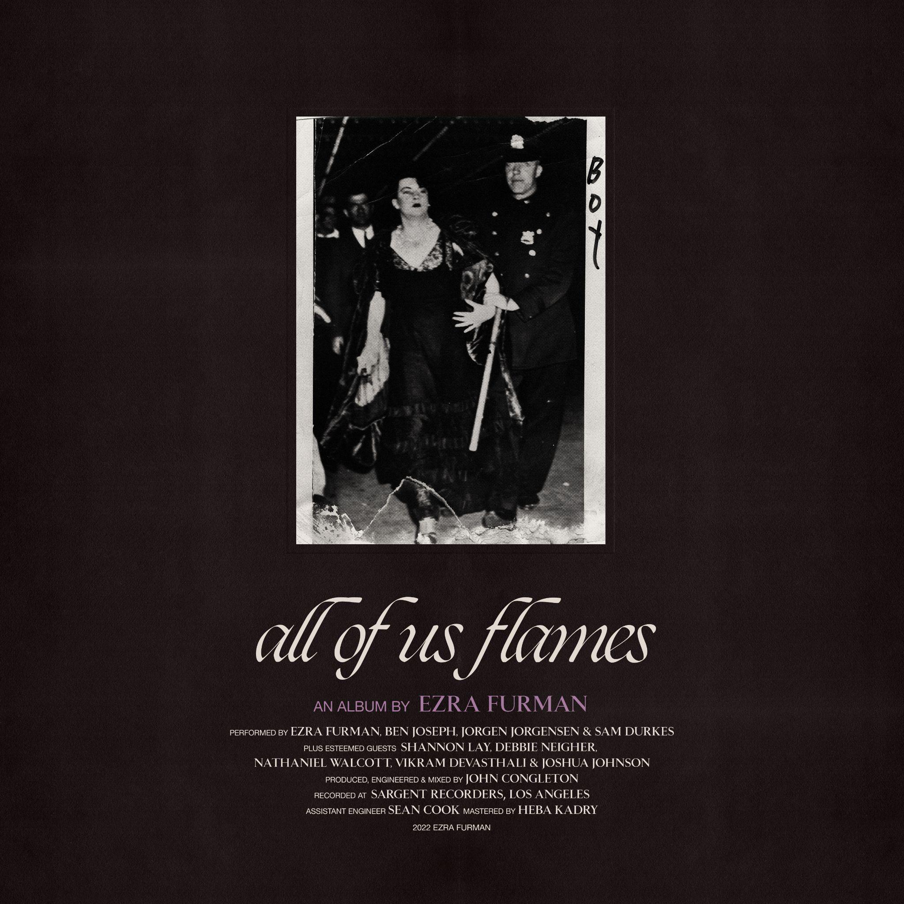
All of Us Flames Cover Artwork

Ezra Furman Online:
Official Site | Facebook | Twitter | Instagram

For more information, please contact:
Yuri Kwon | Pitch Perfect PR – yuri@pitchperfectpr.com, 773-654-1477
Sam McAllister | Pitch Perfect PR - sam@pitchperfectpr.com, 773-942-6573

###

