Release A Very Lonely Solstice This Friday, December 10
13-Tracks Recorded in December 2020, at Brooklyn’s St. Ann & the Holy Trinity Church

Fourth Studio Album Shore Nominated for
Best Alternative Music Album at the 64th GRAMMY Awards

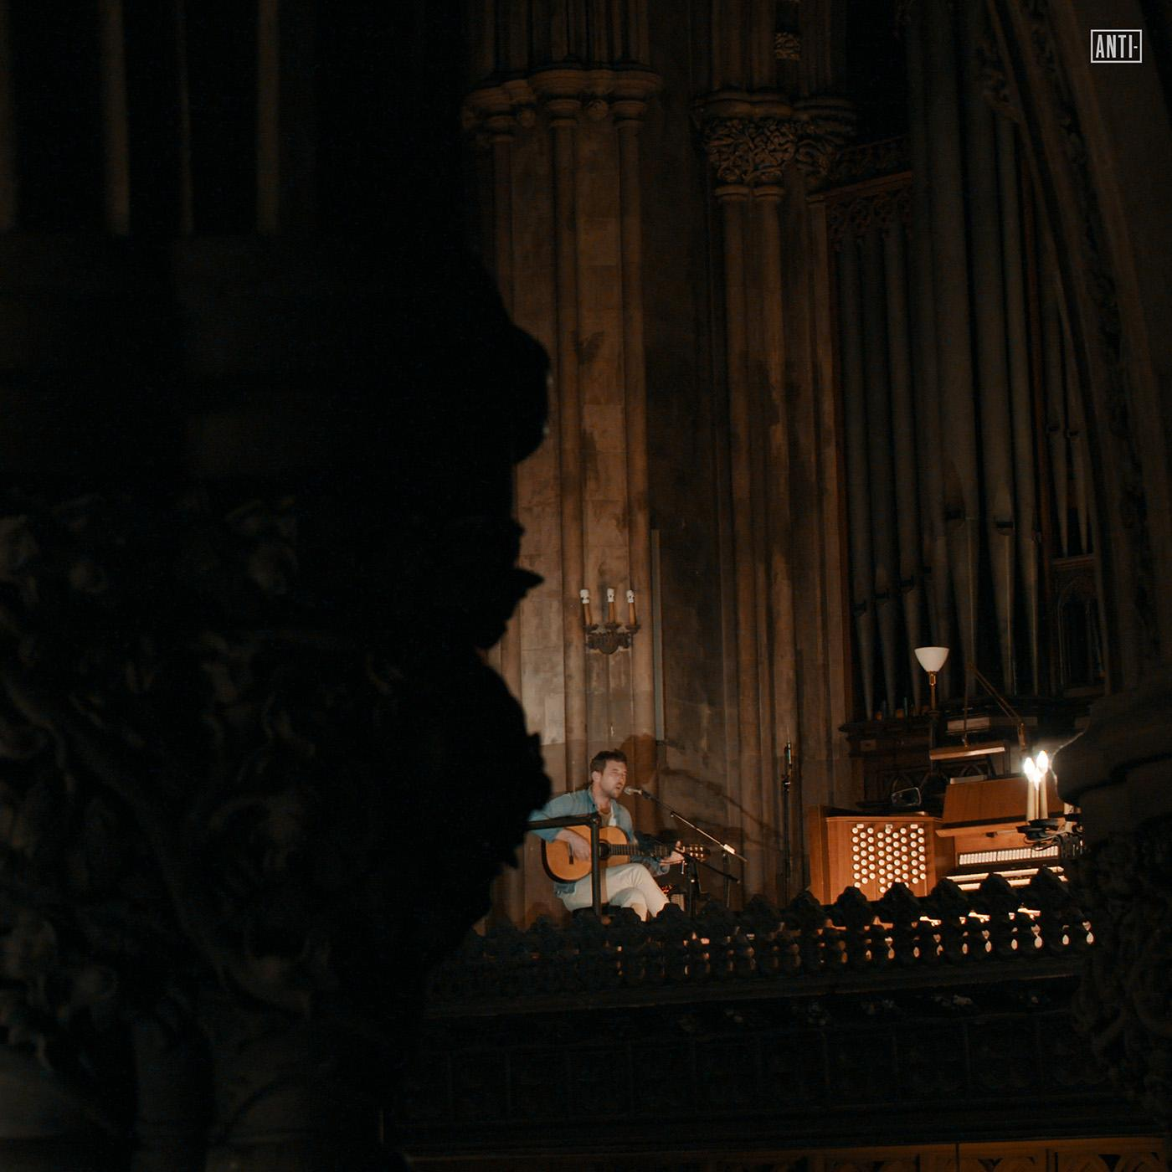
Download high-res art here

[Los Angeles - December 6th, 2021] Robin Pecknold brings light to the bleakest of winters with Fleet Foxes’ A Very Lonely Solstice, a 13-track career spanning collection recorded in December 2020, at Brooklyn, NY’s St. Ann & the Holy Trinity Church. A Very Lonely Solstice is out digitally this Friday, December 10th and available to preorder now on limited edition colored vinyl & CD in the Fleet Foxes store with orders expected to ship in Spring 2022.

In addition, the filmed recording will arrive on YouTube on Friday, December 10th as a premiere event at 12pm PT/ 3pm ET, followed by a Q&A with Robin Pecknold hosted by Elia Einhorn (Sonos Radio, Pitchfork Radio, Talkhouse, Vans Channel 66 DJ) for YouTube Premium subscribers. Set a reminder here.

Now being released for the first time on vinyl, CD and digital formats, A Very Lonely Solstice captures a poignant moment in time. The recording was originally broadcasted as a live-stream event on the winter solstice of 2020, just days after New York declared a state of emergency tightening restrictions again in response to increasing COVID-19 cases. Pecknold describes the set as “me by myself on the longest night of the year… honoring the loneliness of 2020 with a nylon string and some songs new and old.” Fans worldwide tuned in while quarantined at home, finding solace and a sense of community in a period of extreme isolation.

Much of A Very Lonely Solstice showcases a solo focus on Pecknold who offers up acoustic arrangements of fan-favorite songs spanning Fleet Foxes’ catalog. Selections cover all four of the band’s studio albums, including their 2008 self-titled debut album (“Tiger Mountain Peasant Song”) to 2011’s Helplessness Blues (“Blue Spotted Tail”) and 2017’s Crack-Up (“If You Need To, Keep Time On Me”), all the way to their latest GRAMMY nominated release, Shore. Resistance Revival Chorus joins Pecknold on Shore tracks “Wading In Waist-High Water” and “Can I Believe You.” Also featured: a cover of Nina Simone’s “In The Morning” and a rearrangement of the traditional “Silver Dagger.”

This month, Fleet Foxes fourth studio album Shore was nominated for the 64th GRAMMY Awards in the category of Best Alternative Music Album. This is the second nomination for the band, whose sophomore release Helplessness Blues was nominated as Best Folk Album in 2012.

A Very Lonely Solstice Tracklisting
1. Wading In Waist-High Water
2. Sunblind
3. In The Morning
4. Tiger Mountain Peasant Song
5. Maestranza
6. Helplessness Blues
7. Silver Dagger
8. Featherweight
9. A Long Way Past The Past
10. Blue Spotted Tail
11. If You Need To, Keep Time on Me
12. I'm Not My Season
13. Can I Believe You

Promotional Materials Available HERE

Follow Fleet Foxes:
Website - Instagram - Robin’s Instagram - Facebook

For more information on Fleet Foxes, please contact Grandstand Media:
Kate Jackson - katej@grandstandhq.com
Katie Nelson - katien@grandstandhq.com

