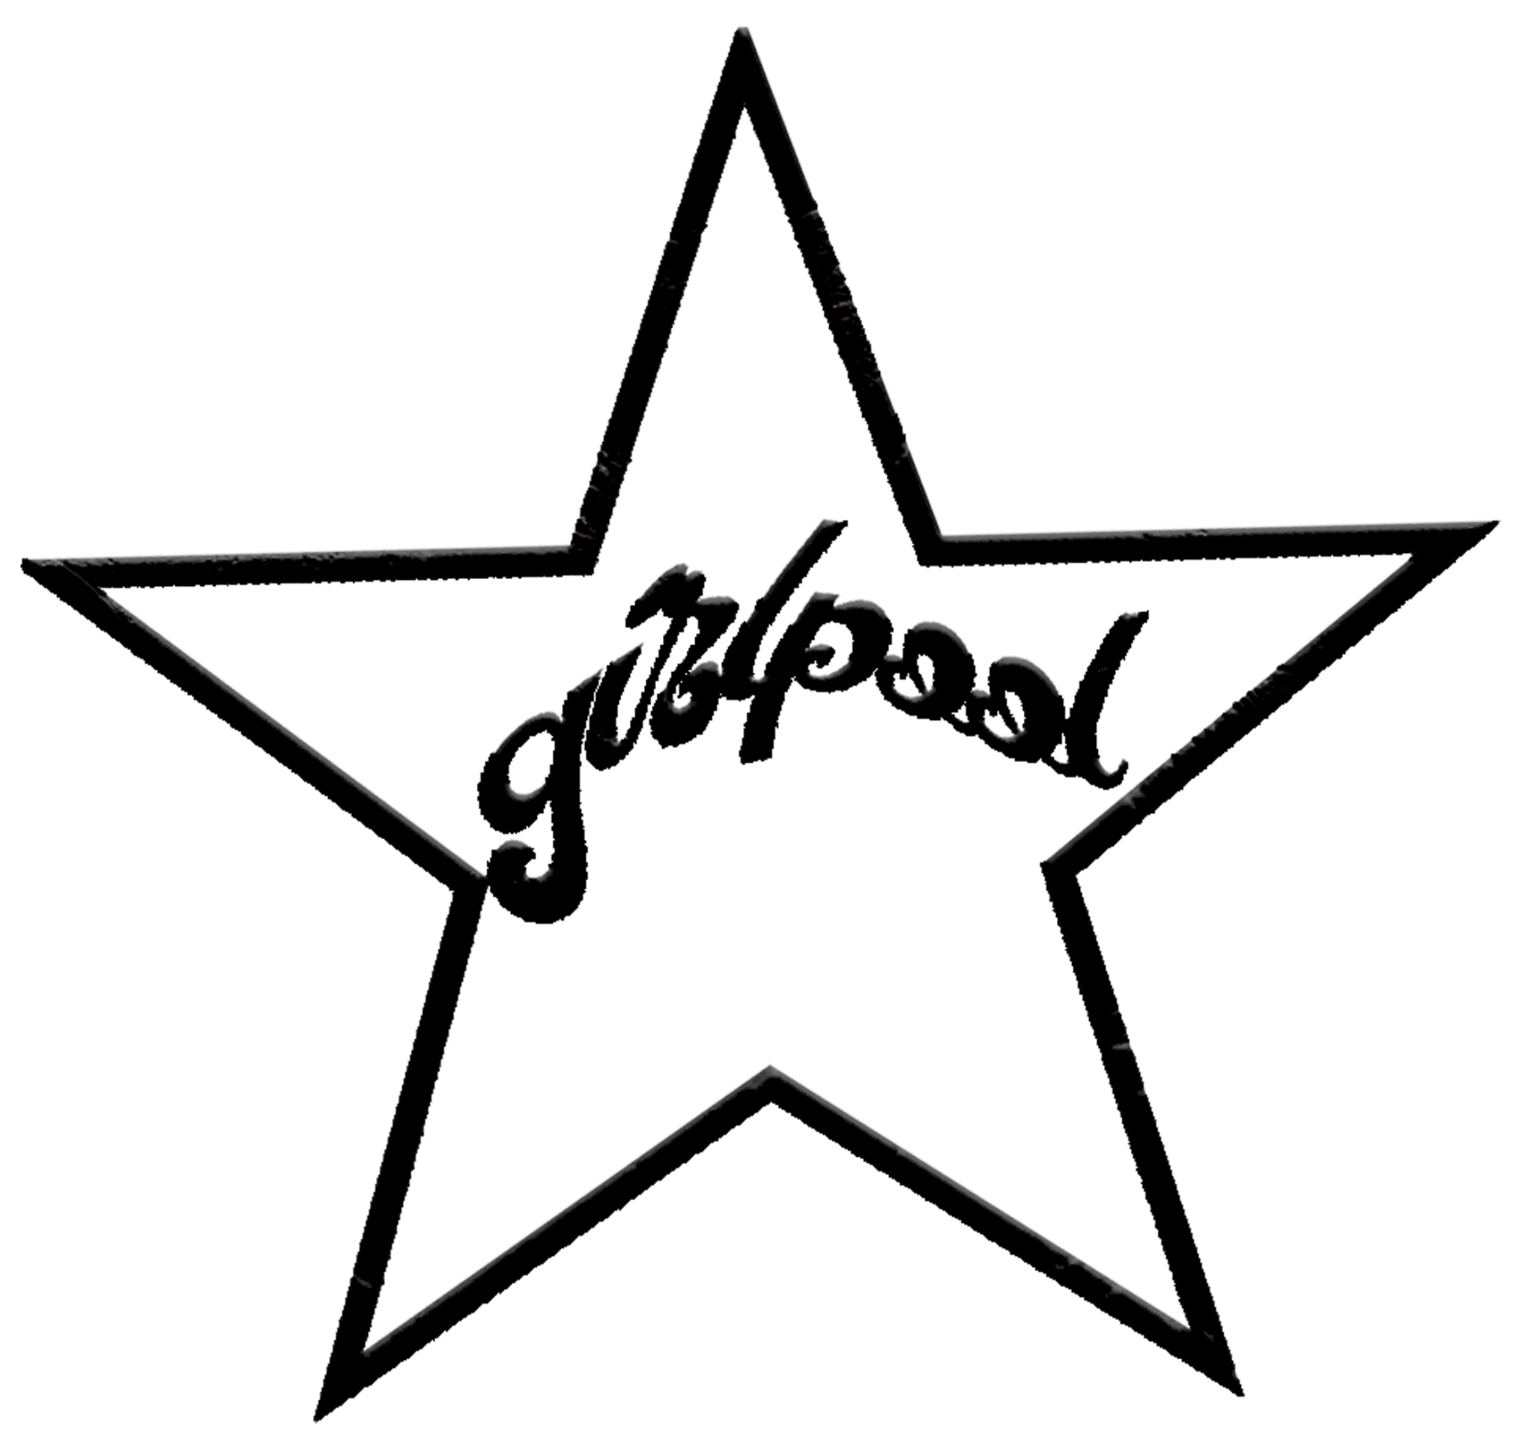

ANNOUNCE NEW ALBUM
FORGIVENESS
OUT APRIL 29TH VIA ANTI- RECORDS

WATCH VIDEO FOR LEAD SINGLE “LIE LOVE LULLABY”

Photo Credit: Amalia Irons (download hi-res)
Early Praise for Forgiveness:

“A country guitar twang, Harmony Tividad’s breathy coos and a sense of impressionistic abandon conjure a cinematic intensity on ‘Faultline.’ But Girlpool doesn’t stop there — instead, it returns with the same propensity for piercing, bleeding-heart lyricism that has defined its work.”
-The New York Times

“On ‘Faultline,’ Girlpool embrace balladry. As they’ve moved from the rough-edged DIY sound of their earliest work to the heavier guitar of 2019’s What Chaos Is Imaginary, Harmony Tividad and Avery Tucker have evolved toward a less abrasive but equally immersive expression of sentimentality. Now, two years later, the duo turns to a smoothed-out, ethereal pop sound with the help of producer Yves Rothman.”
-Pitchfork

“The verses and choruses stream into each other like poetry, each line more transfixing than the last.”
-Billboard

“Few bands have evolved as gracefully as Girlpool… ​​Radiates with pure emotion.”
-MTV

"Swooning and romantic... Despite the heavenly vibe suggested by the track’s soft drums and majestic strings, there’s a darkness bubbling under with Harmony Tividad[‘s] singing."
-The FADER

"Dark and alluring indie rock... A foray into Girlpool’s more experimental direction, creating new textures."
-Paste

“Immaculate… A serene, almost country-tinged track that touches on giving up too much of yourself for someone unworthy.”
-PAPER

“Serves as an introduction to a new sound and feel for Girlpool, wherein the gentle harmony and the song’s melody soars.”
-UPROXX

“A shimmering music box, spinning round and round and there’s no end in sight. It’s one of the band’s loveliest-sounding songs, but it’s also one of their saddest.”
-Stereogum

Girlpool, the Los Angeles duo comprised of Avery Tucker (he/him) and Harmony Tividad (she/her), announce their new album, Forgiveness, out April 29th via ANTI-. The announcement comes with an Amalia Irons-directed video for the album’s lead single “Lie Love Lullaby.”

“‘Lie Love Lullaby’ is a song about a time where I felt that my innocence affected my ability to choose a person who was good for me,” says Tucker. “In the past, it's been painful to choose somebody that didn’t believe in me, and I think the most painful part was that I allowed myself to pick a person that didn’t recognize my entirety. I wrote this song wondering, did I recognize it myself? If I had the wherewithal to tolerate their minimizing perspective?”

Forgiveness, which finds the duo embracing weirdo-pop decadence without sacrificing the poetic curiosity that has always made their music so absorbing, is also their slickest and most ambitious album to date. It’s filled with idiosyncratic and provocative gestures that simultaneously support and complicate the emotionally intricate material. With its unique blend of introspective earworms and surreal party music, Forgiveness reaches beyond the loosely sketched parameters of “indie rock,” challenging any preconceived notions of what a Girlpool album can or should be.

To support their vision of a sound at the intersection of Hollywood futurism and post-grunge sincerity, Girlpool enlisted help from producer Yves Rothman (Yves Tumor, Miya Folick). While they had conversations with other potential collaborators, Rothman’s genuine enthusiasm for crafting music at that crossroads — freaky and fucked-up, but also heartfelt and grounded — helped seal the deal. Rothman’s input on Forgiveness marked the first time Harmony and Avery allowed someone all the way inside their intimate, borderline telepathic approach to song-making — a pure partnership that has remained constant, even as the music has evolved.
WATCH THE “LIE LOVE LULLABY” VIDEO

Avery Tucker and Harmony Tividad have been making critically-acclaimed music as Girlpool since they were high schoolers, scurrying around Los Angeles’ all-ages concert spaces and skipping class to play gigs with their friends. As their radically minimal first full-length Before The World Was Big was winning them fans far beyond the DIY circles they came from, the duo was testing out life on the east coast, where they continued to translate the bittersweet beauty of late-adolescence into melodic punk and indie-pop. Their next two albums, Powerplant and What Chaos Is Imaginary, are sonic time capsules documenting their development — as songwriters, but also as humans, moving through the world together and separately.
A few years ago, Girlpool returned full-time to their hometown of Los Angeles. Now in their mid-20s, Avery and Harmony are coming to terms with what it means to re-engage with the sprawling sunburnt metropolis of their youth as adults. Unsurprisingly, they’ve started making songs that feel as complex and mysterious as the experiences that have shaped this tumultuous era of their lives.

Just like they did for What Chaos Is Imaginary, Harmony and Avery each wrote their Forgiveness songs separately, then came together to decide how to present them in a style that felt representative of what excites and inspires them now. These songs investigate the always-shifting boundaries between a number of elementally human concepts: pain and pleasure, sex and love, reality and delusion, insecurity and confidence, grief and growth.
“A lot of my songs on this record are about relationship dynamics where I experienced frustration and pain, and struggling to hold a lot of complexity in my emotions” Avery explains. “Writing Forgiveness helped me fit all those pieces into an acceptance: that my fate pushes me exactly where I need to go.” Harmony feels similarly: “A lot of life feels like unavoidable experiences to me,” she adds. “To me, Forgiveness is about accepting that concept. It’s about forgiving reality for having to be exactly what it is all the time.”

The aesthetic and thematic breaking points explored on Forgiveness, a collection of songs written by two distinct artists with their own minds and hearts, could have resulted in an album that felt disjointed or unfocused. In Avery and Harmony’s hands, though, these fault lines generate more beauty than tension, as if in Girlpool’s world the movement of tectonic plates doesn’t spell disaster, but rather marks the beginning of something else, something exquisite and new. In this instance, it’s signaling a major step forward for two of this generation’s most accomplished chroniclers of life and love at the edge of the world.

Artwork Credit: (download hi-res)

1. Nothing Gives Me Pleasure
2. Lie Love Lullaby
3. Violet
4. Junkie
5. Dragging My Life Into A Dream
6. Faultline
7. Light Up Later
8. Country Star
9. Butterfly Bulletholes
10. Afterlife
11. See Me Now
12. Love333

WEBSITE | TWITTER | INSTAGRAM | FACEBOOK | BANDCAMP | SPOTIFY

