October 30, 2023
For Immediate Release

MJ Lenderman Announces New Live Album,
And The Wind (Live and Loose!), Out November 17th On ANTI-

Watch “You Have Bought Yourself a Boat” Live Video
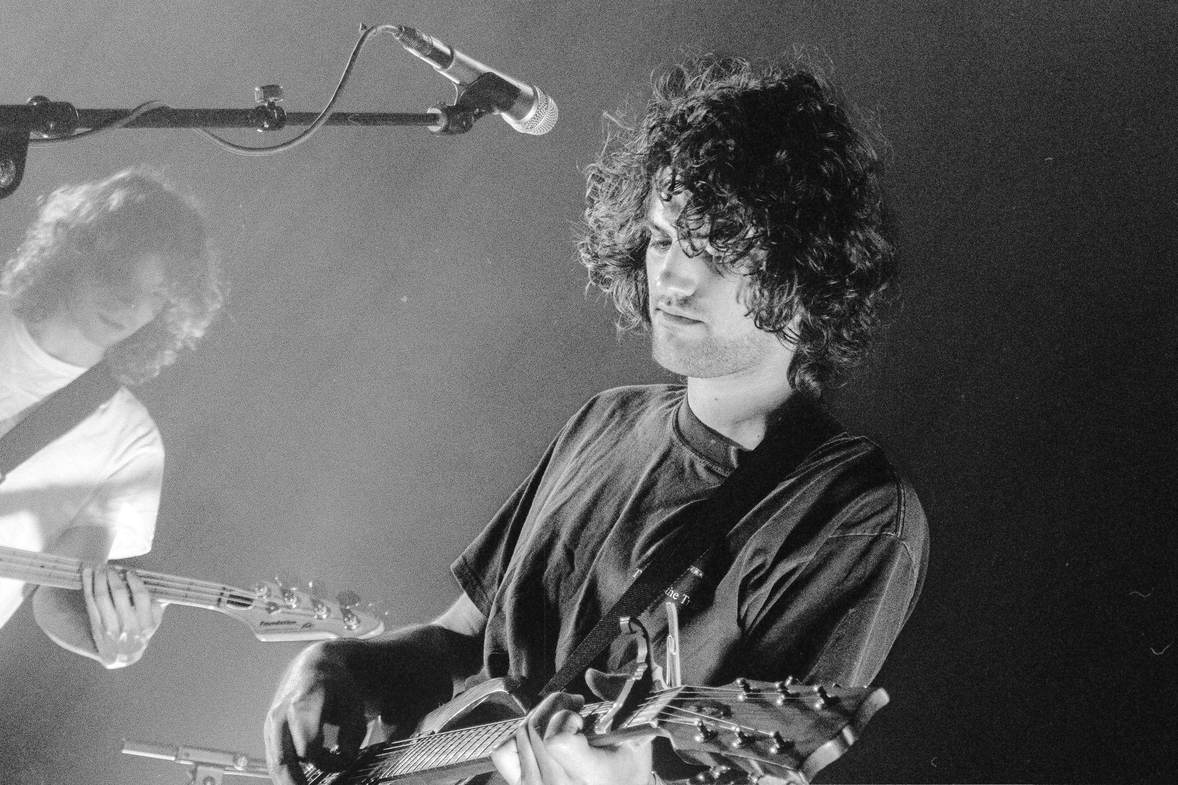
Photo Credit: Yailene Leyva

"MJ Lenderman Is Knockin’ On Rock Stardom’s Door” — Stereogum

"Lenderman’s universe is a familiar one [...] but he moves through it with the grace and conviction of someone born into it." — Pitchfork [BEST NEW TRACK]

“When the scruffy electric-guitar riffs mesh with the pedal steel just right - boom - transcendence” - The Ringer

"[MJ Lenderman] brings exceptional humor, wit and empathy to twangy tracks about fulfillment and failure" — NPR Music, The Best Rock Albums of 2022

Today, Asheville musician MJ Lenderman announces his new live album, And the Wind (Live and Loose!), out November 17th on ANTI-, and presents an accompanying live video for fan favorite “You Have Bought Yourself A Boat.” MJ Lenderman writes songs that are amorphous and elastic, rising to fill the venue they’re in, generous to accommodate the numbers of players on stage (an often unpredictable affair), less concerned with replicating the studio version than they are with meeting the crowd where they’re at. On his records, Lenderman handles most of the playing, but with And the Wind (Live and Loose!) it’s a multi-headed beast. With the help of guitarist Jon Samuels (Friendship, 2nd Grade), drummer Colin Miller, plus fellow Wednesday bandmates Xandy Chelmis (pedal steel) and Ethan Baechtold (bass), And the Wind (Live and Loose!) builds out a number of beloved MJ tracks into something else entirely.

MJ Lenderman And the Wind (Live and Loose!) is culled from sold-out summer 2023 shows on a brief headline run during what some might call a wild-ass couple of months. A nine-week international Wednesday tour, stints in studios with a number of other artists, and Lenderman’s own signing with storied indie label ANTI-. Taped live at Chicago’s Lincoln Hall and Los Angeles’ Lodge Room, And the Wind (Live and Loose!) captures a near-euphoric moment in time — dizzying and exhausting and, most of all, having some real true-blue fucking fun with your best friends.

Watch MJ Lenderman’s “You Have Boat Yourself A Boat (Live)” Video

The songs on Lenderman’s 2021 release, Ghost of Your Guitar Solo (Dear Life Records), are lo-fi, almost skeletal; “Live Jack” a sleepy bedroom mumble, “Catholic Priest” akin to an early Molina ballad. But in the non-stop churn of And the Wind (Live and Loose!), they’ve become boisterous, unwieldy, outgrowing their sparser starts – and now, finally, here the rollicking definitive versions of these songs live outside of the ether of YouTube bootlegs. Even the newer songs, like the just-released “Rudolph,” have room to grow here — namely with a shredding guitar solo courtesy of Samuels that stretches out the second half of the song into a euphoric jam. Boat Songs’ (2022, Dear Life Records) homespun “Dan Marino” is a high-octane ride on And the Wind (Live and Loose!). “Someone Get the Grill Out of the Rain'' punches up its weepy pedal steel, while yowling setlist highlights “Tastes Just it Costs” and “Hangover Game” both come out swinging when played in a roomful of people screaming it back.

It feels like a full-venue affair on some of these songs, especially encore/album closer “Long Black Veil,” a take on the classic country ballad performed alongside tour openers Styrofoam Winos. It’s ‘90s college rock meets Americana hootenanny, an electrifying piece of the MJ Lenderman lore that needs to be experienced live with a light beer in-hand; but in the interim, MJ Lenderman And the Wind (Live and Loose!) does its best to commit the scene to tape.
And the Wind (Live and Loose!) is also available for pre-order on a limited edition cassette from Dear Life Records. Pre-order here.

Pre-order And the Wind (Live and Loose!)

And the Wind (Live and Loose!) Tracklist
1. Hangover Game (Live)
2. Knockin (Live)
3. You Have Bought Yourself A Boat (Live)
4. TLC Cagematch (Live)
4. Rudolph (Live)
5. Toon Town (Live)
6. Dan Marino (Live)
7. Under Control (Live)
8. Dan Marino (Live)
9. SUV (Live)
10. Catholic Priest (Live)
11. Live Jack (Live)
12. Someone Get The Grill Out Of The Rain (Live)
13. You Are Every Girl To Me (Live)
14. Tastes Just Like It Costs (Live)
15. Long Black Veil (Live)

MJ Lenderman Tour Dates
Fri. Dec. 8 - Los Angeles, CA @ Zebulon +
Sat. Dec. 9 - Ojai, CA @ Deer Lodge +
Sun. Dec. 10 - San Francisco, CA @ Rickshaw Stop +
Tue. Dec. 12 - Portland, OR @ Mississippi Studios +
Wed. Dec. 13 - Seattle, WA @ Tractor Tavern +
Tue. Feb. 27, 2024 - Perth, AU @ Perth Festival *
Thu. Feb. 29, 2024 - Sydney, AU @ The Factory *
Sun. Mar. 10, 2024 - Meredith, AU @ Golden Plains Festival

+ Karly Hartzman & MJ Lenderman Solo Show w/ Dan Wriggins
* supporting Wednesday

Download cover art & hi-res images of MJ Lenderman

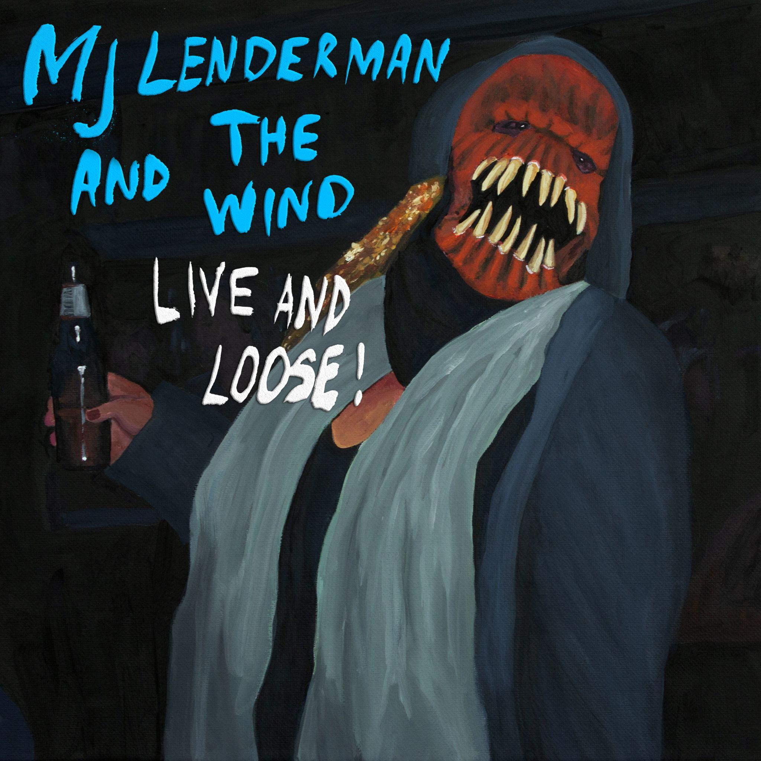
(And the Wind (Live and Loose!) Album Artwork)

Website | Bandcamp | Instagram | Twitter

For more information, contact:
Jessica Linker & Jacob Daneman | Pitch Perfect PR -
jessica@pitchperfectpr.com, jacob@pitchperfectpr.com, 773-942-6573

###

