August 7, 2023
For Immediate Release

MJ Lenderman Presents New Single, “Knockin”

U.S. Tour Runs Through October 14th
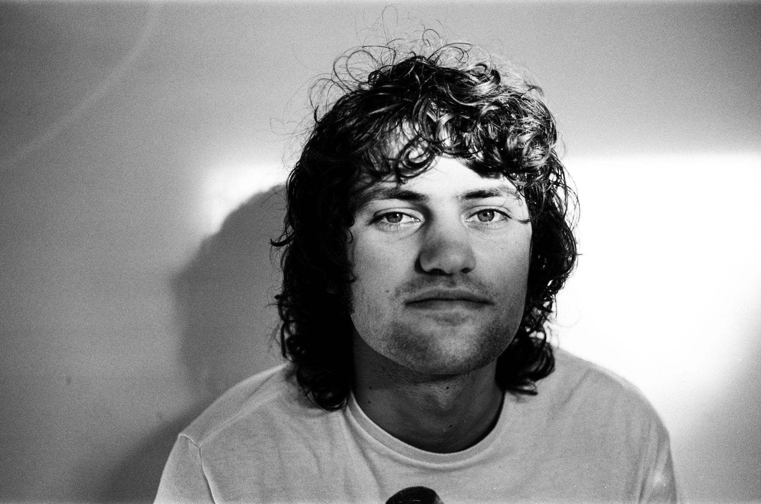
Photo Credit: Charlie Boss

“Hearing his wry stories and those golden, deep fried riffs, I imagined floating down a river on an inner tube, a beer in my hand.” — Pitchfork

"'Rudolph' pairs pure guitar crunch with swooning pedal steel" — Rolling Stone

"'Rudolph' stomps along with a heavy drum groove and melodic pedal steel before Lenderman takes off into a perfectly fuzzed-out guitar solo" — Consequence

"He is one of our best contemporary linguists, coiling slurring prose around the frame of a country track" — Paste

Today, MJ Lenderman presents his new single, “Knockin,” via ANTI-. A beloved staple of his “righteously ragged” (Under The Radar) live sets, “Knockin” is a lightning-in-a-bottle distillation of what makes MJ Lenderman one of the most captivating songwriters in recent memory. First appearing on a self-recorded EP, “Knockin” was written between the recording and release of Lenderman’s 2022 breakthrough Boat Songs. Growing from tender beginnings to a full-blown scream-along chorus, the newly recorded rendition of “Knockin” was recorded at Drop of Sun Studios. Alongside “Rudolph,” the previously-shared “rollicking fusion of country and rock, twangy and heavy at once” (Brooklyn Vegan), “Knockin” will appear on a forthcoming 7-inch single, available for pre-order now and set for release this Fall.

Of “Knockin,” Lenderman adds: “I was spending a lot of time watching John Daly videos and came across a rendition he does of Dylan’s ‘Knockin’ on Heaven’s Door.’ Daly’s version includes an extra verse about golfing. My ‘Knockin’ became a staple of the MJ Lenderman & The Wind live set and it felt like a good idea to re-record it professionally.”

Listen MJ Lenderman’s “Knockin”

Warped pedal steels and skuzzed out guitar; a voice reminiscent of the high-lonesome warble of a choirboy; the keen observations and reflections of a front stoop philosopher. MJ Lenderman’s songs snake their way from a lo-fi home recording to something glossier made with longtime friends at a hometown studio, but the recording setting doesn’t seem to matter much – at its core, a Lenderman song rings true. His music spans stories about everything from a relationship disintegrating outside the high-end butcher shop to a sighting of football star Dan Marino at the local Harris Teeter; from a love song built around a t-shirt kiosk at the airport, or the malaise of a grill rusting in the rain. And those are just some of the things you might find across his three solo records: MJ Lenderman (2019, Sub-Fi), Ghost of Your Guitar Solo (2021, Dear Life), and acclaimed studio debut, Boat Songs (2022, Dear Life).

Lenderman is currently underway on a U.S. tour, performing shows in Pioneertown and Los Angeles, as well as festival performances at Thing Fest and Woodsist Festival. A full list of Lenderman’s tour dates is below and tickets are on sale now.
Watch “Rudolph” Video

MJ Lenderman Tour Dates
Tue. Aug. 8 - Pioneertown, CA @ Pappy + Harriet’s
Thu. Aug. 10 - Los Angeles, CA @ Lodge Room [SOLD OUT]
Fri. Aug. 25 - Port Townsend, WA @ Thing Fest
Sat. Sept. 23 - Sun. Sept. 24 - Accord, NY @ Woodsist Festival
Sat. Oct. 14 - Asheville, NC @ Burnpile Music + Beer Festival

Download cover art & hi-res images of MJ Lenderman

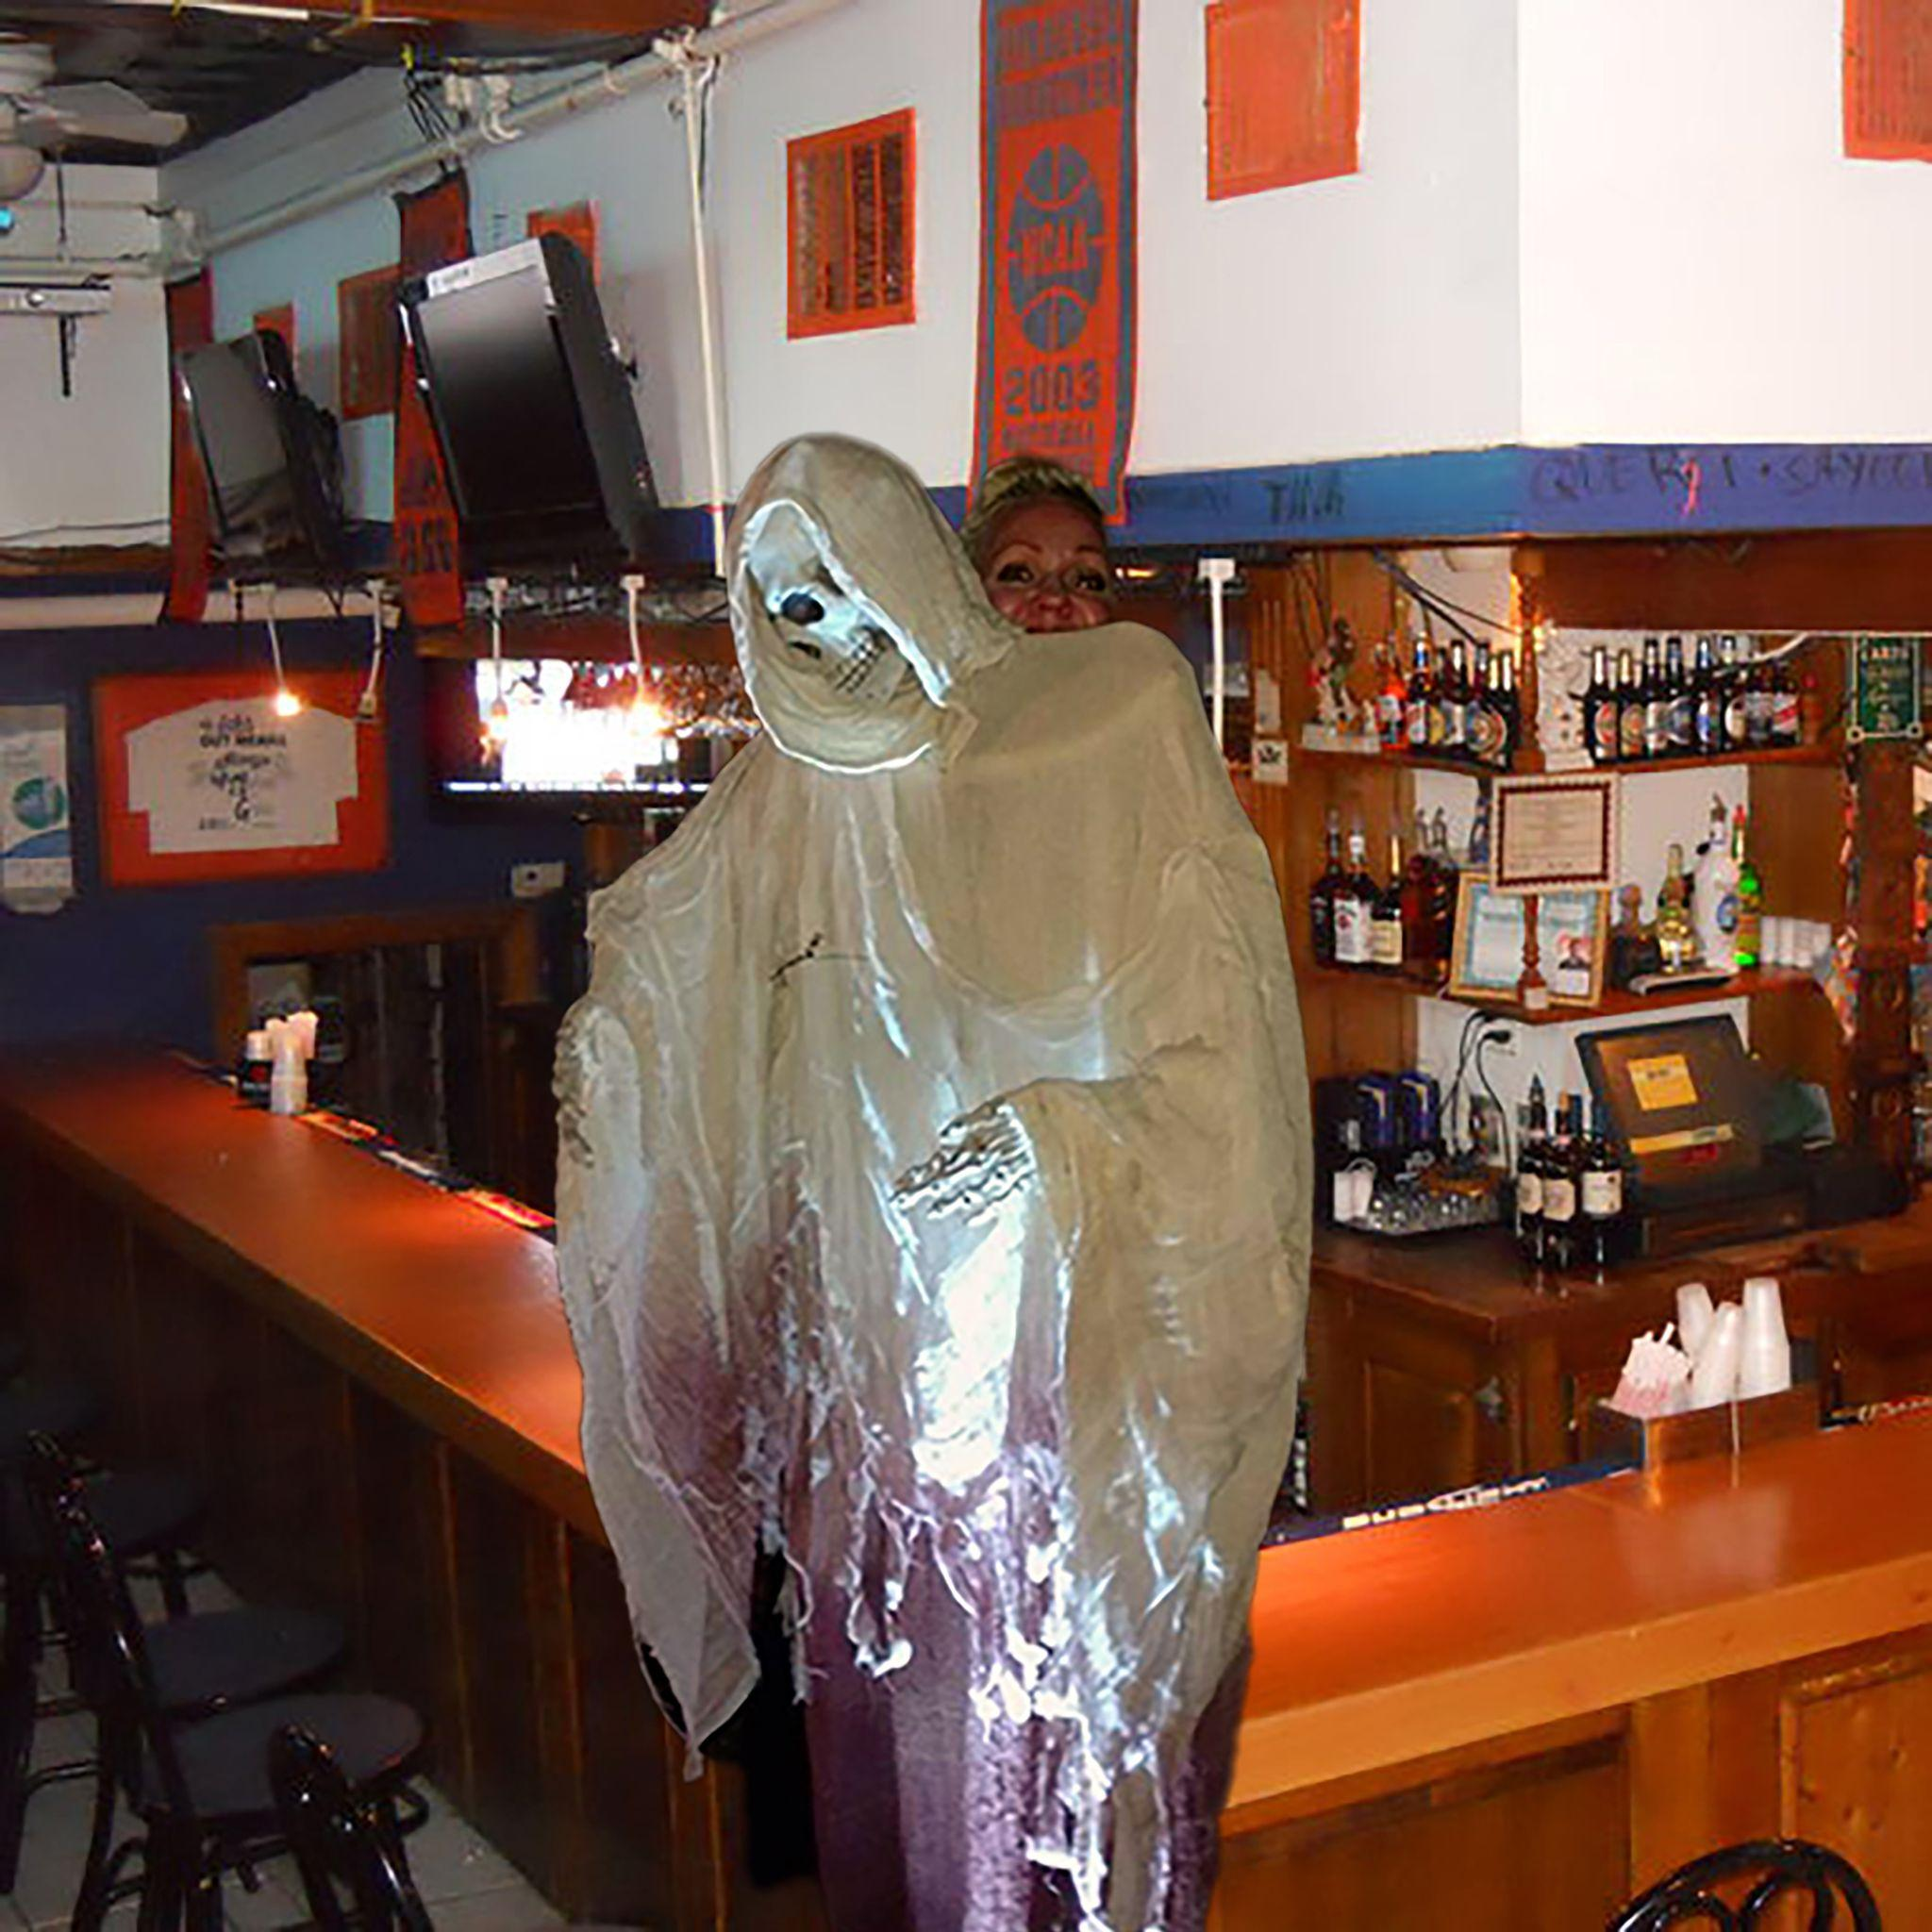
(“Knockin” Cover Artwork)

Website | Bandcamp | Instagram | Twitter

For more information, contact:
Jessica Linker & Jacob Daneman | Pitch Perfect PR -
jessica@pitchperfectpr.com, jacob@pitchperfectpr.com, 773-942-6573

###

