PLAINS
NEW PROJECT FROM
JESS WILLIAMSON & WAXAHATCHEE’S KATIE CRUTCHFIELD

RELEASE VIDEO FOR NEW SINGLE “ABILENE”

I WALKED WITH YOU A WAYS OUT 10/14 VIA ANTI-

NORTH AMERICAN FALL TOUR ANNOUNCED

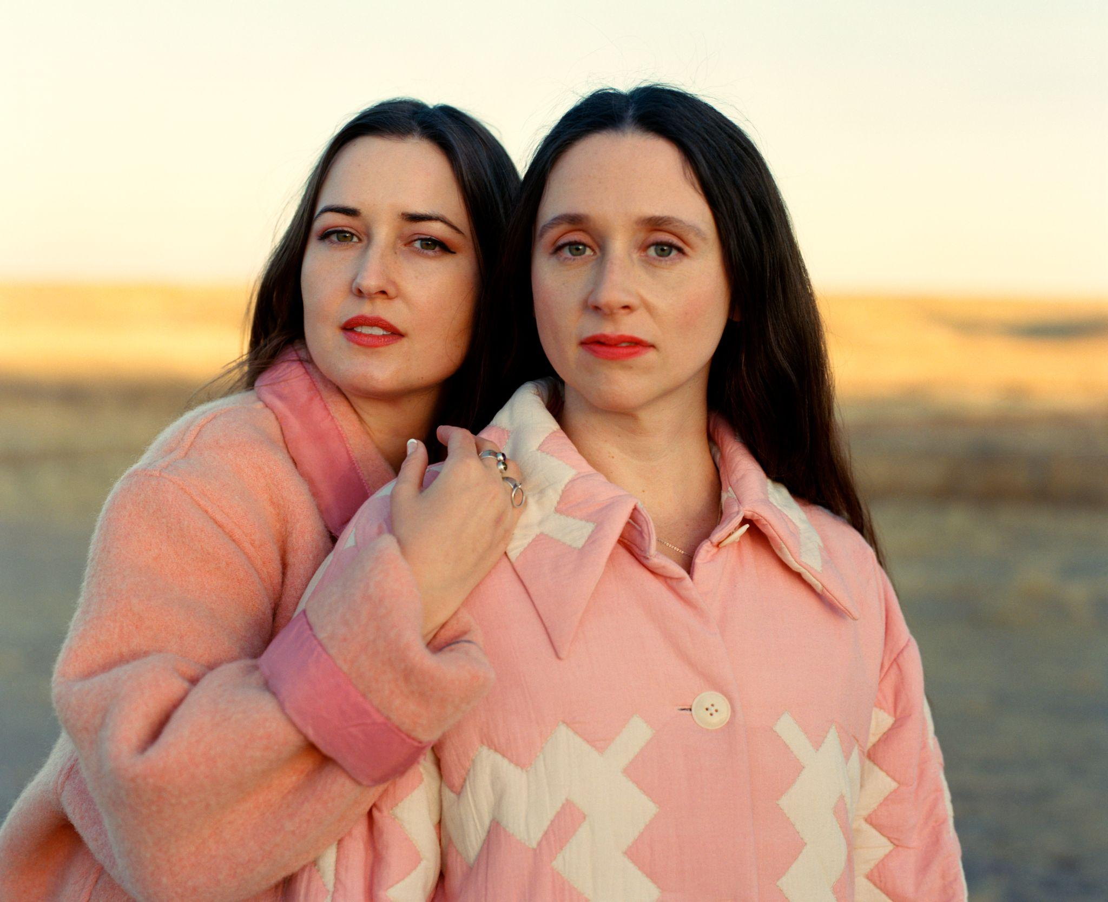
Photo Credit: Molly Matalon (download hi-res)
Jess Williamson and Waxahatchee’s Katie Crutchfield recently announced an album titled I Walked With You A Ways for their new collaborative project, Plains. It’s a one time collaboration with the album out October 14th on ANTI.

Today they give us the second taste of the new album with a video “Abilene,” starring Adriene Mishler of the wildly popular Yoga With Adriene YouTube channel, directed by Corbett Jones & Nick Simonite.

Crutchfield spoke about the new track, saying “The song ‘Abilene’ really solidified the vision of the album for me. I'll never forget how giddy I felt when Jess sent me the original demo. In a very stereotypical-of-a-songwriter way, Jess felt unsure if it fit or made sense & I reassured her immediately that this was probably my favorite song of the bunch. She achieved something really special in my view, which is writing a classic country waltz that feels extremely modern.”

Williamson continues "In the video for ‘Abilene,’ my dear friend Adriene Mishler plays the narrator of the song. We see her struggle in the final stages of a romantic relationship and then make the hard decision to choose herself and leave. I think we all have our own personal ‘Abilene.’ Maybe it’s a place where you used to live and things didn’t turn out as planned, like in the song. It could also be a relationship that ended in disappointment, or a dream that turned into a hard reality, or even an old version of yourself that’s better left in the past. ‘Abilene’ is a song about knowing your worth, having courage in the face of an uncertain future, and trusting your gut."

Plains has already released the album’s lead single “Problem With It” which received widespread critical acclaim.

The record and its accompanying North American tour is a one time only collaboration, which makes Plains incredibly special. All dates are listed below.

ACCLAIM FOR “PROBLEM WITH IT”

"A stunner" - NPR Music

"Crutchfield and Williamson’s voices blend gorgeously on Plains’ hard-driving debut single... Crutchfield’s smoky twang takes center stage on the verses, but Williamson’s harmonies flesh out the chorus so that the lines land like bold, self-assured mantras" - New York Times

"An instant hit that already makes Crutchfield and Williamson’s plan to only ever make one project together seem all too brief." - The FADER

"Crutchfield and Williamson apply their honeysuckle drawls to one of the biggest, stickiest hooks that either of them have written" - Stereogum

"A songwriting force to be reckoned with" - NYLON

"It feels like that spontaneous moment of healing when you’re speeding out of your hometown and away from the heartbreak into the sherbet-colored sunset featured in the accompanying music video." - Paste Magazine

"In a world where art has now been relegated to images on a screen that will never decrease in quality, the flash-in-a-pan nature of Plains is something to take note of. While the nitty gritty of the project is not known, the whole experience of Plains can be compared to a traveling musical. They have their tour planned, and once it is done, it is done…and it is time for the next thing." - The Key XPN

Plains North American Tour
Fri Oct 21: Seattle WA @ The Neptune Theatre
Sat Oct 22: Portland OR @ Revolution Hall
Mon Oct 24: Sonoma CA @ Gundlach Bundschu Winery
Tue Oct 25: San Francisco CA @ The Regency Ballroom
Wed Oct 26: Los Angeles CA @ Belasco Theater
Fri Oct 28: Pioneertown CA @ Pappy and Harriet's
Sat Oct 29: Phoenix AZ @ Crescent Ballroom
Mon Oct 31: Dallas TX @ Studio at The Factory
Tue Nov 1: Austin TX @ Scoot Inn
Thu Nov 3: New Orleans LA @ Tipitina's
Fri Nov 4: Birmingham AL @ Saturn
Sat Nov 5: Nashville TN @ Brooklyn Bowl Nashville
Sun Nov 6: Atlanta GA @ Variety Playhouse
Mon Nov 7: Saxapahaw NC @ Haw River Ballroom
Wed Nov 9: Washington DC @ The Howard Theatre
Thu Nov 10: Philadelphia PA @ Union Transfer
Fri Nov 11: New York NY @ Webster Hall
Sat Nov 12: Jersey City NJ @ White Eagle Hall
Sun Nov 13: Boston MA @ Royale
Tue Nov 15: Toronto ON @ Danforth Music Hall
Wed Nov 16: Detroit MI @ Majestic Theatre
Thu Nov 17: Chicago IL @ Vic Theatre
Fri Nov 18: Minneapolis MN @ First Avenue
Sat Nov 19: Kansas City MO @ Knuckleheads

**All dates w/ MJ Lenderman.

In their solo endeavors you hear a specificity of experience that is so sharp and intimate that it brings the listener into a personal side of the experience of life. With Plains, we are invited into this spaciousness of story, to a shared narrative. There is an essence of their own friendship that clearly emerges that is just as much about joy and playfulness as it is about two people ushering each other through life’s great journeys.

Country music acts - from Waylon and Willie, to The Judds, The Chicks, Trio, and beyond - are groups that are formed out of family and friendship, which lyrically take their listeners on a voyage of sorrow and hope. Similarly, Crutchfield’s sharp, honest edge of truth telling paired with Williamson’s ability to paint the scene shine through on I Walked With You A Ways.

Written between Kansas City, Los Angeles, and Marfa, the album was recorded in Durham, NC with collaborator and producer Brad Cook. The creative magic of only a few vocal takes, tracking with a band comprised of Spencer Tweedy and Phil Cook, gives the album a feel of fresh, on-the-spot conception. The trust and history of Crutchfield and Cook’s collaborations (Saint Cloud, Great Thunder EP) set the tone for this new container of spontaneity and experimentation.
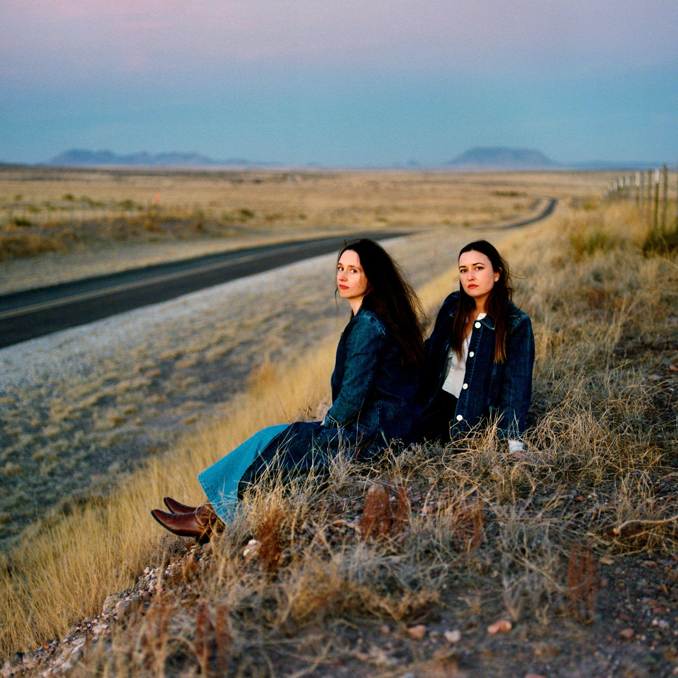
(download hi-res)

Track List:

1- Summer Sun
2- Problem With It
3- Line of Sight
4- Abeline
5- Hurricane
6- Bellafatima
7- Last 2 On Earth
8- Easy
9- No Record of Wrongs
10- I Walked With You A Ways

FOLLOW PLAINS
Website | Twitter | Instagram | Facebook | Spotify

FOLLOW WAXAHATCHEE
Website | Twitter | Instagram | Facebook | Spotify

FOLLOW JESS WILLIAMSON
Website | Twitter | Instagram | Facebook | Spotify

For more information please contact Grandstand Media & Management:
Eloy Lugo + Grace Jones
For tour related inquiries: Katie Nelson

