March 4, 2024
For Immediate Release

Slow Pulp Make Television Debut on CBS Saturday Morning

Touring North America with
Death Cab For Cutie & The Postal Service This Spring

Yard Out Now via Anti-

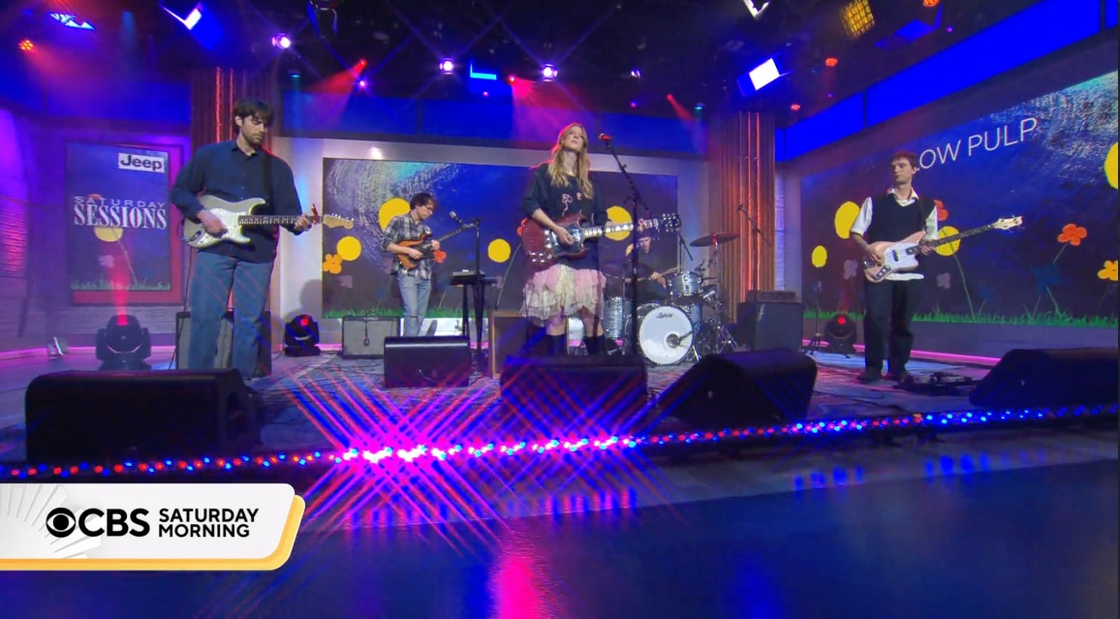
“[Yard] is one of 2023’s best rock records.” - Variety

“Slow Pulp invokes nostalgic memories of friend-filled backseats.” - Rolling Stone

"[Slow Pulp’s songwriting is] sharper-than-ever… chock-full of huge hooks and vivid lyrics."
- Billboard

“[Slow Pulp] motors through big emotions with clear-eyed sincerity, bubblegum hooks, and mellow arrangements that feel like a warm embrace.” - Pitchfork

“The Chicago indie music scene is as robust as any in the country, and Yard illustrates why Slow Pulp belongs at the forefront of the community.” - i-D

This past weekend, Slow Pulp made their television debut on CBS Saturday Morning to perform an array of highlights from Yard, one of 2023’s most beloved records. The Chicago-via-Madison quartet composed of vocalist Emily Massey, guitarist/producer Henry Stoehr, bassist Alex Leeds, and drummer Teddy Mathews released Yard last fall to a warm embrace from critics and fans alike, leading to features in Variety, Billboard, The FADER, Washington Post, and more, plus an almost entirely sold out North American headline tour including three completely sold-out nights in New York City. On CBS Saturday Morning, the band played three standout tracks from Yard - “Slugs,” “a gentle and insistent…sugared, summery indie track” (Paste), the “punky” (The FADER) “Doubt,” and the “cozy and lilting” (Stereogum) “Broadview.” This performance gives a taste of what to expect on their spring tour with Death Cab for Cutie and The Postal Service (a full list of dates can be found below). As the Chicago Tribune praises, “[Yard] has solidified Slow Pulp as one of the best young bands in the country. It is clear Slow Pulp is here to stay.”

Watch Slow Pulp on CBS Saturday Morning
“Slugs”
“Doubt”
“Broadview”

Purchase Yard
Watch “Slugs” Video
Watch “Cramps” Video
Watch “Doubt” Visualizer
Watch “Broadview” Visualizer

Slow Pulp Tour Dates
Tue. April 23 - Alpharetta, GA @ America Bank Amphitheatre &
Wed. April 24 - Orlando, FL @ Amway Center &
Fri. April 26 - Charleston, SC @ Credit One Stadium &
Sat. April 27 - Raleigh, NC @ Coastal Credit Union Music Park at Walnut Creek &
Mon. April 29 - Nashville, TN @ Bridgestone Arena &
Tue. April 30 - Columbus, OH @ The Schottenstein Center &
Thu. May 2 - Pittsburgh, PA @ Petersen Events Center &
Fri. May 3 - Albany, NY @ MVP Arena &
Sat. May 4 - Toronto, ON @ Scotiabank Arena &
Mon. May 6 - Milwaukee, WI @ Miller High Life Theatre &
Tue. May 7 - St. Louis, MO @ Chaifetz Arena &
Thu. May 9 - Kansas City, MO @ T-Mobile Center &
Sat. May 11 - Salt Lake City, UT @ Kilby Block Party
Sun. May 12 - Boise, ID @ Idaho Central Arena &
Tue. May 14 - Vancouver, BC @ Doug Mitchell Thunderbird Sports Centre &
Wed. May 15 - Portland, OR @ Moda Center &
Sat. June 1 - Barcelona, ES @ Primavera Sound
Mon. June 3 - Milan, IT @ Arci Bellezza
Wed. June 5 - Paris, FR @ Point Ephemere
Thu. June 6 - Cologne, DE @ Bumann & Sohn
Fri. June 7 - Brussels, BE @ AB Club
Sun. June 9 - Hilvarenbeek, NL @ Best Kept Secret
Tue. June 11 - Brighton, UK @ Concorde 2
Wed. June 12 - Birmingham, UK @ Hare & Hounds
Fri. June 14 - Glasgow, UK @ The Classic Grand
Sat. June 15 - Dublin, IE @ Whelans
Sun. June 16 - Manchester, UK @ Band on the Wall
Tue. June 18 - Nottingham, UK @ The Bodega Social Club
Wed. June 19 - Cardiff, UK @ Clwb Ifor Bach
Thu. June 29 - London, UK @ Koko

&= w/ Death Cab For Cutie & The Postal Service

More Praise for Yard

“​​Slow Pulp exists in a near-constant state of dazed soul-searching. Across its two albums, the group has made a fuzzy kind of dream pop that scratches the brain with its muted textures.”
- New Yorker

“[Slow Pulp] lean into the empathetic nature of their songwriting and sonically morph based on the guttural feelings of each song… All of this is rooted with a certain ’90s nostalgia alongside a freshness that is endearingly, trademark Slow Pulp.” - The FADER

"Slow Pulp have leveled up to seismic proportions.” - Paste

"Slow Pulp is one of 2023’s best young indie rock bands." - Uproxx

"Be it gentle piano, tasteful but piercing feedback, or singer Emily Massey’s always emotive voice, every moment on Yard hides raw feelings under near-flawless construction.”
- Consequence

"Yard feels like it’s on another level." - Stereogum

Download cover art & hi-res images of Slow Pulp

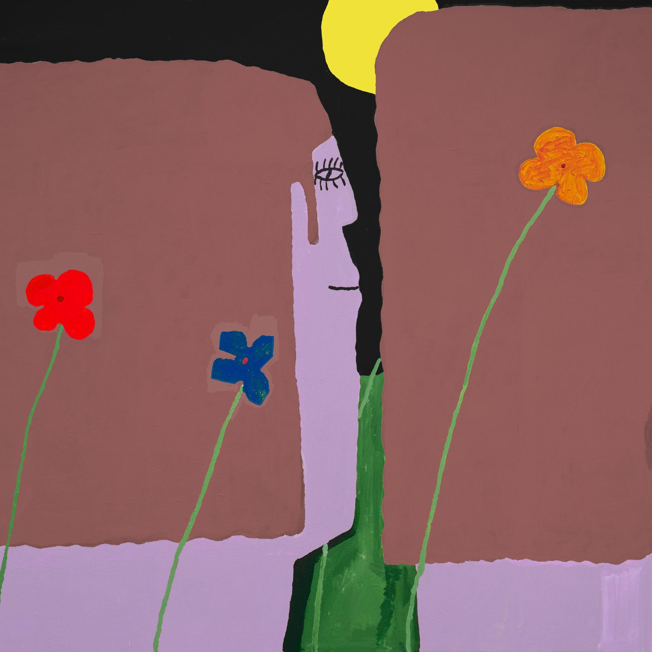
(Yard Cover Artwork by Henry Stoehr)

Slow Pulp Online:
Website | Instagram | Twitter | Facebook | Bandcamp | ANTI-

For more information, contact:
Patrick Tilley, Jaycee Rockhold | Pitch Perfect PR
patrick@pitchperfectpr.com, jaycee@pitchperfectpr.com

##

