June 27, 2022
For Immediate Release

Son Little Announces New Album, Like Neptune, Out Sept. 9th via ANTI-,
and North American Tour

Shares Lead Singles, “deeper” and “stoned love”

(Photo Credit: Cynthia Perez)

Son Little announces his new album, Like Neptune, out September 9th via ANTI-, and a North American tour. In conjunction, he shares two lead singles, “deeper” and “stoned love.” Continuing to revolutionize the modern understanding and expectation of R&B, Son Little delivers an unadulterated transmission of Black American music performed in its praying and pleading mother tongue. Conceived in a cabin overlooking the Delaware River in upstate New York, Like Neptune is an open and vulnerable portrayal of unbridled joy and self-acceptance. In this verdant space of freedom, Son Little transmutes the chronic pain of self-doubt into a beautiful opus about overcoming generational trauma, decorating the altar of the primordial blues and elevating the labor of healing to high art.

"In the beginning of lockdown, I went into a closet full of junk and found a couple of boxes full of my old writing books,” Livingston explained. “There turned out to be 72 books in there. The oldest book I got as a Christmas present when I was 9. In it, I wrote letters to myself about what was happening in my life. One page refers to a neighbor in Queens who abused me sexually around age 5. It was the first and only time I’d ever acknowledge this fact until after my 19th birthday, when I told my mother what had happened. She begged me to go to therapy. I went under protest. My attempt wasn’t sincere. I wasn’t ready. I thought I could just power through it.”

Years of anxiety, depression, panic attacks and existential dread ensued, often dulled or numbed by the effects of alcohol, drugs, or sex. A frightening car crash and arrest finally led him back into therapy in 2017. Aggressively employing progressive methods like EMDR and somatic healing, Livingston, with the help of a trusted therapist, began identifying the roots of his trauma, and where it lives in the body. But the biggest breakthrough came from Internal Family Systems, a methodology that recognizes responses to trauma triggers as distinct entities or ‘parts’ within the person, and requires the patient essentially have conversations with the different traumatized personalities within them.

“One day in therapy I started talking to myself– to that annoying inner voice that criticizes everything when you mess up. I asked them how old they were and they said ‘10’. I asked if they knew who I was, or how old I was and they said ‘no'! Strange as it all seems it’s had some amazing results. I’m able to soothe and comfort my inner…children.”

The open exchange with his wounded inner self challenges a tradition of silence that masks the trauma coursing through the bedrock of the genre; the impact of abuse has infamously undergirded the catalogs and upended the lives of some of R&B’s most iconic musicians. Like Neptune, however, counters that no student or practitioner of the tradition should believe trauma to be a necessary component of their sound. Delving into his journals and happily cooped up inside due to the pandemic, Son Little returned to beat making to craft the core of Like Neptune using apps on his iPad— a method originally tasked with satisfying the nagging urge to create on a daily basis on the road; later he fleshed out the programming and added live instrumentation in Ableton live— while micro dosing LSD and immersing himself in the sounds of ‘70s era David Bowie and psychedelic Amazonian cumbia of the same period.

Today’s “deeper" alludes to Son Little's long-standing desire to understand the human experience beyond mortality, someplace closer to the essence of the divine. Leading into “deeper,” “stoned love” finds him cooing stoner wordplay flanked by the otherworldly synth work of Deshawn “Dvibes” Alexander.

Listen to “deeper” by Son Little

Listen to “stoned love” by Son Little

Noticeably confident from the opening note, Son Little prioritizes his signature rasp as the chief instrument of every song on a 12-track meditation on the mortal struggle to achieve inner peace. Doling out a pearl-strung collection of successive epiphanies he engages each of his re-invigorated parts, empowering them to finally speak freely, with him as the vessel. Like Neptune establishes Son Little as the polyglot translator and rightful torchbearer of the celebrated musical tradition known as rhythm and blues. With it, he completes the daunting tasks of confronting himself and pushing his sound to completion. The result is a timeless body of work reflective of his deep internal desire to inhabit the most radiant version of himself and become a positive force in the lives of people around him.

Son Little will kick off a North America in support of Like Neptune on Tue. Nov. 1st in Los Angeles at the Troubadour. He’ll play a number of west coast cities, including San Francisco, Seattle and Portland before heading through the south and midwest. The tour will conclude with select east coast dates including Brooklyn, Boston, and Philadelphia. A full list of dates is below, with tickets on-sale this Friday.

Pre-order Like Neptune

Like Neptune Tracklist
1. drummer
2. 6 AM
3. like neptune
4. bend yr ear
5. inside out
6. Didn’t Mean a Thing
7. stoned love
8. deeper
9. no friend of mine
10. Playing Both Sides
11. gloria
12. what’s good

Son Little Tour Dates
(new dates in bold)
Sat. July 2 - Portland, OR @ Waterfront Blues Festival 2022
Fri. Sept. 2 - Madrid, ES @ Sala Clamores
Sat. Sept. 3 - Zaragoza, ES @ Rock & Blues Cafe
Sun. Sept. 4 - Barcelona, ES @ La Nau Locales de Ensayo
Wed. Sept. 7 - Hamburg, DE @ Bahnhof Pauli
Thu. Sept. 8 - Berlin, DE @ Privatclub
Fri. Sept. 9 - Köln, DE @ Helios 37
Sat. Sept. 10 - Zürich, CH @ Exil
Mon. Sept. 12 - Antwerpen, BE @ Kavka
Wed. Sept. 14 - Amsterdam, NL @ Paradiso
Thu. Sept. 15 - Rotterdam, NL @ Bird
Fri. Sept. 16 - Paris, FR @ La Maroquinerie
Sat. Sept. 17 - London, UK @ The Garage
Sun. Sept. 18 - Brighton, UK @ The Hope & Ruin
Tue. Nov. 1 - Los Angeles, CA @ Troubadour
Wed. Nov. 2 - San Diego, CA @ Soda Bar
Fri. Nov. 4 - San Francisco, CA @ Great American Music Hall
Sat. Nov. 5 - Santa Cruz, CA @ Moe’s Alley
Mon. Nov. 7 - Seattle, WA @ Neumos
Wed. Nov. 9 - Portland, OR @ Doug Fir Lounge
Thu. Nov. 10 - Boise, ID @ The Olympic
Fri. Nov. 11 - Salt Lake City, UT @ The State Room
Sat. Nov. 12 - Denver, CO @ Bluebird Theater
Tue. Nov. 15 - Dallas, TX @ The Kessler Theater
Wed. Nov. 16 - Austin, TX @ 3TEN ACL Live
Fri. Nov. 18 - Memphis, TN @ Railgarten
Sat. Nov. 19 - Nashville, TN @ The Blue Room at Third Man Records
Thu. Dec. 1 - Charleston, SC @ The Pour House
Fri. Dec. 2 - Atlanta, GA @ Smith’s Olde Bar
Sat. Dec. 3 - Lake Wales, FL @ Orange Blossom Revue
Sun. Dec. 4 - Tampa, FL @ The Attic
Wed. Dec. 7 - Milwaukee, WI @ Back Room at Colectivo
Thu. Dec. 8 - St. Paul, MN @ Turf Club
Fri. Dec. 9 - Chicago, IL @ Chop Shop
Sat. Dec. 10 - Ferndale, MI @ The Loving Touch
Wed. Dec. 14 - Boston, MA @ The Sinclair
Thu. Dec. 15 - Sheffield, MA @ Race Brook Lodge
Fri. Dec. 16 - Brooklyn, NY @ Elsewhere
Sat. Dec. 17 - Philadelphia, PA @ Underground Arts

Download album art & hi-res images of Son Little

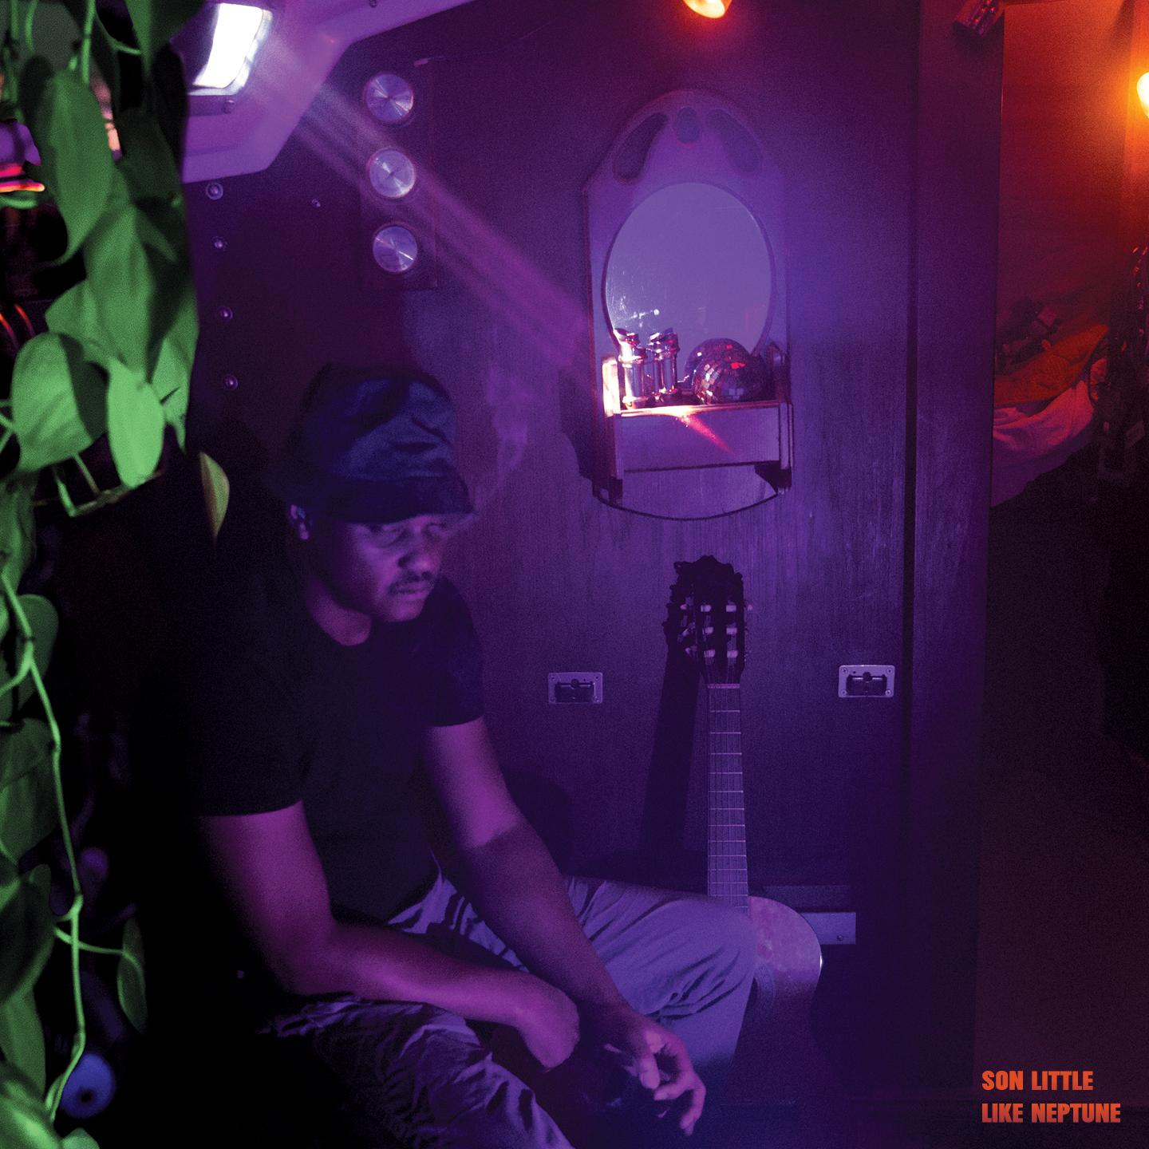
(Like Neptune Cover Artwork)

Artist Site | Facebook | Twitter | Instagram | Youtube | ANTI-

For more information, contact:
Sam McAllister | Pitch Perfect PR - sam@pitchperfectpr.com, 773-942-6573

###

