January 31, 2020
For Immediate Release

Listen to Son Little’s New Album, aloha, Out Today On ANTI-

Watch His Performance On CBS This Morning: Saturday

North American Tour Underway Now

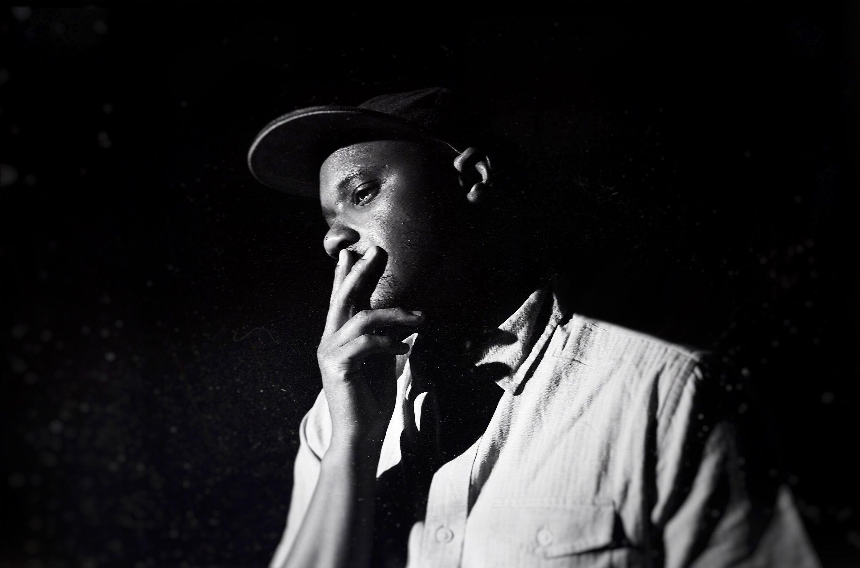
(Photo Credit: Shervin Lainez)

“A deep understanding of classic American roots music ties his records together, lending them old-school credibility even as the occasional unorthodox production choice gives his work a contemporary feel.” — The New York Times

“Son Little has a lithely expressive voice that can locate forgiveness, sorrow, and ecstasy in even the most hackneyed turns of phrase.” — The New Yorker

“The magic at the heart of Son Little‘s music is the way so many of his songs could be standards, but none of them could have come from anyone else.” — Afropunk

Today, Son Little presents his new album, aloha, out now on ANTI-. Written in just eight days and recorded at Paris’s iconic Studio Ferber, aloha was an exercise in letting go and in ceding control. While Little still plays nearly every instrument on the album himself, he worked with an outside producer for the first time - Renaud Letang (Feist, Manu Chao). The album blends classic soul, old-school R&B, and adventurous indie sensibilities into a timeless swirl, resulting in his boldest, most self-assured statement yet.

Stream Son Little’s aloha -
https://sonlittle.ffm.to/aloha

Preceding the release of aloha, Son Little returned to CBS This Morning: Saturday earlier this month. Little gave a compelling performance of three of the album’s tracks - “hey rose,” “about her. again,” and “suffer.” This appearance gives a look at what to expect on his North American tour, which is currently underway. Tickets are available now and a full list of dates can be found below.

Watch Son Little Perform on CBS This Morning: Saturday:
“hey rose” - https://cbsn.ws/2TV2UKc
“about her. again.” - https://cbsn.ws/36nVK3u
“suffer” - https://cbsn.ws/2uzZFwP

Born to a preacher and a teacher in Los Angeles, Little first came to international prominence with his self-titled 2015 debut, following collaborations with hip-hop legends The Roots and electronic pioneer RJD2. In 2016, Little showed off his production chops, earning a GRAMMY Award for his work helming Mavis Staples’ acclaimed See That My Grave Is Kept Clean, and in 2017, he released a critically lauded sophomore album, New Magic.

In order to create aloha, Little began writing and assembling album demos in Petaluma, California. However, after his hard drive fried and he lost nearly a dozen detailed demos, he was forced to begin with a blank slate, leading him to write aloha at a tiny house and its adjacent barn. aloha is a potent reminder that letting go doesn’t mean giving in; in fact, quite the opposite. Letting go can be an act of defiance, of growth, of empowerment.

Watch/Listen/Share:
“hey rose” video - https://youtu.be/KTzEVH4f434
“suffer” video - https://youtu.be/xLo0a_mKmx4
“mahalia” stream - https://youtu.be/Mpcl0_4cPns
“neve give up” video - https://youtu.be/jaZcnBog0Zs

Purchase aloha -
https://sonlittle.ffm.to/aloha

Son Little Tour Dates:
Fri. Jan. 31 - Burlington, VT @ Arts Riot
Sat. Feb. 1 - Portsmouth, NH @ 3s Artspace
Thu. Feb. 13 - Northridge, CA @ Valley Performing Arts Center
Sat. Feb. 15 - Pioneertown, CA @ Pappy & Harriet’s
Sun. Feb. 16 - Morro Bay, CA @ The Siren
Mon. Feb. 17 - Mill Valley, CA @ Sweetwater Music Hall
Tue. Feb. 18 - Santa Cruz, CA @ Moe’s Alley
Thu. Feb. 20 - Edmonton, AB @ Station On Jasper
Fri. Feb. 21 - Calgary, AB @ Block Heater Festival
Sat. Feb. 22 - Winnipeg, MB @ Festival du Voyager
Fri. Feb. 28 - Boulder, CO @ Fox Theatre
Sat. Feb. 29 - Fort Collins, CO @ Washington’s
Fri. March 27 - Brighton, UK @ Patterns
Sat. March 28 - London, UK @ Oslo
Mon. March 30 - Paris, FR @ La Maroquinerie
Tue. March 31 - Antwerp, BE @ Kavka VZW
Wed. April 1 - Amsterdam, NL @ Paradiso Noord
Thu. April 2 - Rotterdam, NL @ Bird
Sat. April 4 - Hamburg, DE @ Bahnhof Pauli
Sun. April 5 - Berlin, DE @ Privatclub
Mon. April 6 - Cologne, DE @ Blue Shell
Tue. April 7 - Zurich, CH @ Exil
Thu. April 9 - Zaragoza, ES @ Rock & Blues Café
Fri. April 10 - Barcelona, ES @ La Nau

Download album art & hi-res images of Son Little -
http://pitchperfectpr.com/son-little

Stream/Purchase Son Little’s invisible EP (digital only) -
https://sonlittle.ffm.to/invisible

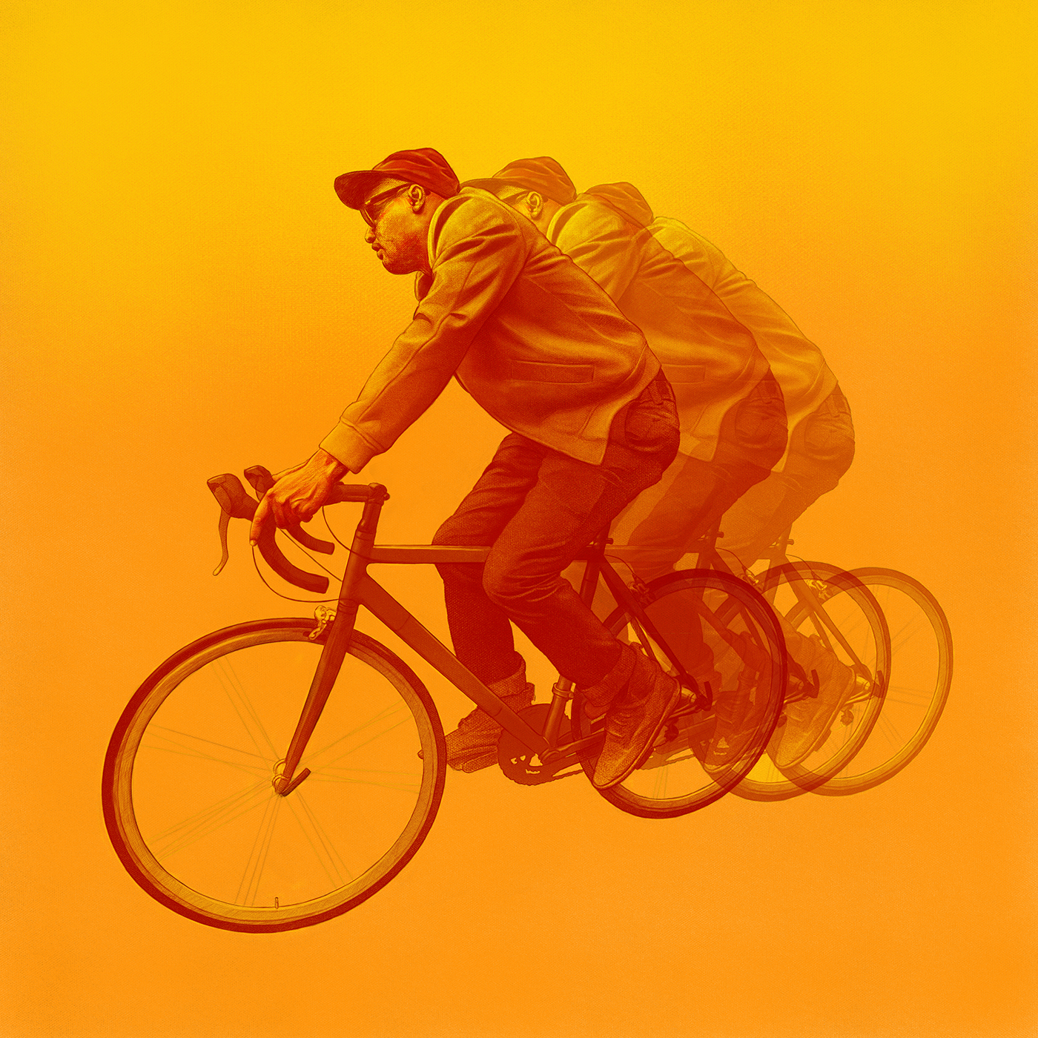
(aloha Album Art)

Artist Site | Facebook | Twitter | Instagram | Youtube | ANTI-

For more information, contact:
Sam McAllister | Pitch Perfect PR - sam@pitchperfectpr.com, 773-942-6573

