September 18, 2019
For Immediate Release

Son Little Returns With invisible, New EP Out October 11th on ANTI-, And Presents Video For New Single “hey rose”

Touring North America In November/December

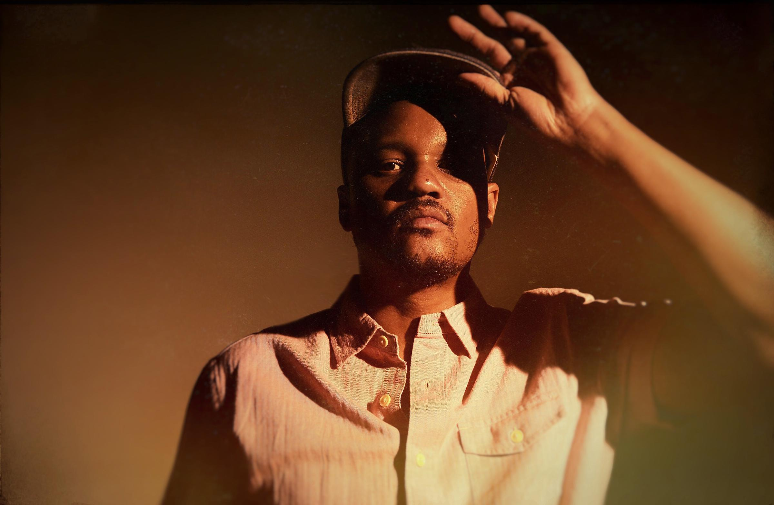
(photo by Shervin Lainez)

Son Little, the musical nom de plume of LA’s Aaron Earl Livingston, whose “impeccably crafted songs are honest and unpretentious” (NPR Music), today announces invisible, a new EP due October 11th via ANTI-. Recorded at Paris’s iconic Studios Ferber with producer Renaud Letang (Feist, Manu Chao), invisible offers up a tantalizing preview of Little’s third full-length album, set for release early next year. Watch the video for lead single, “hey rose,” below.

Watch Video For “hey rose” -
https://youtu.be/KTzEVH4f434

While Little plays nearly every instrument on the EP himself, he put his songs in the hands of an outside producer for the first time here, collaborating with Letang to create his boldest, most self-assured statement yet. Equal parts vintage and modern, the collection blends classic soul, old-school R&B, and adventurous indie sensibilities into a timeless swirl fueled by gritty instrumental virtuosity and raw, raspy vocals. It’s an ambitious work of vision and reflection, to be sure, but more than that, it’s an ecstatic testament to the freedom that comes from letting go.

Little’s newfound liberation is clear from the outset of invisible, which revels in freewheeling wordplay and daring sonic juxtaposition. Opener “hey rose” marries distorted, jittery guitar with smooth, sinuous vocals, while the slow-burning “about her. again.” injects trippy psychedelia into Sam Cooke soul, and a cover of “Skid” from Love’s long lost masterpiece Black Beauty uses a 1973 meditation on homelessness to make a pointed statement about our indifference to suffering in modern America.

Born to a preacher and a teacher in Los Angeles, Little first came to international prominence with his self-titled 2015 debut. While Little had already made a name for himself in his adopted hometown of Philadelphia for his collaborations with hip-hop legends The Roots and electronic pioneer RJD2, critics on both sides of the pond were quick to recognize the unique power of his solo recordings. The album landed Little dates with everyone from Leon Bridges and Kelis to Shakey Graves and Mumford & Sons alongside festival appearances at Bonnaroo, Newport Folk, and more. Never one to rest on his laurels, Little showed off his production chops the following year, earning a GRAMMY Award for his work helming Mavis Staples’ acclaimed See That My Grave Is Kept Clean, and in 2017, he released a critically lauded sophomore album, New Magic.

Little will tour in support of invisible through November and December. A full list of dates are below, with tickets on-sale now.

invisible EP Tracklist:
01. hey rose
02. about her. again.
03. i’m a builder
04. skid
05. hey rose (quantic remix)

Listen to “hey rose” / Pre-save invisible -
https://sonlittle.ffm.to/invisible

Son Little Tour Dates:
Mon. Nov. 11 - San Francisco, CA @ Swedish American Hall
Wed. Nov. 13 - Portland, OR @ The Old Church
Thu. Nov. 14 - Seattle, WA @ The Crocodile
Sat. Nov. 16 - Salt Lake City, UT @ The State Room
Sun. Nov. 17 - Denver, CO @ Daniels Hall
Tue. Nov. 19 - Minneapolis, MN @ Cedar Cultural Center
Wed. Nov. 20 - Chicago, IL @ Old Town School of Folk Music
Thu. Nov. 21 - Ferndale, MI @ Magic Bag
Fri. Nov. 22 - Pittsburgh, PA @ Thunderbird Café & Music Hall
Sat. Nov. 23 - Lancaster, PA @ Chameleon Club
Mon. Nov. 25 - Cambridge, MA @ The Sinclair
Tue. Nov. 26 - New York, NY @ Bowery Ballroom
Fri. Nov. 29 - Philadelphia, PA @ World Cafe Live
Sat. Nov. 30 - Washington, DC @ Rock & Roll Hotel
Sun. Dec. 1 - Asheville, NC @ The Grey Eagle
Tue. Dec. 3 - Nashville, TN @ WMOT Finally Friday - 3rd & Lindsley
Wed. Dec. 4 - Atlanta, GA @ The Earl
Thu. Dec. 5 - New Orleans, LA @ Gasa Gasa
Fri. Dec. 6 - Austin, TX @ 3TEN ACL Live
Sat. Dec. 7 - Dallas, TX @ The Blue Light Dallas
Tue. Dec. 10 - Phoenix, AZ @ Valley Bar
Wed. Dec. 11 - San Diego, CA @ Soda Bar
Thu. Dec. 12 - Los Angeles, CA @ Lodge Room

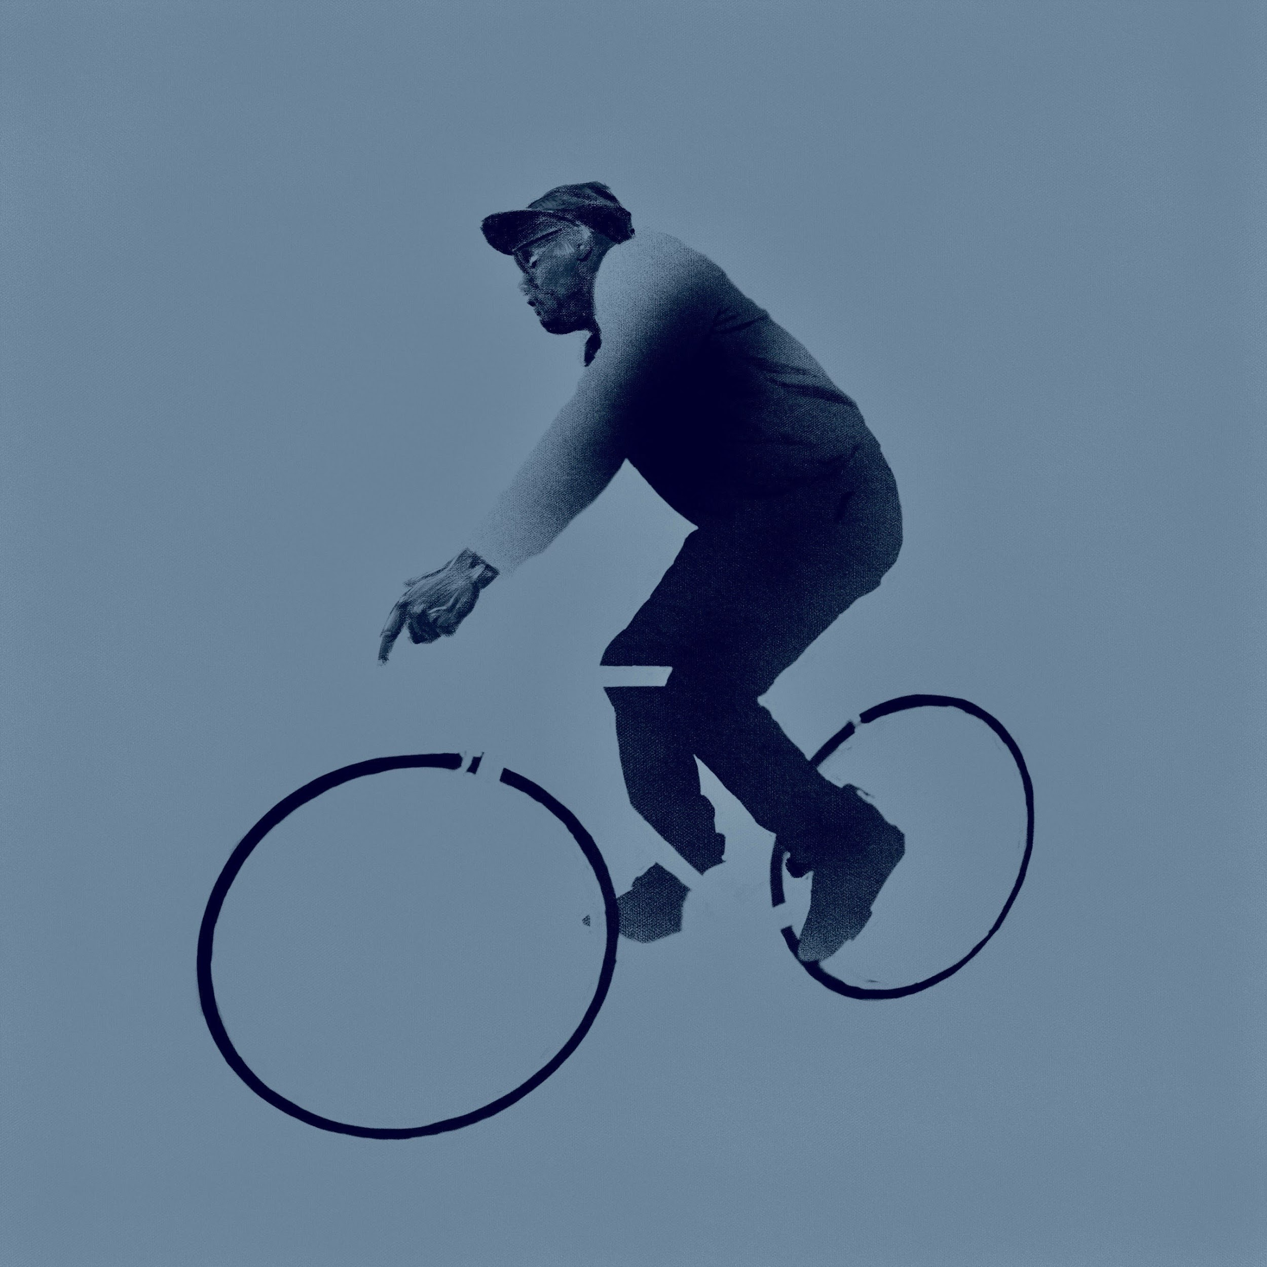
(invisible EP Cover Art)

Artist Site | Facebook | Twitter | Instagram | Youtube | ANTI-

For more information, contact:
Sam McAllister | Pitch Perfect PR - sam@pitchperfectpr.com, 773-271-6844

