January 15, 2020
For Immediate Release

Son Little Presents New Single/Video, “neve give up”

New Album, aloha, Out January 31st On ANTI-

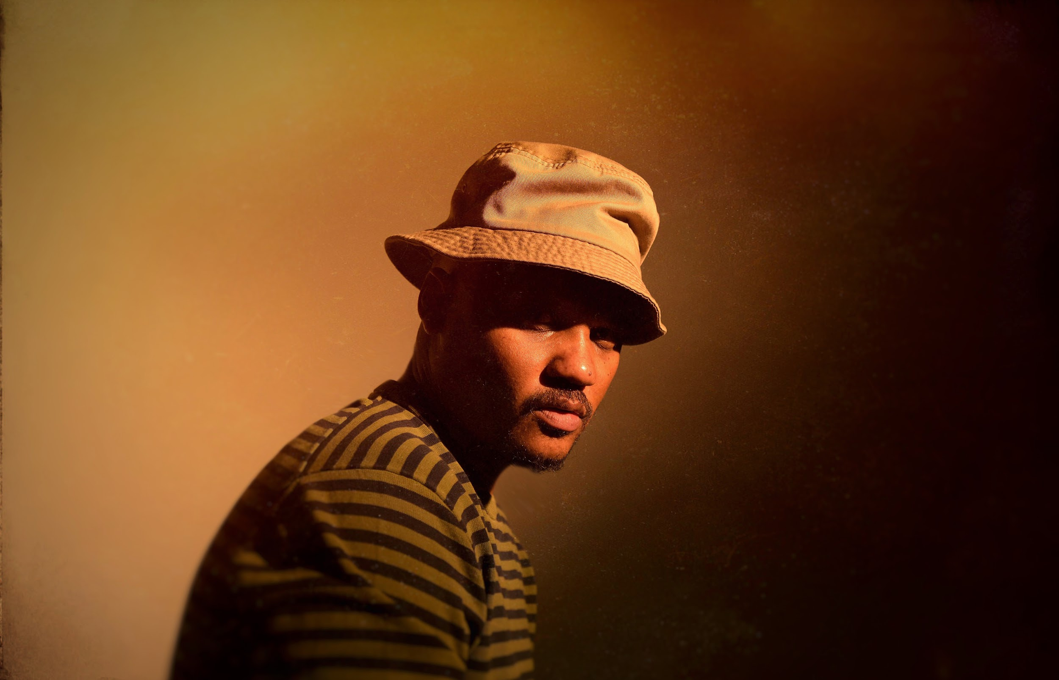
(Photo Credit: Shervin Lainez)

“With bluesy distorted guitar chords, a hint of Latin rhythm and perhaps a distant echo of the Zombies ‘Time of the Season,’ Son Little offers a genial comedown in ‘hey rose’...”
— The New York Times

“Son Little has a lithely expressive voice that can locate forgiveness, sorrow, and ecstasy in even the most hackneyed turns of phrase.” — The New Yorker

Son Little, the moniker of Los Angeles-based musician Aaron Earl Livingston, will release his new album, aloha, on January 31st via ANTI-. Today, he premieres the video for the new single, “neve give up,” via Billboard. Following previously released singles “hey rose,” “suffer,” and “mahalia,” “neve give up” is a gorgeous track about perseverance. “Hallelujah,” Little sings, “though I’m battered and blue / feel like I’m born to lose…Never will I give up.” It is a potent reminder that letting go doesn’t mean giving in; it can be an act of defiance, of growth, of empowerment. The accompanying animated video was created by Piotr Kabat.

Watch Video For Son Little’s “neve give up” -
https://youtu.be/jaZcnBog0Zs

In anticipation of aloha’s release and in conjunction with the premiere of “neve give up”, Son Little is also pleased to present his performance on NPR’s World Cafe. The episode is available to listen to here.

Recorded at Paris’s iconic Studios Ferber with producer Renaud Letang (Feist, Manu Chao), aloha is Little’s first album to be recorded with an outside producer. The result is his boldest, most self-assured statement yet. In order to create aloha, Little began writing and assembling album demos in Petaluma, California. However, after his hard drive fried and he lost nearly a dozen detailed demos, he was forced to begin with a blank slate, leading him to write aloha in only eight days at a tiny house and its adjacent barn. The entire project was an exercise in letting go, in ceding control, in surrendering to fate.

This Friday, Son Little will kick off a North American tour in support of aloha. Afterwards, he will continue to tour across Europe. A full list of tour dates is below and all dates are on-sale now.

Watch/Listen/Share:
“hey rose” video - https://youtu.be/KTzEVH4f434
“suffer” video - https://youtu.be/xLo0a_mKmx4
“mahalia” stream - https://youtu.be/Mpcl0_4cPns

Pre-order aloha -
https://sonlittle.ffm.to/aloha

Son Little Tour Dates (new dates in bold):
Fri. Jan. 17 - Asbury Park, NJ @ Asbury Lanes
Sat. Jan. 18 - Sellersvile, PA @ Sellersville Theater 1894
Mon. Jan. 20 - Brooklyn NY @ Brooklyn Academy of Music
Wed. Jan. 22 - Baltimore, MD @ The 8x10
Thu. Jan. 23 - Charlotte, NC @ Blumenthal Performing Arts
Fri. Jan. 24 - Raleigh, NC @ Kings Barcade
Sat. Jan. 25 - Virginia Beach, CA @ Smartmouth Brewery
Sun. Jan. 26 - Charlottesville, VA @ The Southern Café and Music Hall
Tue. Jan. 28 - Northampton, MA @ Iron Horse Music Hall
Wed. Jan. 29 - Fairfield, CT @ Stage One
Fri. Jan. 31 - Burlington, VT @ Arts Riot
Sat. Feb. 1 - Portsmouth, NH @ 3s Artspace
Thu. Feb. 13 - Northridge, CA @ Valley Performing Arts Center
Sat. Feb. 15 - Pioneertown, CA @ Pappy & Harriet’s
Sun. Feb. 16 - Morro Bay, CA @ The Siren
Mon. Feb. 17 - Mill Valley, CA @ Sweetwater Music Hall
Tue. Feb. 18 - Santa Cruz, CA @ Moe’s Alley
Thu. Feb. 20 - Edmonton, AB @ Station On Jasper
Fri. Feb. 21 - Calgary, AB @ Block Heater Festival
Sat. Feb. 22 - Winnipeg, MB @ Festival du Voyager
Fri. Feb. 28 - Boulder, CO @ Fox Theatre
Sat. Feb. 29 - Fort Collins, CO @ Washington’s Sports Bar & Grill
Fri. March 27 - Brighton, UK @ Patterns
Sat. March 28 - London, UK @ Oslo
Mon. March 30 - Paris, FR @ La Maroquinerie
Tue. March 31 - Antwerp, BE @ Kavka VZW
Wed. April 1 - Amsterdam, NL @ Paradiso Noord
Thu. April 2 - Rotterdam, NL @ Bird
Sat. April 4 - Hamburg, DE @ Bahnhof Pauli
Sun. April 5 - Berlin, DE @ Privatclub
Mon. April 6 - Cologne, DE @ Blue Shell
Tue. April 7 - Zurich, CH @ Exil
Thu. April 9 - Zaragoza, ES @ Rock & Blues Café
Fri. April 10 - Barcelona, ES @ La Nau

Stream/Purchase Son Little’s invisible EP (digital only) -
https://sonlittle.ffm.to/invisible

Download album art & hi-res images of Son Little -
http://pitchperfectpr.com/son-little

Artist Site | Facebook | Twitter | Instagram | Youtube | ANTI-

For more information, contact:
Sam McAllister | Pitch Perfect PR - sam@pitchperfectpr.com, 773-942-6573

