April 12, 2023
For Immediate Release

The Tallest Man On Earth Unveils “Looking For Love” Single/Video,
Off New Album, Henry St., Out This Friday, April 14th, on ANTI-

Performing on CBS This Morning: Saturday on April 15th

North American Tour Runs September 5th — October 14th
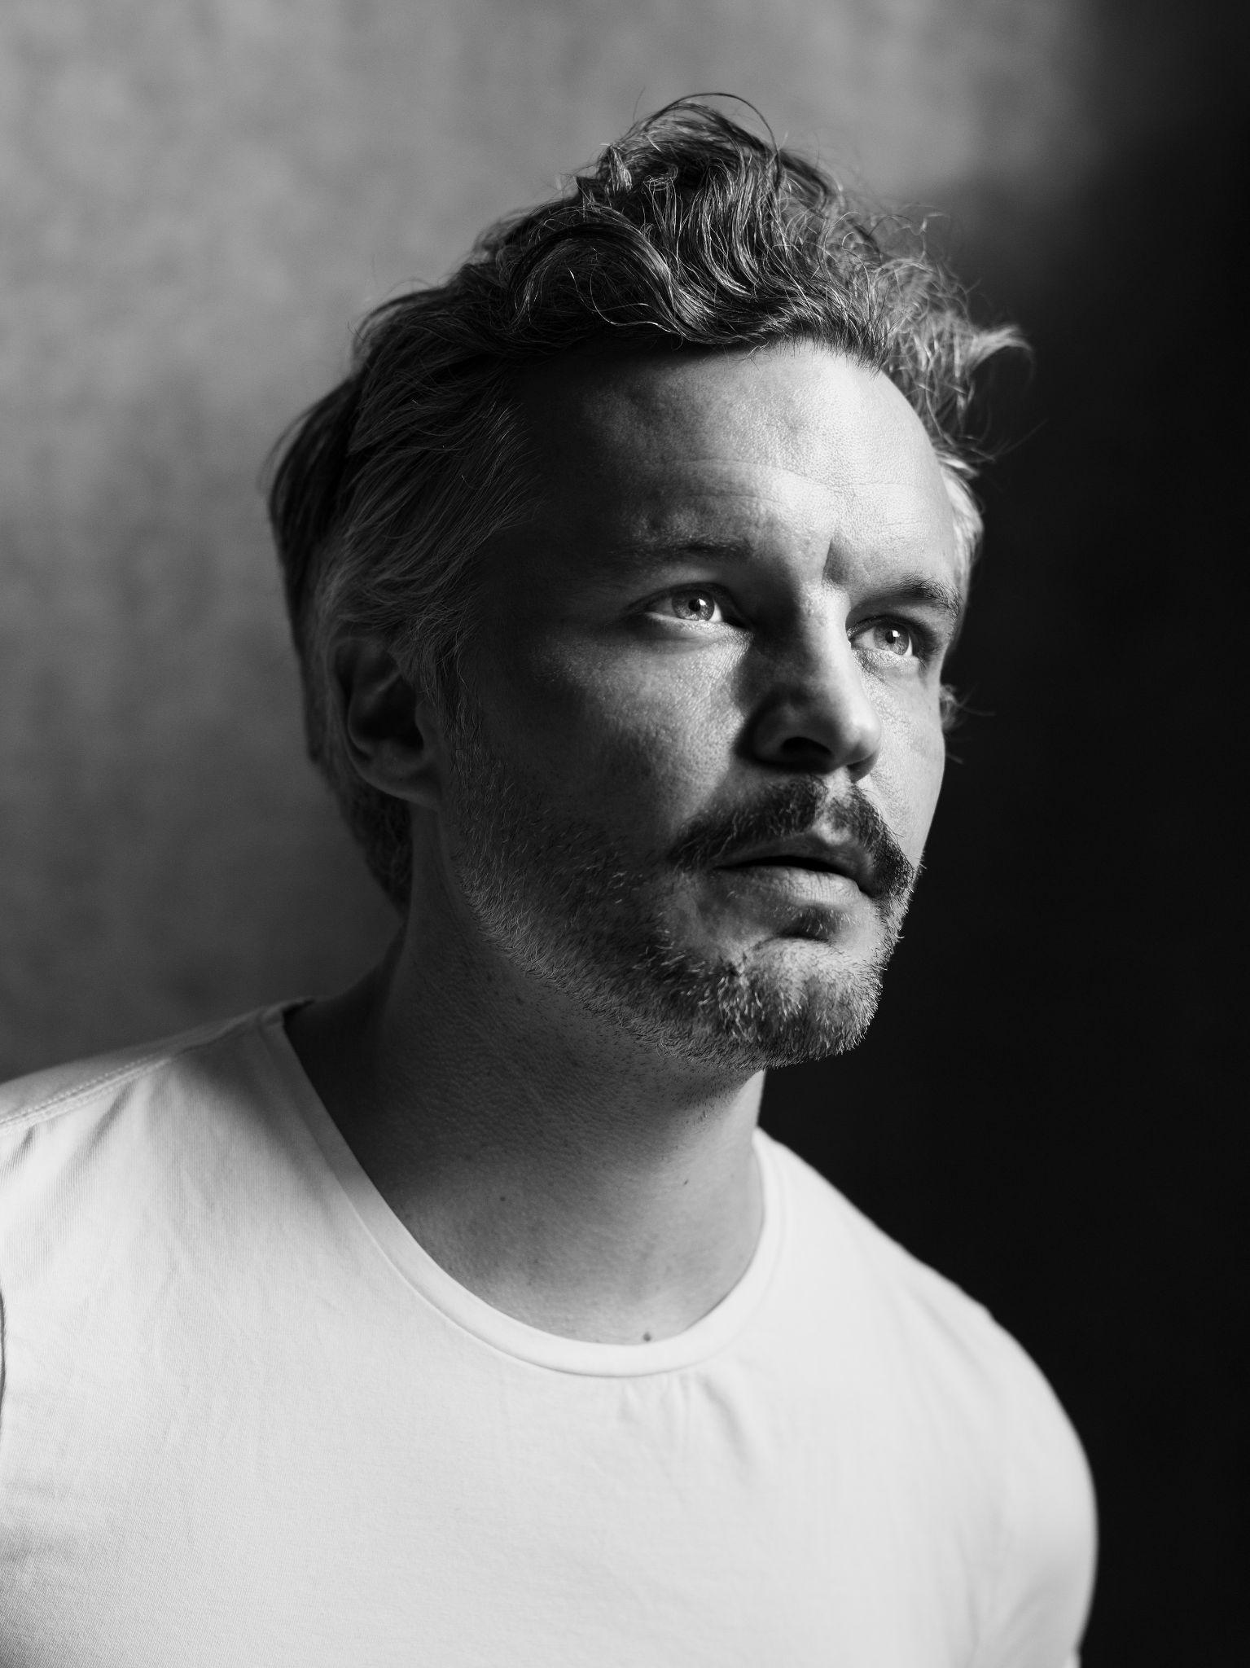
Photo Credit: Stephan Vanfleteren

"The Tallest Man On Earth is reaching new heights.” — American Songwriter

"The way redwoods and cathedrals scrape the sky, Matsson’s fingers pluck and strum his strings with a higher purpose, and his secret-weapon voice has remained a potent tool in the emotional arms race of modern music.” — MTV

“[The Tallest Man On Earth’s] first band album is bittersweet and beautiful.” - UNCUT

This Friday, The Tallest Man On Earth aka Kristian Matsson will release Henry St., his first new album in four years on ANTI-. Named one of the year’s most anticipated releases by Pitchfork, Matsson today unveils its final single/video, “Looking For Love,” a song about Matsson’s stubborn optimism, and a shining example of producer Nick Sanborn of Sylvan Esso’s influence on the album.

“The first day in the studio, Nick created this hissing noise while I was feedbacking electric guitar. We had so much fun jamming like that. Then Nick put down some piano to overdub my guitar, and we knew we had the song.” The tone for their collaboration was set. “Nick is so emotionally intelligent, and we share an almost childlike joy in things that can happen with music. He makes the songs come truly alive by keeping the performances and the humanity in––the kind of stuff that just happens during the session.”

The accompanying “Looking For Love” video was filmed at a beach near Amsterdam, and completes a trilogy of Jeroen Dankers-directed videos made for Henry St., preceded by the “moody” (Consequence) “Henry St.” and “Every Little Heart,” whose video was praised by SPIN as “captivating.” Of the “Looking For Love” video, Dankers adds: “With this part I wanted to show an awakening, going out, discovering, becoming a new version of yourself but not always knowing where you go.”

This weekend, The Tallest Man On Earth will return to CBS This Morning: Saturday to perform songs off Henry St. for their Saturday Sessions series. For those who didn’t catch The Tallest Man On Earth on this recent intimate spring run, including back-to-back sold out shows in Los Angeles and New York, Matsson’s Saturday Sessions offers a glimpse into his vibrant live show and what can be expected on his forthcoming fall North American tour. Full dates are listed below and tickets are on sale now.

Watch The Tallest Man on Earth’s “Looking For Love” Video

The Tallest Man On Earth’s sixth album, Henry St., marks the first time Matsson recorded an album in a band setting. As described by Matsson, it’s the “most me album yet, because it covers so many of the different noises in my head. Having been away from it taught me that making music and performing is what I’m doing for the rest of my life, and I’m so grateful for it. It has given me new confidence and playfulness. This is what I do. It’s unconditional.”

Watch The “Henry St.” Video

Watch The "Every Little Heart" Video

Pre-order Henry St.

The Tallest Man On Earth Tour Dates:
Wed. Apr. 12 - Copenhagen, DK @ Amager Bio - SOLD OUT
Thu. Apr. 13 - Aarhus, DK @ Voxhall - SOLD OUT
Sun. Apr. 16 - Glasgow, UK @ QMU
Mon. Apr. 17 - Dublin, IE @ Vicar Street
Tue. Apr. 18 - Manchester, UK @ Manchester Cathedral
Wed. Apr. 19 - Leeds, UK @ The Leeds Irish Centre
Fri. Apr. 21 - London, UK @ O2 Forum
Sat. Apr. 22 - Bristol, UK @ Trinity - SOLD OUT
Mon. Apr. 24 - Amsterdam, NL @ Paradiso - SOLD OUT
Tue. Apr. 25 - Antwerp, BE @ De Roma
Wed. Apr. 26 - Paris, FR @ La Cigale
Thu. Apr. 27 - Lausanne, CH @ Les Docks
Sat. Apr. 29 - Milan, IT @ Fabrique
Sun. Apr. 30 - Munich, DE @ Freiheitshalle - SOLD OUT
Mon. May 1 - Berlin, DE @ Metropol
Tue. May 2 - Hamburg, DE @ Uebel & Gefahlrlich
Wed. May 3 - Malmo, SE @ Plan B - SOLD OUT
Fri. May 5 - Oslo, NO @ Sentrum Scene
Sat. May 6 - Stockholm, SE @ Cirkus - SOLD OUT
Sun. May 7 - Stockholm, SE @ Cirkus
Mon. May 8 - Goteborg, SE @ Pustervik - SOLD OUT
Tue. May 9 - Goteborg, SE @ Pustervik - SOLD OUT
Thu. Aug. 17 - Stockholm, SE @ Gröna Lund
Fri. Aug. 18 - Knislinge, SE @ Wanås Music & Arts
Sat. Aug. 19 - Örebro, SE @ Humlehagen
Mon. Aug. 21 - Skellefteå, SE @ Sara Kulturhus
Tue. Aug. 22 - Umeå, SE @ Idun
Wed. Aug. 23 - Uppsala, SE @ Almost A Festival
Fri. Aug. 25 - Göteborg, SE @ Liseberg
Sat. Aug. 26 - Husknarva @ Folkets Park
Tue. Sep. 5 - Durham, NC @ The Carolina Theatre
Thu. Sep. 7 - Washington, DC @ 9:30 Club
Fri. Sep. 8 - Philadelphia, PA @ Union Transfer
Sat. Sep. 9 - Boston, MA @ Royale
Sun. Sep. 10 - Brooklyn, NY @ Brooklyn Steel
Wed. Sep. 13 - Montreal, QC @ Corona Theatre
Fri. Sep. 15 - Toronto, ON @ The Danforth Music Hall
Sat. Sep. 16 - Detroit, MI @ The Majestic Theatre
Sun. Sep. 17 - Chicago, IL @ Thalia Hall
Tue. Sep. 19 - St. Paul, MN @ Palace Theatre
Thu. Sep. 21 - Bozeman, MT @ The Elm
Sat. Sep. 23 - Seattle, WA @ Neptune Theatre
Sun. Sep. 24 - Vancouver, BC @ Commodore Ballroom
Tue. Sep. 26 - Portland, OR @ Revolution Hall
Fri. Sep. 29 - Los Angeles, CA @ The Theatre at Ace Hotel
Sat. Sep. 30 - San Diego, CA @ The Observatory North Park
Sun. Oct. 1 - Tucson, AZ @ Rialto Theatre
Wed. Oct. 4 - Austin, TX @ Scoot Inn
Thu. Oct. 5 - Dallas, TX @ Granada Theater
Sat. Oct. 7 - Saint Louis, MO @ The Pageant
Wed. Oct. 11 - Nashville, TN @ Brooklyn Bowl
Thu. Oct. 12 - Knoxville, TN @ Bijou Theatre
Fri. Oct. 13 - Atlanta, GA @ Variety Playhouse
Sat. Oct. 14 - Asheville, NC @ The Orange Peel

Download hi-res images & jpegs of The Tallest Man On Earth

Henry St. Cover Artwork

Website | Instagram | Twitter

For more information, contact:
Jessica Linker | Pitch Perfect PR – jessica@pitchperfectpr.com, 773-942-6954
Yuri Kwon | Pitch Perfect PR – yuri@pitchperfectpr.com, 773-654-1477

