ALFA MIST - ‘VARIABLES’
NEW ALBUM FROM EAST LONDON ARTIST, PRODUCER &
LABEL FOUNDER OUT APRIL 21ST VIA ANTI-

SHARES NEW SINGLES ‘4TH FEB (STAY AWAKE)’ AND ‘BC’ - LISTEN

US & EU TOUR DATES ANNOUNCED - BUY TICKETS HERE

Photo credit: Kay Ibrahim / download hi-res here

Alfa Mist announces his forthcoming new record, Variables out April 21 via Anti-, along with a string of tour dates in the United States and Europe to coincide with the album’s release – see more below. The East London artist, producer and label founder also shares two new singles from the Variables - the dark, introspective “4th Feb (Stay Awake)” and the seven-minute free improvised “BC.” Listen to both tracks and pre-save the album here: https://alfamist.ffm.to/variables.

“4th Feb (Stay Awake)” is a lofi offering that pairs Alfa’s reflective bars with a groove-heavy production. Expressing his inner thoughts, he finds solace in solitude before the swoon of strings closes the track. “BC” is a colourful swell of the percussion - expressive and unrestrained, it demonstrates the ingenuity of Alfa Mist and his close knit band.

LISTEN TO “4TH FEB (STAY AWAKE)” & “BC”

“I’ve been focused on who I am in my music, but now I’m exploring where I am,” Alfa Mist says. “I’m asking: how did I get here?” This is the journeying question that underpins Alfa’s fifth album, Variables. Traversing luscious, big band swing, head-nodding boom-bap rhythms and yearning vocal melodies, the record is expansive, soulful and moving, in both body and spirit. On Variables, Alfa achieves his most fully-realised, expressive musical work to date, coupling his keen ear for looping, memorably emotive piano melodies with intuitive grooves and a free-flowing jazz improvisation.

Variables sees Alfa Mist offer a diverse listening experience, as he dives into the argument of nature versus nurture on the rhythmic “Borderline” to the airy, crystallic sounds of “Cycles.” The album’s standout features are captivating, with long-time collaborator and band’s bass player Kaya Thomas-Dyke’s gentle vocals adding an ethereal essence on “Aged Eyes,” whilst the South African folk singer Bongeziwe Mabandla drapes the vibrant backdrop and Jas Kayser’s frenetic drum playing with his crystalline falsetto on “Apho.”

‘VARIABLES’ TRACKLISTING
01 - Foreword
02 - Borderline
03 - Aged Eyes (feat. Kaya Thomas-Dyke)
04 - Cycles
05 - The Gist
06 - Genda (Go Away)
07 - Apho (feat. Bongeziwe Mabandla)
08 - Variables
09 - 4th Feb (Stay Awake)
10 - BC

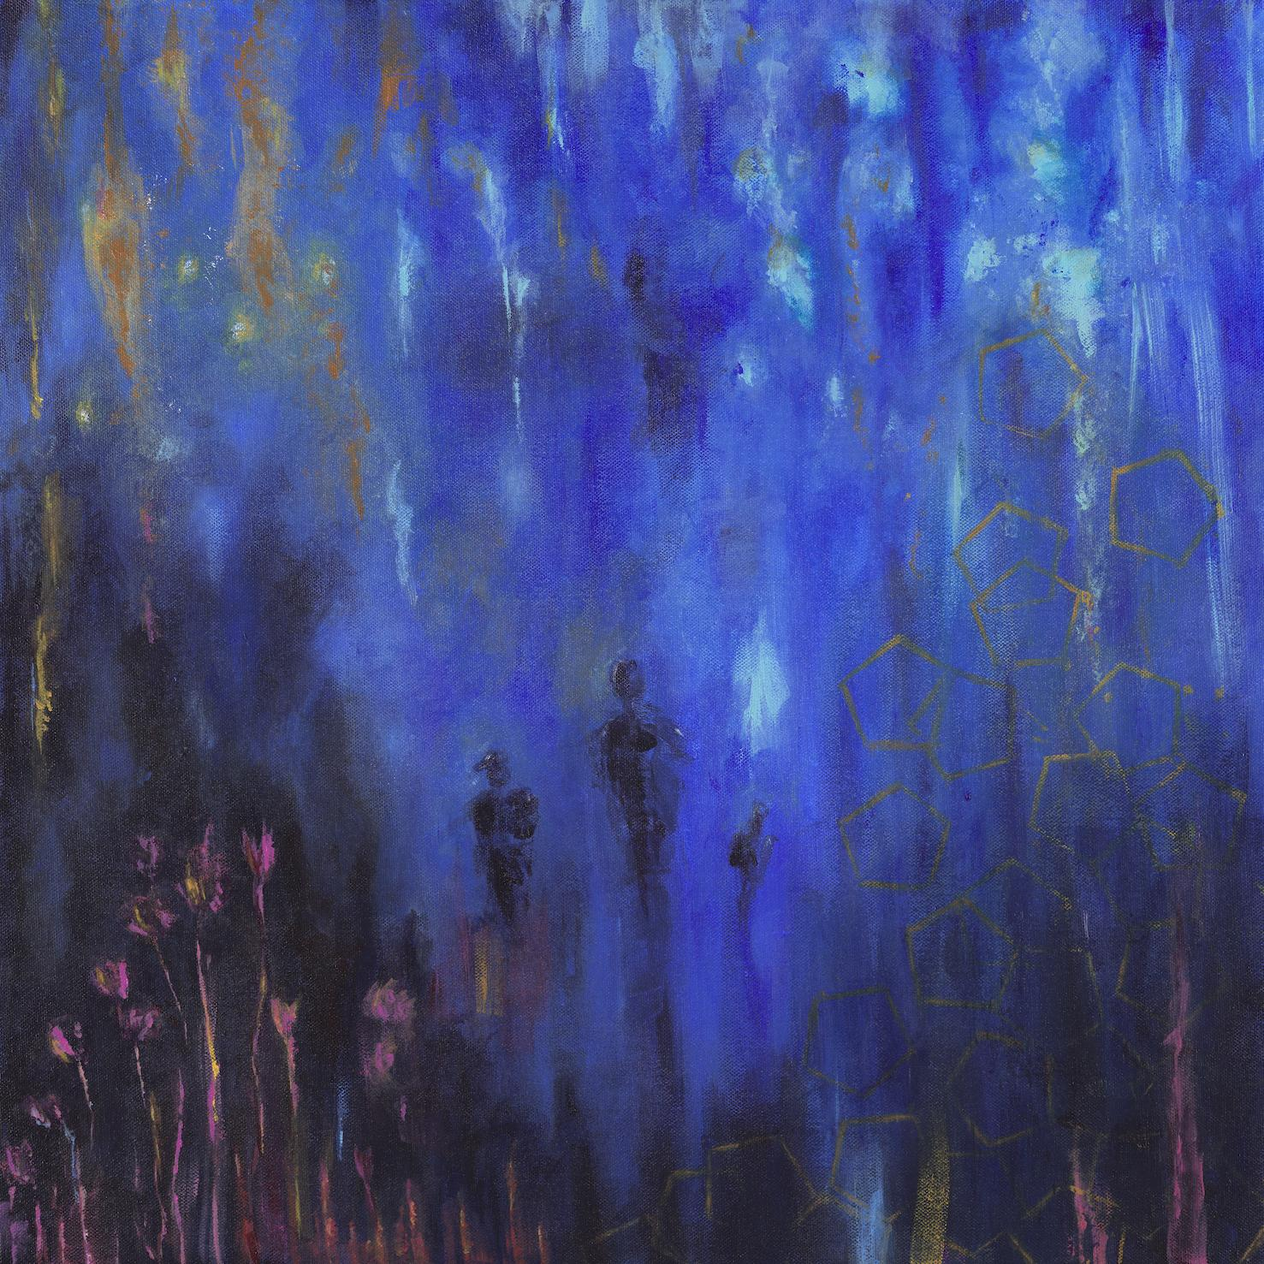
Variables artwork (Credit: Kaya Thomas-Dyke) / download here

Since the release of his first full-length project Nocturne in 2015, Alfa has established himself as one of the UK’s most focused, in-demand and distinct musical voices, and has worked with the likes of Jordan Rakei and Tom Misch. Artists look to him for his unique blend of intimate bedroom production and expansive jazz group orchestration, since Alfa is yet to be boxed into a specific genre. His music spans everything from hip-hop beat-making to producing for artists such as rapper Loyle Carner, composing neo-classical works for the London Contemporary Orchestra, and reworking tracks from composer Ólafur Arnalds and pioneering jazz label Blue Note.

The urgent energy of Alfa’s live presence speaks of his restless creativity – a driving force that has enabled his remarkable work-ethic to date. “Music is an extension of my life; it is the practice of creating” he notes. That practice is certainly fruitful and Alfa continues to head up his own label Sekito, releasing records from Jamie Leeming, trumpeter Jsphynx and bassist Rudi Creswick, with more slated for 2023.

The return to live shows has been a welcome one for Alfa and his fans, resulting in an instantly sold-out run of debut US shows in 2022 and an expanded run of US shows slated for 2023. Tickets are now available and will include stops in New York, Chicago and Germany, before closing with a headline slot at London’s Cross The Tracks festival where he’ll share the stage with the likes of Anderson Paak, Knxledge and Masego in May. See all current Alfa Mist tour dates below.

ALFA MIST TOUR DATES
Mar 03 Hannover, Germany - Pavilion / Großer Saal
Apr 01 Utrecht, Netherlands - Transition Festival
Apr 27 Philadelphia, PA - The Ardmore Music Hall
Apr 29 Brooklyn, NY - Music Hall of Williamsburg
Apr 30 New York, NY - Racket
May 02 Chicago, IL - Thalia Hall
May 04 Los Angeles, CA - Fonda Theatre
May 05 San Francisco, CA - August Hall
May 08 - 14 Berlin, Germany - Xjazz Festival
May 25 - 28 Liège, Belgium - Jazz A Liege
May 28 London, UK - Cross The Tracks Festival
Ticket Available Here: https://alfamist.co.uk/live

FOLLOW ALFA MIST
Twitter * Instagram * Spotify

