May 10, 2021
For Immediate Release

Andy Shauf Announces Fall North American Tour in
Support of The Neon Skyline

Releases Video for “Living Room”
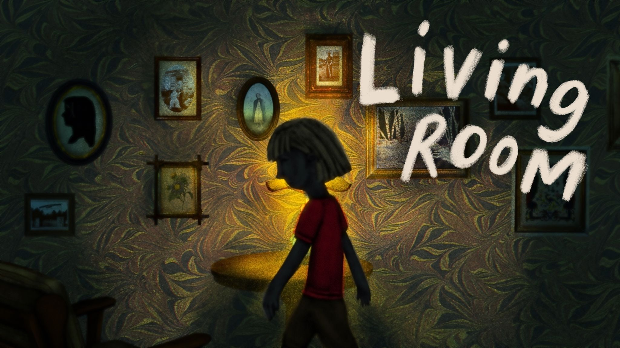
“Living Room” video still by Anne Douris

Today, Andy Shauf announces a fall North American tour in support of The Neon Skyline, one of 2020’s most highly praised albums, and releases a new video for one of its highlights, “Living Room.” The Neon Skyline, released on ANTI-, was beloved by fans and critics alike, and earned glowing year-end praise from Esquire, Stereogum, Consequence, Uproxx, The Atlantic, Paste, and more. In “Living Room,” “a polite question about a friend’s kid...turns into a hallucinogenic vision quest about death and reincarnation and living out our parents’ mistakes” (Pitchfork). Director Anne Douris visualizes this generational fear in its video. Douris elaborates:

“This is a story about growing up lonely. In particular, it's about how wage labour - the business of having to work to survive - shapes our lives from the moment we are born. I think we mistake childhood as being a time of ‘freedom’ when actually our lives are entangled in the struggle of working adults. So I wanted to weave together these scenes of childhood solitude, foggy recollections of being left alone in our empty house, where playfulness and imagination are tainted by fear. Fear of the dark, fear of abandonment, fear of loss. Visually inspired by the NFB cartoons I devoured as a kid, I wanted it to feel like an old worn out memory, discoloured by time and distorted each time it's remembered. Like these memories that we don't share with anyone else are more vulnerable - ephemeral to the point of disintegrating.”

Watch Andy Shauf’s Video for “Living Room”

Purchase Tickets for North American Tour

Watch/Listen/Share:
Stream/Purchase The Neon Skyline
“Try Again” Video
“Things I Do” Stream
“Neon Skyline” Video
“Living Room” Stream
"Clove Cigarette" Video
“You Slipped Away” Stream

Andy Shauf Tour Dates
(all shows on sale now)
Thu. Sept. 9 - Brooklyn, NY @ Warsaw
Fri. Sept. 10 - Brooklyn, NY @ Warsaw
Tue. Sept. 14 - Madison, WI @ Majestic Theatre *
Wed. Sept. 15 - Grand Rapids, MI @ Calvin College *
Thu. Sept. 16 - Indianapolis, IN @ Hi-Fi
Fri. Sept. 17 - Cleveland, OH @ The Grog Shop *
Thu. Feb. 3, 2022 - Ottawa, ON @ Bronson Centre
Fri. Feb. 4, 2022 - Montreal, QC @ Corona Theatre
Sat. Feb. 5, 2022 - Toronto, ON @ Danforth Music Hall
Sun. Feb. 6, 2022 - Toronto, ON @ Danforth Music Hall
Thu. Feb. 17, 2022 - Sheffield, MA @ Race Brook Lodge
Fri. Feb. 18, 2022 - Woodstock, NY @ Colony Cafe
Sun. Feb. 20, 2022 - Charlottesville, VA @ The Southern Music Hall
Tue. Feb. 22, 2022 - Carrboro, NC @ Cat’s Cradle
Wed. Feb. 23, 2022 - Asheville, NC @ The Grey Eagle
Thu. Feb. 24, 2022 - Birmingham, AL @ Saturn
Fri. Feb. 25, 2022 - Atlanta, GA @ Terminal West
Tue. March 30, 2022 - Washington, DC @ Black Cat
Wed. March 31, 2022 - Philadelphia, PA @ Union Transfer
Sun. April 3, 2022 - Boston, MA @ Paradise Rock Club
Mon. April 18, 2022 - Düdingen, CH @ Bad Bonn
Wed. April 20, 2022 - Mérignac, FR @ Le Krakatoa
Thu. April 21, 2022 - Paris, FR @ Trianon
Fri. April 22, 2022 - Rouen, FR @ Le 106
Sat. April 23, 2022 - Esch-Sur-Alzette, LU @ Kulturfabrik
Sun. April 24, 2022 - Utrecht, NL @ Tivoli Vredenburg
Mon. April 25, 2022 - Rotterdam, NL @ Rotown
Tue. April 26, 2022 - Nijmegen, NL @ Doornroosje
Thu. April 28, 2022 - Copenhagen, DK @ Loppen
Fri. April 29, 2022 - Oslo, NO @ Ingensteds
Sat. April 30, 2022 - Stockholm, SE @ Nalen Klubb
Mon. May 2, 2022 - Hamburg, DE @ Knust
Tue. May 3, 2022 - Berlin, DE @ Silent Green
Thu. May 5, 2022 - Bruxelles, BE @ Les Nuits Botanique Festival
Fri. May 6, 2022 - Cologne, DE @ Luxor
Sat. May 7, 2022 - Genk, BE @ Little Waves Festival
Mon. May 9, 2022 - Birmingham, UK @ The Castle & Falcon
Tue. May 10, 2022 - Edinburgh, UK @ Summerhall
Wed. May 11, 2022 - Glasgow, UK @ Drygate
Thu. May 12, 2022 - Manchester, UK @ Gorilla
Fri. May 13, 2022 - Leeds, UK @ Brudenell Social Club
Sat. May 14, 2022 - Bristol, UK @ Fiddlers
Sun. May 15, 2022 - Brighton, UK @ Chalk
Mon. May 16, 2022 - London, UK @ Shepherd’s Bush Empire
Wed. May 18, 2022 - Belfast, UK @ Em in pire
Thu. May 19, 2022 - Dublin, IE @ Button Factory

*= tickets on sale May 14th at 10am local time
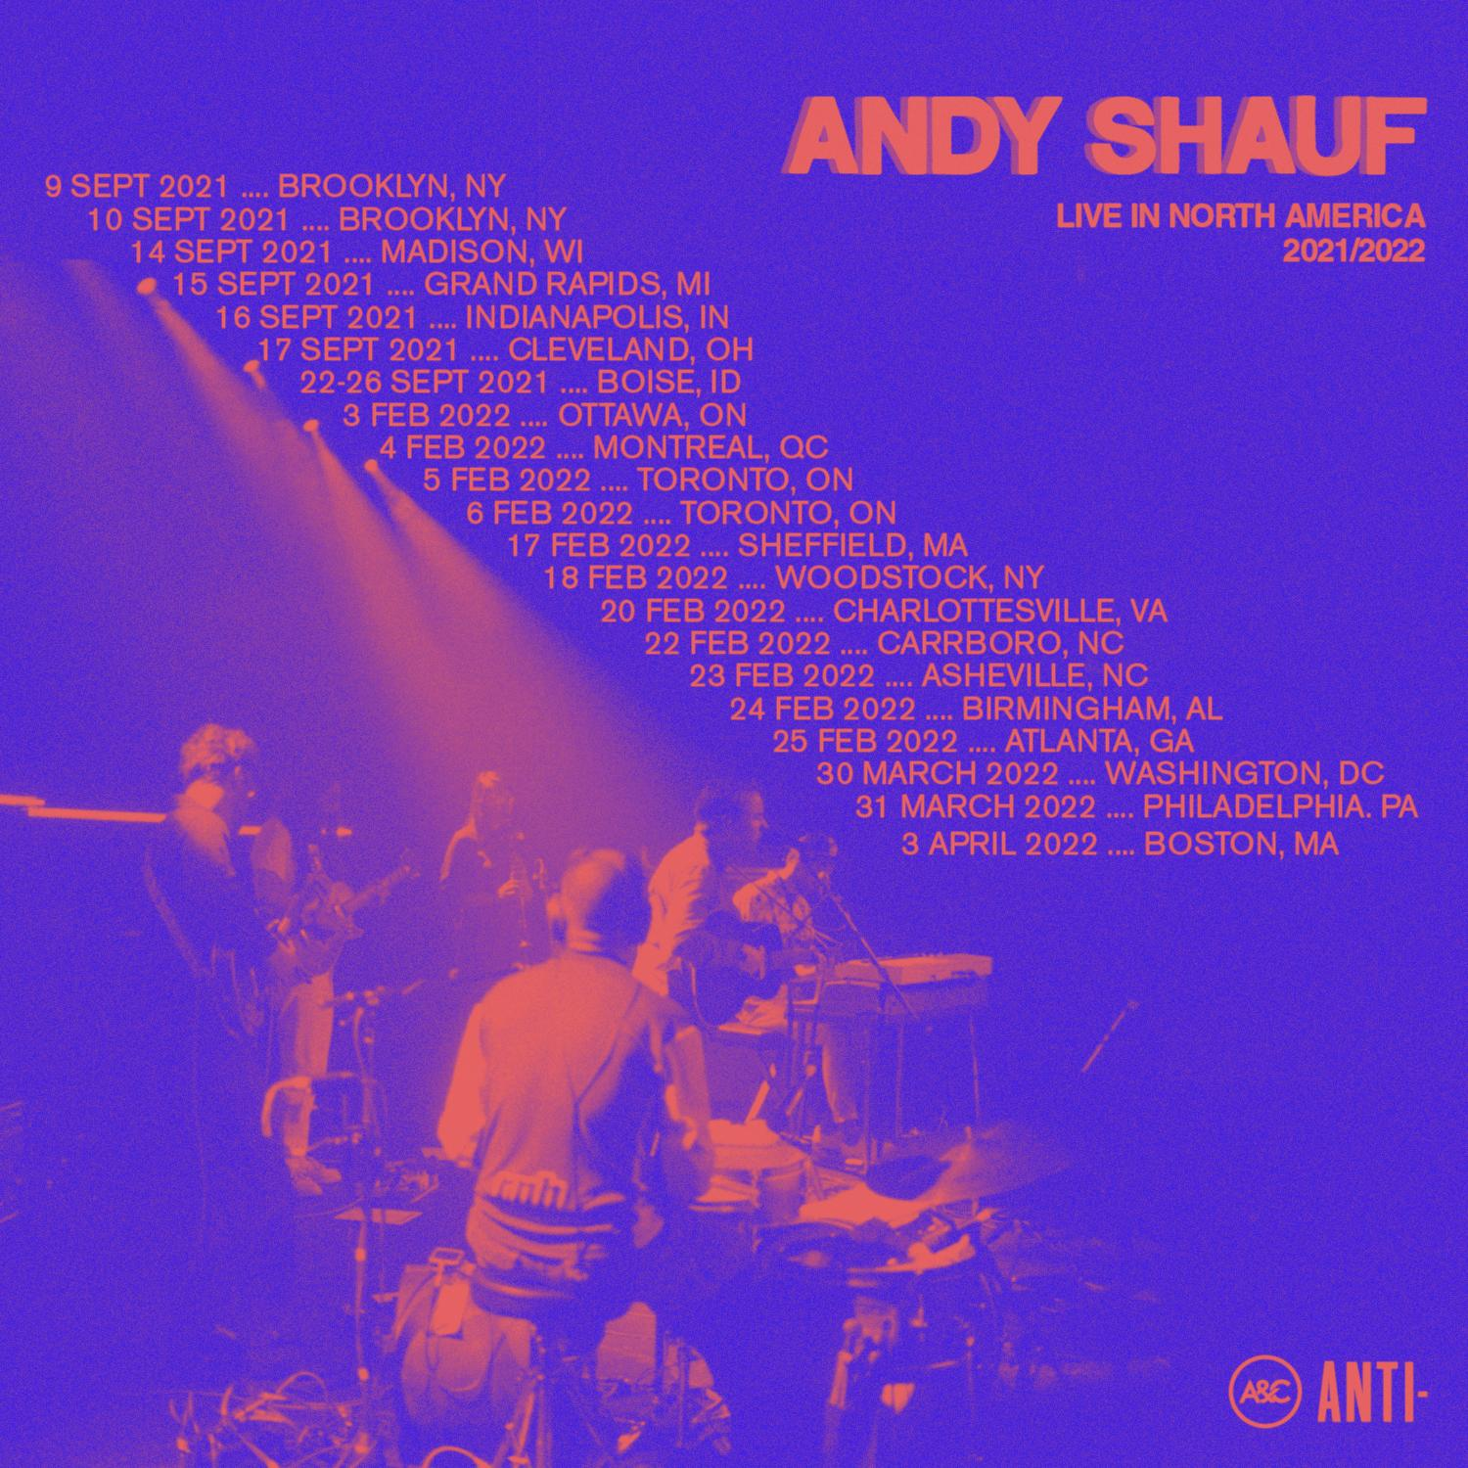

Praise for The Neon Skyline:

“A gifted singer-songwriter. More than that, a gifted storyteller.” - NPR Music

“When he sings about an intimate story transporting him into someone else’s home, you feel like you’re there with him.” - Pitchfork

“All singer-songwriters are storytellers of a sort, but neither term does justice to what Andy Shauf accomplishes on The Neon Skyline. ” - Stereogum

“Listening to an Andy Shauf album in full is akin to bingeing a particularly compelling TV show: Both pull you in with characters that feel just as real as you or me, who populate a world we’d like to escape to.” - Paste

“Andy Shauf’s songs are charming tales of everyday life. . . perhaps the least pretentious concept album you'll find.” - Esquire

“The Neon Skyline is a wise and transportive album, with Shauf taking his place among the great contemporary songwriters.” - Uproxx

Download hi-res images & jpegs of Andy Shauf
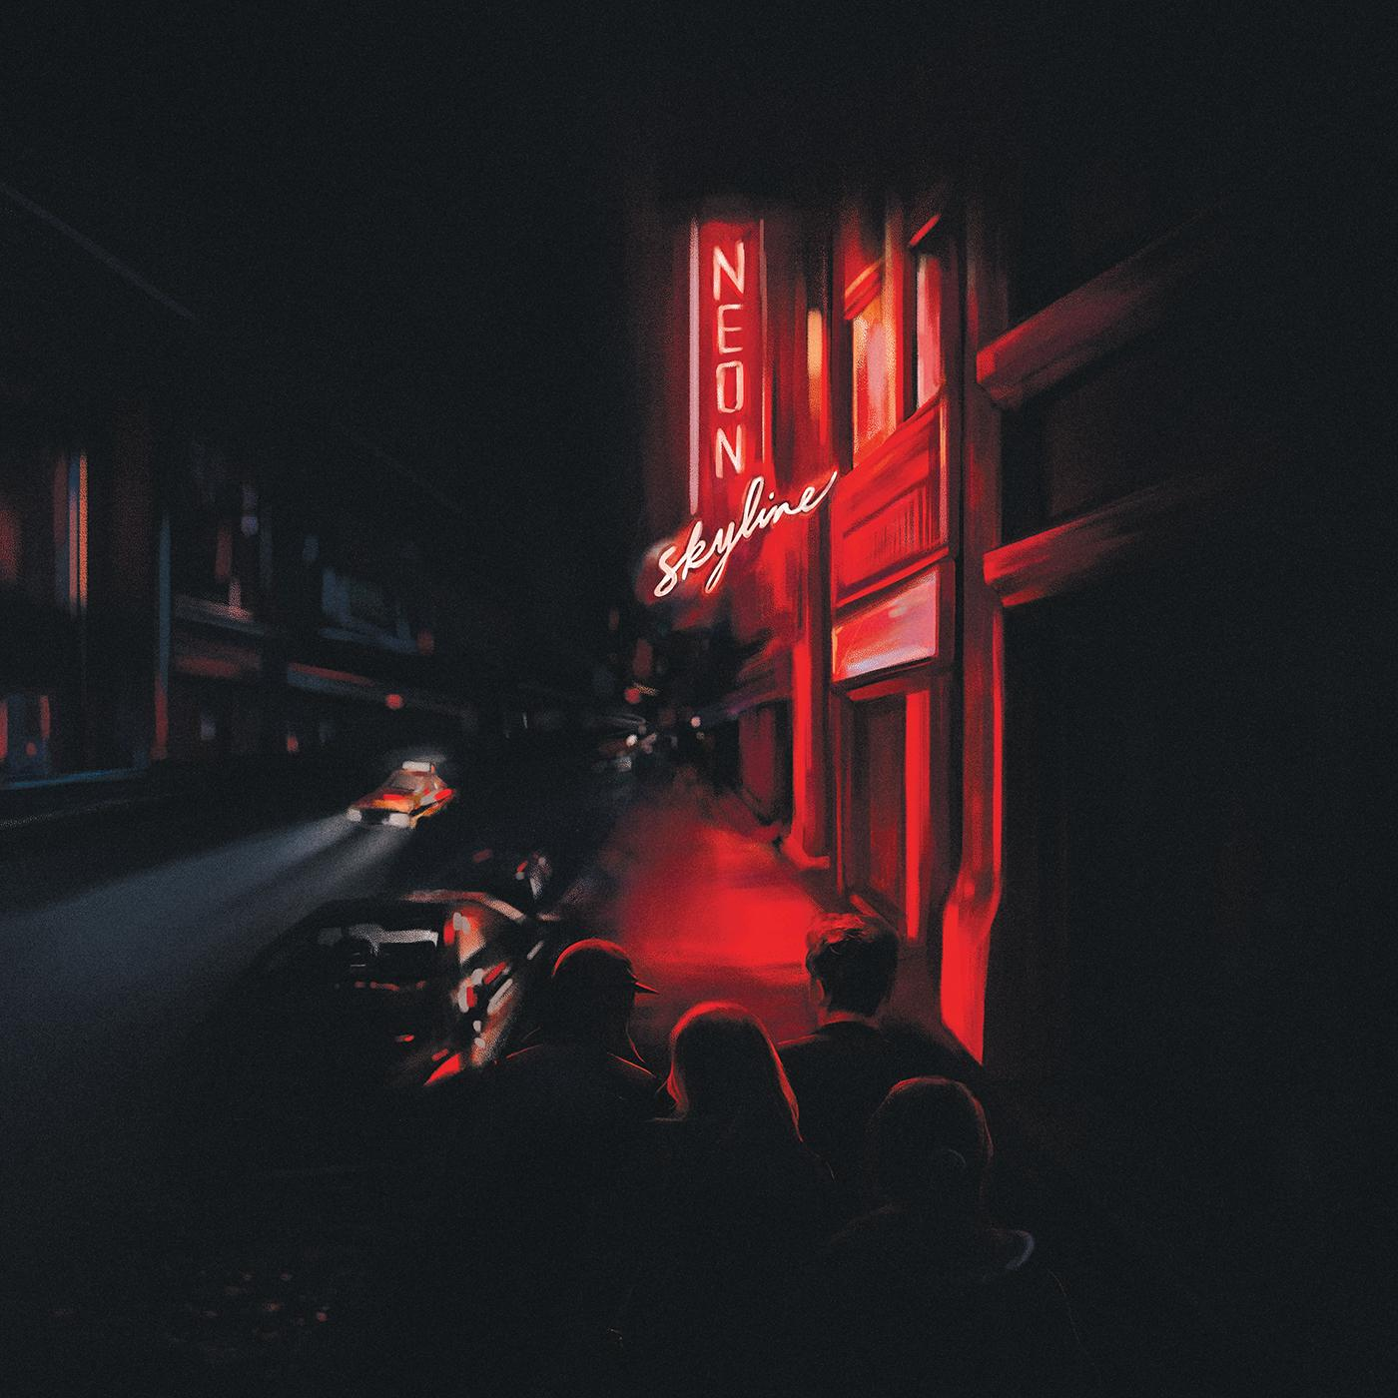
The Neon Skyline Cover Artwork

Website | ANTI- | Instagram | Facebook | Twitter | Bandcamp

For more information, contact:
Jessica Linker & Patrick Tilley | Pitch Perfect PR –
jessica@pitchperfectpr.com, patrick@pitchperfectpr.com

##

