September 22, 2021
For Immediate Release

Andy Shauf Announces New Album, Wilds,
Out THIS FRIDAY, September 24th (Digital)/November 19th (Physical) on ANTI-

Listen to “Jaywalker”

On Tour Now
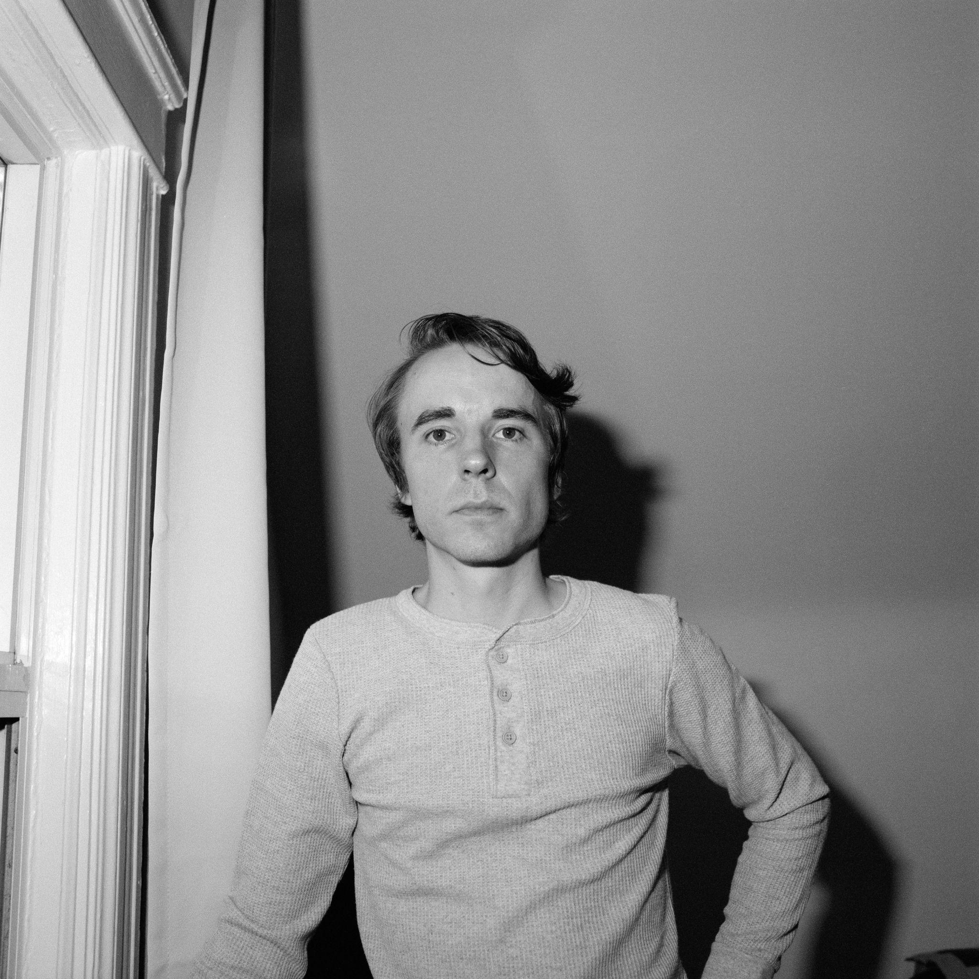
Photo Credit: Colin Medley

Andy Shauf is “a gifted singer-songwriter. More than that, a gifted storyteller” (NPR Music). Today, he announces Wilds, a surprise new album out this Friday, September 24th (digitally)/November 19th (physically) via ANTI-, that offers a peek into Shauf’s creative process and how the multi-instrumentalist first begins building his songs into more ornately arranged final products. Additionally, he presents a new song, “Jaywalker.” Wilds is a collection of nine songs culled from around fifty tracks recorded by Shauf during the writing of his widely lauded last album, 2020’s The Neon Skyline. Presented in a near-unfiltered form, the unstudied rawness of the songs on Wilds is a revealing look at Shauf’s mindset during the time he was writing Skyline. Though it’s not necessary to be familiar with The Neon Skyline to “get” Wilds, the album can certainly be interpreted as a companion piece to that record, a revisiting of the doomed lovers throughout various stages of their relationship. The songs are presented here in their most nascent shape - Shauf playing all the instruments, coming up with the arrangements on the fly, and recording it all himself to “a little tape machine” in his studio in Toronto.

All songs on Wilds were written and recorded closely together, during a period when Shauf became disenchanted with the idea of centering the Skyline narrative around one night at a bar. To shake off the writer’s block, he began experimenting with a different concept, penning songs about a woman named Judy. Shauf ultimately decided to return to his original plan, but the creative exercise was fundamental to what Skyline eventually became.

As first presented in “Spanish On The Beach,” hearing his songs pared back to the sparest of parts reveals not only how good a songwriter Shauf really is, but also how affectingly personal his songs are when his songs are unlatched from the mise en scène of a conceptual storyline. Today’s offering, “Jaywalker,” is a loping ballad that nominally tells the tale of a person not looking where he’s going while crossing the street and, by song’s end, waking up alone in a hospital with a dream of Judy driving a car, and no idea what the hell happened. But peer a bit deeper and you’ll find that Shauf is exploring a far more existential theme: the experience of the lost soul meandering through life (“Hanging around town never looked good on you”), the low-level level depression so common as to be invisible to everyone around (“All of your friends started wondering why/ You were choking back tears at an easy goodbye”) and the ways, both good and bad, that life can broadside you when you least expect it.

Listen to Andy Shauf’s “Jaywalker”

Ultimately Wilds is not only another spin on the barstool at the Skyline—this time a bit wiser, with a little more clarity—but a standalone chapter in Shauf’s own artistic narrative. The organic nature of the songs make the stories they tell feel truer to life as it’s experienced in the moment rather than via carefully edited words on a page or through the golden, unreliable haze of memory.

Andy Shauf is in the midst of a North American tour. Tickets for all dates are on sale now and a full list can be found below.

Listen to “Spanish On The Beach”

Wilds Pre-Order

Wilds Tracklist
1. Judy (Wilds)
2. Spanish On The Beach
3. Jaywalker
4. Call
5. Television Blue
6. Green Glass
7. Wicked and Wild
8. Believe Me
9. Jeremy’s Wedding (Wilds)

Purchase Tickets for North American Tour

Andy Shauf Tour Dates
Wed. Sept. 22 - Boulder,CO @ Fox Theatre !
Thu. Sept. 23 - Salt Lake City, UT @ The Urban Lounge @
Fri. Sept. 24 - Boise, ID @ Treefort Music Fest
Sat. Sept. 25 - Eugene, OR @ Sessions Music Hall #
Sun. Sept. 26 - Tacoma, WA @ McMenamins Elks Temple #
Tue. Sept. 28 - Santa Cruz, CA @ Moe’s Alley #
Wed. Sept. 29 - Santa Barbara, CA @ Soho Restaurant & Music Club #
Thu. Sept. 30 - Los Angeles, CA @ Hollywood Forever Cemetery ^
Fri. Oct. 1 - Sonoma, CA @ Sebastiani Theatre #
Sat. Oct. 2 - San Francisco, CA @ Hardly Strictly Bluegrass
Sat. Oct. 30 - Austin, TX @ Levitation Festival
Sat. Nov. 13 - Perris, CA @ Desert Daze Festival
Fri. Nov. 19 – Atlanta, GA @ The Stuffing
Thu. Feb. 3, 2022 - Ottawa, ON @ Bronson Centre
Fri. Feb. 4, 2022 - Montreal, QC @ Corona Theatre
Sat. Feb. 5, 2022 - Toronto, ON @ Danforth Music Hall
Sun. Feb. 6, 2022 - Toronto, ON @ Danforth Music Hall
Thu. Feb. 17, 2022 - Sheffield, MA @ Race Brook Lodge
Fri. Feb. 18, 2022 - Woodstock, NY @ Colony Cafe
Sun. Feb. 20, 2022 - Charlottesville, VA @ The Southern Music Hall
Tue. Feb. 22, 2022 - Carrboro, NC @ Cat’s Cradle
Wed. Feb. 23, 2022 - Asheville, NC @ The Grey Eagle
Thu. Feb. 24, 2022 - Birmingham, AL @ Saturn
Fri. Feb 25, 2022 - Atlanta, GA @ Terminal West
Fri. March 11, 2022 – Los Angeles, CA @ Walt Disney Concert Hall
Thu. March 24-27, 2022 – Knoxville, TN @ Big Ears Festival
Sun. Mar. 20, 2022 - Bruxelles, BE @ Le Botanique
Tue. March 30, 2022 - Washington, DC @ Black Cat
Wed. March 31, 2022 - Philadelphia, PA @ Union Transfer
Sun. April 3, 2022 - Boston, MA @ Paradise Rock Club
Mon. April 18, 2022 - Düdingen, CH @ Bad Bonn
Wed. April 20, 2022 - Mérignac, FR @ Le Krakatoa
Thu. April 21, 2022 - Paris, FR @ Trianon
Fri. April 22, 2022 - Rouen, FR @ Le 106
Sat. April 23, 2022 - Esch-Sur-Alzette, LU @ Kulturfabrik
Sun. April 24, 2022 - Utrecht, NL @ Tivoli Vredenburg
Mon. April 25, 2022 - Rotterdam, NL @ Rotown
Tue. April 26, 2022 - Nijmegen, NL @ Doornroosje
Thu. April 28, 2022 - Copenhagen, DK @ Loppen
Fri. April 29, 2022 - Oslo, NO @ Ingensteds
Sat. April 30, 2022 - Stockholm, SE @ Nalen Klubb
Mon. May 2, 2022 - Hamburg, DE @ Knust
Tue. May 3, 2022 - Berlin, DE @ Silent Green
Thu. May 5, 2022 - Bruxelles, BE @ Les Nuits Botanique Festival
Fri. May 6, 2022 - Cologne, DE @ Luxor
Sat. May 7, 2022 - Genk, BE @ Little Waves Festival
Mon. May 9, 2022 - Birmingham, UK @ The Castle & Falcon
Tue. May 10, 2022 - Edinburgh, UK @ Summerhall
Wed. May 11, 2022 - Glasgow, UK @ Drygate
Thu. May 12, 2022 - Manchester, UK @ Gorilla
Fri. May 13, 2022 - Leeds, UK @ Brudenell Social Club
Sat. May 14, 2022 - Bristol, UK @ Fiddlers
Sun. May 15, 2022 - Brighton, UK @ Chalk
Mon. May 16, 2022 - London, UK @ Shepherd’s Bush Empire
Wed. May 18, 2022 - Belfast, UK @ Em in pire
Thu. May 19, 2022 - Dublin, IE @ Button Factory

# = w/ Hand Habits
! = w/ Son Little
@ = w/ Wild Pink
^ = w/ Lord Huron

Download hi-res images & jpegs of Andy Shauf
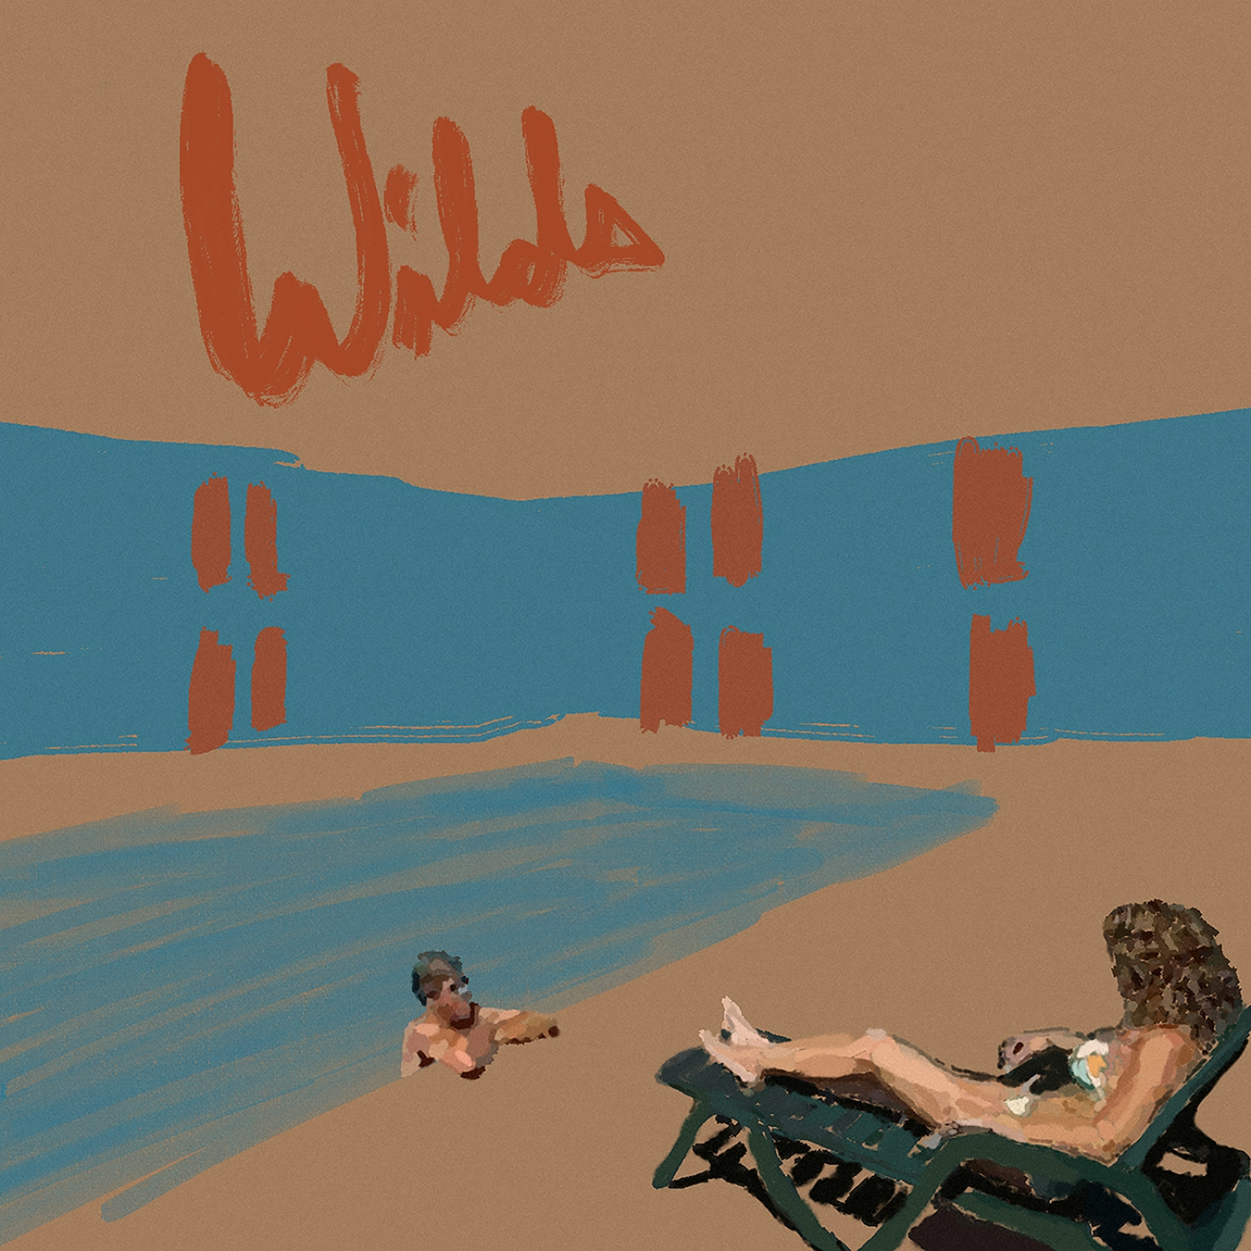
Wilds Cover Artwork

Website | ANTI- | Instagram | Facebook | Twitter | Bandcamp

For more information, contact:
Jessica Linker & Jaycee Rockhold | Pitch Perfect PR – jessica@pitchperfectpr.com, jaycee@pitchperfectpr.com, 773-942-6954

##

