September 1, 2021
For Immediate Release

Andy Shauf Releases New Single, “Spanish On The Beach”

US Tour Kicks Off Next Week
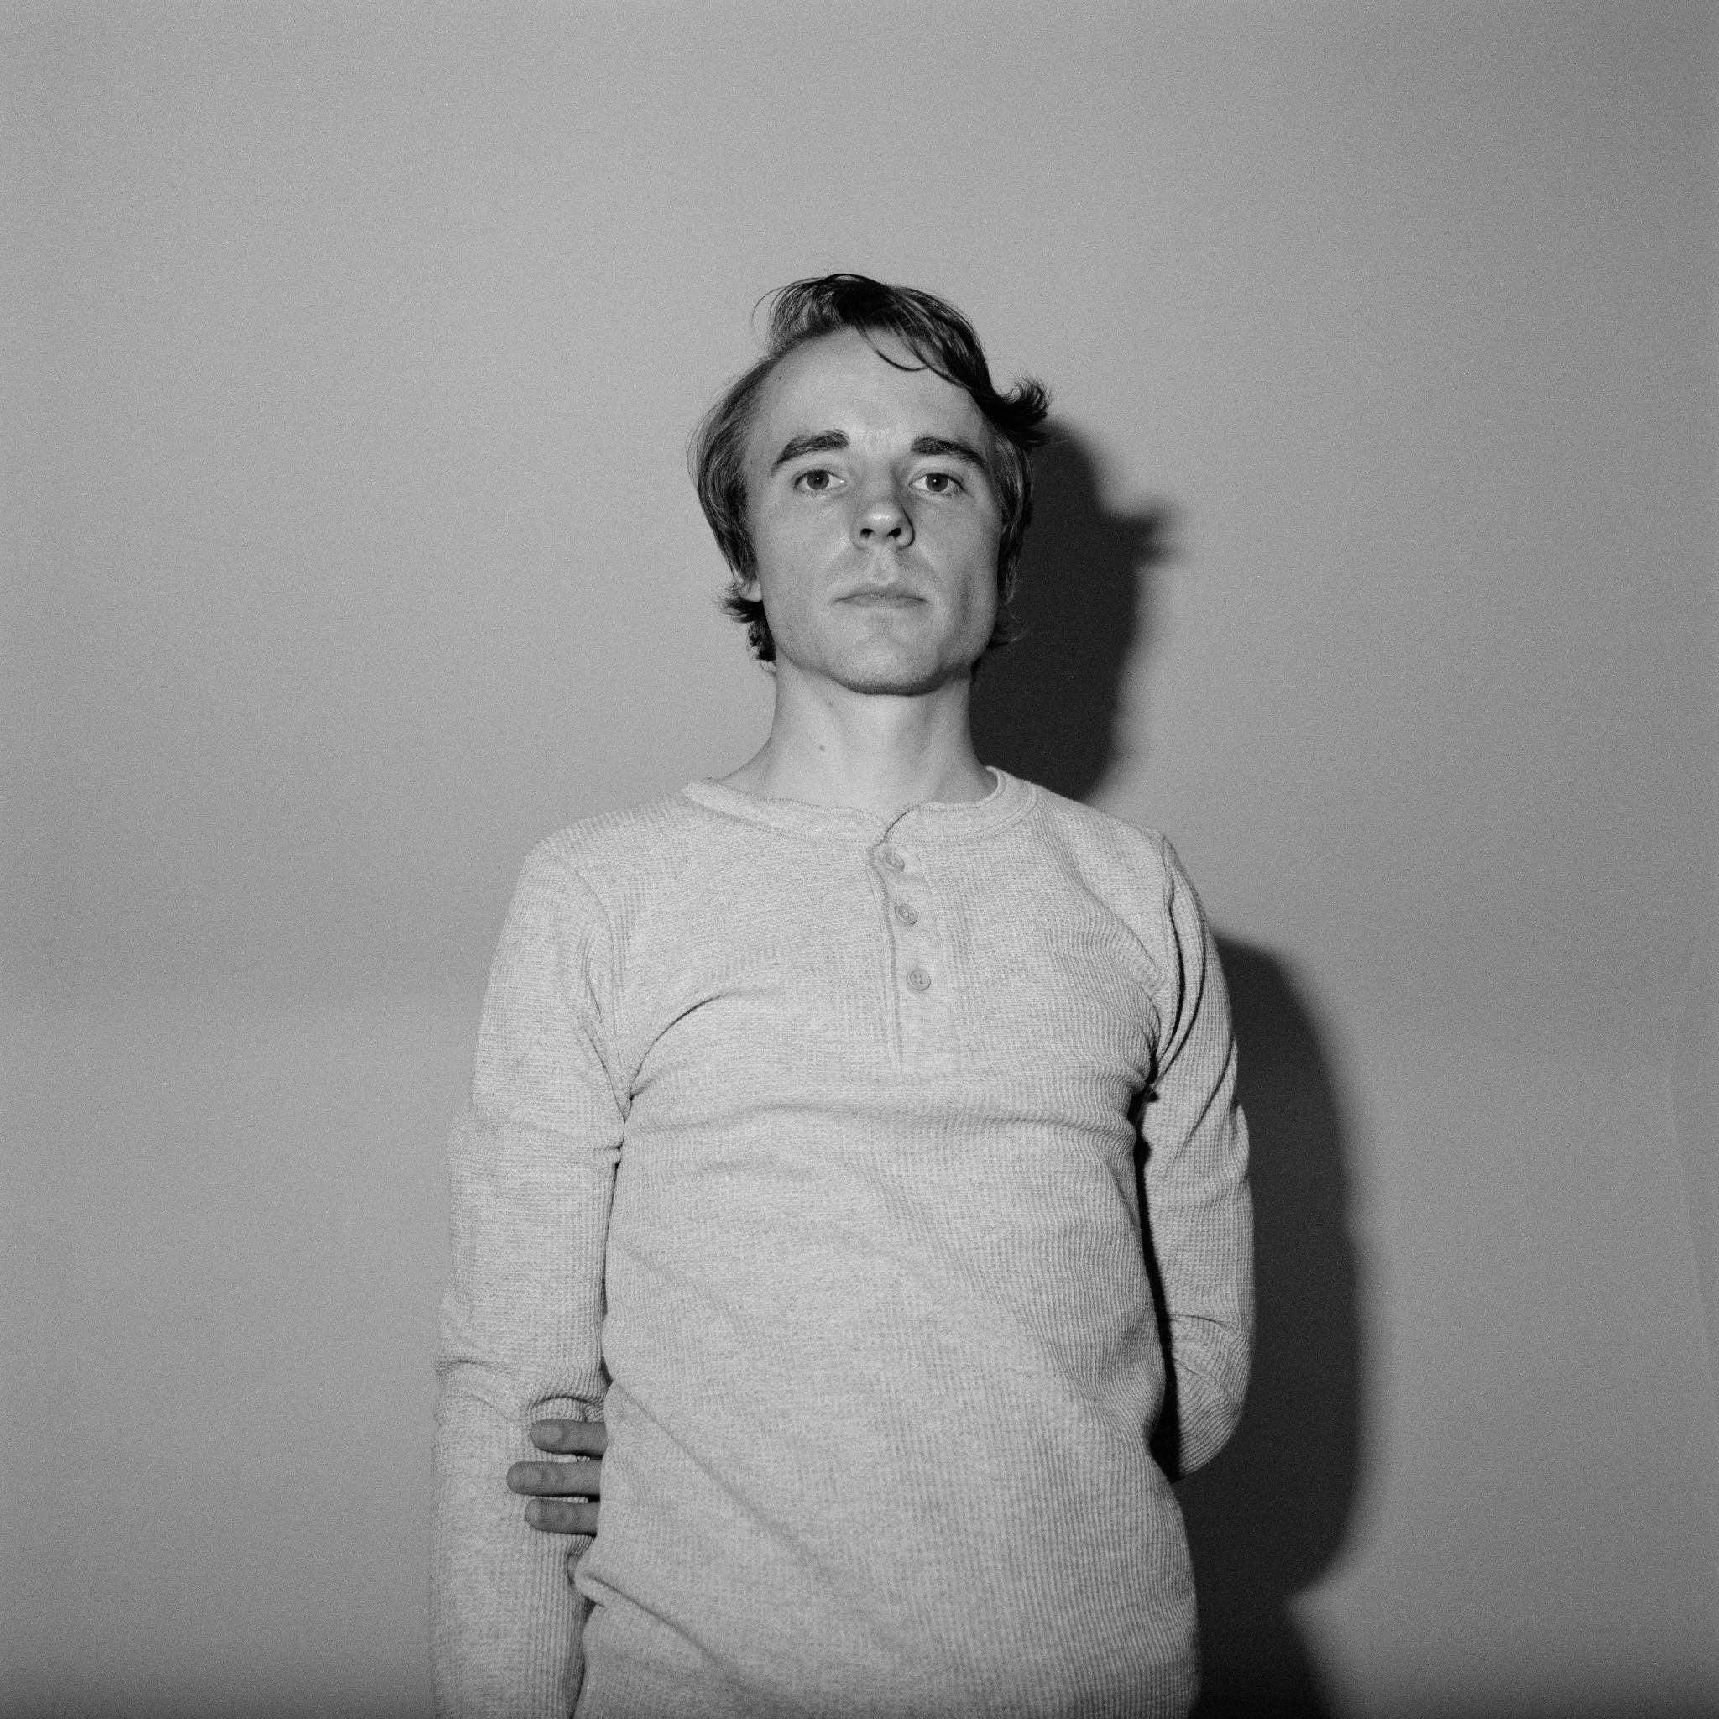
Photo Credit: Colin Medley

Today, Andy Shauf returns with a new single, “Spanish On The Beach,” via ANTI-, preceding his US tour, which kicks off next week. “Spanish On The Beach” could neatly slot into The Neon Skyline, his most recent album and “a wistful, funny, and heartbreaking world of its own” (Pitchfork). Over gentle, jazzy guitar strums augmented with the wispiest of woodwinds, Shauf tells an empathetic, funny story of a couple’s time on an all-inclusive resort vacation, using the idea of a language barrier as a metaphor for the beginning stages of communication breakdown. It ends with the narrator envisioning an imagined scenario in which he proposes to Judy, a character mentioned across The Neon Skyline, before bursting into song, musical theater-style, with the resort’s house band. “It’s the same theme as the story ended up being at the Skyline but the narrator's life is a little bit booze-fueled,” says Shauf on the song. “And this vacation is kind of like the first stop on the way to destruction.”

Andy Shauf kicks off his full band US tour next week with two shows at Warsaw in Brooklyn before heading to the Pitchfork Music Festival. He’ll tour all month across the country and return at the end of October for the Levitation Festival in Austin, Texas and Desert Daze in Perris, CA. The Andy Shauf band is comprised of Shauf (guitar, vocals), Colin Nealis (keys, synth), Daniel Pencer (woodwinds), Chris Bezant (guitar), Josh Daignault (bass) and Sean Mullins (drums).

Listen to Andy Shauf’s “Spanish On The Beach”

Purchase Tickets for North American Tour

Andy Shauf Tour Dates
Thu. Sept. 9 - Brooklyn, NY @ Warsaw *
Fri. Sept. 10 - Brooklyn, NY @ Warsaw - SOLD OUT *
Sun. Sept. 12 - Chicago, IL @ Pitchfork Music Festival
Tue. Sept. 14 - Madison, WI @ Majestic Theatre *
Wed. Sept. 15 - Grand Rapids, MI @ Calvin College *
Thu. Sept. 16 - Indianapolis, IN @ Hi-Fi *
Fri. Sept. 17 - Cleveland, OH @ The Grog Shop *
Sat. Sept. 18 - Pittsburgh, PA @ Sound Series: Block Party *
Tue. Sept. 21 - Fort Collins, CO @ Washington’s Foco #
Wed. Sept. 22 - Boulder,CO @ Fox Theatre !
Thu. Sept. 23 - Salt Lake City, UT @ The Urban Lounge @
Fri. Sept. 24 - Boise, ID @ Treefort Music Fest
Sat. Sept. 25 - Eugene, OR @ Sessions Music Hall #
Sun. Sept. 26 - Tacoma, WA @ McMenamins Elks Temple #
Tue. Sept. 28 - Santa Cruz, CA @ Moe’s Alley #
Wed. Sept. 29 - Santa Barbara, CA @ Soho Restaurant & Music Club #
Thu. Sept. 30 - Los Angeles, CA @ Hollywood Forever Cemetery ^
Fri. Oct. 1 - Sonoma, CA @ Sebastiani Theatre #
Sat. Oct. 2 - San Francisco, CA @ Hardly Strictly Bluegrass
Sat. Oct. 30 - Austin, TX @ Levitation Festival
Sat. Nov. 13 - Perris, CA @ Desert Daze Festival
Thu. Feb. 3, 2022 - Ottawa, ON @ Bronson Centre
Fri. Feb. 4, 2022 - Montreal, QC @ Corona Theatre
Sat. Feb. 5, 2022 - Toronto, ON @ Danforth Music Hall
Sun. Feb. 6, 2022 - Toronto, ON @ Danforth Music Hall
Thu. Feb. 17, 2022 - Sheffield, MA @ Race Brook Lodge
Fri. Feb. 18, 2022 - Woodstock, NY @ Colony Cafe
Sun. Feb. 20, 2022 - Charlottesville, VA @ The Southern Music Hall
Tue. Feb. 22, 2022 - Carrboro, NC @ Cat’s Cradle
Wed. Feb. 23, 2022 - Asheville, NC @ The Grey Eagle
Thu. Feb. 24, 2022 - Birmingham, AL @ Saturn
Fri. Feb. 25, 2022 - Atlanta, GA @ Terminal West
Sun. Mar. 20, 2022 - Bruxelles, BE @ Le Botanique
Tue. March 30, 2022 - Washington, DC @ Black Cat
Wed. March 31, 2022 - Philadelphia, PA @ Union Transfer
Sun. April 3, 2022 - Boston, MA @ Paradise Rock Club
Mon. April 18, 2022 - Düdingen, CH @ Bad Bonn
Wed. April 20, 2022 - Mérignac, FR @ Le Krakatoa
Thu. April 21, 2022 - Paris, FR @ Trianon
Fri. April 22, 2022 - Rouen, FR @ Le 106
Sat. April 23, 2022 - Esch-Sur-Alzette, LU @ Kulturfabrik
Sun. April 24, 2022 - Utrecht, NL @ Tivoli Vredenburg
Mon. April 25, 2022 - Rotterdam, NL @ Rotown
Tue. April 26, 2022 - Nijmegen, NL @ Doornroosje
Thu. April 28, 2022 - Copenhagen, DK @ Loppen
Fri. April 29, 2022 - Oslo, NO @ Ingensteds
Sat. April 30, 2022 - Stockholm, SE @ Nalen Klubb
Mon. May 2, 2022 - Hamburg, DE @ Knust
Tue. May 3, 2022 - Berlin, DE @ Silent Green
Thu. May 5, 2022 - Bruxelles, BE @ Les Nuits Botanique Festival
Fri. May 6, 2022 - Cologne, DE @ Luxor
Sat. May 7, 2022 - Genk, BE @ Little Waves Festival
Mon. May 9, 2022 - Birmingham, UK @ The Castle & Falcon
Tue. May 10, 2022 - Edinburgh, UK @ Summerhall
Wed. May 11, 2022 - Glasgow, UK @ Drygate
Thu. May 12, 2022 - Manchester, UK @ Gorilla
Fri. May 13, 2022 - Leeds, UK @ Brudenell Social Club
Sat. May 14, 2022 - Bristol, UK @ Fiddlers
Sun. May 15, 2022 - Brighton, UK @ Chalk
Mon. May 16, 2022 - London, UK @ Shepherd’s Bush Empire
Wed. May 18, 2022 - Belfast, UK @ Em in pire
Thu. May 19, 2022 - Dublin, IE @ Button Factory
* = w/ Tomberlin
# = w/ Hand Habits
! = w/ Son Little
@ = w/ Wild Pink
^ = w/ Lord Huron

Download hi-res images & jpegs of Andy Shauf
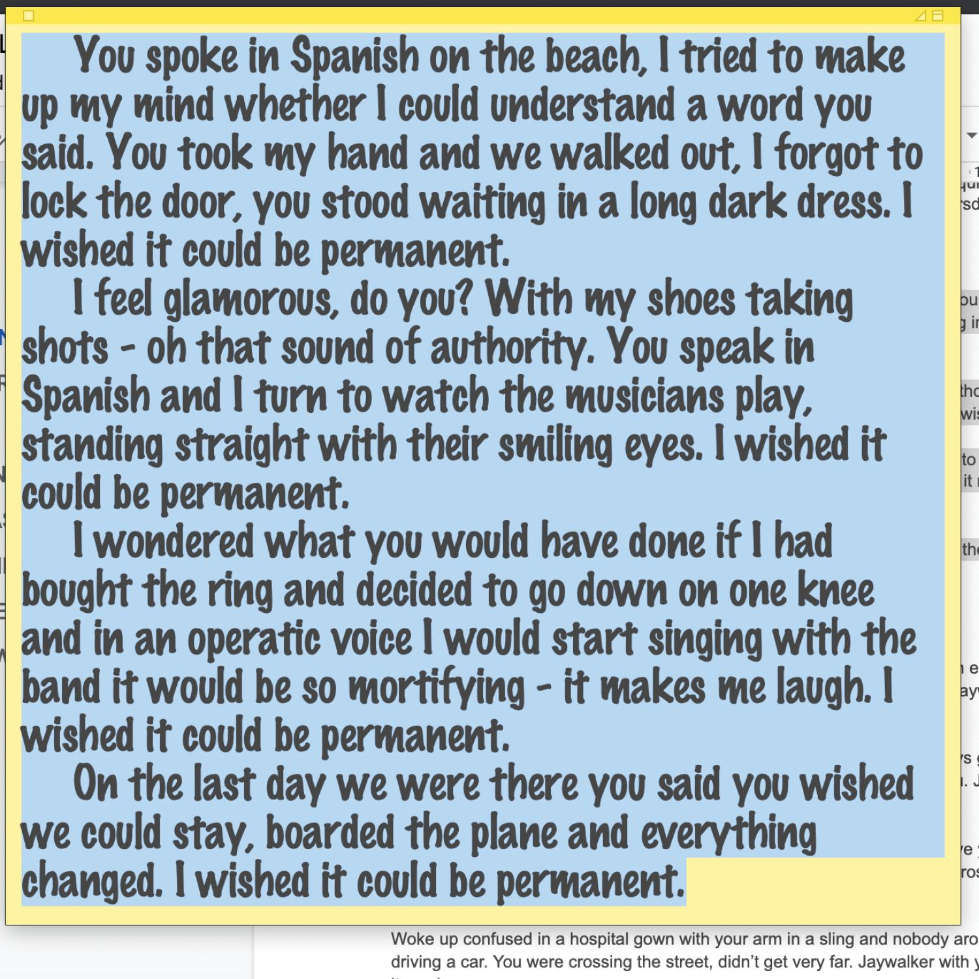
“Spanish On The Beach” Track Artwork

Website | ANTI- | Instagram | Facebook | Twitter | Bandcamp

For more information, contact:
Jessica Linker | Pitch Perfect PR – jessica@pitchperfectpr.com, 773-942-6954

##

