October 1, 2020
For Immediate Release

Andy Shauf Releases Stunning New Video for “Clove Cigarette,”
Off Of The Neon Skyline

Watch the Video, Made Using LiDAR, HERE

Announces Livestream Performance on October 18th at 5pm EST
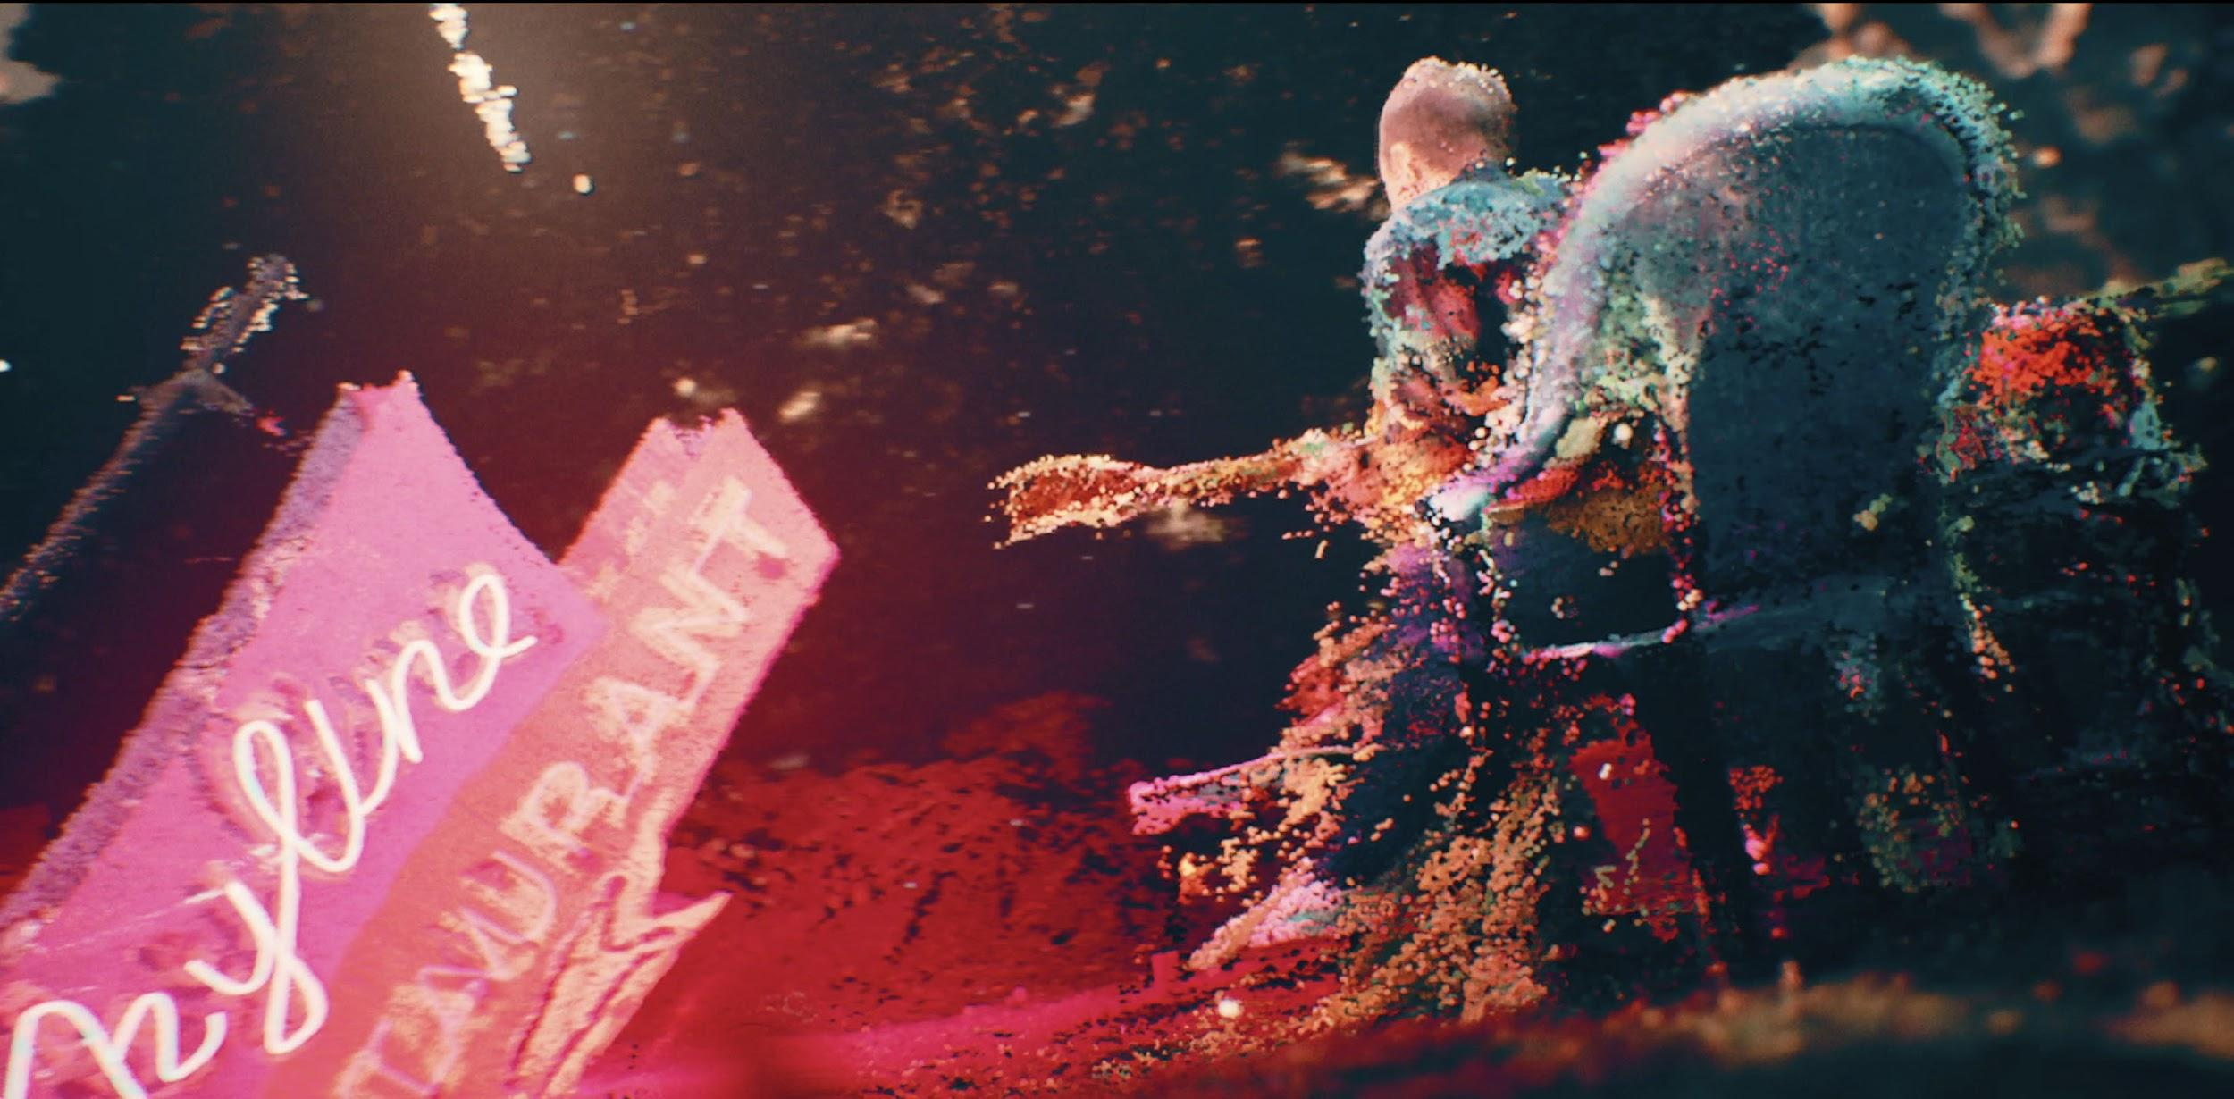
“Clove Cigarette” Video Still

Andy Shauf’s The Neon Skyline, released earlier this year via ANTI-, is one of 2020’s most highly praised records. The “gorgeously rendered folk-pop storytelling” (Billboard, The 50 Best Albums of 2020 So Far) continues to garner incredible praise from critics and fans alike. Today, Shauf presents a stunning video for the album’s “Clove Cigarette,” which explores the better times, honing in on hazy memories. The video, directed by Colin Medley and Jared Raab, was made using a variety of cutting edge technologies: LiDAR, a 3D scanning technique using laser light that’s often used for 3D maps and self-driving cars, photogrammetry, and a video game engine. It features static tableaus of Shauf in various settings, playing his guitar in the yard and the Skyline bar. These scans were then relit and rendered out using an animated virtual camera. “The song is about half-forgotten moments, so Jared and I wanted to make something dreamlike and imperfect,” explains Medley.

Jared Raab further explains: “If you listen closely to the song, the lyrics drift seamlessly in and out of memories, so we wanted to find visuals that could capture the same sparse quality. We noticed that these scans were almost impressionistic, like computer generated pointillism. Along with our technical director Luca, we stumbled on a brilliant artist RubenFro, who was using the Unity game engine to render point clouds. The results are surprisingly natural, like ghostly moments frozen in time. Though we ended up going with a different game engine (Unreal), we knew we had found the right tool to articulate the feeling of the song. In the end, I think the results stunned us.”

Watch Andy Shauf’s Video for “Clove Cigarette”

Additionally, Shauf is pleased to announce a livestream concert happening October 18th at 5pm EST. $5 from every ticket will benefit The Encampment Support Network (ESN), an organization that addresses Toronto's housing crisis head-on by bringing humanitarian aid to neighbors living in encampments around the city. “There are a lot of people in our city who need our help and support right now, and winter is approaching quickly,” says Shauf. “ESN is doing crucial work helping bring basic essentials to Toronto's homeless population living in encampments around the city, and I want to support that cause."

Watch/Listen/Share:
Stream/Purchase The Neon Skyline
“Try Again” Video
“Things I Do” Stream
“Neon Skyline” Video
“Living Room” Stream
Jimmy Kimmel Live! Performance

Mid-year Praise for The Neon Skyline:

“All singer-songwriters are storytellers of a sort, but neither term does justice to what Andy Shauf accomplishes on The Neon Skyline. ”
- Stereogum, Best Albums of 2020 So Far

“Listening to an Andy Shauf album in full is akin to bingeing a particularly compelling TV show: Both pull you in with characters that feel just as real as you or me, who populate a world we’d like to escape to.” - Paste, Best Indie Rock Albums of 2020 (So Far)

“Andy Shauf’s songs are charming tales of everyday life. . . perhaps the least pretentious concept album you'll find.” -- Esquire, Best Songs of 2020 So Far

“The Neon Skyline is a wise and transportive album, with Shauf taking his place among the great contemporary songwriters.” -- Uproxx, The Best Indie Albums Of 2020 So Far

Website | ANTI- | Instagram | Facebook | Twitter | Bandcamp

For more information, contact:
Jessica Linker & Patrick Tilley | Pitch Perfect PR –
jessica@pitchperfectpr.com, patrick@pitchperfectpr.com

##

