BONNY DOON
.
SHARE NEW SINGLE “CROOKED CREEK”

JANUARY TOUR KICKS OFF NEXT WEEK

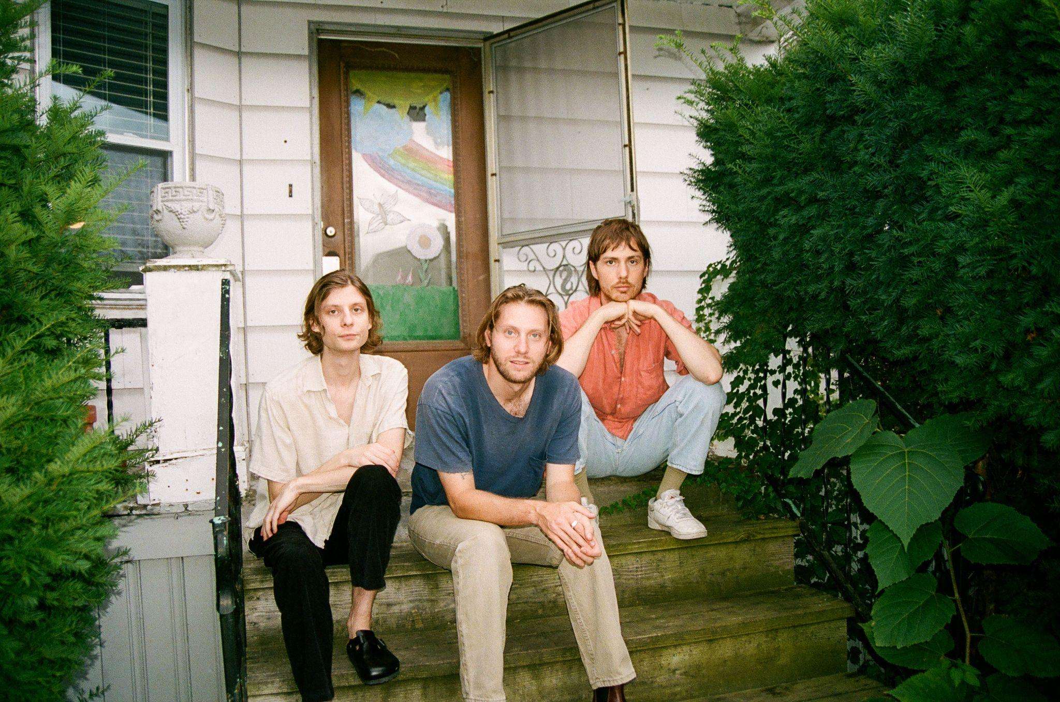
Photo Credit: Anna Friss (download hi-res)

“Detroit’s Bonny Doon recline deep in the kind of alternative folk music that gives off its own warmth, wise enough to sit back with some guitars and watch the world crumble.”
-Pitchfork

“Heroes of ambling, melancholy, poetic indie rock”
-Stereogum

“Folk rock with some alt-country sprinklings—but the band’s more spontaneous approach lends it a scrappiness that feels fresh. Rather than rein these songs in to the point of suffocation, the band allows them to breathe, rambling and untangling themselves in unexpected ways.”
-FLOOD

Bonny Doon have shared “Crooked Creek,” the rollicking new single from the Detroit, MI trio. "We were trying to be more free in our writing and I think this song is a good example,” explained Bobby Colombo. “We had a lot of fun with the words, which is sometimes not the fun part. I love writing with Bill’s voice in mind, and he was able to really capture the spirit of this one I think.”

Bonny Doon is hitting the road next week on a tour that includes shows with Bnny, Hazel City and Ulna. All dates below.

Bonny Doon is Bill Lennox, Bobby Colombo and Jake Kmiecik.

LISTEN TO “CROOKED CREEK”

TOUR DATES:
1/19 - Chicago, IL @ The Empty Bottle
1/20 - Milwaukee, WI @ Cactus Club
1/21 - Indianapolis, IN @ Lo-Fi Lounge
1/22 - Nashville, TN @ The Blue Room at Third Man Records
1/24 - Cincinnati, OH @ Northside Tavern
1/25 - Louisville, KY @ Zanzibar
1/26 - Columbus, OH @ Natalie’s Grandview
1/27 - Kalamazoo, MI @ Bell’s Eccentric Cafe

LISTEN TO THE PREVIOUSLY RELEASED SINGLE
“SAN FRANCISCO”

Bonny Doon formed in 2014 and put out a few 7”s before releasing their self-titled debut in 2017, which Pitchfork called “at once jagged and unfinished, languid and detail-oriented, restless and at peace.” In 2018 the band began performing as Waxahatchee’s backing band and released their latest record Longwave. UK’s CLASH Magazine called it “a gently simple record but one which manages to exert an almost hypnotic pull,” while VICE said it “improves on the homespun charm that made their debut so inviting.” Lennox and Colombo were also close collaborators on Waxahatchee’s critically acclaimed 2020 album Saint Cloud and wrote many of the record’s beloved guitar arrangements.

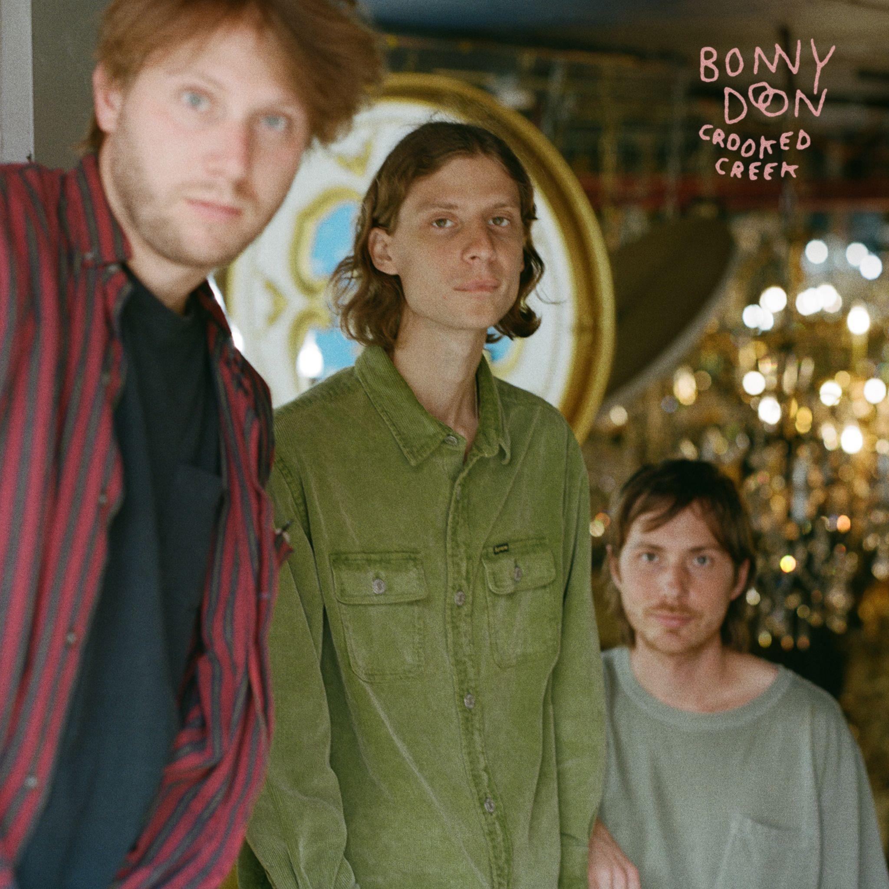
(download hi-res)

FOLLOW BONNY DOON
Bandcamp | Spotify | YouTube
Twitter | Instagram | Facebook

