BONNY DOON
.
SHARE NEW SINGLE “ON MY MIND”

LET THERE BE MUSIC OUT JUNE 16 VIA ANTI- RECORDS

SUMMER TOUR DATES ANNOUNCED
.
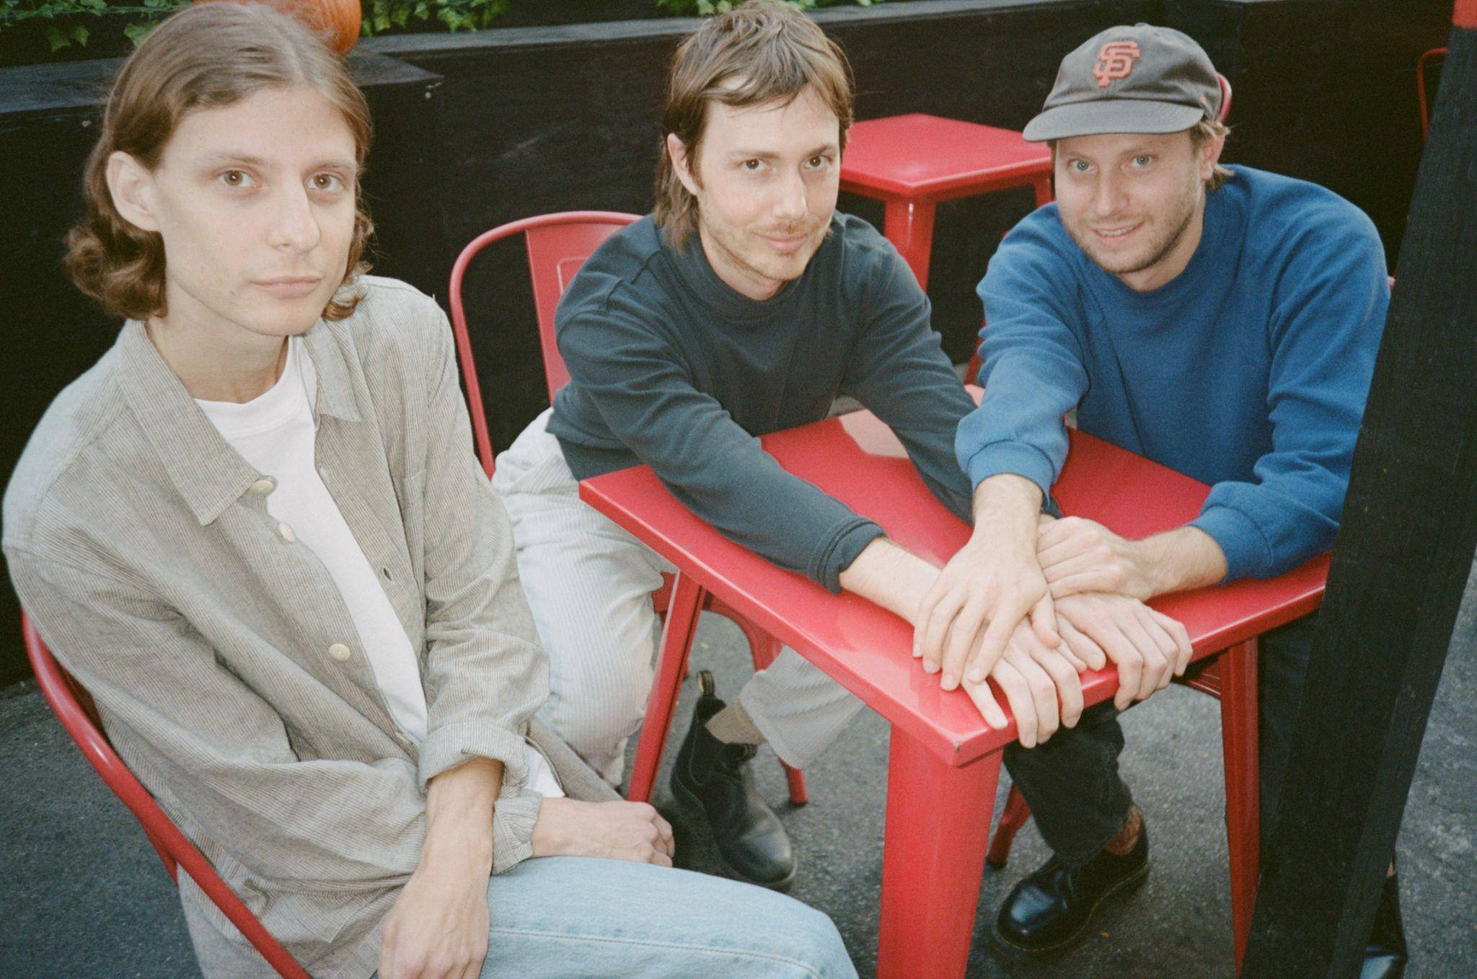
Photo Credit: Andi Kerr (download hi-res)

“Masters of midwestern chill”
-Rolling Stone

“Detroit’s Bonny Doon recline deep in the kind of alternative folk music that gives off its own warmth, wise enough to sit back with some guitars and watch the world crumble.”
-Pitchfork

“Heroes of ambling, melancholy, poetic indie rock”
-Stereogum

“Folk rock with some alt-country sprinklings—but the band’s more spontaneous approach lends it a scrappiness that feels fresh. Rather than rein these songs in to the point of suffocation, the band allows them to breathe, rambling and untangling themselves in unexpected ways.”
-FLOOD

Detroit, MI trio Bonny Doon share “On My Mind,” the wistful new single and final preview of their upcoming new album, Let There Be Music, out June 16th via ANTI- Records.

"I realized at some point that most of my thoughts, in one way or another, are just about people I know. Partners, crushes, family, friends active and friends estranged, people you barely know but who somehow manage to take up outsized psychic space, people no longer with us on this plane, etc. I don’t really know, but I would guess that’s true for most people. That’s what this song’s about," Bobby Colombo explains.
Bonny Doon is hitting the west coast next week and have announced a US summer tour. Tickets are available via the band’s website. All dates below.

LISTEN TO “ON MY MIND”

After extensively touring their 2018 sleeper cult-classic Longwave by supporting Band of Horses, Snail Mail and Waxahatchee, Lennox and Bobby Colombo were invited by Katie Crutchfield to collaborate on Waxahatchee’s critically acclaimed album Saint Cloud. “The experience raised the ceiling on our imagination,” Colombo said. Soon after, Colombo and Jake Kmiecik, whose steady percussion and devotion to the songs creates a container for the indelible guitar lines, both entered a time of serious healing, Jake tending to complications of his Crohn’s disease and Bobby to a brain injury and undiagnosed Lyme disease. While these detours of doctors’ appointments and experimental care were taking place, the members of Bonny Doon were also Waxahatchee’s backing band on the Saint Cloud tour. These obstacles and commitments drew out the making of Let There Be Music for several additional years, and in the process, redefined the record as an achievement in perseverance for the band.

On their long-awaited third album, we get a glimpse into the pure joy of Bonny Doon. The album serves as less of one conceptual story, and each song as their own Individual offerings of putting words to the ordinary experience of being alive. The band is at their most dynamic and the songwriting deftly explores new terrain. Let There Be Music is brimming with small truths - both profound and mundane, comforting and difficult - and we are invited to revel in them all.

Bonny Doon is Bill Lennox, Bobby Colombo and Jake Kmiecik.

Tour Dates:
5/9 - Vista, CA @ Booze Bros Brewing Co.
5/10 - Los Angeles, CA @ Gold Diggers
5/11 - Los Angeles, CA @ Gold Diggers - SOLD OUT
5/12 - Ojai, CA @ Ojai Women’s Club
6/16 - Detroit, MI @ MOCAD *
6/17 - Cleveland, OH @ Beachland Tavern *
6/18 - Philadelphia, PA @ PhilaMOCA ^
6/20 - New York, NY @ Bowery Ballroom ^
6/21 - Kingston, NY @ Tubby's ^
6/22 - Washington, DC @ Comet Ping Pong ^
6/23 - Carrboro, NC @ Cat's Cradle ^
6/24 - Atlanta, GA @ 529 ^
6/26 - Houston, TX @ White Oak Music Hall ~
6/27 - Austin, TX @ Empire ~
6/28 - Denton, TX @ Rubber Gloves ~
6/30 - Tucson, AZ @ Club Congress ~
7/1 - Phoenix, AZ @ Valley Bar ~
7/2 - San Diego, CA @ Casbah ~
7/6 - San Francisco, CA @ The Chapel ~
7/8 - Portland, OR @ Doug Fir ~
7/9 - Seattle, WA @ Barboza ~
7/13 - Minneapolis, MN @ 7th St. Entry ~
7/14 - Chicago, IL @ Thalia Hall ~
10/24 - London, UK @ The Lexington

* w/ Neu Blume
^ w/ John Andrews & The Yawns
~ w/ Anna St. Louis

LISTEN TO PREVIOUSLY RELEASED SINGLES
“NATURALLY,” “CROOKED CREEK,”
“SAN FRANCISCO,” & “LET THERE BE MUSIC”

In a world of urgency, there’s little regard to the spiritual, emotional, or physical well-being of musicians. The creative process, often hidden from the listeners, remains a mystery, though we may pick up clues in the songs themselves. Throughout the ten tracks in their new album Let There Be Music, you can hear the spaciousness Bonny Doon allowed themselves since 2018’s Longwave. Their latest musical journey is one that has big payoffs for devoted followers and undeniable rewards for anyone just stumbling across the band for the first time.
In the past five years Bonny Doon has shifted from being a Detroit band to an outfit spread between California and Michigan, and now Michigan and New York. Despite the new challenge of distance, members Bill Lennox (guitar and vocals), Bobby Colombo (guitar and vocals), and Jake Kmiecik (drums) leaned on their friendship to sustain the collaboration, which has blossomed more than ever on their third album. While many songwriters work in solitude, the back and forth magic of Colombo and Lennox's process is what gives Bonny Doon their unique voice. The two write and compose each song together, planning writing retreats throughout the year - to gather ideas, edit songs, and give each other feedback, continuing to dedicate themselves to the collaborative effort of being a songwriting team.

“San Francisco”, the big city next to Colombo’s rural home of Lagunitas, offers a glimpse into the way this band sees the world - with both critical eyes and hope. Backup vocals from Crutchfield, who has become a continued collaborator, lend to the essence of the song’s building finale. “Crooked Creek” boasts a robustness and thundering pulse that energizes the album with its presence. The playful imagery nods to the spiritual in an authentic but self-aware way - If you’re stepping in shit, you’re probably on the path.

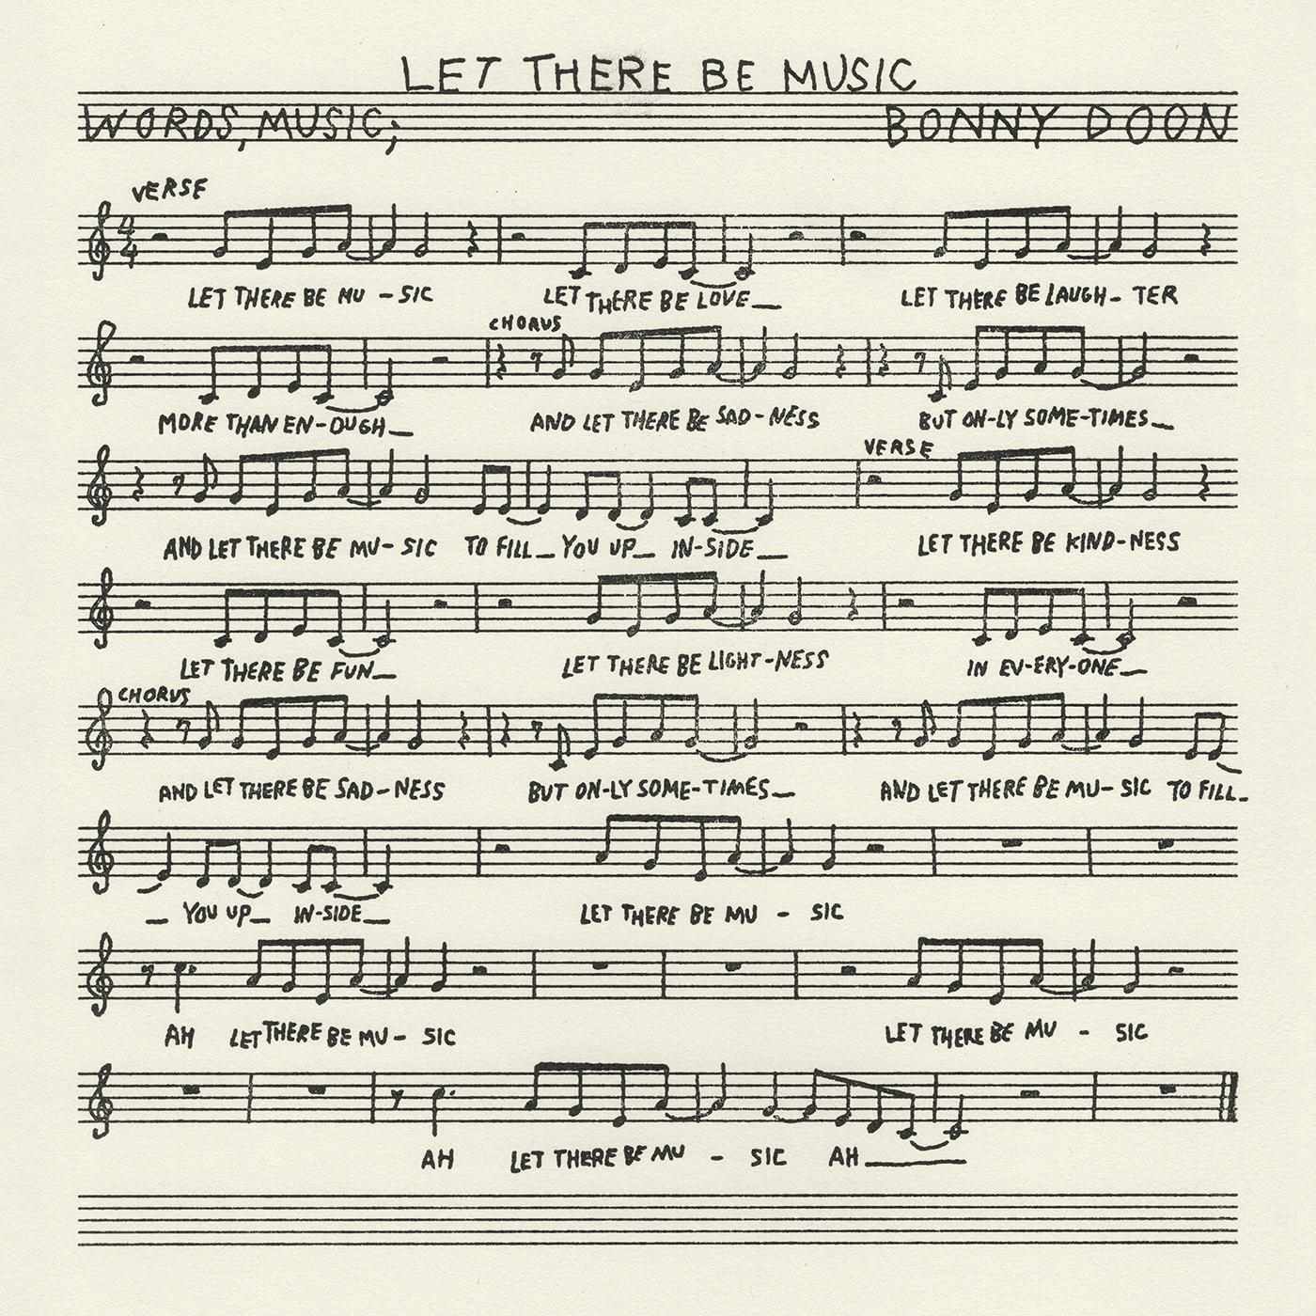
(download hi-res)

1. San Francisco
2. Naturally
3. Crooked Creek
4. Let There Be Music
5. Maybe Today
6. You Can’t Stay The Same
7. Roxanne
8. On My Mind
9. Fine Afternoon
10. Famous Piano

FOLLOW BONNY DOON
Bandcamp | Spotify | YouTube | Twitter | Instagram | Facebook

