November 16, 2022
For Immediate Release

Cass McCombs Announces Rescheduled North American Tour for January 2023

New Album, Heartmind, Out Now Via ANTI-
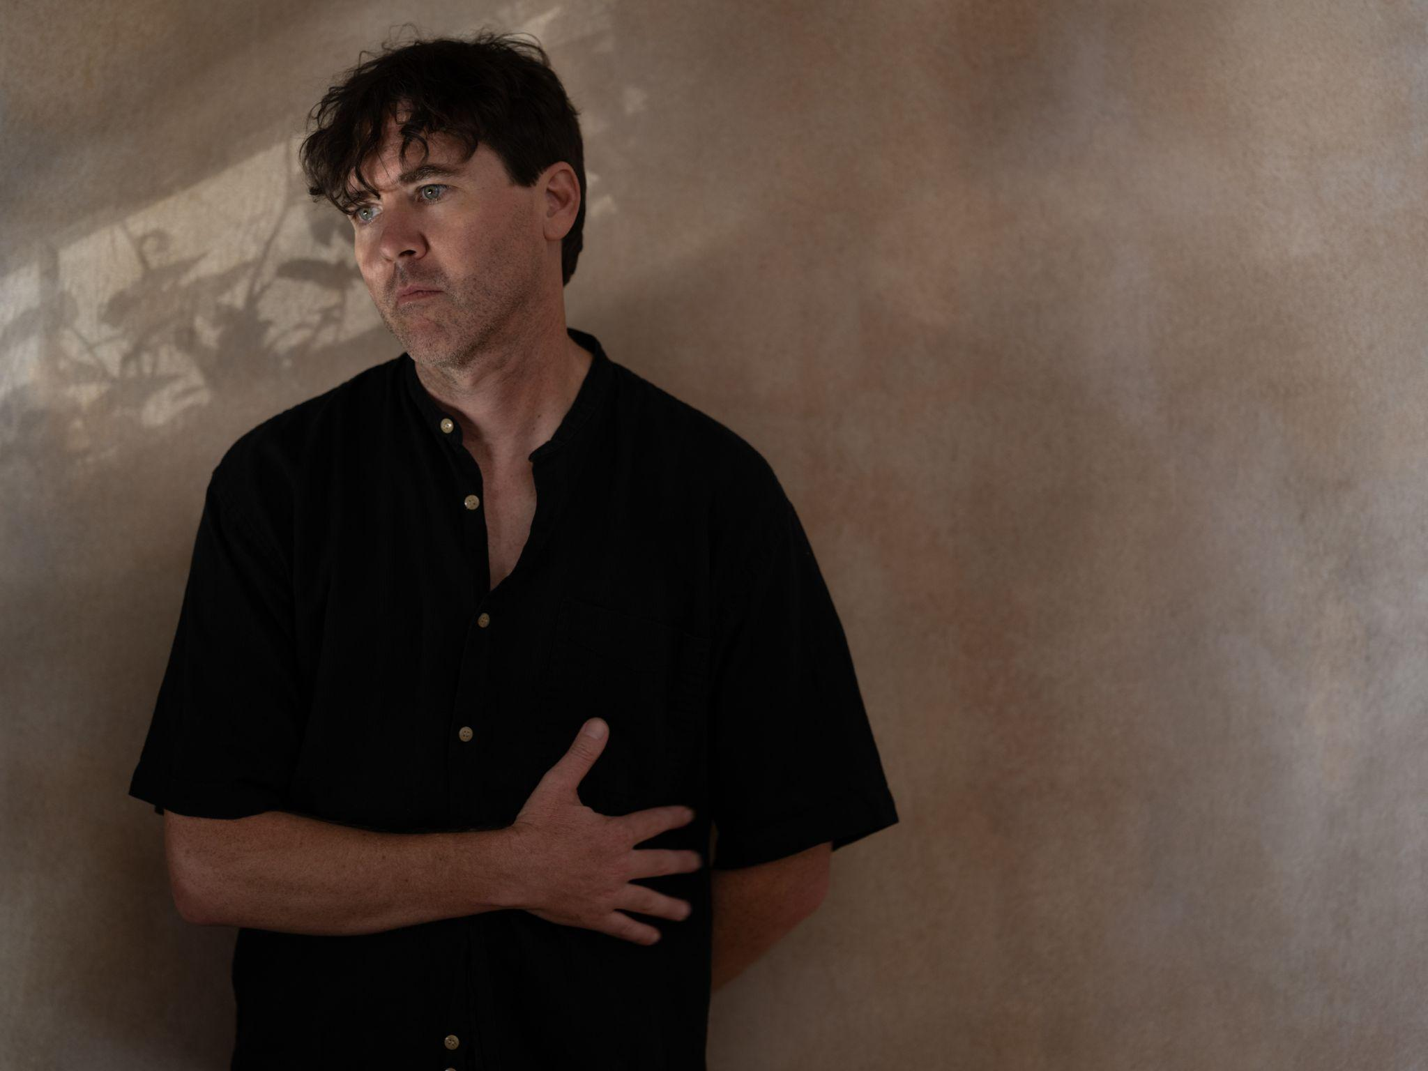
Photo Credit: Ebru Yildiz

On Cass McCombs’ latest album, Heartmind, he “has never sounded so confident or intentional” (Pitchfork). The album, out now via ANTI-, received a slew of glowing praise, including from the Wall Street Journal, who deemed it an “an arresting collection of songs that tackles pain and uncertainty with humor and grace,” The FADER, Aquarium Drunkard, FLOOD, and more. Today, he’s pleased to announce a North American tour, which previously was scheduled for this fall, but will now take place in January 2023. McCombs is consistently recognized for his incredible musicianship and athletic lyricism, and this will be the first time he’s playing songs off of Heartmind in these cities. A full list of dates can be found below and tickets are on sale this Friday at 10am EST.

Watch/Listen/Share
Purchase Heartmind
“Belong to Heaven” Video
"Unproud Warrior" Video
“Karaoke” Video
“Instrumental Karaoke Version”

Cass McCombs Tour Dates
Fri. Jan. 13 - Amherst, MA @ The Drake
Sat. Jan. 14 - Providence, RI @ Columbus Theatre
Sun. Jan. 15 - Boston, MA @ The Sinclair
Tue. Jan. 17 - Indianapolis, IN @ Hi-Fi
Wed. Jan. 18 - Chicago, IL @ Thalia Hall
Fri. Jan. 20 - Toronto, ON @ Great Hall
Sat. Jan. 21 - Pittsburgh, PA @ The Andy Warhol Museum
Sun. Jan. 22 - Charleston, WV @ Mountain Stage
Tue. Jan. 24 - Washington, DC @ 9:30 Club
Wed. Jan. 25 - Ardmore, PA @ Ardmore Music Hall
Thu. Jan. 26 - New York, NY @ Bowery Ballroom

Praise for Heartmind

“[Heartmind], the latest subtle reinvention in an ever evolving career, spools out similarly thoughtful tales, contemplating grief and politics in darkly comic verse.” - Pitchfork

“One of America’s most reliably excellent singer-songwriters.” - The Guardian

“Like so much of [Cass McComb’s] best work, [Heartmind] tackles hard questions and draws on a wide range of music, but it’s ultimately accessible and easy to appreciate on first listen.”
- Wall Street Journal

"Within [Heartmind’s] classic run-time of 8 songs and 43 minutes is a genuine attempt at avoiding betraying direction and attempting to understand more of the world around us.”
- Aquarium Drunkard

“On his new album, Heartmind, one of American music’s great mystics is at his improvisational and imaginative best.” - The FADER

"The characters and narratives on Heartmind reflect some of the most mature writing of McCombs’ career.” - FLOOD

"[Cass] has pieced together one of the more sonically mesmerizing, and intellectually thought-provoking discographies in the realm of indie-country-Americana rock.” - SPIN

Download Cass McCombs’ hi-res press images and album art

Heartmind Cover Artwork (photo by Cass McCombs)

Website | Facebook | Instagram | Twitter

For more information, contact:
Jessica Linker | Pitch Perfect PR – jessica@pitchperfectpr.com, 773-942-6954
Jaycee Rockhold | Pitch Perfect PR - jaycee@pitchperfectpr.com, 816-731-8260

